SUPPLEMENTARY MATERIAL
Table S1. Descriptive statistics of measurement items
Node | items | content | RMSE | Predictability (R2)
PHQ9-1 | Anhedonia | Little interest or pleasure in doing things | 0.577 | 0.667
PHQ9-2 | Depressed mood | Feeling down, depressed, or hopeless | 0.534 | 0.715
PHQ9-3 | Sleep | Trouble falling or staying asleep, or sleeping too much | 0.613 | 0.624
PHQ9-4 | Energy | Feeling tired or having little energy | 0.538 | 0.711
PHQ9-5 | Appetite | Poor appetite or overeating | 0.621 | 0.614
PHQ9-6 | Guilty | Feeling bad about yourself-or that you are a failure or have let yourself or your family down | 0.559 | 0.687
PHQ9-7 | Consideration | Trouble concentrating on things, such as reading the newspaper or watching television | 0.608 | 0.63
PHQ9-8 | Motor | Moving or speaking so slowly that other people could have noticed | 0.563 | 0.683
PHQ9-9 | Suicidal ideation | Thoughts that you would be better off dead, or thoughts of hurting yourself in some way | 0.66 | 0.565
GAD7-1 | Nervousness | Feeling nervous, anxious, or on edge | 0.482 | 0.768
GAD7-2 | Uncontrollable worry | Not being able to stop or control worrying | 0.462 | 0.786
GAD7-3 | Excessive worry | Worrying too much about different things | 0.455 | 0.793
GAD7-4 | Trouble relaxing | Trouble relaxing | 0.483 | 0.767
GAD7-5 | Restlessness | Being so restless that it's hard to sit still | 0.475 | 0.775
GAD7-6 | Irritability | Becoming easily annoyed or irritable | 0.487 | 0.762
GAD7-7 | Negative future anticipation | Feeling afraid as if something awful might happen | 0.508 | 0.742
APGAR1 | Adaptation | utilization of resources for problem-solving when family equilibrium during a crisis | 0.592 | 0.649
APGAR2 | Partnership | sharing of decision-making and nurturing  responsibilities among family members | 0.497 | 0.752
APGAR3 | Growth | physical and emotional maturation and self-fulfillment achieved by family members through mutual support and guidance | 0.556 | 0.691
APGAR4 | Affection | caring or loving relationship between family members | 0.537 | 0.712
APGAR5 | Resolve | commitment to devote time to other family members for physical and emotional nurturing | 0.624 | 0.61
PHQ9: the 9-item Patient Health Questionnaire; GAD7: 7-item Generalized Anxiety Disorder Scale; APGAR: The Family APGAR Index Questionnaire

Figure S1. The bridge symptoms of anxiety, depression and family adaption symptoms in higher vocational school students.

Figure S2. Bootstrapped confidence intervals of edge weights. The red dots represent the values of each edge weight. The gray area corresponds to the 95% Confidence Intervals of edge weights, calculated using the non-parametric bootstrap procedure.

Figure S3. Estimation of edge weight difference by bootstrapped difference test. The network was subject to bootstrapped difference tests to examine differences between edge weights. Edges that did not exhibit significant differences are depicted in gray boxes, while those that did are shown in black boxes. The diagonal line of colored boxes represents the edge weight colors in the variable network. Blue boxes indicate a positive relationship, while light red boxes indicate negative relationships.

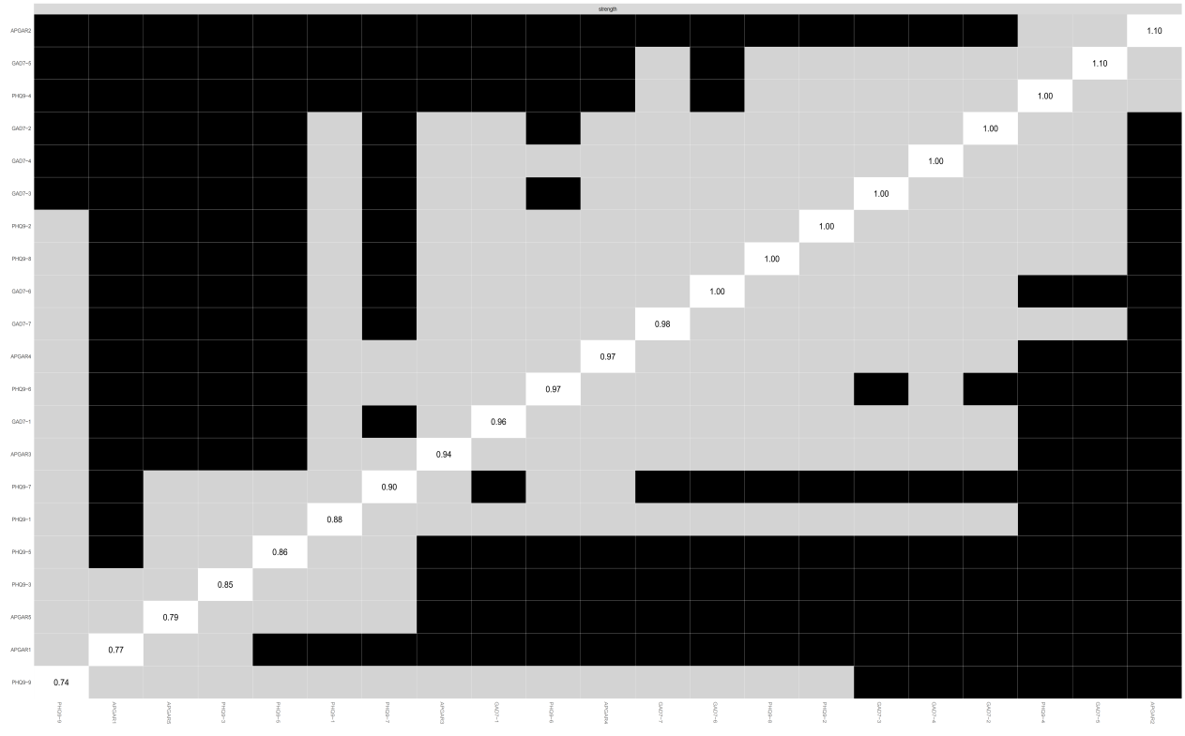

Figure S4. Estimation of node strength difference by bootstrapped difference test. The nodes were compared to each other, with gray boxes indicating nodes that did not exhibit significant differences and black boxes representing nodes that did. White boxes, on the other hand, represent the values of the node strength.

B ).
A ).

Figure S5. Longitudinal NCT results. (A) Network edge invariance test. (B) Network global invariance test.
a2. male bridge strength
a1.female bridge strength
b2. male bridge expected Influence
b1.female bridge expected Influence

Figure S6. Centrality bridge stability coefficient (CS-coefficients) a. bridge strength b. bridge Expected Influence

