Supplementary documents RS01X validation

Appendix 1: Analysis clustered measurements
Appendix Table 1: Paired Samples T-test
Inhalation profiles | Mean | CI 95%  (lower ; upper) | P-value
IPR Duration – smart DPI Duration (milliseconds) | -2 | -18 ; 14 | 0.827
IPR Volume – smart DPI Volume (milliliters) | 19 | 3 ; 36 | 0.024
IPR PIF – smart DPI PIF (liters/minute) | 0.945 | 0.286 ; 1.603 | 0.005
Abbreviations: IPR = inhalation profile recorder, smart DPI = smart dry powder inhaler, PIF = Peak inspiratory flow.

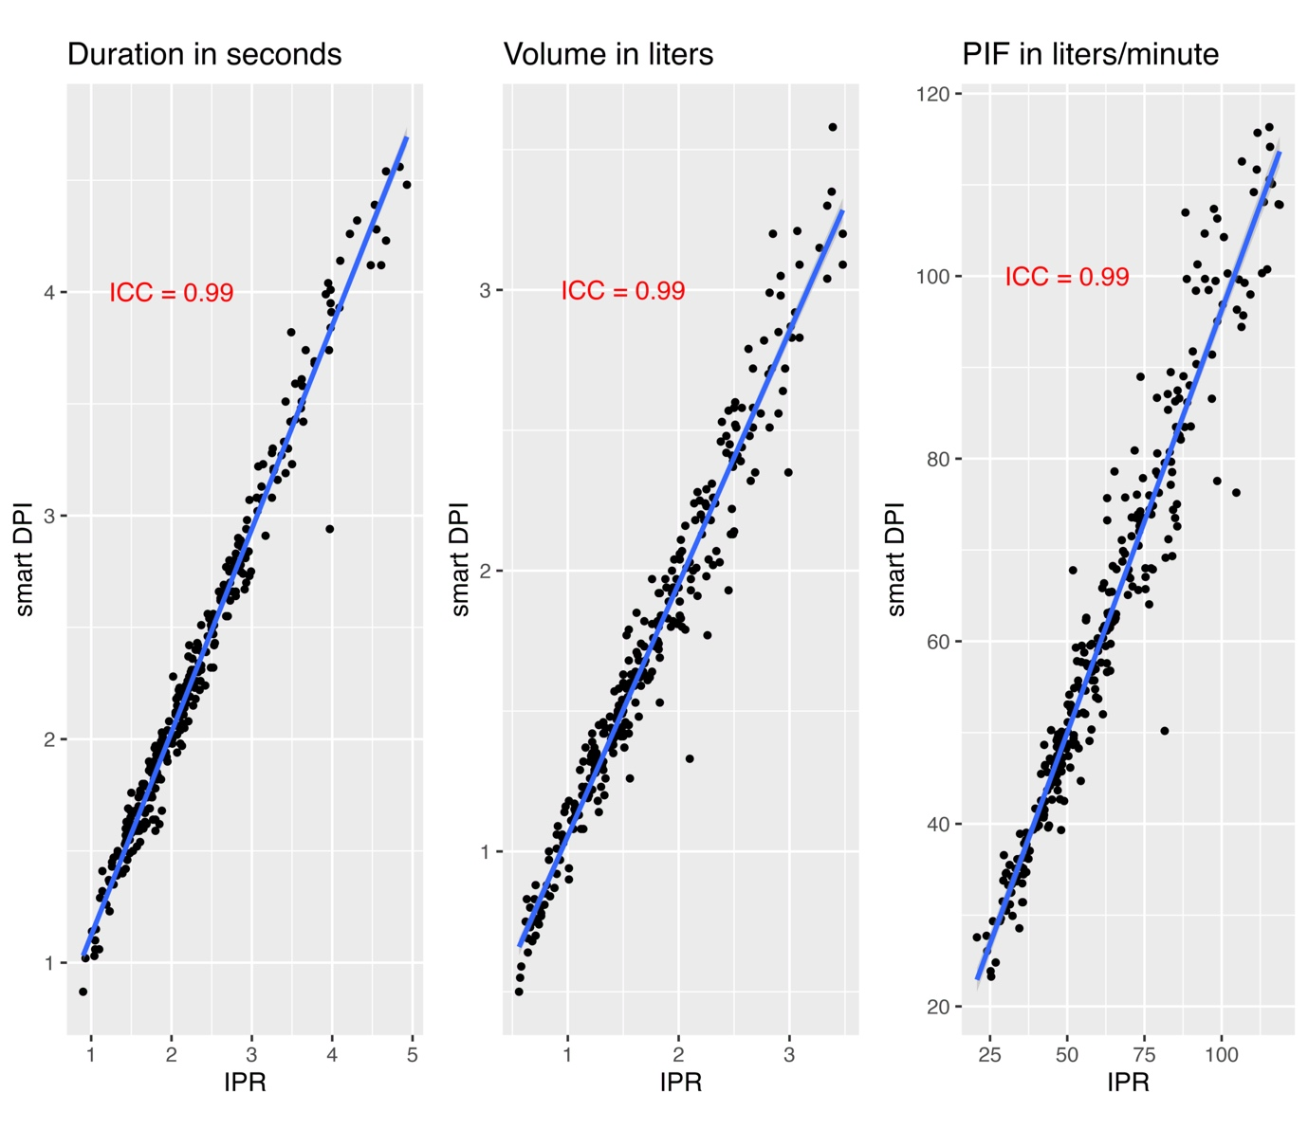
Appendix Figure 1. Population Characteristics; Scatterplot for duration, volume, and peak inspiratory flow (PIF).

Appendix 2: Analyses within groups
Appendix Table 2.1: Paired Samples T-Test -Healthy
Inhalations | Mean | CI 95%  (lower ; upper) | p-value
First inhalation
IPR Duration – smart DPI Duration (milliseconds) | 41 | -7 ; 88 | 0.092
IPR Volume – smart DPI Volume (milliliters) | -5 | -31 ; 20 | 0.683
IPR PIF – smart DPI PIF (liters/minute) | -0.601 | -1.986 ; 0.784 | 0.384
Second inhalation
IPR Duration – smart DPI Duration (milliseconds) | -3 | 98 ; 17 | 0.878
IPR Volume – smart DPI Volume (milliliters) | 8 | -36 ; 52 | 0.704
IPR PIF – smart DPI PIF (liters/minute) | -0.271 | -1.976 ;1.435 | 0.749
Third inhalation
IPR Duration – smart DPI Duration (milliseconds) | 50 | 6 ; 94 | 0.027
IPR Volume – smart DPI Volume (milliliters) | 75 | 6 ; 145 | 0.035
IPR PIF – smart DPI PIF(liters/minute) | 1.717 | -0.757 ; 4.191 | 0.168
Abbreviations: IPR = inhalation profile recorder, smart DPI = smart dry powder inhaler, PIF = Peak inspiratory flow.

Appendix Table 2.2: Paired Samples T-Test -Asthma
Inhalations | Mean | CI 95%  (lower ; upper) | p-value
First inhalation
IPR Duration – smart DPI Duration (milliseconds) | -3 | -47 ; 42 | 0.898
IPR Volume – smart DPI Volume (milliliters) | 2 | -50 ; 53 | 0.951
IPR PIF – smart DPI PIF (liters/minute) | 0.802 | -0.979 ; 2.583 | 0.365
Second inhalation
IPR Duration – smart DPI Duration (milliseconds) | -0.035 | -73 ; 2 | 0.064
IPR Volume – smart DPI Volume (milliliters) | 0.063 | -1 ; 127 | 0.052
IPR PIF – smart DPI PIF (liters/minute) | 0.820 | -1.615 ; 3.255 | 0.497
Third inhalation
IPR Duration– smart DPI Duration (milliseconds) | 0.015 | -34 ; 63 | 0.541
IPR Volume – smart DPI Volume (milliliters) | 0.066 | 7 ; 124 | 0.029
IPR PIF – smart DPI PIF (liters/minute) | 2.562 | 0.512 ; 4.612 | 0.016
Abbreviations: IPR = inhalation profile recorder, smart DPI = smart dry powder inhaler, PIF = Peak inspiratory flow.
Appendix Table 2.3: Paired Samples T-Test -COPD
Inhalations | Mean | CI 95%  (lower ; upper) | p-value
First inhalation
IPR Duration – smart DPI Duration (milliseconds) | -0.037 | -78 ; 4 | 0.073
IPR Volume – smart DPI Volume (milliliters) | -0.024 | -64 ; 15 | 0.219
IPR PIF – smart DPI PIF (liters/minute) | 0.897 | -0.574 ; 2.367 | 0.222
Second inhalation
IPR Duration – smart DPI Duration (milliseconds) | -0.018 | -99 ; 63 | 0.652
IPR Volume – smart DPI Volume (milliliters) | -0.002 | -50 ; 46 | 0.944
IPR PIF – smart DPI PIF (liters/minute) | 2.597 | -0.075–5.269 | 0.056
Third inhalation
IPR Duration – smart DPI Duration (milliseconds) | -0.041 | -90 ; 8 | 0.099
IPR Volume – smart DPI Volume (milliliters) | -0.016 | -63 ; 31 | 0.482
IPR PIF – smart DPI PIF (liters/minute) | 0.221 | -1.789 –2.230 | 0.824
Abbreviations: IPR = inhalation profile recorder, smart DPI = smart dry powder inhaler, PIF = Peak inspiratory flow.

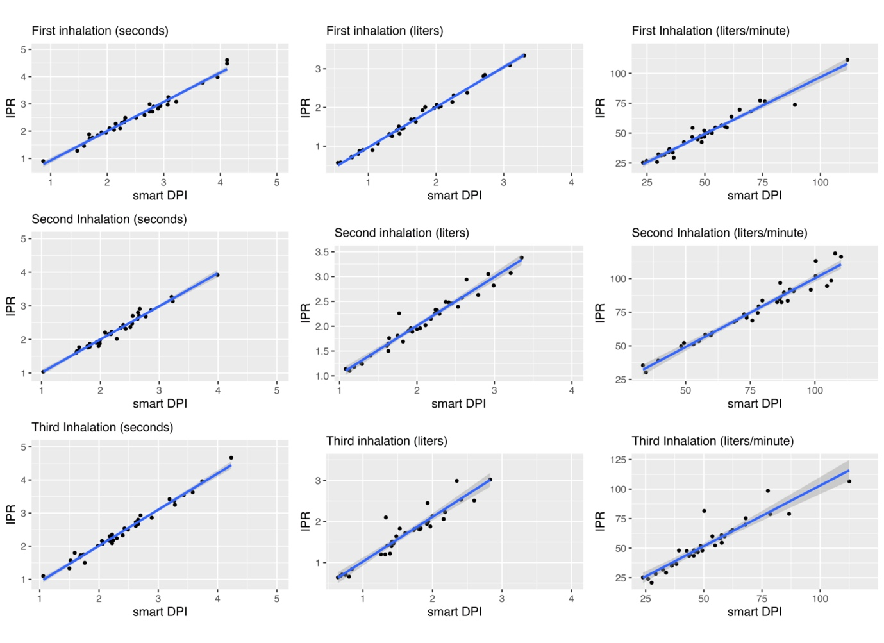
Appendix Figure 2.1: Scatterplots healthy population per inhalation (duration in seconds, volume in liters and Peak Inspiratory Flow in liters/minute).

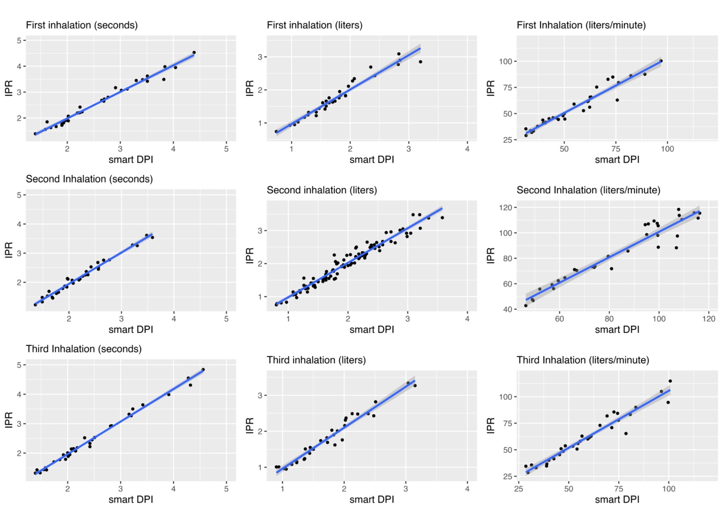
Appendix Figure 2.2: Scatterplots asthma population per inhalation (duration in seconds, volume in liters and Peak Inspiratory Flow in liters/minute).

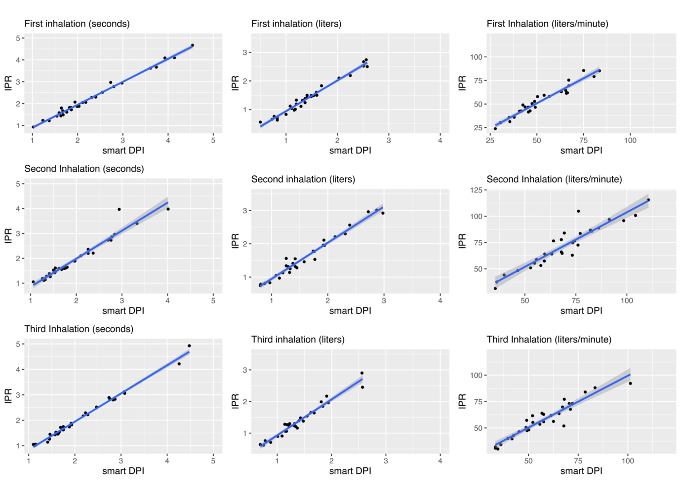
Appendix Figure 2.3: Scatterplots COPD population per inhalation (duration in seconds, volume in liters and Peak Inspiratory Flow in liters/minute).

Appendix Table 2.4: Intraclass Correlation Coefficient -Healthy
Inhalations | Intraclass correlation coefficient | CI 95%  (lower-upper)
First inhalation
IPR Duration– smart DPI Duration (seconds) | 0.99 | 0.97–0.992
IPR Volume – smart DPI Volume (liters) | 1.00 | 0.99–1.00
IPR PIF – smart DPI PIF (liters/minute) | 0.98 | 0.95 –0.99
Second inhalation
IPR Duration – smart DPI Duration (seconds) | 0.99 | 0.97 –0.99
IPR Volume – smart DPI Volume (liters) | 0.98 | 0.96–0.99
IPR PIF – smart DPI PIF (liters/minute) | 0.97 | 0.95 –0.99
Third inhalation
IPR Duration – smart DPI Duration (seconds) | 0.98 | 0.97–0.99
IPR Volume – smart DPI Volume (liters) | 0.94 | 0.88–0.97
IPR PIF – smart DPI PIF (liters/minute) | 0.93 | 0.87–0.96
Abbreviations: IPR = inhalation profile recorder, smart DPI = smart dry powder inhaler, PIF = Peak inspiratory flow.

Appendix Table 2.5: Intraclass Correlation Coefficient -Asthma
Inhalations | Intraclass correlation coefficient | CI 95%  (lower; upper)
First inhalation
IPR Duration – smart DPI Duration (seconds) | 0.99 | 0.98–0.99
IPR Volume– smart DPI Volume (liters) | 0.97 | 0.95–0.99
IPR PIF – smart DPI PIF (liters/minute) | 0.96 | 0.93–0.98
Second inhalation
IPR Duration – smart DPI Duration (seconds) | 0.98 | 0.97–0.99
IPR Volume– smart DPI Volume (liters) | 0.95 | 0.90–0.98
IPR PIF – smart DPI PIF (liters/minute) | 0.96 | 0.92–0.98
Third inhalation
IPR Duration – smart DPI Duration (seconds) | 0.99 | 0.98–1.00
IPR Volume – smart DPI Volume (liters) | 0.96 | 0.91 –0.98
IPR PIF – smart DPI PIF (liters/minute) | 0.96 | 0.91–0.98
Abbreviations: IPR = inhalation profile recorder, smart DPI = smart dry powder inhaler, PIF = Peak inspiratory flow.

Appendix Table 2.6: Intraclass Correlation Coefficient -COPD
Inhalations | Intraclass correlation coefficient | CI 95%  (lower; upper)
First inhalation
IPR Duration – smart DPI Duration (seconds) | 0.99 | 0.98 –1.00
IPR Volume – smart DPI Volume (liters) | 0.98 | 0.97–0.99
IPR PIF – smart DPI PIF (liters/minute) | 0.97 | 0.93 –0.98
Second inhalation
IPR Duration – smart DPI Duration (seconds) | 0.96 | 0.92–0.98
IPR Volume – smart DPI Volume (liters) | 0.98 | 0.96–0.99
IPR PIF – smart DPI PIF (liters/minute) | 0.93 | 0.85–0.97
Third inhalation
IPR Duration– smart DPI Duration (seconds) | 0.99 | 0.98–1.00
IPR Volume– smart DPI Volume (liters) | 0.97 | 0.93 –0.99
IPR PIF – smart DPI PIF (liters/minute) | 0.95 | 0.89 –0.98
Abbreviations: IPR = inhalation profile recorder, smart DPI = smart dry powder inhaler, PIF = Peak inspiratory flow.

