Supplementary Table 1. Roughness values and tooth structure loss for treated acid-etched dentin
 | Roughness values and tooth structure loss (TSL) for the erosion induced dentin
 | Group | Ra (nm) | Rq (nm) | Rmax (nm) | TSL (nm)
 | Deionized water | 486.56 ± 228.93^{abc} | 611.76 ± 293.86^{ab} | 4450.06 ± 2392.36^{d} | 267.92 ± 51.27ª
 | Ethanol | 446.06 ± 78.76^{abc} | 590.87 ± 96.08^{ab} | 6037.91 ± 1540.05^{abc} | 263.38 ± 57.92ª
 | FS-50 | 391.03 ± 38.27^{c} | 517.27 ± 58.16^{b} | 4625.38 ± 813.78^{d} | 241.87 ± 65.46^{ab}
 | FS-100 | 396.03 ± 36.40^{c} | 540.14 ± 55.75^{b} | 4711.00 ± 515.63^{cd} | 222.24 ± 49.90^{ab}
 | FS-200 | 530.15 ± 150.16^{ab} | 688.69 ± 199.42ª | 6137.73 ± 2019.67^{ab} | 158.68 ± 54.79^{c}
 | FX-50 | 478.11 ± 104.63^{abc} | 615.81 ± 121.54^{ab} | 4939.36 ± 726.13^{bcd} | 265.87 ± 54.24^{ab}
 | FX-100 | 430.33 ± 42.00^{bc} | 579.15 ± 39.79^{ab} | 5397.94 ± 462.98^{abcd} | 231.84 ± 56.88^{ab}
 | FX-200 | 559.13 ± 92.51ª | 724.34 ± 121.67ª | 6330.67 ± 1255.95ª | 196.43 ± 60.71^{bc}
^{a,b,c,d} Values marked with the same superscript letter in the same column were not significantly different (P>0.05)
Average roughness (Ra) value: arithmetic mean for the peak height and valley depth from a mean line. Root mean square roughness (Rq): height distribution relative to the mean line. Maximum roughness depth (Rmax): value representing isolated profile features. Tooth structure loss (TSL): depth of the height between the unexposed and exposed areas.

Supplementary Table 2. Molecular docking results of fucosterol/fucoxanthin with MMP.
Ligand-macromolecule | Hydrogen bonds | Alkyl | Pi-Alkyl | Pi-Sigma | Carbon Hydrogen bond
MMP-2-FS | TYR223 (2.280) | ILE222 (5.330) | HIS166(5.189), HIS205(5.114), HIS211(5.097) | TYR155 (3.703), PHE168 (3.665) | -
MMP-2-FX | ALA169 (2.731), ALA167 (2.537) | LEU163(4.980), LEU164(4.278), ILE222(5.357) | - | - | PHE168 (2.939), ALA167 (3.385)
MMP-9-FS | ARG162 (2.501), TRY160 (2.739) | - | TRP124(5.310), TYR160(5.358) | - | -
MMP-9-FX | - | LEU188(5.388), LEU397(4.323), VAL398(4.571), LEU418(5.052), PRO430(5.069) | HIS401(3.989), TYR423(5.404) | HIS401 (3.655) | -
The number inside the parentheses indicate the bond length for interaction in Å.

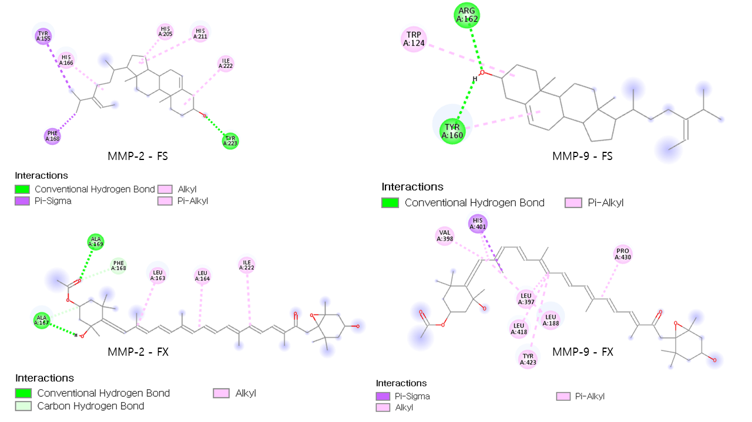
Supplementary Figure 1. Representative 2D images of the interaction between MMPs and fucosterol/fucoxanthin. Different binding modes with specific residues are presented.

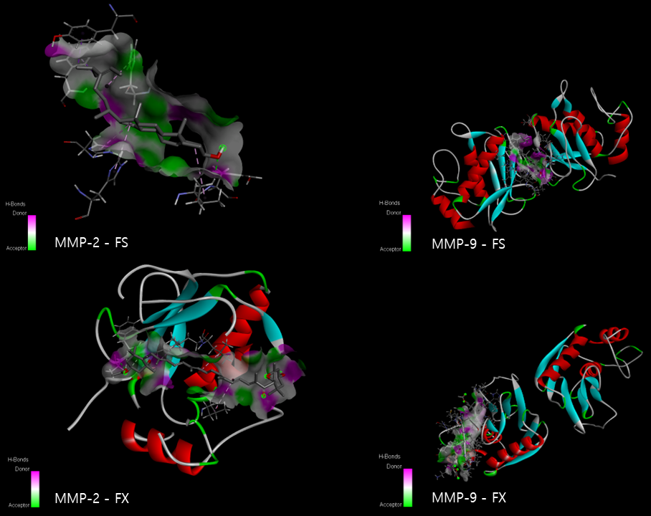
Supplementary Figure 2. Molecular docking. Representative 3D illustrations of the docked MMP-2 – FS/FX complex and MMP-9 - FX/FX complex. Related hydrogen bonds with the donor/receptor abilities are shown in a spectrum between pink and green.

Supplementary Table 3. Molecular docking results of FS/FX with collagen.
Ligand-macromolecule | Hydrogen bonds | Alkyl | Carbon Hydrogen bond
Collagen-FS | - | PRO16(5.404), PRO70(4.559), PRO70(4.550), LYS74(4.851) | -
Collagen-FX | LYS14(2.083), HYP80(2.527), GLU43(2.234) | PRO76(4.374), PRO79(4.491) | PRO82(2.607)
The number inside the parentheses indicate the bond length for interaction in Å.

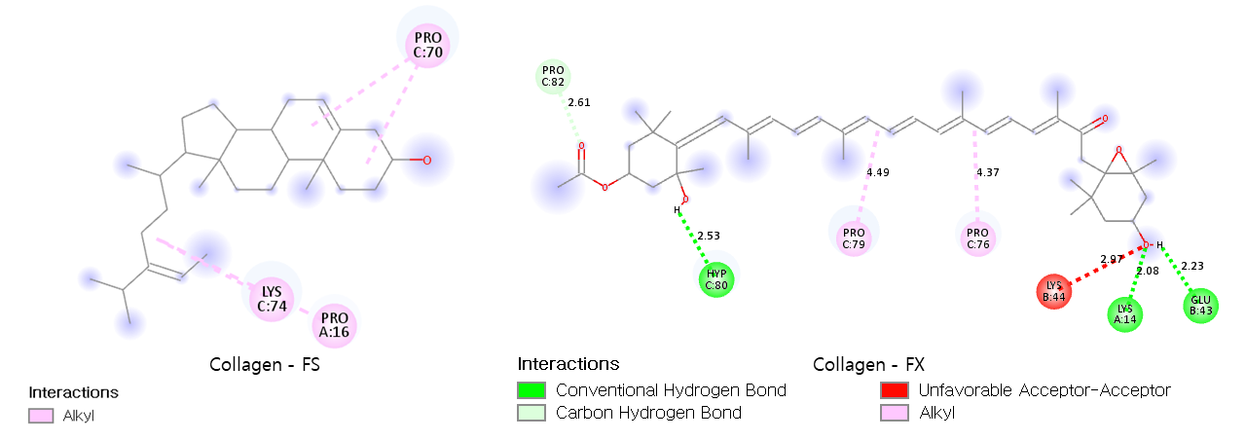
Supplementary Figure 3. Representative 2D Images of the interaction between type-I collagen and FS/FX. Different binding modes with specific residues are presented.

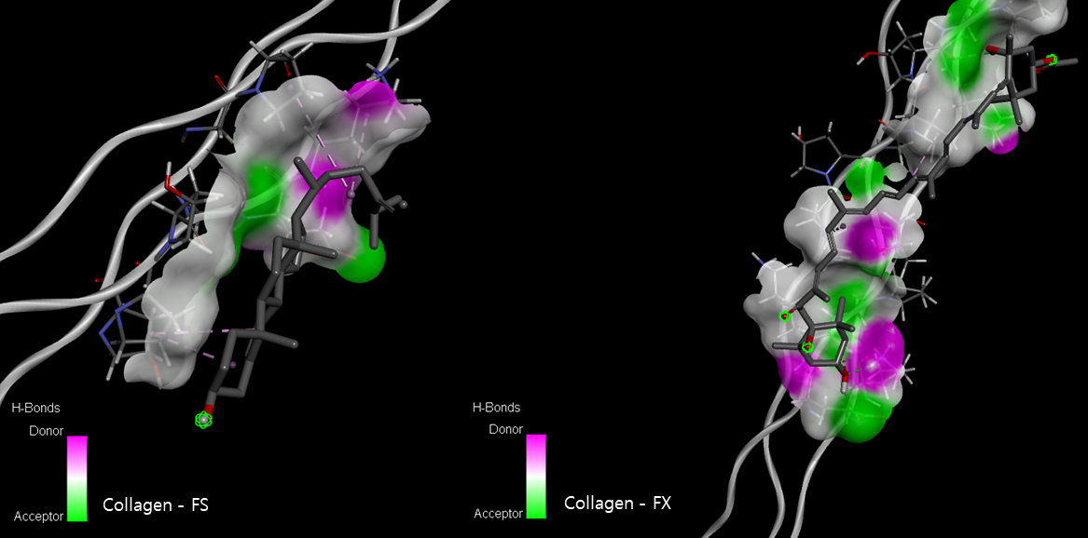
Supplementary Figure 4. Molecular docking. Representative 3D illustrations of the docked collagen – FS/FX complex. Related hydrogen bonds with the donor receptor abilities are shown in a spectrum between pink and green.

