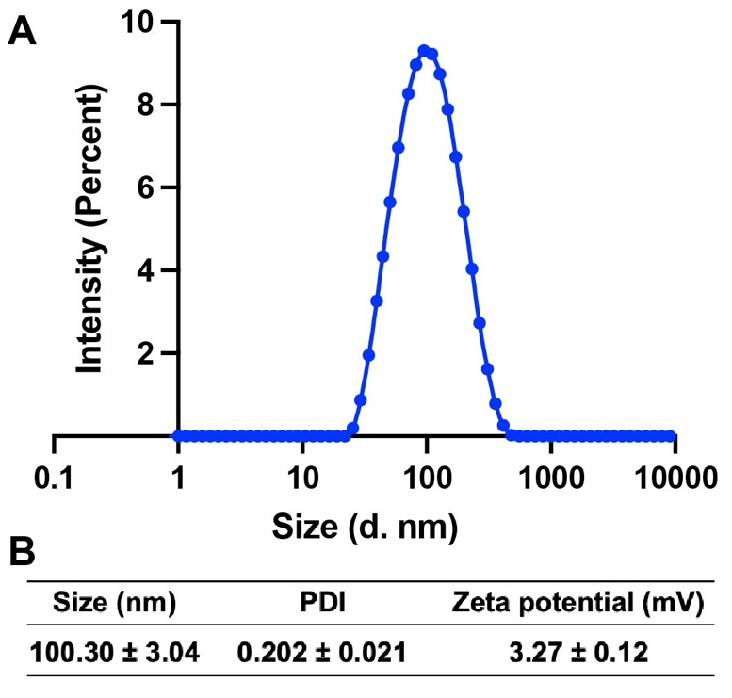
Figure S1. (A) Intensity result of size distribution size via dynamic light scattering (DLS) measurement of Fe₃O₄ Nanoparticles in H₂O. (B) size, PDI and zeta potential of Fe₃O₄ nanoparticles (n = 5; mean ± SD).

Figure S2. Storage stability of Fe₃O₄ nanoparticles after incubation in DMEM with/without 10% FBS at 37 °C as indicated by the particle size measured by dynamic light scattering (DLS) (n = 5; mean ± SD).
Figure S3. In vitro release of DOX from aqueous solutions of Fe/DOX@SL microrobots (n = 5; mean ± SD). Dialysis method was used to study the release property of DOX from microrobots.

Figure S4. Cell viability of T24 cells incubated with free DOX, and Fe/DOX@SL microrobots after 24 h (n = 5; mean ± SD).
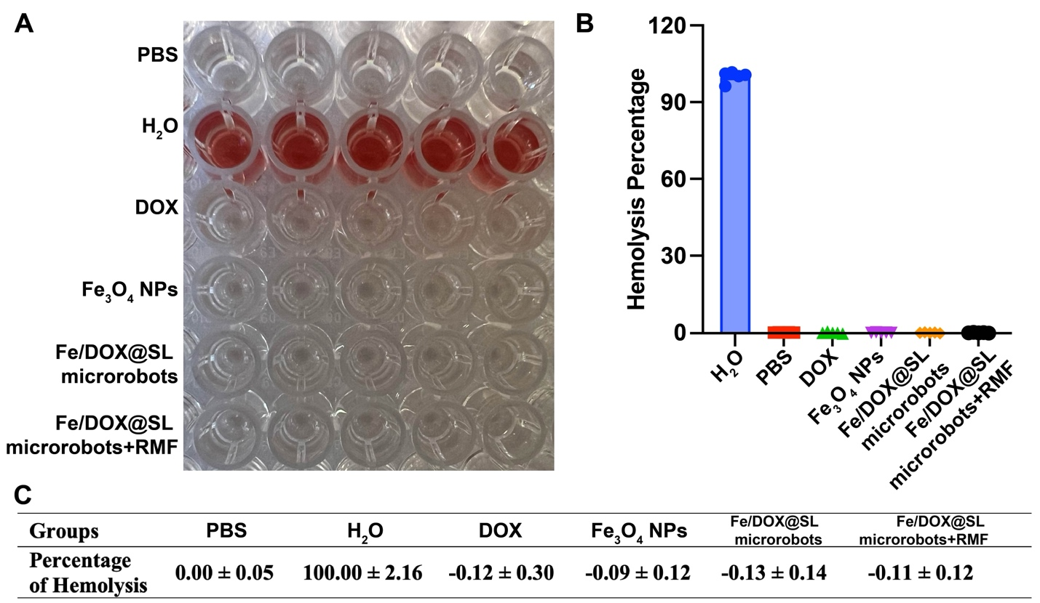
Figure S5. In vitro analysis of hemolytic properties. (A) The images showed the profiles of the centrifuged solution incubated with PBS, distilled water, free DOX, Fe₃O₄ nanoparticles (NPs), Fe/DOX@SL microrobots, and Fe/DOX@SL microrobots with RMF. (B) and (C) Percentage of hemolysis of different groups (n = 5; mean ± SD).

