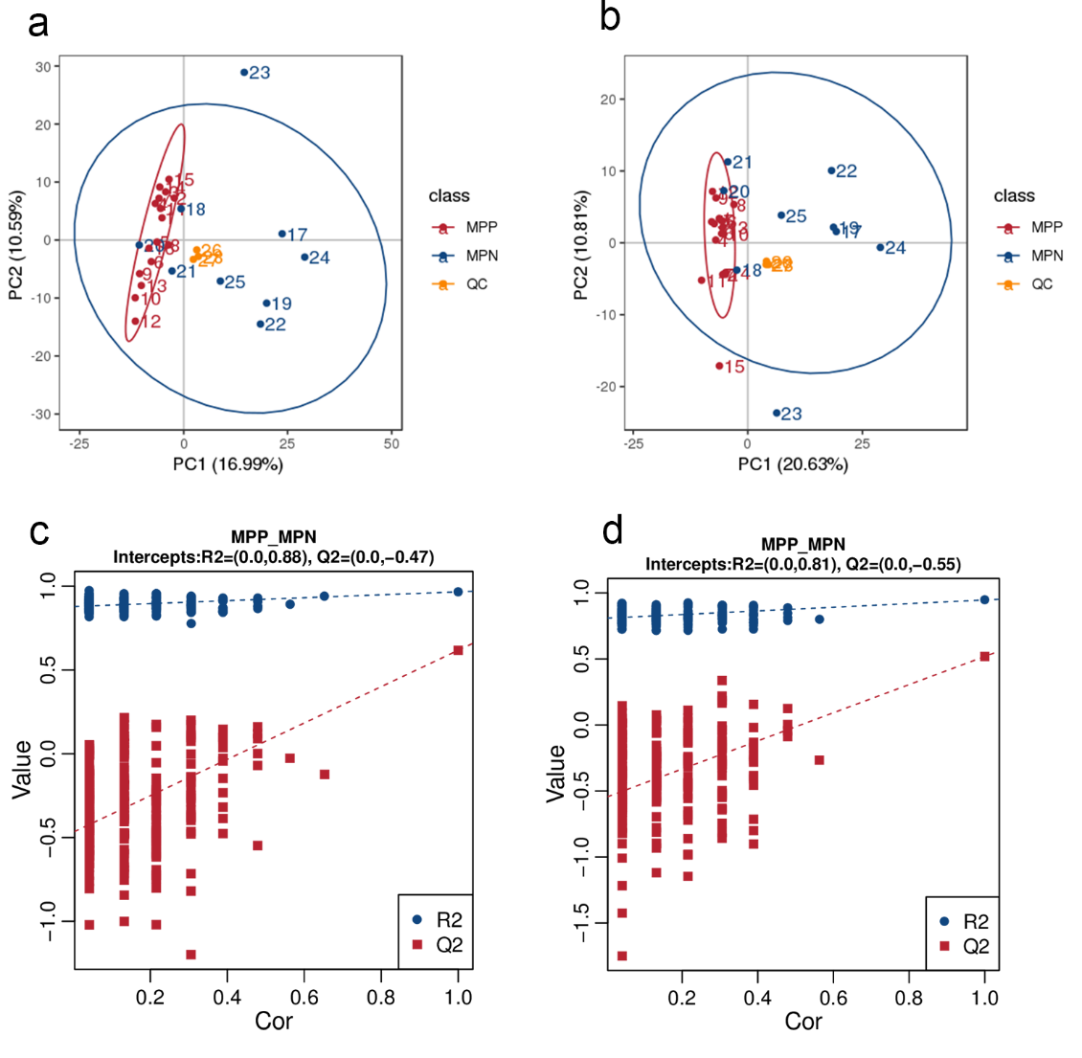
Figure S1. Score plots of principal component analysis based on the ESI⁺ and ESI⁻ modes. (a-b) Orange solid circle represented the QC samples. (c-d) Validated plot of response permutation testing. The Y-axis designates R2Y (triangles) and Q2Y (squares) for PLSDA model. The X-axis represents the correlation coefficient between original and permuted response data.

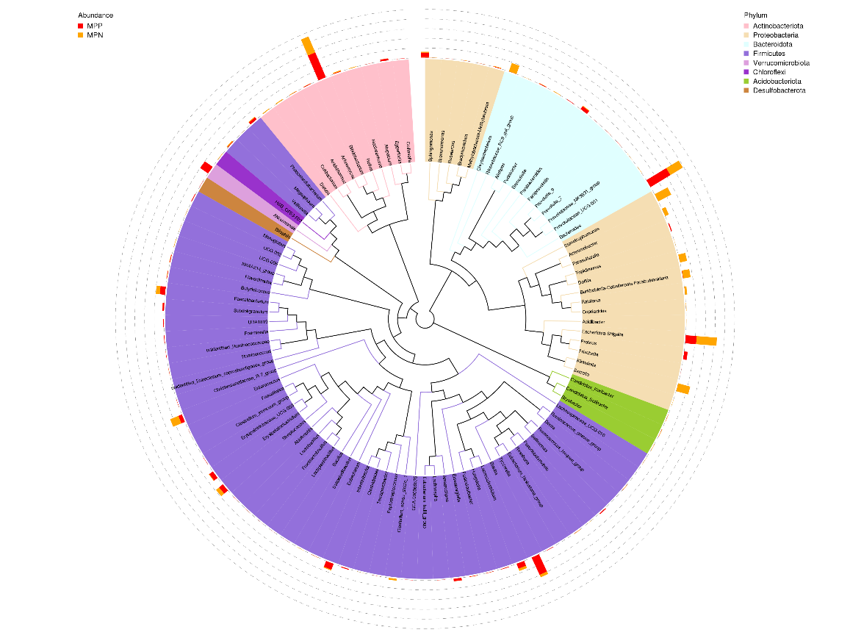
Figure S2. Phylogenetic tree of top 100 abundant species at genus level of patients infected with MP compared to normal children of MPN group. Different colors of the branches represent different phyla. Relative abundance of each genus in each group was displayed outside the circle and different colors represent different groups.

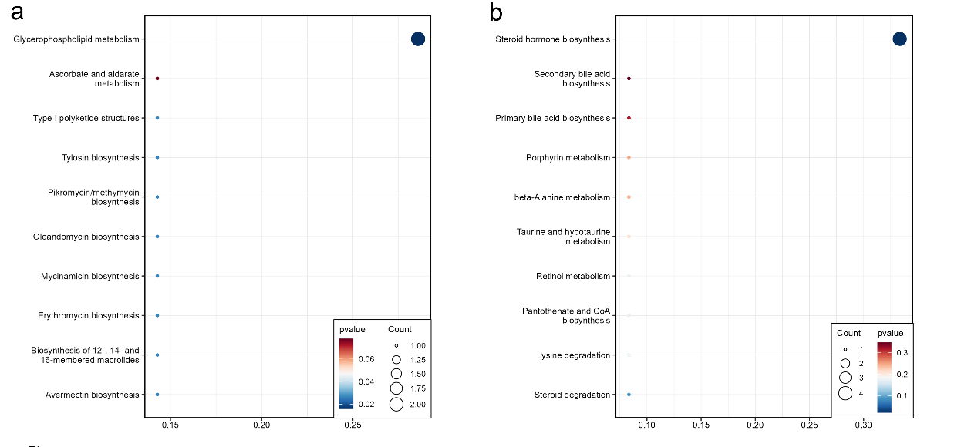
Figure S3. Metabolic KEGG enrichment analysis based on the differential metabolites between groups. (a) KEGG pathway analysis of differentiating metabolites enriched in the MPP group. The color of bubbles represents the value of P value, and the size of bubbles represents the number of counts (sorted by enrichment ratio), (b) KEGG pathway analysis of distinguishing metabolites that down-regulated in the MPP group.

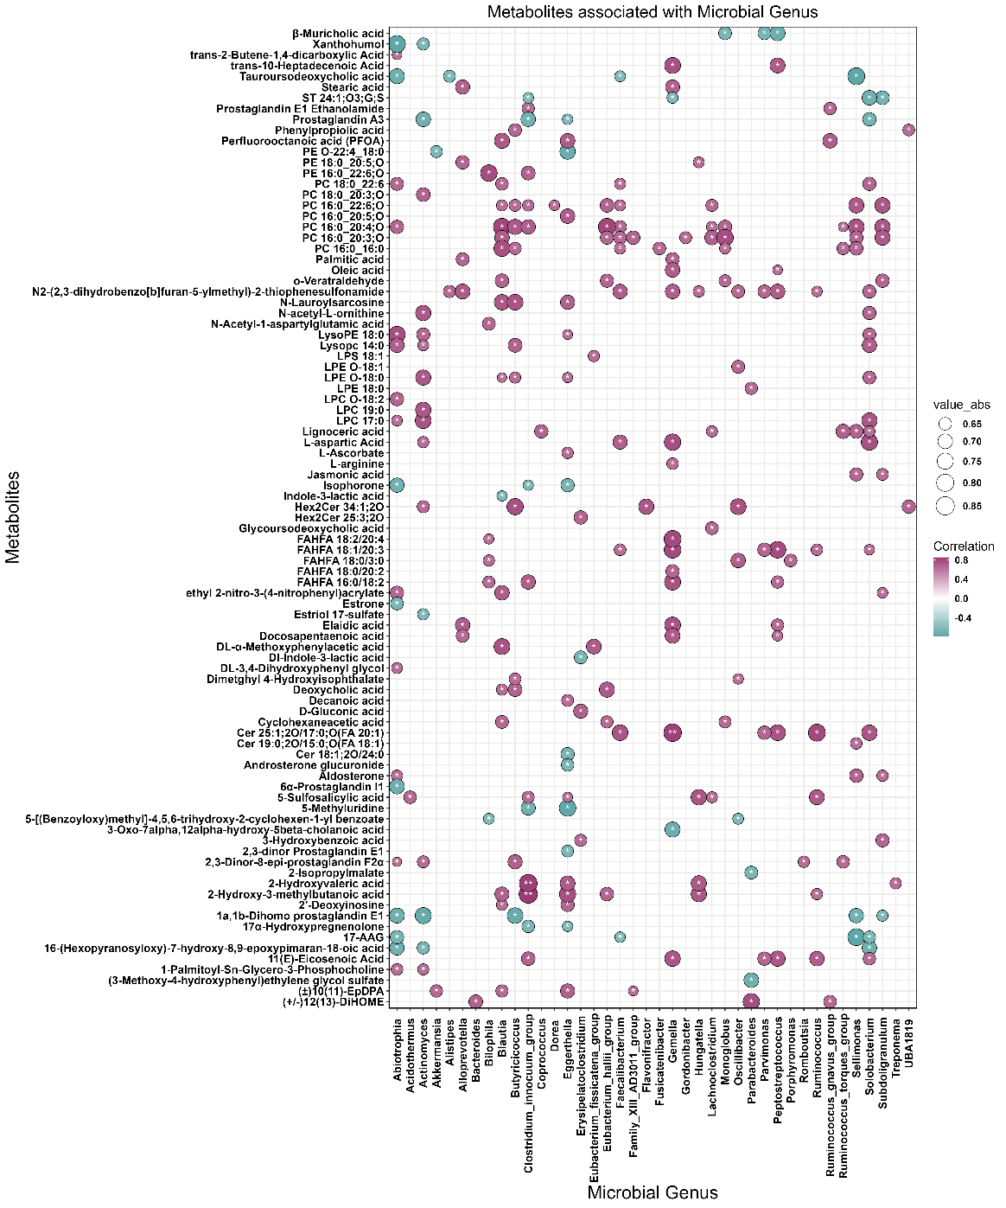
Figure S4. The correlations between gut microbiota at genus and serum metabolites in negative ion mode were calculated. The absolute correlation coefficient (|r|) is represented by the size of the circle, and the adjusted P-value is indicated by an asterisk ("*", P < 0.05; "**", P < 0.01, "***", P<0.001).

Table S1. The titer of mycoplasma pneumoniae in the MP infected participants and individuals that regarded as control.
Sample | The titer of MP
MP_P_1 | ＞1：320
MP_P_2 | 1：80
MP_P_3 | 1：80
MP_P_4 | ＞1：320
MP_P_5 | 1：80
MP_P_6 | 1：320
MP_P_7 | ＞1：320
MP_P_8 | 1：40
MP_P_9 | 1：320
MP_P_10 | 1：160
MP_P_11 | ＞1：320
MP_P_12 | 1：320
MP_P_13 | 1：320
MP_P_14 | 1：320
MP_P_15 | ＞1：320
MP_P_16 | ＞1：320
MP_N_1 | <1:40
MP_N_2 | <1:40
MP_N_3 | <1:40
MP_N_4 | <1:40
MP_N_5 | <1:40
MP_N_6 | <1:40
MP_N_7 | <1:40
MP_N_8 | <1:40
MP_N_9 | <1:40
MP_N_10 | <1:40

