Design, synthesis and evaluation of novel cyclopropanesulfonamide derivatives for the treatment of EGFR^{C797S} mutation in non-small cell lung cancer
Mengxuan Wang^{a,1}, Zhenhong Xia^{a,1},Wenyan Nieª, Chunlong Wangª, Haoran Nieª, Shuai Zhangª, Jiaqi Qiuª, Yang Yangª, Cuifang Yaoª, Ling Xu^{b}*, and Baijiao Anª*.

ª Shandong Technology Innovation Center of Molecular Targeting and Intelligent Diagnosis and Treatment, Binzhou Medical University, Yantai, Shandong

^{b} Department of Respiratory Critical Care Medicine, Binzhou Medical University Hospital，Yantai, Shandong, 264003, PR China
Corresponding author
Ling Xu，1659996191@qq.com
Baijiao An，anbj3@bzmc.edu.cn

Supplementary Contents
Table S1 and Table S2 P2-P3
Figure S1 Original Western blot P4
Figure S2 and Figure S3 Protein statistical analysis diagram P5-P6
Supplementary Information NMR and HPLC spectra of target compounds P7-P35
Table S1.Compounds inhibiting cancer cell lines harboring the EGFR19del construct.
 | IC₅₀(μM)
 | PC-9 | A549
5a | 0.158±0.020 | 0.693±0.116
5b | 0.011±0.003 | 0.582±0.025
5c | 0.048±0.003 | 0.745±0.007
5d | 0.016±0.001 | 0.845±0.002
5e | 0.011±0.006 | 0.823±0.309
5f | 0.035±0.002 | 1.037±0.026
5g | 0.016±0.001 | 0.387±0.155
5h | 0.151±0.001 | 3.116±0.385
17b | 0.080±0.005 | 0.428±0.348
17a | 0.095±0.004 | 0.690±0.415
Osimertinib | 0.011±0.003 | 3.956±1.986
Table S2 Antiproliferative activity of 5d against three human normal cellsª.
Compd | 5d | Selectivity ratio^{b} | Brigatinib | Selectivity ratio^{b}
LO2 | 7.55±0.15 | 411.22 | 2.203±0.02 | 4.156
HK2 | 7.583±0.09 | 412.02 | 3.845±0.09 | 7.254
293A | 4.030±0.01 | 219.49 | 3.532±0.014 | 6.66
Baf3-EGFR^{L858R/T790M/C797S} | 0.01836±0.0065 | / | 0.426±0.018 | /
ªData are presented as the mean ± SE from the dose−response cures of at least three independent experiments. ^{b}Selectivity ratio = (IC₅₀ human normal cells)/(IC₅₀ Baf3-EGFR^{L858R/T790M/C797S}).

Figure S1. Original Western blot.

Protein statistical analysis diagram
Figure S2. Compound 5d inhibited cancer progression by inhibiting the EGFR and m-TOR signaling pathways.
Figure S3. Compound 5d blocks the cell cycle.

Supplementary Information NMR，HRMS and HPLC spectra of target compounds
Intermediate 4
¹H NMR for N-(2-((2,5-dichloropyrimidin-4-yl)amino)phenyl)methanesulfonamide: ¹H NMR (400 MHz, Chloroform-d) δ 8.38 (s, 1H), 8.23 (s, 1H), 8.04 (d, J = 9.1 Hz, 1H), 7.47 – 7.34 (m, 2H), 3.06 (s, 3H).
N-(2-((2,5-dichloropyrimidin-4-yl)amino)phenyl)ethanesulfonamide: ¹H NMR (400 MHz, Chloroform-d) δ 8.19 (s, 1H), 7.37 (d, J = 7.8 Hz, 2H), 7.21 (ddt, J = 10.5, 7.4, 2.4 Hz, 2H), 3.12 (q, J = 7.4 Hz, 2H), 1.41 (t, J = 7.4 Hz, 3H).
¹H NMR for N-(2-((2,5-dichloropyrimidin-4-yl)amino)phenyl)cyclopropanesulfonamide: ¹H NMR (400 MHz, Chloroform-d) δ 8.00 (s, 1H), 7.48 – 7.29 (m, 3H), 7.22 – 7.18 (m, 1H), 1.33 (s, 1H), 1.14 – 1.08 (m, 2H), 1.03 – 0.94 (m, 2H).
8b
¹H NMR (400 MHz, Chloroform-d) δ 6.62 (d, J = 8.3 Hz, 1H), 6.51 (d, J = 2.3 Hz, 1H), 6.40 (dd, J = 8.3, 2.4 Hz, 1H), 3.82 (s, 3H), 3.40 (s, 2H), 3.16 – 3.01 (m, 4H), 2.69 – 2.53 (m, 4H), 2.34 (s, 3H).
8c
¹H NMR (400 MHz, Chloroform-d) δ 6.87 (d, J = 8.3 Hz, 1H), 6.52 (d, J = 2.8 Hz, 1H), 6.47 (dd, J = 8.3, 2.8 Hz, 1H), 3.43 (s, 2H), 2.84 (t, J = 4.8 Hz, 4H), 2.54 (s, 4H), 2.33 (s, 3H), 2.22 (s, 3H).
Intermediate 11
¹H NMR (400 MHz, Chloroform-d) δ 8.72 (d, J = 5.8 Hz, 2H), 7.78 (s, 1H), 7.29 (d, J = 5.9 Hz, 2H), 6.96 (s, 1H), 3.96 (s, 3H), 2.25 (s, 3H).
Intermediate 12
¹H NMR (400 MHz, Chloroform-d) δ 7.69 (s, 1H), 6.82 (s, 1H), 5.68 – 5.55 (m, 1H), 3.91 (s, 3H), 3.10 (s, 2H), 2.67 (t, J = 5.6 Hz, 2H), 2.43 (s, 3H), 2.41 (s, 2H), 2.26 (s, 3H).
Intermediate 13
¹H NMR (400 MHz, Chloroform-d) δ 6.47 (s, 1H), 6.42 (s, 1H), 5.42 (dq, J = 3.7, 1.8 Hz, 1H), 3.69 (s, 3H), 3.04 (d, J = 3.3 Hz, 2H), 2.61 (t, J = 5.7 Hz, 2H), 2.36 (s, 3H), 2.34 (s, 2H), 2.07 (s, 3H).
Intermediate 14
¹H NMR (400 MHz, Chloroform-d) δ 7.78 (s, 1H), 7.09 (s, 1H), 3.94 (s, 3H), 2.36 (s, 3H).
Intermediate 16
¹H NMR (400 MHz, Chloroform-d) δ 11.55 (s, 1H), 8.67 (dd, J = 8.6, 4.5 Hz, 1H), 8.22 (s, 1H), 7.59 (t, J = 8.0 Hz, 1H), 7.29 (dd, J = 13.7, 7.9 Hz, 1H), 7.18 (t, J = 6.9 Hz, 1H), 1.85 (d, J = 13.2 Hz, 6H).
N-(2-((5-chloro-2-((2-methoxy-4-(4-methylpiperazin-1-yl)phenyl)amino)pyrimidin-4-yl)amino)phenyl)cyclopropanesulfonamide (5a)
White solid. ¹H NMR (400 MHz, DMSO-d6) δ 8.47 (s, 1H), 8.08 (s, 2H), 8.03 (d, J=8.1Hz,1H), 7.91 (s, 1H), 7.44 (d, J = 8.7 Hz, 1H), 7.37 (d, J = 7.8, 1H), 7.22 (t, J=7.4 Hz,1H), 7.14 (t, J = 8.3 Hz, 1H), 6.60 (d, J=2.5 Hz,1H), 6.39-6.36 (m, 1H) 3.76 (s, 3H), 3.16-3.06 (m, 4H), 2.57-2.53 (m, 1H), 2.48-2.47 (m, 4H), 2.24 (s, 3H), 0.93-0.82 (m, 4H). ¹³C NMR (126 MHz, DMSO) δ 159.19, 155.57, 154.85, 152.25, 149.04, 134.85, 129.95, 127.09, 125.93, 124.56, 124.17, 123.50, 120.67, 107.08, 103.96, 100.43, 55.92, 55.16, 49.21, 46.24, 29.72, 5.56. HRMS (ESI+ ) calcd for C₂₅H₃₀ClN₇O₃S [M + H]+ 544.1898; found, 544.1931. HPLC purity: 97.16%.
N-(2-((5-chloro-2-((3-methyl-4-(4-methylpiperazin-1-yl)phenyl)amino)pyrimidin-4-yl)amino)phenyl)cyclopropanesulfonamide (5b)
White solid. ¹H NMR (500 MHz, DMSO-d₆) δ 9.17 (s, 1H), 8.54 (s, 1H), 8.15 (s, 1H), 8.07 – 8.03 (m, 1H), 7.46 – 7.36 (m, 2H), 7.29 (q, J = 7.4 Hz, 2H), 7.21 (t, J = 7.6 Hz, 1H), 6.86 (d, J = 8.7 Hz, 1H), 2.78-2.76 (m, 4H), 2. 47 – 2.42 (m, 4H), 2.24 (s, 3H), 2.12 (s, 3H), 0.89 – 0.84 (m, 4H). ¹³C NMR (126 MHz, DMSO) δ 158.28, 156.00, 155.02, 145.75, 136.01, 135.09, 132.28, 129.44, 128.36, 127.37, 125.33, 125.03, 122.13, 119.13, 118.10, 104.17, 55.31, 52.49, 51.48, 45.74, 29.59, 18.10, 5.59. HRMS (ESI+ ) calcd for C₂₅H₃₁ClN₇O₂S [M + H]+ 528.1948; found, 528.1959. HPLC purity: 99.55%.
N-(2-((5-chloro-2-((2-methoxy-5-methyl-4-(1-methylpiperidin-4-yl)phenyl)amino)pyrimidin-4-yl)amino)phenyl)cyclopropanesulfonamide (5c)
White solid. ¹H NMR (500 MHz, Chloroform-d) δ 8.06 (s, 1H), 7.94 (s, 1H), 7.89 (d, J = 8.0 Hz, 1H), 7.79 (s, 1H), 7.52 (d, J = 7.9 Hz, 1H), 7.46 (s, 1H), 7.31 (t, J = 8.3 Hz, 1H), 7.21 (t, J = 7.7 Hz, 1H), 6.68 (s, 1H), 3.79 (s, 3H), 3.04 (d, J = 11.2 Hz, 2H), 2.61 – 2.56 (m, 1H), 2.47 – 2.42 (m, 1H), 2.38 (s, 3H), 2.15 – 2.10 (m, 2H), 1.99 (s, 3H), 1.82 – 1.73 (m, 2H), 1.67 (d, J = 12.4 Hz, 2H), 1.09 –1.05 (m, 2H), 0.93 – 0.82 (m, 2H). ¹³C NMR (126 MHz, CDCl₃) δ 157.69, 156.19, 154.76, 146.44, 136.99, 134.54, 129.56, 128.04, 127.74, 126.80, 126.33, 125.56, 125.35, 120.32, 107.53, 104.88, 56.29, 55.77, 45.99, 37.05, 32.21, 29.73, 18.70, 5.68. HRMS (ESI+ ) calcd for C₂₇H₃₄ClN₆O₃S [M + H]+ 557.2102; found, 557.2104. HPLC purity: 99.55%.
N-(2-((5-chloro-2-((4-(1-methylpiperidin-4-yl)phenyl)amino)pyrimidin-4-yl)amino)phenyl)cyclopropanesulfonamide (5d)
White solid. ¹H NMR (400 MHz, Chloroform-d) δ 9.13 (s, 1H), 8.51 (s, 1H), 8.13 (s, 1H), 8.08 (t, J = 8.3 Hz, 1H), 7.45-7.37(m, 3H), 7.36-7.30 (m, 1H), 7.21 (t, J = 7.7 Hz, 1H), 7.23 (d, J = 7.7 Hz, 1H), 6.78 (dd, J = 9.2, 2.1 Hz, 2H), 3.08 –2.94 (m, 4H), 2.57-2.52 (m, 1H), 2.49 –2.47 (m, 4H), 2.24 (s, 3H), 0.90 –0.83 (m, 4H). ¹³C NMR (101 MHz, DMSO) δ 158.34, 158.25, 155.93, 155.02, 145.46, 135.17, 133.53, 128.53, 127.65, 125.41, 125.04, 120.91, 116.68, 104.03, 53.56, 47.62, 45.65, 43.66, 5.64. HRMS (ESI+ ) calcd for C₂₄H₂₉ClN₇O₂S [M + H]+ 514.1792; found, 514.2170. HPLC purity: 95.87%.
N-(2-((5-chloro-2-((4-(4-methylpiperazin-1-yl)phenyl)amino)pyrimidin-4-yl)amino)phenyl)methanesulfonamide (5e)
White solid. ¹H NMR (400 MHz, DMSO-d₆) δ 9.17 (d, J = 2.5 Hz, 0H), 8.51 (s, 0H), 8.14 (s, 1H), 8.02 (t, J = 8.7 Hz, 1H), 7.47 – 7.32 (m, 4H), 7.25 (t, J = 7.6 Hz, 1H), 6.82 (dd, J = 9.1, 2.4 Hz, 2H), 3.22 – 3.20 (m, J, 4H), 3.05 – 3.02 (m, 4H), 2.96 (s, 3H), 2.64 (s, 3H). ¹³C NMR (101 MHz, DMSO) δ 158.25, 156.11, 155.00, 145.49, 134.93, 133.50, 129.69, 129.50, 127.52, 126.00, 125.50, 120.86, 116.63, 104.10, 53.66, 47.74, 45.65, 43.81. HRMS (ESI+) calcd for C₂₂H₂₇ClN₇O₂S [M + H]+ 488.1635; found, 488.1636. HPLC purity: 96.19%.
N-(2-((5-chloro-2-((2-methoxy-5-methyl-4-(4-methylpiperazin-1-yl)phenyl)amino)pyrimidin-4-yl)amino)phenyl)methanesulfonamide (5f)
White solid. ¹H NMR (500 MHz, Chloroform-d) δ 8.05 (s, 1H), 8.02 – 7.90 (m, 1H), 7.85 (t, J = 7.7 Hz, 1H), 7.74 (s, 1H), 7.49 (d, J = 7.8 Hz, 1H), 7.45 (s, 1H), 7.29 (d, J = 7.5 Hz, 1H), 7.23 (d, J = 7.7 Hz, 1H), 6.65 (s, 1H), 3.79 (s, 3H), 3.09 –3.07 (m, 2H), 2.92 (s, 3H), 2.60 –2.55 (m, 1H), 2.42 (s, 3H), 2.20 – 2.16 (m, 2H), 1.93 (s, 3H), 1.82 – 1.75 (m, 2H), 1.65-1.64 (m, 2H). ¹³C NMR (126 MHz, CDCl₃) δ 157.66, 156.32, 154.76, 146.43, 136.60, 134.10, 130.55, 127.31, 126.74, 126.59, 126.39, 125.99, 125.86, 120.26, 107.47, 104.89, 56.11, 55.78, 45.66, 39.21, 36.83, 31.83, 18.66. HRMS (ESI+ ) calcd for C₂₄H₃₀ClN₇O₃S [M + H]+ 531.1945; found, 531.1948. HPLC purity: 95.48%.
N-(2-((5-chloro-2-((3-methyl-4-(4-methylpiperazin-1-yl)phenyl)amino)pyrimidin-4-yl)amino)phenyl)ethanesulfonamide (5g)
White solid. ¹H NMR (500 MHz, DMSO-d₆) δ 9.17 (s, 1H), 8.57 (s, 1H), 8.14 (s, 1H), 7.91 (d, J = 6.8 Hz, 1H), 7.41 – 7.32 (m, 2H), 7.28 (t, J = 7.6 Hz, 1H), 7.23 (t, J = 7.3 Hz, 2H), 6.83 (d, J = 8.6 Hz, 1H), 3.00 (q, J = 7.2 Hz, 2H), 2.79-2.73 (m, 4H), 2.51-2.49 (m, 4H), 2.25 (s, 3H), 2.09 (s, 3H), 1.16 (t, J = 7.3 Hz, 3H). ¹³C NMR (126 MHz, DMSO) δ 158.30, 156.35, 155.00, 145.87, 135.96, 134.40, 132.22, 130.55, 126.97, 126.91, 126.27, 125.69, 122.02, 119.07, 117.99, 104.16, 55.60, 51.86, 46.13, 45.58, 18.09, 8.34. HRMS (ESI+ ) calcd for C₂₄H₃₀ClN₇O₂S [M + H]+ 516.1948; found, 516.1947. HPLC purity: 98.59%.
N-(2-((5-chloro-2-((2-methoxy-4-(4-methylpiperazin-1-yl)phenyl)amino)pyrimidin-4-yl)amino)phenyl)ethanesulfonamide (5h)
White solid. ¹H NMR (500 MHz, DMSO-d₆) δ 8.66 (s, 1H), 8.07 (s, 1H), 7.97 (s, 1H), 7.86 (s, 1H), 7.44 (d, J = 8.6 Hz, 1H), 7.35 – 7.28 (m, 1H), 7.10 (dd, J = 5.8, 3.5 Hz, 2H), 6.60 (d, J = 2.3 Hz, 1H), 6.36 (dd, J = 8.7, 2.0 Hz, 1H), 3.76 (s, 3H), 3.14 – 3.07 (m, 4H), 2.97 (q, J = 7.3 Hz, 2H), 2.49 – 2.43 (m, 4H), 2.23 (s, 3H), 1.19 (t, J = 7.3 Hz, 3H). ¹³C NMR (126 MHz, DMSO) δ 159.10, 155.84, 154.83, 152.01, 148.87, 134.37, 125.99, 125.53, 124.70, 124.28, 124.19, 120.75, 107.08, 100.43, 55.93, 55.13, 49.20, 46.21, 46.05, 45.58, 10.43, 8.55. HRMS (ESI+ ) calcd for C₂₄H₃₀ClN₇O₃S [M + H]+ 531.1898; found, 532.1919. HPLC purity: 97.23%.
(2-((5-chloro-2-((2-methoxy-5-methyl-4-(1-methylpiperidin-4-yl)phenyl)amino)pyrimidin-4-yl)amino)phenyl)dimethylphosphine oxide (17a)
White solid. ¹H NMR (400 MHz, Chloroform-d) δ 10.80 (s, 1H), 8.64 (d, J = 8.4 Hz, 1H), 8.08 (d, J = 22.5 Hz, 2H), 7.50 (t, J = 7.8 Hz, 1H), 7.44 (s, 1H), 7.34 – 7.27 (m, 1H), 7.12 (t, J = 7.4 Hz, 1H), 6.80 (s, 1H), 3.84 (s, 3H), 3.06 (d, J = 10.8 Hz, 2H), 2.77-2.66 (m, 2H), 2.39 (s, 3H), 2.22 (s, 3H), 2.18-2.13 (m, 2H), 1.92 – 1.86 (m, 1H), 1.85 (s, 3H), 1.83 (s, 3H)1.81 – 1.72 (m, 2H). ¹³C NMR (126 MHz, Chloroform-d) δ 157.51, 155.89, 154.93, 146.71, 143.86, 137.26, 132.66, 129.63, 129.55, 126.80, 126.63, 122.73, 122.68, 122.41, 122.31, 120.77, 119.86, 107.73, 106.36, 56.46, 55.76, 46.25, 37.25, 32.61, 18.90, 18.29. HRMS (ESI+ ) calcd for C₂₆H₃₄ClN₅O₂P [M + H]+ 514.2139; found, 514.2170. HPLC purity: 96.15%.
(2-((5-chloro-2-((4-(4-methylpiperazin-1-yl)phenyl)amino)pyrimidin-4-yl)amino)phenyl)dimethylphosphine oxide (17b)
¹H NMR (400 MHz, DMSO-d₆) δ 11.12 (s, 1H), 9.19 (s, 1H), 8.61 (s, 1H), 8.14 (s, 1H), 7.68 – 7.46 (m, 4H), 7.25 – 7.12 (m, 1H), 6.90 (d, J = 9.1 Hz, 2H), 3.24 –3.19 (m, 4H), 2.98 –2.89 (s, 4H), 2.56 (s, 3H), 1.80 (s, 3H), 1.76 (s, 3H). ¹³C NMR (101 MHz, DMSO) δ 158.20, 155.69, 155.23, 145.20, 143.40, 133.74, 132.44, 131.20, 131.10, 122.94, 122.60, 121.43, 116.95, 104.81, 52.89, 46.91, 45.65, 19.00, 18.30. HRMS (ESI+ ) calcd for C₂₃H₂₉ClN₆OP [M + H]+ 471.1829; found, 471.1827. HPLC purity: 98.18%.

^{H} NMR of Compound 5a
^{C} NMR of Compound 5a
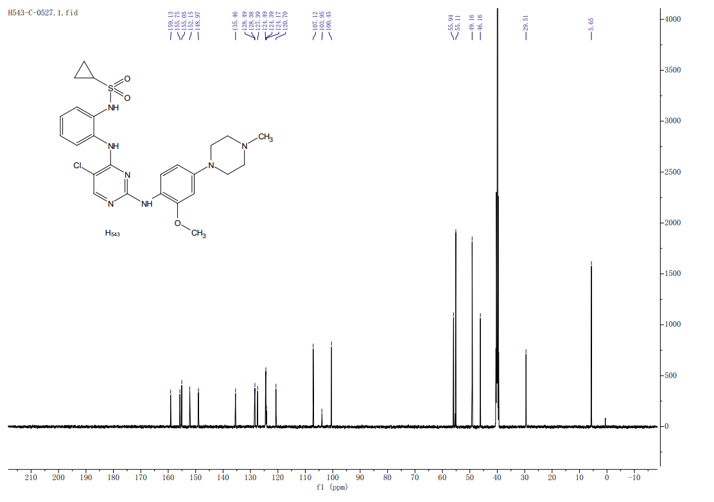

^{H} NMR of Compound 5b
^{C} NMR of Compound 5b

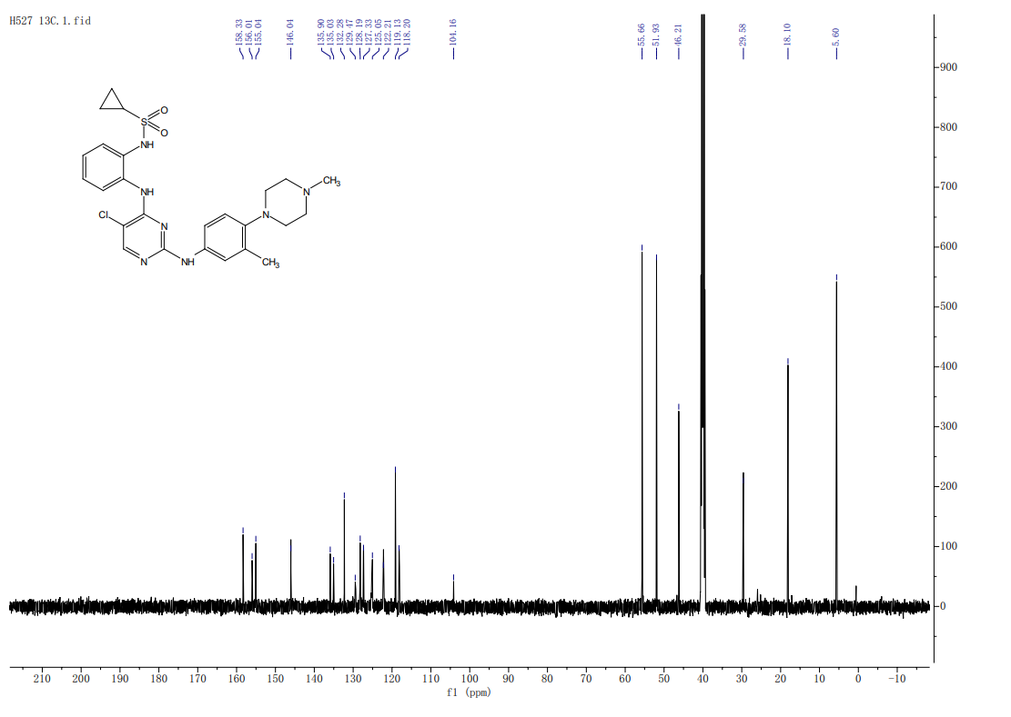

^{H} NMR of Compound 5C
^{C} NMR of Compound 5C

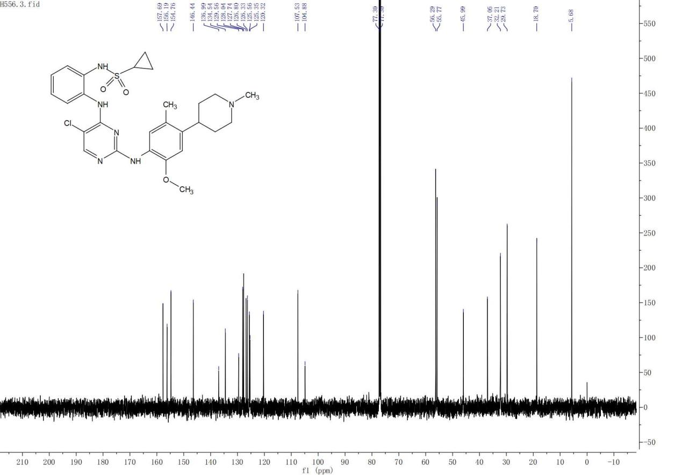

^{H} NMR of Compound 5d
^{C} NMR of Compound 5d
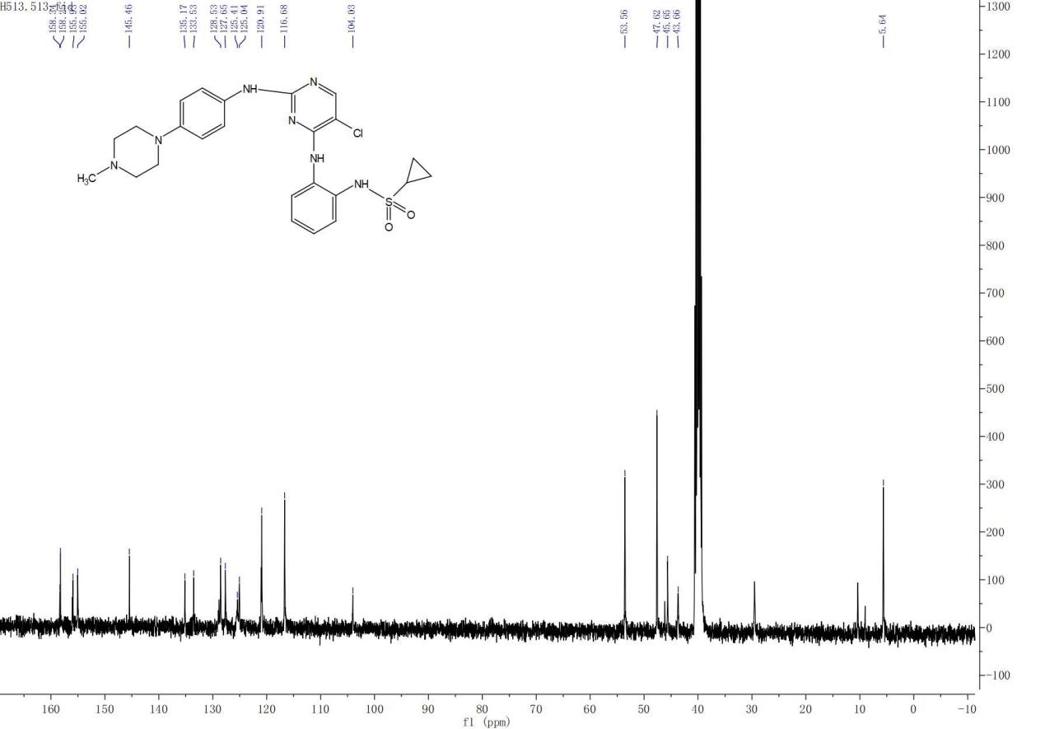

^{H} NMR of Compound 5e
^{C} NMR of Compound 5e
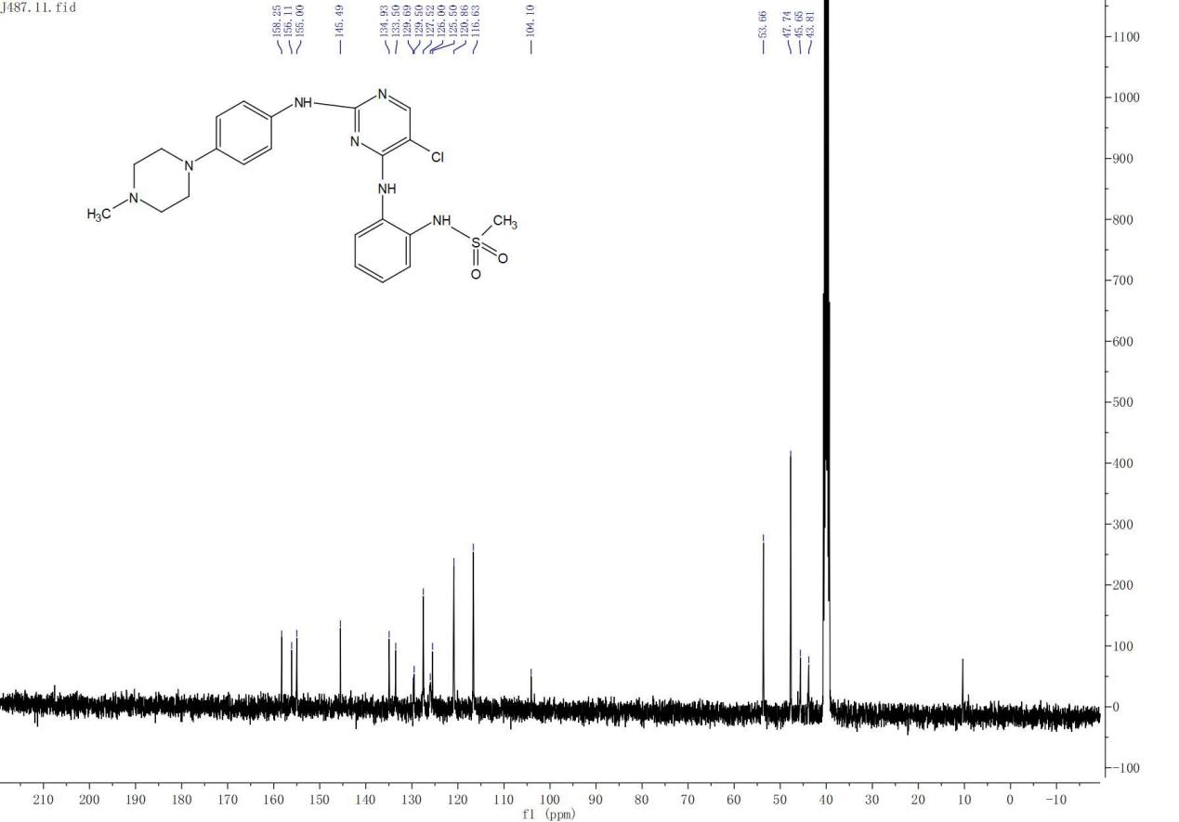

^{H} NMR of Compound 5f

^{C} NMR of Compound 5f
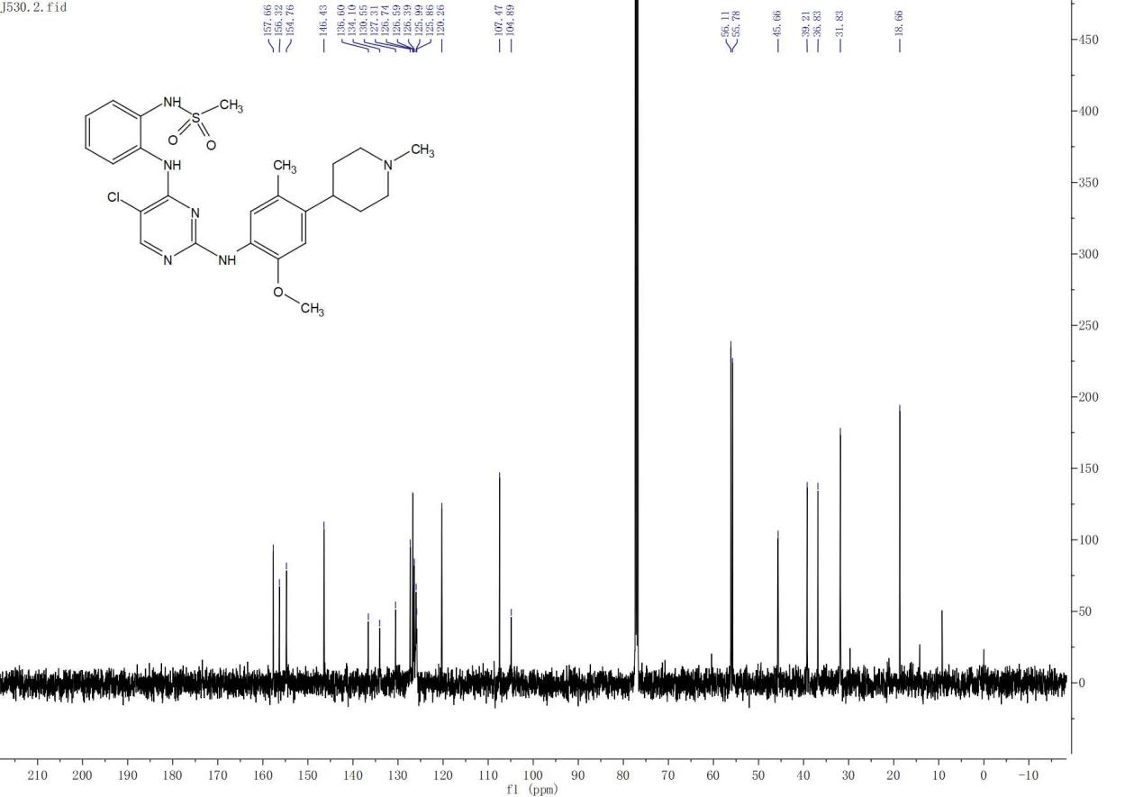

^{H} NMR of Compound 5g
^{C} NMR of Compound 5g
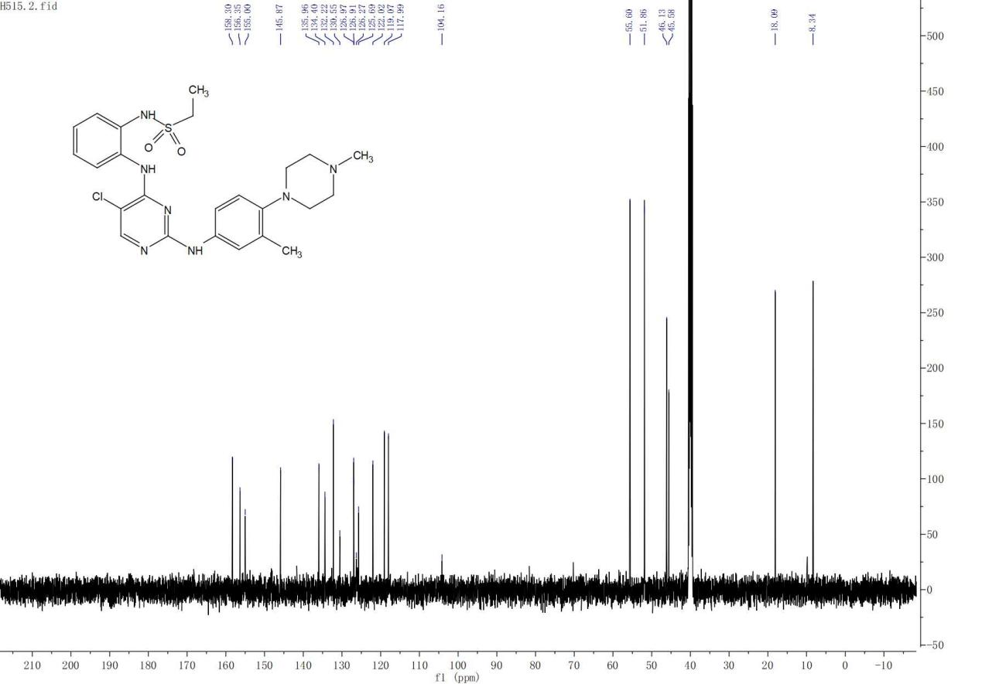

^{H} NMR of Compound 5h
^{C} NMR of Compound 5h
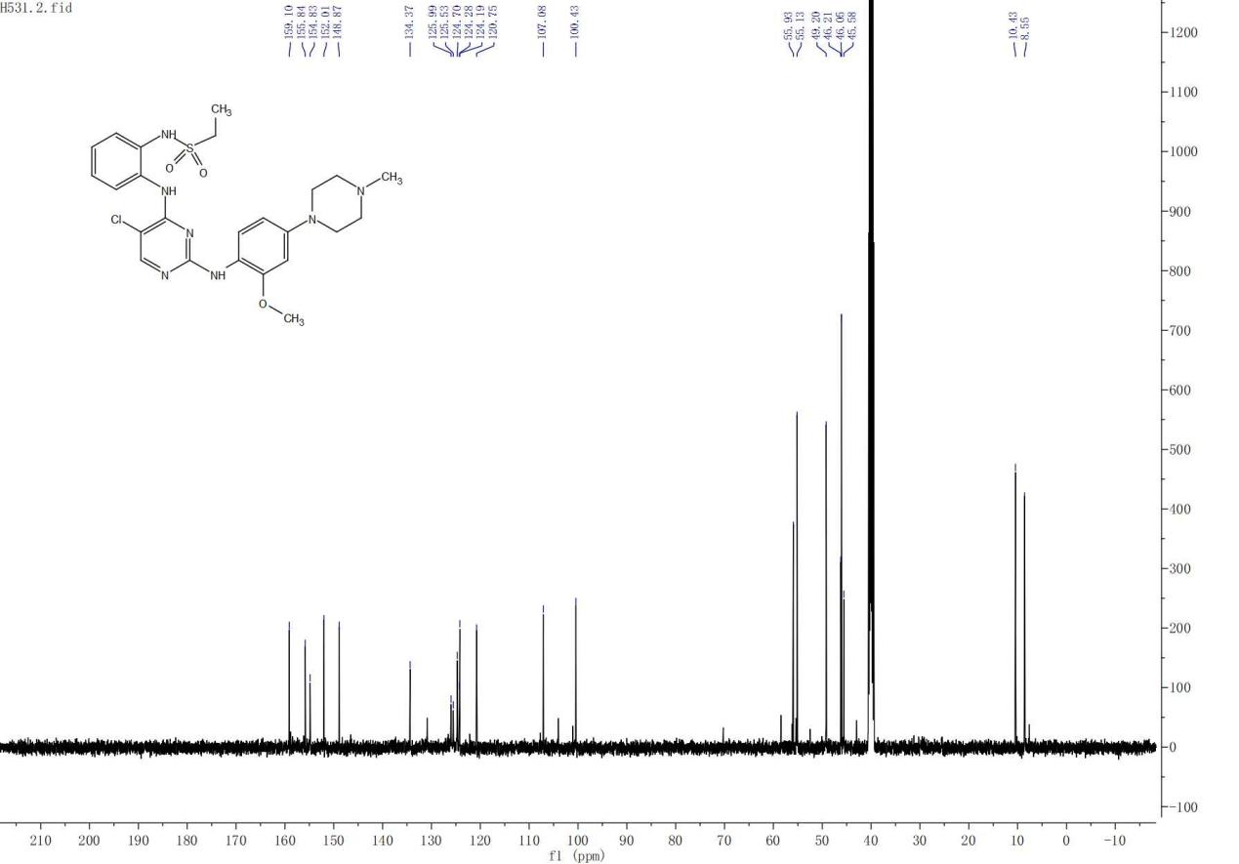

^{H} NMR of Compound 17a

^{C} NMR of Compound 17a
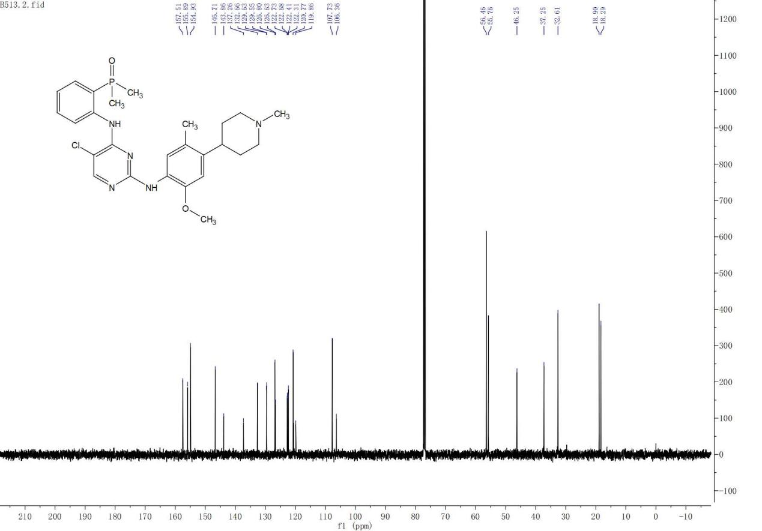

^{H} NMR of Compound 17b

^{C} NMR of Compound 17b
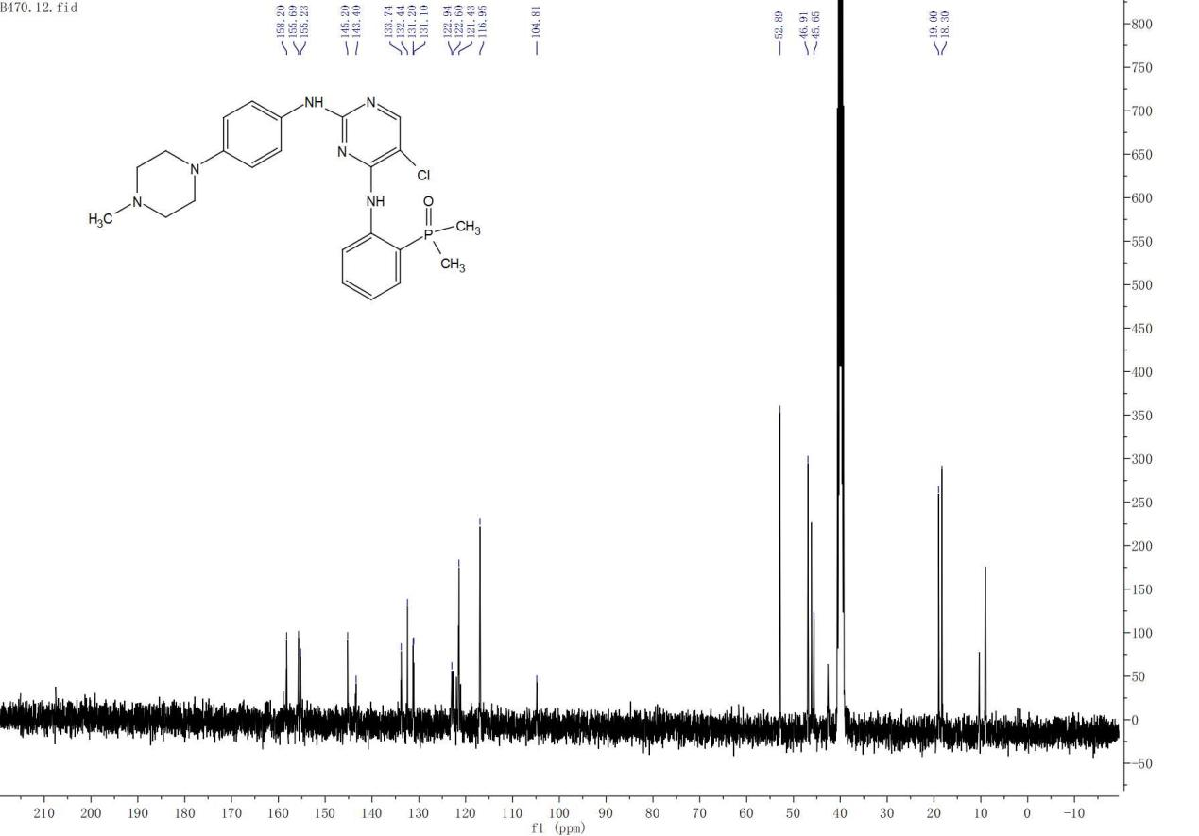

HRMS of 5a

HRMS of 5b

HRMS of 5c

HRMS of 5d

HRMS of 5e

HRMS of 5f

HRMS of 5g

HRMS of 5h

HRMS of 17a

HRMS of 17b

HPLC purity of 5a (97.16%)
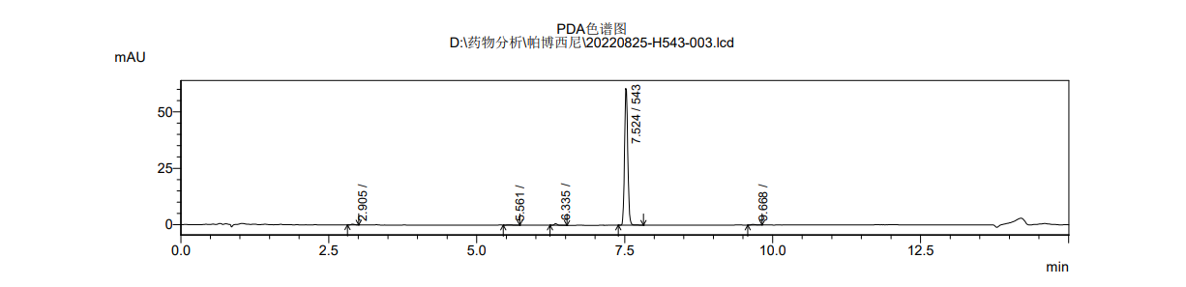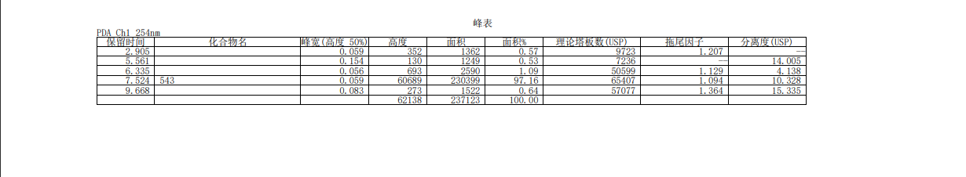
HPLC purity of 5b (99.55%)

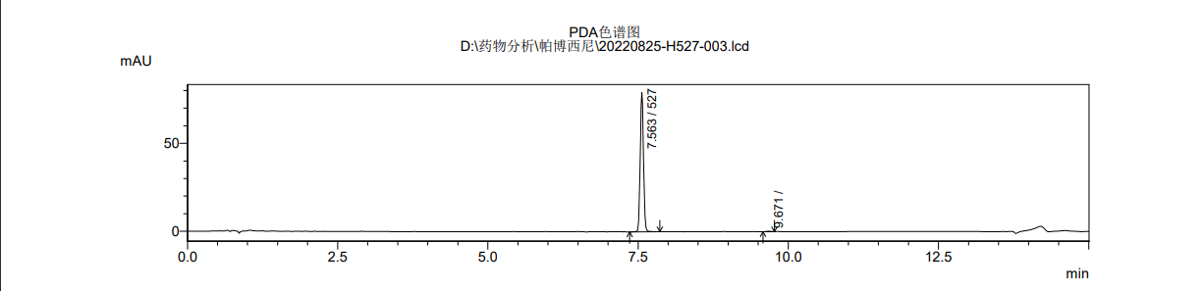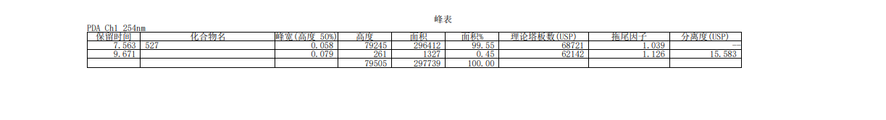
HPLC purity of 5c (96.54%)
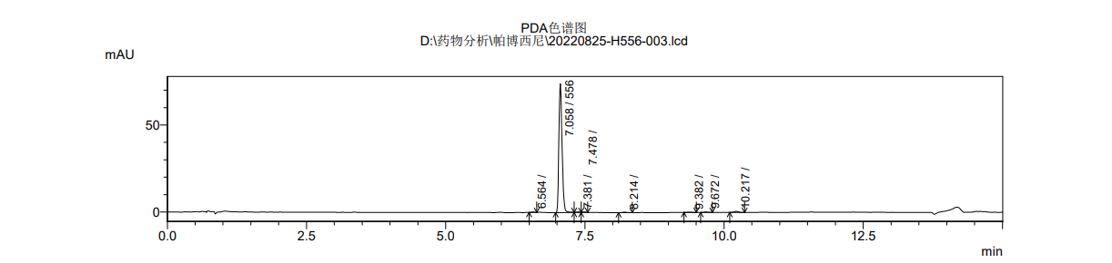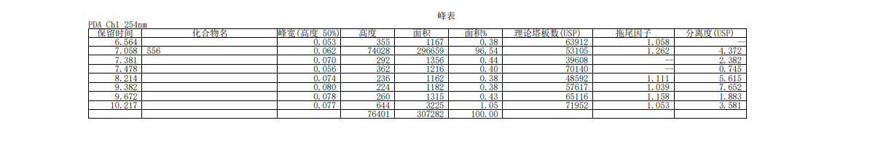

HPLC purity of 5d (95.87%)
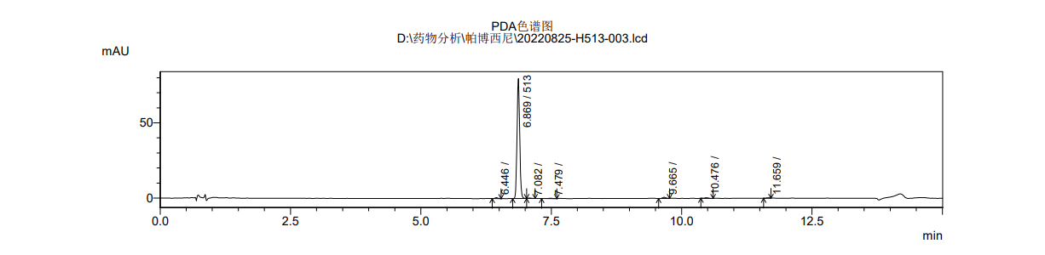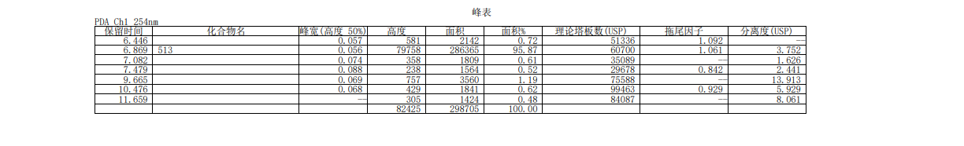
HPLC purity of 5e (96.19%)

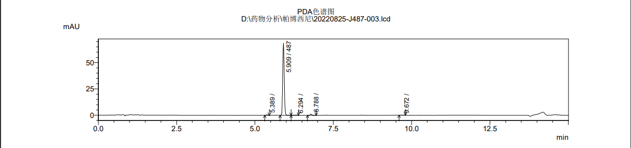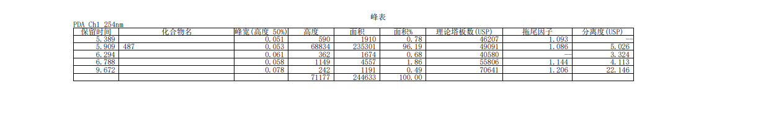
HPLC purity of 5f (95.48%)

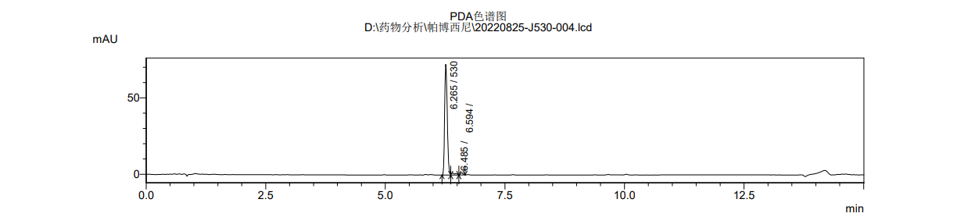
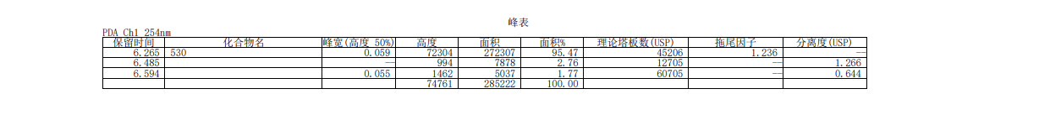

HPLC purity of 5g (98.59%)
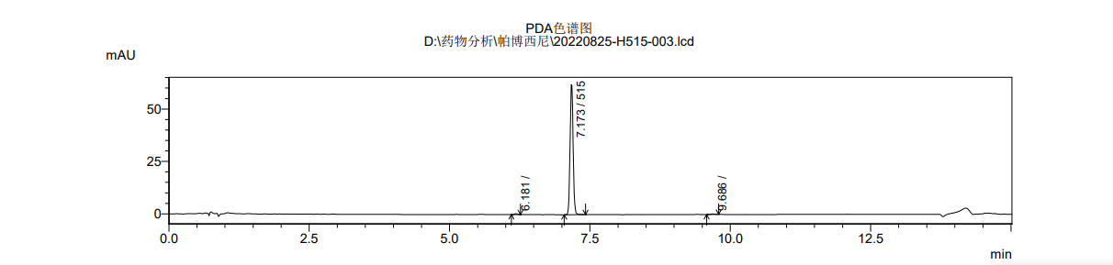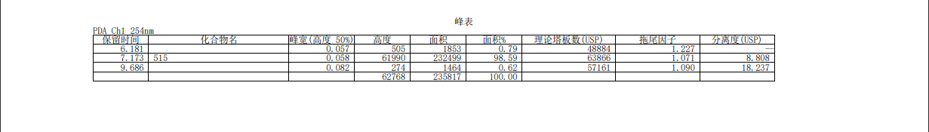
HPLC purity of 5h (97.23%)

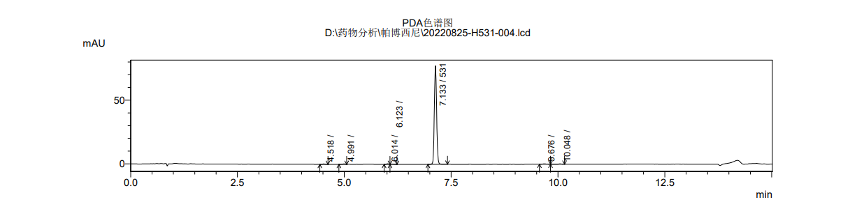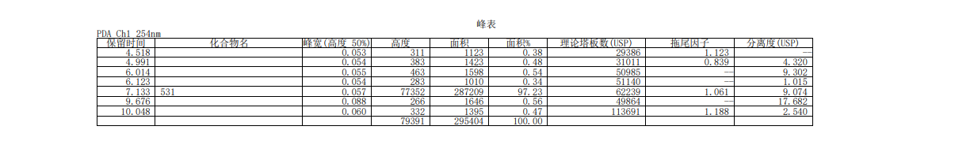
HPLC purity of 17a (96.15%)
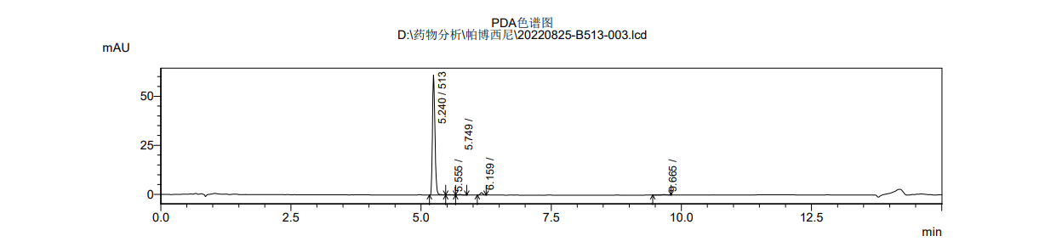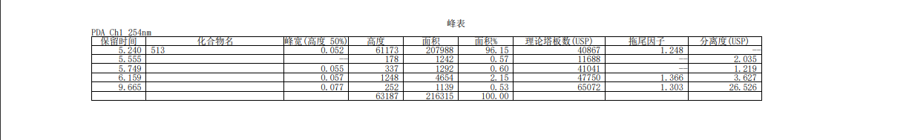

HPLC purity of 17b (98.18%)

