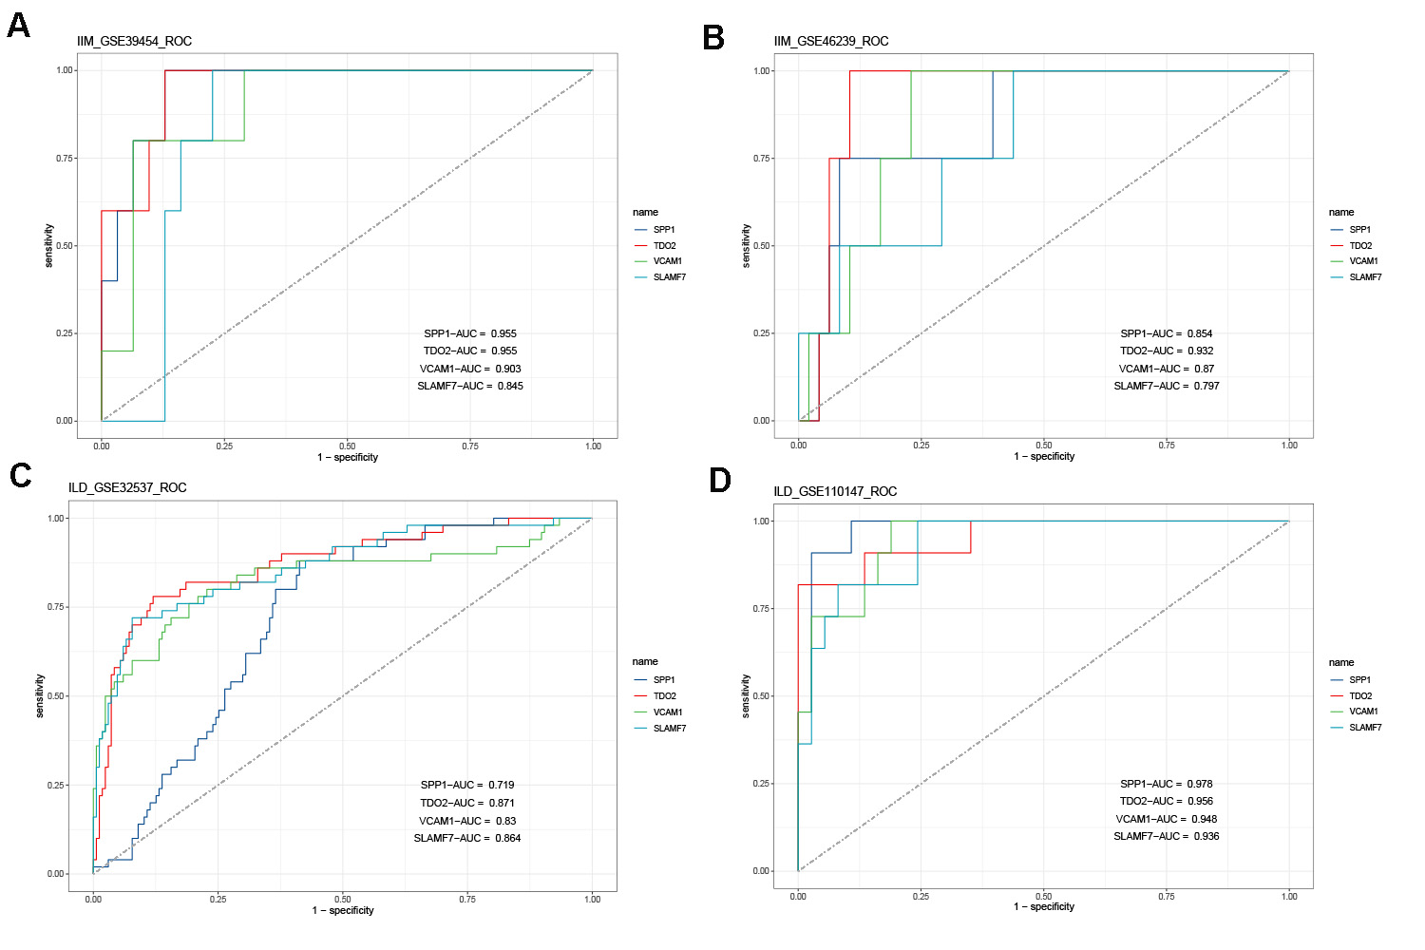
Figure S1. ROC showing the sensitivity and specificity of the common DEGs for the diagnosis of IIM (A, B) and ILD (C, D).

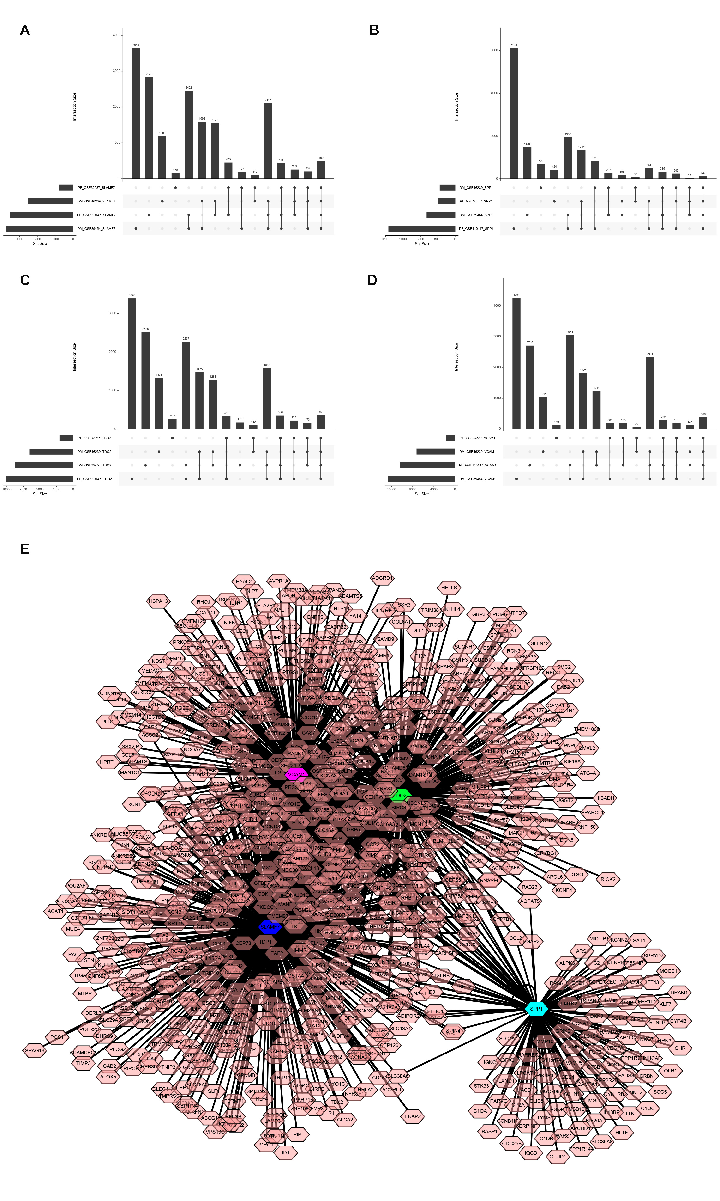
Figure S2. Common DEGs-associated genes. (A, B, C, D) Veen diagrams showing that each common DEGs-associated genes in the four datasets. (E) Regulatory networks of the common DEGs.

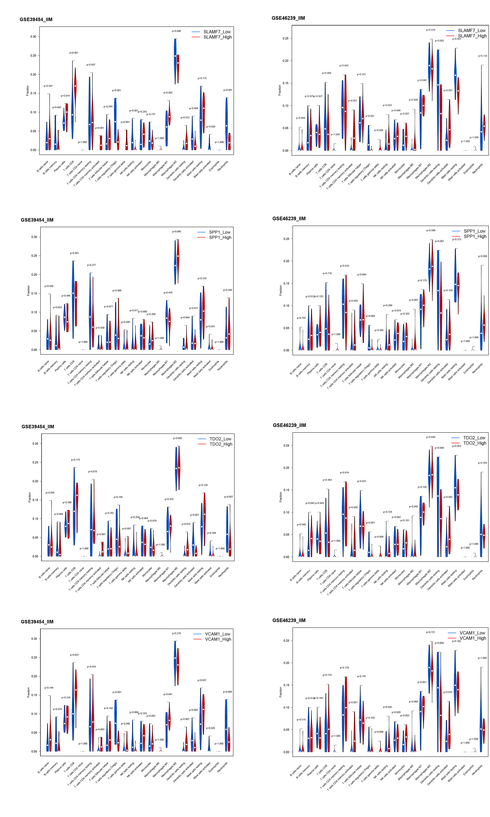
Figure S3. Relationship between the expression levels of common DEGs and 22 immune cell infiltration in the IIM.

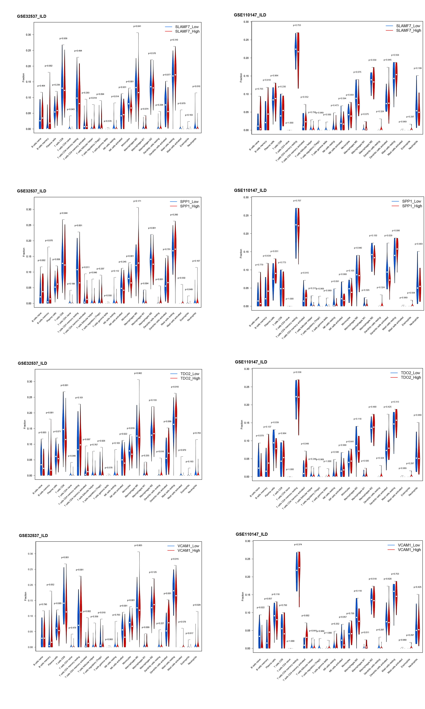
Figure S4. Relationship between the expression levels of common DEGs and 22 immune cell infiltration in the ILD.

