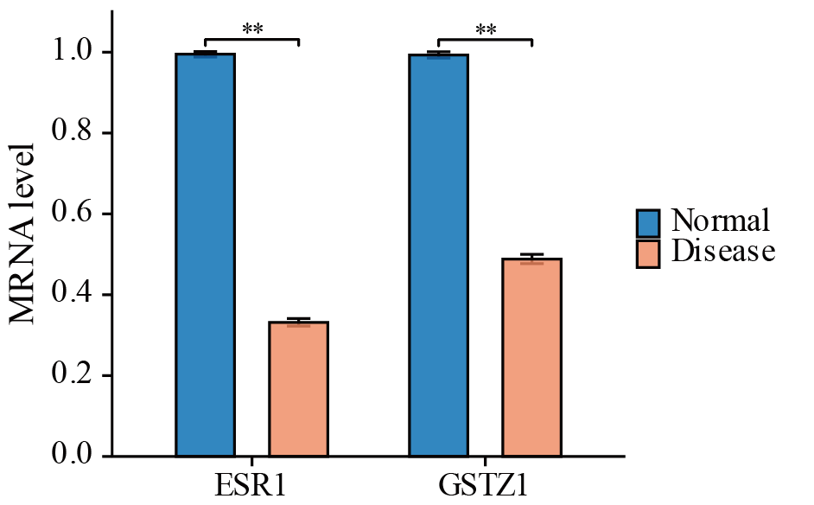
Figure S1 The mRNA levels of ESR1 and GSTZ1 in G2 and L02 cells. Blue represents the L02 normal group, and red represents the G2 disease group. **P<0.01.

Table S1 List of ferroptosis-related genes
Gene symbol
A2M-AS1
AADAC
ABCC1
ABCC5
ABHD12
ACACA
ACO1
ACSF2
ACSL1
ACSL3
ACSL4
ACVR1B
ADAM23
ADAMTS9-AS1
ADIPOR1
AEBP1
AGAP2-AS1
AGPS
AIFM2
AKR1C1
AKR1C2
AKR1C3
ALG3
ALKBH5
ALOX12
ALOX12B
ALOX15
ALOX15B
ALOX5
ALOXE3
ANGPTL4
ANO1
ANO6
AOC1
APELA
APOC1
APOE
AR
ARF6
ARGLU1-DT
ARHGEF26-AS1
ARMC5
ARNTL
ARPC1A
ASAP2
ASMTL-AS1
ATF2
ATF3
ATF4
ATF6
ATG5
ATG7
ATM
ATP5MC3
ATXN8OS
AURKA
AXL
BACH1
BAP1
BBOX1-AS1
BCAT2
BDNF-AS
BECN1
BEX1
BMAL1
BMP4
BNC1
BRD4
BRD7
C19orf12
C8orf76
CA9
CAMKK2
CAPRIN2
CARS
CARS1
CAV1
CBS
CBSLR
CCDC6
CCT3
CD38
CD44
CD82
CDC25A
CDC27
CDH1
CDKN1A
CDKN2A
CDO1
CEMIP
CERK
CERS6-AS1
CGAS
CHAC1
CHMP5
CHMP6
CIRBP
CISD1
CISD2
CISD3
CLTRN
CNR1
COMMD10
COPZ1
COX7A1
CP
CPEB1
CPLX2
CRYAB
CS
CSE
CUL9
CX3CL1
CYB5R1
CYGB
DDIT4
DDR2
DECR1
DHODH
DKK1
DLD
DNAJB6
DPP4
ECH1
EGFR
EGLN2
EHMT2
EIF4E
ELAVL1
ELK1
ELOVL5
EMC2
EMP1
ENO1
ERN1
ESR1
ETHE1
ETV4
EZH2
FABP4
FADS1
FADS2
FAF1
FAM98A
FANCD2
FAR1
FBLN1
FBXO31
FBXW7
FDFT1
FGFR4
FH
FNDC5
FSCN1
FTH1
FTL
FTMT
FTO
FUNDC2
FXN
FXR1
FZD7
G3BP1
G6PD
GABARAPL1
GALNT14
GCH1
GCLC
GCLM
GDF15
GGT1
GJA1
GLRX5
GLS
GLS2
GOT1
GPX4
GPX7
GSK3B
GSS
GSTM1
GSTZ1
H19
HCAR1
HDDC3
HDLBP
HELLS
HEPFAL
HERPUD1
HIF1A
HLF
HMGB1
HMGCL
HMGCR
HMOX1
HNRNPD
HNRNPL
HOXA11-AS
HPCAL1
HPX
HRH1
hsa_circ_0008367
HSBP1
HSF1
HSPA5
HSPA8
HSPB1
HULC
ICA1
IDH1
IDH2
IDO1
IFNA1
IFNG
IGF2BP3
IL1B
IL6
IREB2
ISCU
ITGB3
JUND
KAT6B
KDM1A
KDM3B
KDM4A
KDM5A
KDM5C
KDM6B
KEAP1
KIF20A
KLF2
KLHDC3
LAMP2
LAMTOR5
LCN2
LIFR
LONP1
LPCAT3
LRP8
LRRK2
LTBP2
MALAT1
MAPK1
MAPK3
MAPK8
MARCHF6
MAZ
MCF2L
MCU
MDM2
MDM4
ME1
MEF2C
MEG8
MEN1
METTL14
METTL16
METTL3
MGST1
MIB1
MICU1
MIOX
MITD1
MITF
MPC1
MPO
MT1DP
MT1G
MTDH
MTF1
MTHFR
MTTP
MUC1
MXRA8
MYB
MYC
MYCN
NAT10
NCOA4
NEAT1
NEDD4
NEDD4L
NF2
NFE2L1
NFE2L2
NFS1
NKAP
NOD1
NOTCH3
NOX1
NOX4
NQO1
NR1H4
NSUN5
NTN1
NTRK2
NUAK2
NUP62
NUPR1
OGFRP1
OIP5-AS1
OTUB1
P4HB
PANX1
PANX2
PAQR3
PARK7
PCAT1
PCBP1
PCBP2
PCDH7
PCDHB14
PCSK9
PDGFRA
PDIA2
PDK4
PDSS2
PEBP1
PEDS1
PELATON
PER1
PEX10
PEX12
PEX14
PEX2
PEX3
PGD
PGM5P3-AS1
PHGDH
PHKG2
PIEZO1
PIM1
PIR
PKM2
PLA2G6
PLTP
PML
POR
PPARA
PRDX1
PRDX2
PRDX4
PRDX6
PRKAA1
PRKAA2
PRKCA
PRKCB
PROM2
PSEN1
PSEN2
PSTK
PTGS2
PTPMT1
PTPN18
PTPN6
PVT1
PYCR1
QSOX1
RARRES2
RB1
RB1CC1
RBM24
RBMS1
RHEBP1
RND1
RNF113A
RPL8
RRM1
RRM2
SAT1
SCARA5
SCD
SEC24B
SENP1
SESN2
SHARPIN
SHP-1
SIAH2
SIRT1
SIRT3
SIRT6
SLC11A2
SLC16A1
SLC16A1-AS1
SLC1A5
SLC25A11
SLC25A28
SLC25A37
SLC39A14
SLC39A7
SLC3A2
SLC40A1
SLC47A1
SLC6A14
SLC7A11
SMG9
SMPD1
SNCA
SND1
SOCS1
SOCS2
SOX2
SP1
SQLE
SQOR
SQSTM1
SRC
SREBF1
SREBF2
SRSF1
SRSF9
SSBP1
STAT3
STAT6
STC1
STEAP3
STING
STING1
STK11
SUFU
SUV39H1
TAFAZZIN
TBX1
TCF4
TF
TFAM
TFAP2A
TFRC
TGFB2
TGFBR1
TIGAR
TILRLS
TLR4
TMBIM4
TMEM161B-DT
TNF
TNFAIP3
TP53
TP63
TRIB2
TRIM26
TRIM46
TRIM59
TRIM7
TRPM2
TRPM7
TRPV1
TSC1
TUG1
TYRO3
UFL1
USF2
USP11
USP14
USP35
VAMP2
VCP
VDAC2
WWTR1
YAP1
YTHDC2
YY1AP1
YY2
ZEB1
ZFAS1
ZFP36
ZSCAN25

Table S2 The sequences of primers used for RT-PCR
Genes | Forward primer (5′-3′) | Reverse primer (5′-3′)
IL1B | GAAATGCCACCTTTTGACAGTG | TGGATGCTCTCATCAGGACAG
GSTZ1 | CGCTGAAAATTGATGGAATCACC | GATGCCACTAGCGATGAGGT
LIFR | ATGCAAACGGTCTGAAGAGAG | TGGGTGACAAGAATGGAACCT
SLC25A37 | CCTACTCCACGATGCAGTAATG | AGTGAATTGACTGGAAGGGGATA
PTGS2 | TTCCAATCCATGTCAAAACCGT | AGTCCGGGTACAGTCACACTT
MT1G | AAGAGTGAGTTGGGACACCTT | CGAGACAATACAATGGCCTCC
HSPB1 | GGTTGCCCGATGAGTGGTC | CTGAGCTGTCGGTTGAGCG
ESR1 | CCCGCCTTCTACAGGTCTAAT | CTTTCTCGTTACTGCTGGACAG
PHGDH | ATGGCCTTCGCAAATCTGC | AGTTCAGCTATCAGCTCCTCC
GPX4 | TGTGCATCCCGCGATGATT | CCCTGTACTTATCCAGGCAGA
SLC7A11 | GGCACCGTCATCGGATCAG | CTCCACAGGCAGACCAGAAAA
GAPDH | AGGTCGGTGTGAACGGATTTG | GGGGTCGTTGATGGCAACA

Table S3 Comparison of the results of current study with those from other studies in the literature
Study | Main Results
Reference16 | FGF21 is a novel inhibitor of ferroptosis and alleviates liver fibrosis by inhibiting ferroptosis.
Reference17 | The absence of TAK1 in hepatocytes leads to ferroptosis and promotes the progression of liver  fibrosis and hepatocellular carcinoma through the cGAS-STING signaling pathway.
Reference34 | This study identifies ELAVL1-autophagy-dependent ferroptosis as a potential target for the  treatment of liver fibrosis.
Reference35 | This research reveals ZFP36-mediated autophagy-dependent ferroptosis as a promising  therapeutic target for addressing liver fibrosis.
Current study | Targeting ESR1 and GSTZ1 to regulate ferroptosis may be a potential approach for the  treatment of hepatic fibrosis.

