Table E1 MR scanners with different venders in all ten centers
Center | Manufacturer | Manufacturer Model Name
1 | Philips Medical Systems | Achieva
2 | Siemens | Verio
2 | United Imaging Healthcare | uMR 560
2 | Siemens | Avanto
3 | GE Medical Systems | Discovery MR 750
4 | Philips Medical Systems | Ingenia
5 | Siemens | Verio
6 | GE Medical Systems | Discovery MR 750
6 | Siemens | Aera
6 | GE Medical Systems | Optima MR360
7 | Siemens | Skyra
7 | GE Medical Systems | Signa HDxt
8 | GE Medical Systems | Signa HDxt
9 | Siemens | Verio
9 | Philips Medical Systems | Ingenia
10 | GE Medical Systems | Discovery MR 750
10 | GE Medical Systems | Signa Pioneer
10 | GE Medical Systems | Signa HDxt

Table E2 Recommended parameters for liver scans
Sequence | Repetition time (TR)/ms | Echo time (TE)/ms | Slice thickness/mm | Slices | Matrix | Field of view (FOV)/mm | Other
Coronal T2WI | 2000 | 93 | 5 | 24 | 256×179 | 350×350 | Breath hold
Transverse T2WI | 2000 | 78 | 6 | 26 | 320×224 | 350×280 | Respiratory trigger
Fast-spoiled gradient-recalled echo T1WI | 200 | 1.54/2.91 | 6 | 26 | 256×192 | 380×285 | Breath hold
DWI | 1500 | 60 (Minimum) | 6 | 26 | 128×104 | 350×280 | Multiple breath hold; b value 0，600 s/mm2
DCE T1WI | 3.92 (Minimum) | 1.39 (Minimum) | 3 | 64 | 320×224 | 380×285 | conventional extracellular and hepatocyte-specific contrast agents
Note— T1WI, T1-weighted imaging; T2WI, T2-weighted imaging; DWI, diffusion weighted imaging; DCE, dynamic contrast-enhanced.

Table E3 The interobserver agreement of radiological features
Feature | Interobserver Agreement
Distance of the tumor from the capsule (cm) | 0.60 (0.49 - 0.69)
Tumor size (cm) | 0.99 (0.98 - 0.99)
Shape | 0.81 (0.75 - 0.86)
Margin | 0.82 (0.76 - 0.87)
Intratumoural fat | 0.63 (0.53 - 0.71)
Intratumoural hemorrhage and/or necrosis | 0.70 (0.61 - 0.77)
Corona enhancement | 0.70 (0.61 - 0.77)
Pseudo-Capsule | 0.69 (0.60 - 0.76)

Table E4 Radiomics features selected in the radiomics model for prediction of treatment reponse at six month after TACE
No. | Phase | Features | Coefficient
1 | Shape | PVP_original_shape_Elongation | -0.14
2 |  | PVP_original_shape_Flatness | -0.03
3 |  | PVP_original_shape_Maximum3DDiameter | 0.52
4 |  | PVP_original_shape_VoxelVolume | -0.40
1 | Non-shape-AP | AP_original_firstorder_MeanAbsoluteDeviation | -0.59
2 |  | AP_original_firstorder_Variance | 0.65
3 |  | AP_original_gldm_DependenceEntropy | 0.34
4 |  | AP_original_gldm_DependenceNonUniformityNormalized | -0.12
5 |  | AP_original_gldm_DependenceVariance | 0.13
6 |  | AP_original_glrlm_RunLengthNonUniformity | -0.39
7 |  | AP_original_glszm_GrayLevelVariance | -0.09
8 |  | AP_original_glszm_SmallAreaLowGrayLevelEmphasis | 0.37
1 | Non-shape-PVP | PVP_original_glcm_Idmn | -0.81
2 |  | PVP_original_gldm_DependenceVariance | 0.04
3 |  | PVP_original_glrlm_LongRunLowGrayLevelEmphasis | -0.95
1 | Non-shape-T2 | T2_original_firstorder_10Percentile | 0.30
2 |  | T2_original_firstorder_90Percentile | 0.05
3 |  | T2_original_firstorder_Maximum | 0.14
4 |  | T2_original_firstorder_MeanAbsoluteDeviation | 0.03
5 |  | T2_original_gldm_LargeDependenceLowGrayLevelEmphasis | -0.80
6 |  | T2_original_gldm_LowGrayLevelEmphasis | 0.26
Note—TACE, Transarterial embolization; AP, arterial phase; PVP, portal venous phase.

Table E5 Predictive performance of radiomics signature on treatment response at six months after TACE
Predictive models | Training set (n = 157)
 | AUC (95% CI) | Accuracy | Sensitivity | Specificity
Shape | 0.61 (0.52-0.70) | 66% | 91% | 31%
AP | 0.68 (0.59-0.77) | 67% | 67% | 66%
PVP | 0.70 (0.62-0.78) | 62% | 42% | 89%
T2WI | 0.65 (0.57-0.74) | 63% | 60% | 68%
Shape+AP+PVP+T2WI | 0.81 (0.74-0.88) | 78% | 94% | 55%
Predictive models | Test set (n = 64)
 | AUC (95% CI) | Accuracy | Sensitivity | Specificity
Shape | 0.67 (0.54-0.81) | 66% | 68% | 64%
AP | 0.67 (0.54-0.80) | 66% | 94% | 39%
PVP | 0.55 (0.41-0.69) | 59% | 61% | 58%
T2WI | 0.61 (0.47-0.75) | 63% | 68% | 58%
Shape+AP+PVP+T2WI | 0.67 (0.53-0.80) | 66% | 90% | 42%
Note—TACE, Transarterial chemoembolization; AP, arterial phase; PVP, portal venous phase; T2WI, T2-weighted imaging; AUC, area under the curve; CI, confidence interval.

Table E6 Univariable and multivariable analysis of all clinical information, laboratory tests, and radiological features for treatment response prediction at six months
Variables | Univariable Analysis |  |  | Multivariable Analysis
 | Odds Ratio | 95% CI | P Value | Odds Ratio | 95% CI | P Value
Patient demographics
Age | 1.00 | 0.96-1.04 | .87
Gender | 1.38 | 0.58-3.25 | .47
Cirrhosis | 0.56 | 0.27-1.15 | .12
Baseline factors
Child-Pugh grade | 0.89 | 0.33-2.43 | .82
ECOG | 1.48 | 0.52-4.16 | .46
Total bilirubin (µmol/L) | 1.00 | 0.96-1.04 | ＞.99
Direct bilirubin (µmol/L) | 0.98 | 0.90-1.07 | .64
Aspartate aminotransferase (U/L) | 1.00 | 0.98-1.02 | .88
Alanine aminotransferase (U/L) | 1.01 | 0.99-1.03 | .35
Alkaline phosphatase (U/L) | 1.00 | 0.99-1.01 | .67
Albumin (g/L) | 0.99 | 0.97-1.01 | .17
Total protein (g/L) | 1.00 | 0.96-1.04 | .99
Alpha-fetoprotein (µg/L) | 1.00 | 1.00-1.00 | .39
Prothrombin time | 0.94 | 0.79-1.14 | .54
Total amount of TANDEM + Epirubicin delivered (ml)* | 0.99 | 0.98-1.01 | .38
Distance of the tumor from the capsule (cm) | 1.01 | 0.76-1.35 | .94
Tumor long diameter (cm) | 0.79 | 0.63-0.97 | .03 |  |  | NS
Shape | 0.71 | 0.36-1.39 | .32
Margin | 1.17 | 0.60-2.30 | .64
Intratumoral fat | 0.79 | 0.34-1.85 | .59
Intratumoral hemorrhage and/or necrosis | 0.51 | 0.25-1.03 | .06
Corona enhancement | 3.71 | 1.90-7.24 | ＜.001 | 2.26 | 1.08-4.73 | .03
Pseudo-Capsule | 0.81 | 0.42-1.59 | .55
One month laboratory parameters
Total bilirubin (µmol/L) | 0.98 | 0.94-1.01 | .17
Direct bilirubin (µmol/L) | 0.95 | 0.88-1.02 | .15
Aspartate aminotransferase (U/L) | 1.00 | 0.99-1.02 | .67
Alanine aminotransferase (U/L) | 1.01 | 1.00-1.03 | .13
Alkaline phosphatase (U/L) | 1.00 | 1.00-1.01 | .86
Albumin (g/L) | 0.99 | 0.97-1.01 | .23
Total protein (g/L) | 1.01 | 0.96-1.07 | .67
Alpha-fetoprotein (µg/L) | 0.99 | 1.00-1.00 | .17
Prothrombin time | 0.83 | 0.67-1.04 | .10
Child-Pugh grade | ... | ... | ＞.99
Treatment response at one month | 3.36 | 2.15-5.25 | ＜.001 | 2.92 | 1.84-4.64 | ＜.001
Difference of laboratory tests between one month and baseline
Total bilirubin (µmol/L) | 0.94 | 0.89-1.00 | .04 |  |  | NS
Direct bilirubin (µmol/L) | 0.87 | 0.76-1.00 | .05 |  |  | NS
Aspartate aminotransferase (U/L) | 1.00 | 0.99-1.02 | .74
Alanine aminotransferase (U/L) | 1.01 | 0.99-1.02 | .42
Alkaline phosphatase (U/L) | 1.00 | 1.00-1.01 | .68
Albumin (g/L) | 1.00 | 0.98-1.02 | .98
Total protein (g/L) | 1.01 | 0.96-1.08 | .63
Alpha-fetoprotein (µg/L) | 1.00 | 1.00-1.00 | .20
Prothrombin time | 0.78 | 0.55-1.10 | .16
Child-Pugh grade | 0.52 | 0.27-0.98 | .04 |  |  | NS
Note—TACE, Transarterial chemoembolization; CI, Confidence interval. ECOG, Eastern Cooperative Oncology Group.
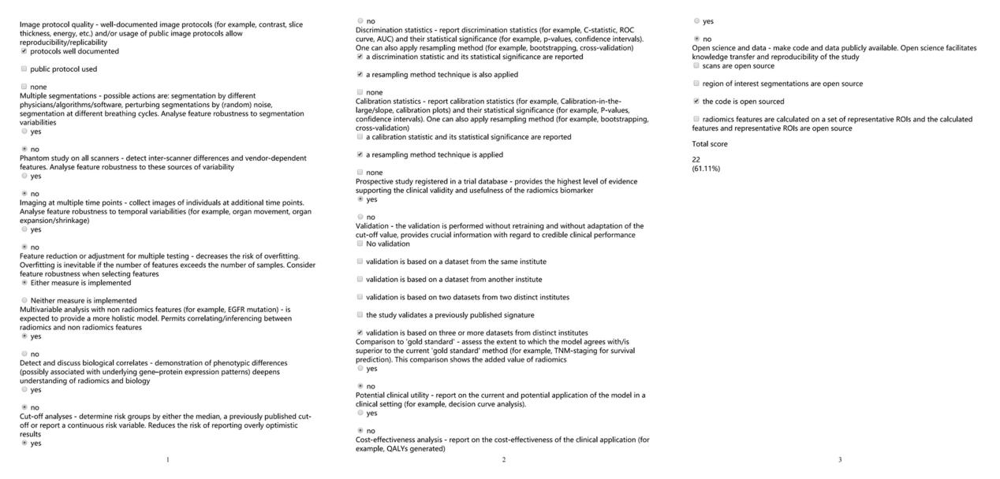
Figure E1 online. The radiomics process quality evaluation final score of the study.

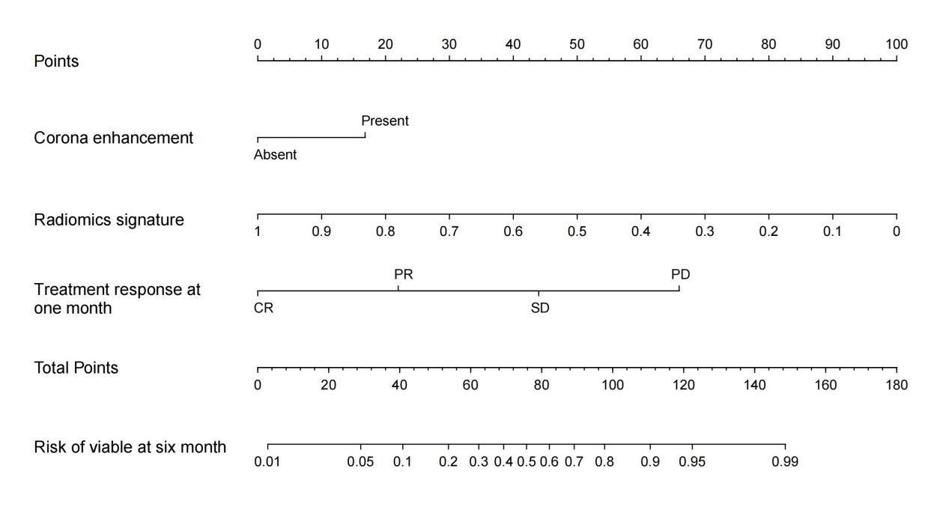
Figure E2 online. The nomogram of the TRCAE model based on the Treatment response at one month, RAdiomics signature and Corona Enhancement. CR, Complete response; PR, Partial response; SD, Stable disease; PD, Progressive disease.
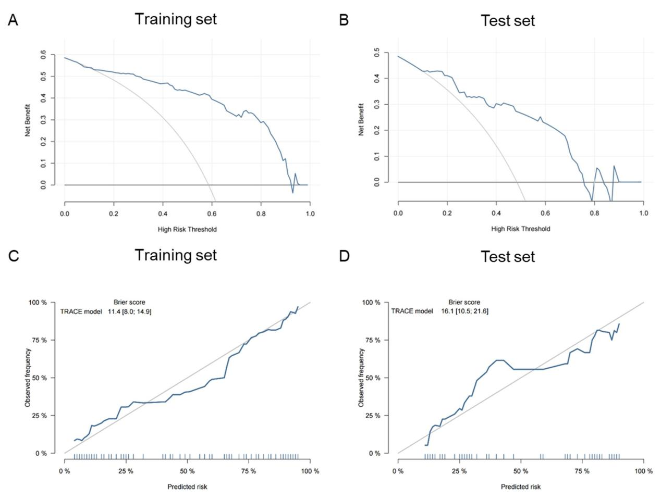
Figure E3 online. Decision curve analysis (A-B) and calibration curves (C-D) for the TRACE model (a model based on the Treatment response at one month, RAdiomics signature and Corona Enhancement) in the training cohort and test set at six month. (A-B) The y-axis represents the net benefit, and the x-axis represents the threshold probability. The TRACE model obtained more benefit than either the treat-all-patients scheme (gray line) or the treat-none scheme (horizontal black line) within certain ranges of threshold probabilities for predicting treatment response to TACE in HCC.(C-D) The closer the fit is to the diagonal line, the better the evaluation.
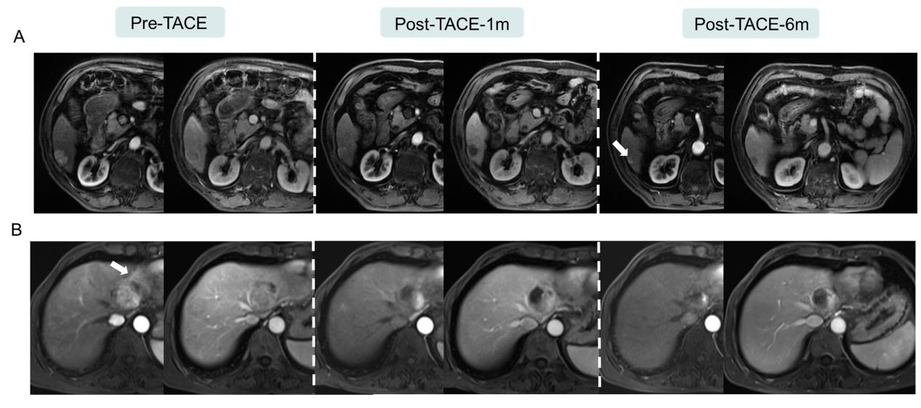
Figure E4 online. Representative MR images of late arterial phase for nonviable & equivocal and viable HCCs. (A) The baseline tumor diameter was 2.8 cm, and MRI showed nonviable at six months after TACE, coagulative necrosis of the lesion at six month, with slightly T1WI hyperintensity (arrow), while high predictive values of 0.809 was obtained in the TRACE model at six month. (B) Example of viable HCC. Tumor showed corona enhancement (arrow) with a baseline diameter of 4.9 cm, while lower predictive values of 0.259 was obtained in the TRACE model at six month.

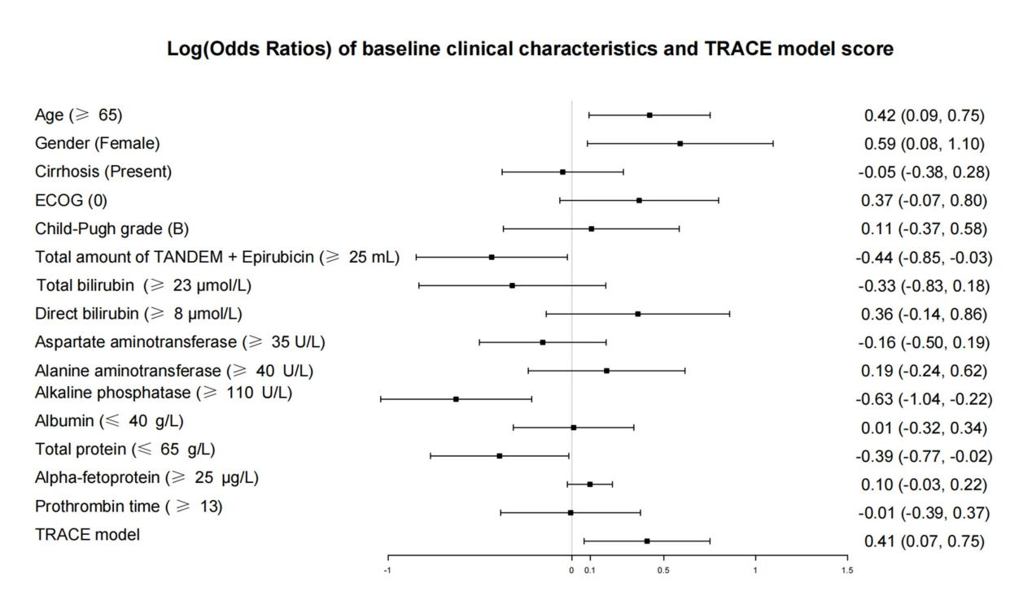
Figure E5 online. Forest plot of baseline clinical information and TRACE model score of OS with a multivariate proportional hazards regression. All data are categorical variables. ECOG, Eastern Cooperative Oncology Group (the inclusion ECOG score is 0 or 1.

