Supplemental Figure.1 The ROC Curve of CAR,PLR,NLR,IINS and CALLY for overall survival(OS) in the training cohort.
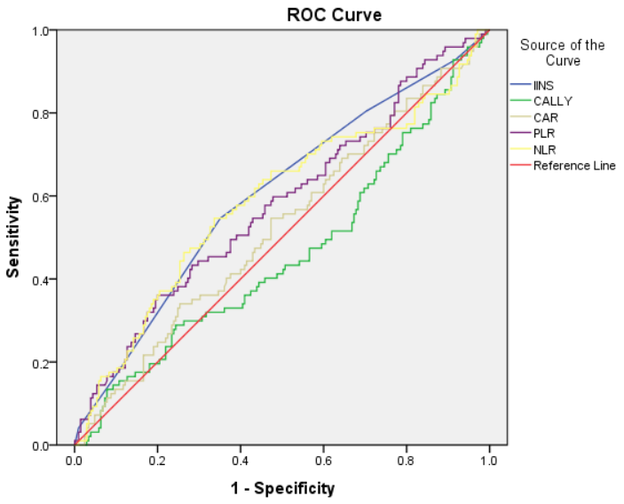
Abbreviations: ROC, receiver operating characteristic; CAR, CRP/ALB;PLR, PLT/LYM; NLR, NEU/LYM; IINS, inflammation-immunity-nutrition score; CALLY, high-sensitivity C-reactive protein-albumin-lymphocyte index.

Supplemental Table.1 The AUC of CAR,PLR,NLR,IINS and CALLY for overall survival(OS) in the training cohort
Variable | Calculations | AUC (95% CI) | Specificity | Sensitivity | p value
IINS |  | 0.602(0.533,0.672) | 0.165 | 0.098 | 0.004
CALLY | ALB×LYM/(hsCRP×10) | 0.460(0.388,0.532) | 0.784 | 0.854 | 0.261
CAR | CRP/ALB | 0.524(0.453,0.594) | 0.835 | 0.824 | 0.507
PLR | PLT/LYM | 0.579(0.509,0.649) | 0.887 | 0.805 | 0.026
NLR | NEU/LYM | 0.588(0.516,0.661) | 0.825 | 0.839 | 0.013

Abbreviations: IINS, inflammation-immunity-nutrition score; CALLY, high-sensitivity C-reactive protein-albumin-lymphocyte index; CAR, CRP/ALB; PLR, PLT/LYM; NLR, NEU/LYM.

Supplemental Figure.2 Kaplan–Meier survival curve of IINS and CALLY in the training cohort and the validation cohort for overall survival(OS). (a) Kaplan–Meier curve of IINS for OS; (b) Kaplan–Meier curve of CALLY for OS.

Abbreviations: IINS, inflammation-immunity-nutrition score; CALLY, high-sensitivity C-reactive protein-albumin-lymphocyte index.
Supplemental Figure.3 Decision curve analysis (DCA) of models in the training cohort and the validation cohort for overall survival (OS). (A) Comparison of IINS and CALLY for predicting 1-year survival; (B) Comparison of IINS and CALLY for predicting 2-year survival; (C) Comparison of IINS and CALLY for predicting 3-year survival.

Abbreviations: IINS, inflammation-immunity-nutrition score; CALLY, high-sensitivity C-reactive protein-albumin-lymphocyte index.

