Table S1. Summary of Subject Characteristics
Dataset | Sample Source | Sample Collection Time | Sample Size | Subject Characteristics
GSE145989 | University Health Network, Canada | End of cold ischemia (CIT) and 1-2 hours after reperfusion (H) | 134 samples (multiple groups, pre- and post-transplant) | All samples are from lung transplant patients, collected from lung biopsies pre- and post-transplant. Focused on transcriptomic changes.
GSE18995 | Seoul National University Hospital, Korea | Pre-transplant and post-transplant | 35 samples (11 from DCD group, 24 from DBD group) | DCD group: 6 pre-transplant samples, 5 post-transplant samples; DBD group: 12 pre-transplant samples, 12 post-transplant samples. Focused on gene expression differences between heart-death and brain-death donors.
DCD, donation after cardiac death; DBD, donation after brain death.

Table S2. Key characteristics of the Mendelian randomization study
Category | Details
Database | DF5 database (released May 11, 2021), including 218,792 Finnish individuals
Cases and Controls | 97 cases, 218,695 controls
Genetic Variants | 16,962,023 SNPs
Reference Genome | HG19/GRCh37
Phenotype Classification | Binary: Case/Control
SNPs, single nucleotide polymorphisms; HG19, human genome version 19; GRCh37, genome reference consortium human build 37.

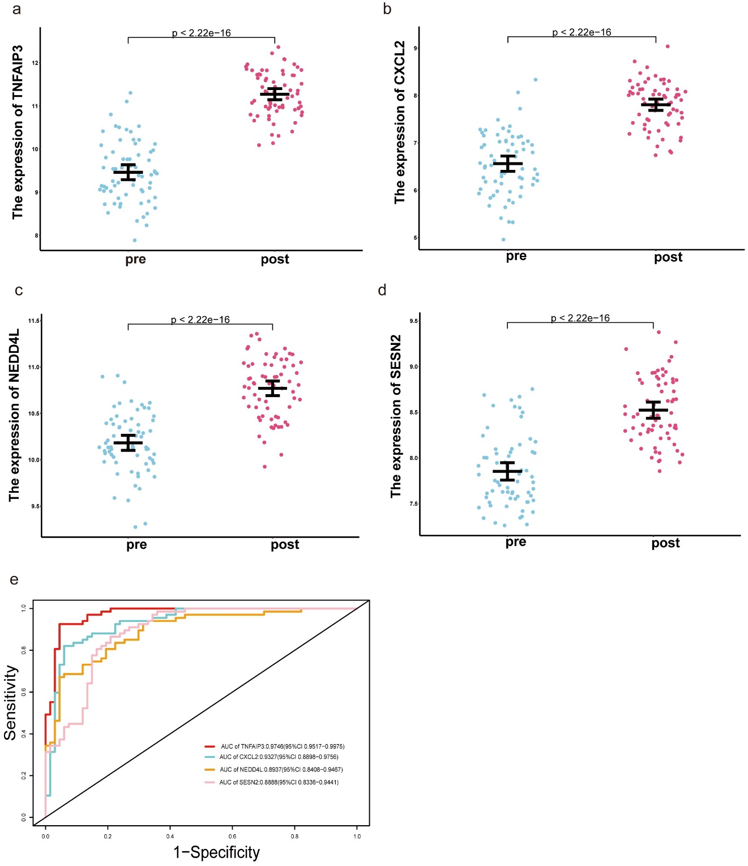

Figure S1 Validation of candidate genes in GSE145989. (a–d) Changes in expression of candidate genes before and after reperfusion. (e) ROC curves of candidate genes.
Abbreviation: ROC, receiver operating characteristic.

