Supplementary data
Estimating costs associated with adverse events in patients with advanced lung cancer

Supplementary Figure 1. Comparing the costs with and without adverse event (AE) for incremental cost.
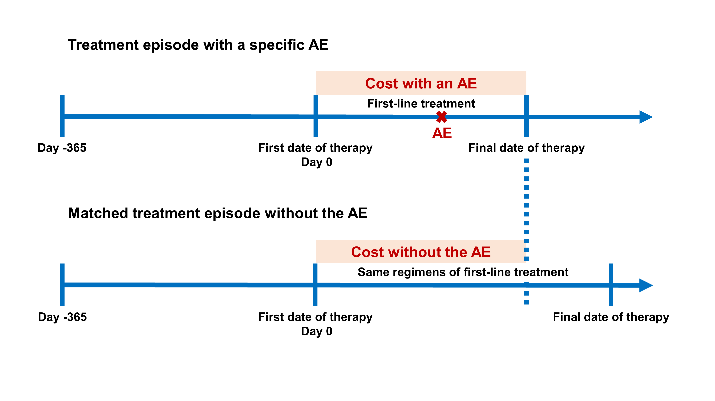
Supplementary Figure 2. (A) Time on first-line treatment and (B) Overall survival of targeted therapy, immunotherapy, and chemotherapy. CI: confidence interval.
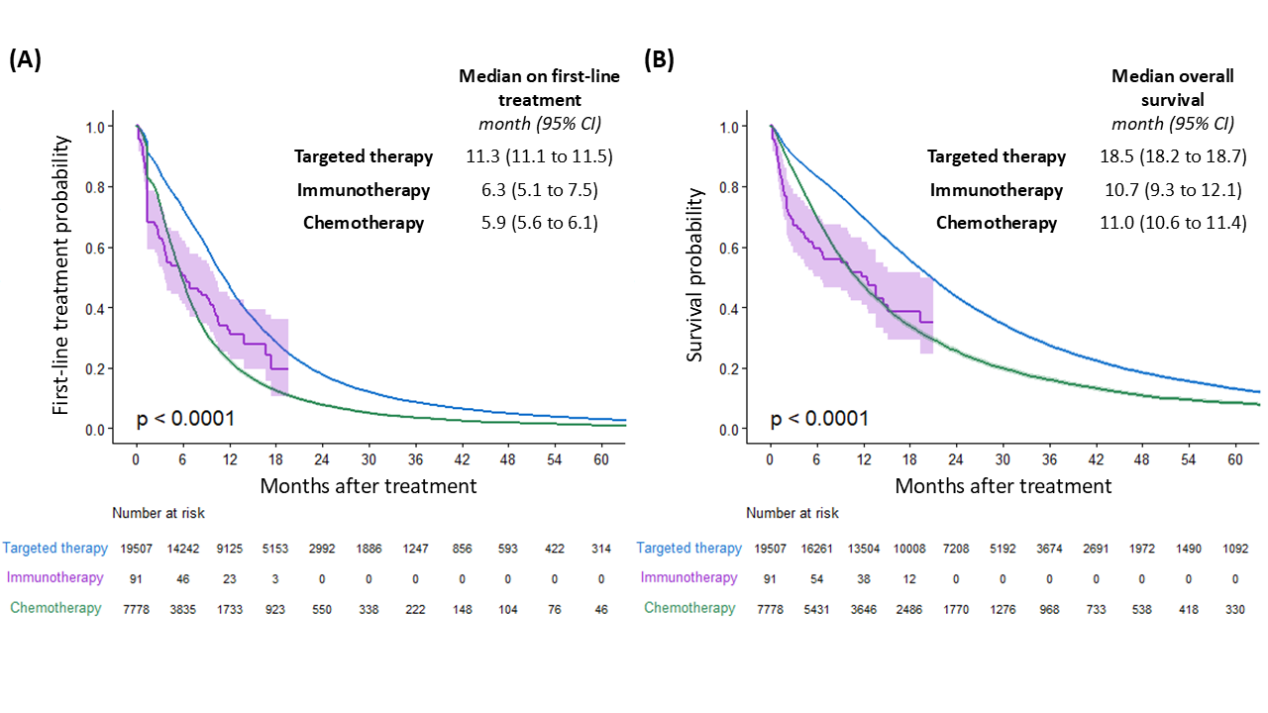
Supplementary Table 1. NHI codes for identifying first-line treatment
 | NHI code
Targeted therapy, oral dosing
Afatinib | B026031100, B026032100, B026033100, B026034100, BC26031100, BC26032100, BC26033100, BC26034100
Alectinib | BC27028100
Ceritinib | BC26674100
Crizotinib | BC25938100, BC25939100
Erlotinib | B024407100, B024410100, B025071100, B025077100, BC24407100, BC24410100, BC25071100, BC25077100, BC26873100, BC26874100
Gefitinib | B023808100, BC23808100
Immunotherapy, intravenous
Pembrolizumab | KC01025219
Chemotherapy, intravenous
Carboplatin, | AC57314235, AC573142AP, B020725235, B0207252AP, B020966248, B020966261, B020966272, B021047221, B021047235, B0210472AP, B021701235, B0217012AP, B024591235, B0245912AP, B025626235, B0256262AP, BC21701235, BC217012AP, BC25626235, BC256262AP, BC27083235, BC270832AP
Cisplatin | B012020248, B012184229, B018873238, B018873255, B019333229, B019333248, B021782229, B021782248, B021782255, BC18873238, BC18873255, , BC21782248, BC21782255, BC27762229, BC27762248
Docetaxel | AC61087209, AC61087209, B025055206, B025055212, B025558226, BB25600212, BB25600226, BC25558212, BC25558226, BC27138206, BC27138212, BC27712209, BC27712219, BC27786209, BC27786219
Etoposide | A036593221, B020480221, B020682221, B020881221, B020881229, B021714221, B022435221, B022921221, B024579221, X000171100
Gemcitabine | AC61175263, B025183209, B025183212, B025183263, B025899221, B025899240, B025899248, B026065209, B026065212, B026065263, BB25183212, BB25183263, BB25183263, BC25183209, BC25183263, BC25899221, BC25899240, BC25899248, BC26065209, BC26065212, BC26065263, BC266272AF, BC266272FS, BC27106209, BC27106263, BC27468209, BC27468263, BC27808221, BC27808240, BC27808248
Paclitaxel | A045331221, A045331229, A045331235, A045331240, A045331248, A0453312E2, A046429221, AC45331229, AC45331235, AC45331240, AC45331248, AC453312E2, B021157221, B0211572E2, B022400221, B022400240, B024476221, B024476240, B024476248, B0244762E2, BB21157221, BB211572E2, BC21157221, BC211572E2, BC27434221, BC27434240, BC27434248, BC27434255, BC27434296, BC274342E2, BC27504221, BC27504248, BC275042E2, BC28013221, BC280132E2, X000221255, X000222255
Pemetrexed | AC60575255, AC60596277, B024084277, BC26921255, BC26921277, BC27066255, BC27347277, BC27532255, BC27532277, BC27822277
Vinorelbine | B024472209, B024472221, B025898209, B025898221, BC24472209, BC24472221, BC25898209, BC25898221, X000217209, X000225209
NHI: National Health Insurance.
Supplementary Table 2. ICD codes for identifying adverse events
Adverse events | ICD-9 code | ICD-10 code
Acute kidney injury | 584.5, 584.6, 584.7, 584.8, 584.9 | N17.0, N17.1, N17.2, N17.8, N17.9
Alopecia | 704.00, 704.09 | L63.0, L64.0, L65.8, L65.9
Anemia | 285.0, 281.8, 281.9, 284.8, 285.22, 285.29, 285.8, 285.9 | D53.8, D53.9, D63.0, D63.8, D64.1, D64.2, D64.3, D64.81, D64.89, D64.9
Anorexia | 307.59, 783.0 | F50.8, R63.0
Colitis | 558.2, 558.9 | K52.1, K52.89, K52.9, K92.81
Constipation | 564.0 | K59.00, K59.01, K59.09
Diarrhea | 564.5, 787.6, 787.7, 787.91 | K52.89, K59.1, R15.0, R15.2, R15.9, R19.5, R19.7
Dyspnea | 786.00, 786.01, 786.05, 786.06, 786.09 | R06.00, R06.02, R06.09, R06.4, R06.82, R06.89, R06.9
Edema | 782.3 | R60.0, R60.1, R60.9
Electrolyte imbalance | 276.9, 276.1, 276.8, 275.41, 275.2 | E87.8, E87.1, E87.6, E83.51, E83.42
Epistaxis/hemoptysis | 784.7, 786.3 | R04.0, R04.2, R04.89, R04.9
Fatigue/asthenia | 300.5, 780.71, 780.79, 799.3 | F48.8, R53.0, R53.1, R53.81, R53.82, R53.83
Folliculitis | 704.8, 704.9, 706.0, 706.1 | L66.3, L70.1, L70.8, L70.9, L73.8, L73.9, L73.9
Hypertension | 401.0, 401.1, 401.9, 402.00, 402.01, 402.10, 402.11, 402.90, 402.91, 405.09, 405.19, 405.99, 997.91 | I10, I11.0, I11.9, I15.8, I15.9, I97.3
Hypothyroidism/ hyperthyroidism | 244.3, 244.8, 244.9, 245.4, 245.8, 245.9 | E03.2, E03.8, E03.9, E06.4, E06.5, E06.9
Hepatitis | 571.49, 573.3 | K71.0, K71.10, K71.11, K71.2, K71.6, K71.7, K71.8, K71.9, K73.1, K73.2, K73.8, K75.2, K75.89, K75.9, K77
Interstitial lung disease/pneumonitis | 495.8, 495.9, 508.8, 508.9, 515, 516.8, 516.9 | J70.2, J70.3, J70.4, J70.8, J70.9, J84.09, J84.111, J84.113, J84.17, J84.89, J84.9
Mucositis/stomatitis | 528.0, 528.1, 528.2, 528.9 | A69.0, K12.0, K12.1, K12.30, K12.31, K12.32, K12.33, K12.39
Musculoskeletal pain | 719.40, 719.41, 719.42, 719.43, 719.44, 719.45, 719.46, 719.47, 719.48, 719.49, 724.1, 724.2, 724.3, 729.5 | M25.50, M25.511, M25.512, M25.519, M25.521, M25.522, M25.529, M25.531, M25.532, M25.539, M25.551, M25.552, M25.559, M25.561, M25.562, M25.569, M25.571, M25.572, M25.579, M54.30, M54.31, M54.32, M54.40, M54.41, M54.42, M54.5, M54.6, M79.601, M79.602, M79.603, M79.604, M79.605, M79.606, M79.609, M79.621, M79.622, M79.629, M79.631, M79.632, M79.639, M79.641, M79.642, M79.643, M79.644, M79.645, M79.646, M79.651, M79.652, M79.659, M79.661, M79.662, M79.669, M79.671, M79.672, M79.673, M79.674, M79.675, M79.676
Nausea/vomiting | 536.2, 787.01, 787.02, 787.03 | R11.0, R11.10, R11.11, R11.12, R11.14, R11.2
Neutropenia/  febrile neutropenia | 288.0 | D70.1, D70.2, D70.3, D70.4, D70.8, D70.9, D72.819
Neuropathy | 356.4, 356.8, 357.3, 357.4, 357.6, 357.7, 357.8, 357.9 | G13.0, G60.3, G62.0, G62.2, G62.89, G62.9, G63
Pruritus | 698.2, 698.8, 698.9 | L28.2, L29.8, L29.9, R21
Rash/erythema | 695.89, 782.1, 782.8, 782.9 | L53.8, L53.9, L54, R21, R23.4, R23.8, R23.9
Sepsis/septicemia | 038.8, 038.9 | A41.89, A41.9, I26.90, R65.20, R65.21
Thrombocytopenia | 287.4, 287.5 | D69.59, D69.6
Tinnitus/hearing loss | 388.2, 388.30, 388.31, 388.32, 388.40, 389.8, 389.9, V41.2 | H91.20, H91.21, H91.22, H91.8X1, H91.8X2, H91.8X3, H91.8X9, H91.90, H91.91, H91.92, H91.93, H93.11, H93.12, H93.13, H93.19, H93.241, H93.242, H93.243, H93.249
Visual disturbance | 368.10, 368.11, 368.12, 368.13, 368.8, 368.9, 369.3, 369.8, 369.9, V41.0, V41.1 | H53.10, H53.11, H53.121, H53.122, H53.123, H53.129, H53.131, H53.132, H53.133, H53.139, H53.141, H53.142, H53.143, H53.149, H53.19, H53.8, H53.9, H54.3, H54.60, H54.61, H54.62, H54.7, H57.9
ICD: International Classification of Disease.

