Supplementary Table 1. The baseline characteristics of the training and validation groups
Variable |  | Training (%) |  | Validation (%) |  | P
Number |  |  | 159 (100%) |  | 47 (30%)
Age, years | <40 |  | 30 (18.9%) |  | 12 (25.5%) |  | 0.609
Age, years | 40–65 |  | 85 (53.5%) |  | 23 (48.9%)
Age, years | >65 |  | 44 (27.7%) |  | 12 (25.5%)
Sex | Male |  | 85 (53.5%) |  | 25 (53.2%) |  | 0.974
Sex | Female |  | 74 (46.5%) |  | 22 (46.8%)
Marital status | Married |  | 130 (81.8%) |  | 34 (72.3%) |  | 0.159
Marital status | Other |  | 29 (18.2%) |  | 13 (27.7%)
Occupation | Farmer |  | 150 (94.4%) |  | 41 (87.2%) |  | 0.238
Occupation | Worker |  | 1 (0.6%) |  | 0 (0.00%)
Occupation | Student |  | 4 (2.5%) |  | 4 (8.5%)
Occupation | Other |  | 4 (2.5%) |  | 2 (4.3%)
Education | Primary school or below |  | 141 (88.7%) |  | 39 (83.0%) |  | 0.732
Education | Junior school |  | 6 (3.8%) |  | 2 (4.3%)
Education | High school |  | 10 (6.3%) |  | 5 (10.6%)
Education | College |  | 2 (1.3%) |  | 1 (2.10%)
Body mass index (kg/m²) |  | 22.47±3.46 |  | 22.34±3.58 |  | 0.823
Albumin (g/L) |  | 39.60±5.04 |  | 39.22±3.38 |  | 0.684
White blood cell count (10⁹/L) |  | 13.31±56.87 |  | 7.00±2.10 |  | 0.454
Neutrophil count (%) |  | 61.91±10.18 |  | 60.05±11.43 |  | 0.292
Lymphocyte count (10⁹/L) |  | 1.84±0.58 |  | 1.88±0.57 |  | 0.706
Duration (months) |  | 1.94±1.31 |  | 1.76±1.20 |  | 0.378
Erythrocyte sedimentation rate (mm/H) | <20 |  | 24 (20.2%) |  | 7 (24.1%) |  | 0.638
Erythrocyte sedimentation rate (mm/H) | ≥20 |  | 95 (79.8%) |  | 22 (75.9%)
Family income (yuan) | >10000 |  | 27 (17.0%) |  | 12 (25.5%) |  | 0.189
Family income (yuan) | ≤10000 |  | 132 (83.0%) |  | 35 (74.5%)

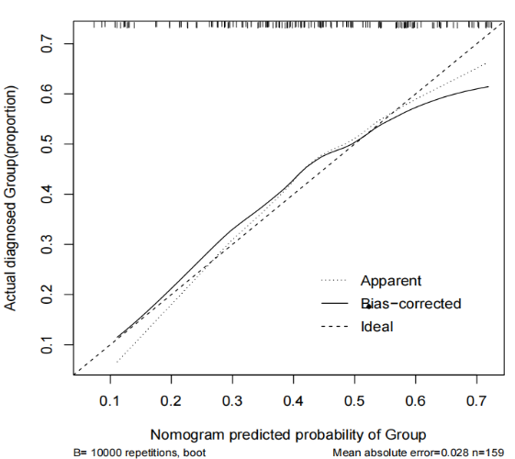
Supplementary Figure 1. Column line chart model calibration curve. The calibration curve for both the training and testing sets showed strong consistency, with no significant differences (P>0.05) between the predicted and actual values, indicating good predictive accuracy.

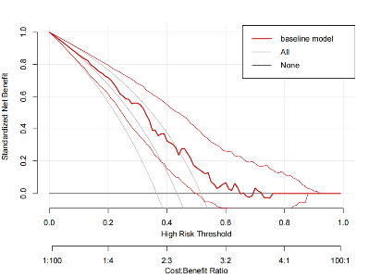
Supplementary Figure 2. Clinical decision curve. Decision curve analysis demonstrating the model’s clinical utility, with decision curves above the extremes (intervening none or all) in probability threshold ranges of 0–1 and 0.45–0.9, suggesting a higher clinical applicability and a broader effective prothrombin range.

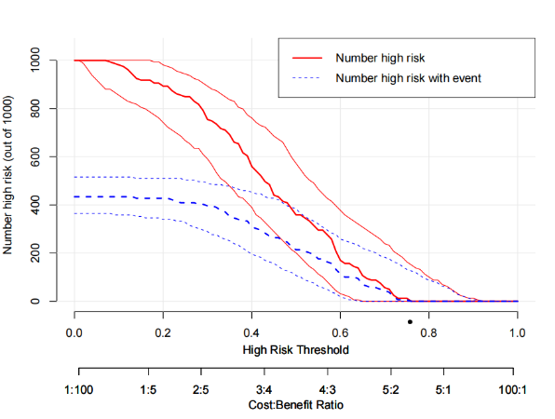
Supplementary Figure 3. Clinical impact curve. The clinical impact curve confirming the model’s effectiveness, showing a high concordance between the predicted high-risk patients and the actual cases of persistent airflow obstruction at risk thresholds above 0.36, demonstrating a high clinical prediction efficiency.

