Supplementary Material

Supplementary Figures
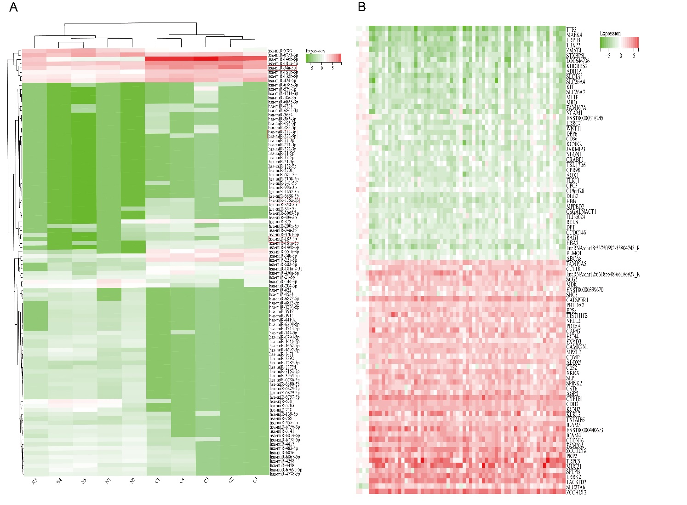
Figure S1. Multiple differentially expressed miRNAs and genes in PTC. (A) Fifty up-regulated and fifty down-regulated miRNAs with the most significant expression changes. (B) Fifty up-regulated and fifty down-regulated target genes with the most significant expression changes. (Cancer vs normal, green color indicates up-regulation, red color indicates down-regulation).
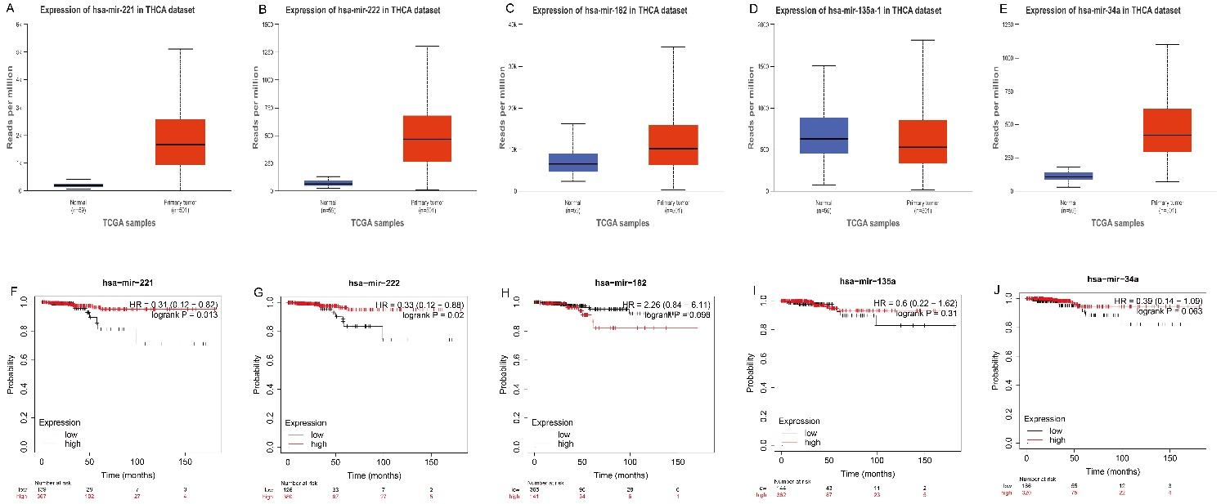
Figure S2. The expression levels and survival analysis results of the key miRNAs in online database. (A-E) The over-expression of hsa-miR-221, hsa-miR-222, hsa-miR-182, and hsa-miR-34a as well as down-expression of hsa-miR-135a in PTC patients tissue samples were detected from the data of TCGA database and The Cancer Genome Atlas Program (https://ualcan.path.uab.edu/). (F-J) The high expression of hsa-miR-182, which was predicted as an oncogene, significantly reduced the survival rate of patients. The high expression of hsa-miR-221, hsa-miR-222, hsa-miR-135a and hsa-miR-34a significantly improved the survival rate of patients. The data was analyzed by Kapler-Meier Plotter analysis (https://kmplot.com/).

Supplementary Tables

Table S1. The most significantly dysregulated miRNAs and their corresponding target genes-encoded proteins in PTC.
miRNA | Target genes
hsa-miR-221-3p | KCNK2 KHDRBS2 KIT
hsa-miR-222-3p | KCNK2 KHDRBS2 KIT
hsa-miR-182-5p | TNS3 TP53INP2 VLDLR ANGPTL1 ELMO1
hsa-miR-135a-5p | ARHGEF4 CXCL12 GHR SCUBE3 TBC1D4 VLDLR
hsa-miR-34a-5p | FAM167A GAS1 LRRC7 MPPED2 RAP1GAP

Table S2. The correlation between the expression levels of five key miRNAs and the tumor markers.
Marker | miR-182-5p | miR-221-3p | miR-222-3p | miR-135a-5p | miR-34a-5p
TgAb | >0.05 | >0.05 | >0.05 | >0.05 | >0.05
Ctn | >0.05 | >0.05 | >0.05 | >0.05 | >0.05
CEA | >0.05 | >0.05 | >0.05 | >0.05 | >0.05
TSH | >0.05 | >0.05 | >0.05 | >0.05 | >0.05

