Supplementary File
Supplementary Table 1: Phytochemical Composition and Bioactivity Potential of Extracts
Sr NO | Phytochemical | Presence in Leaves | Presence in Inflorescences | Properties
1 | Phenols | Detected | Detected | Antioxidant properties
2 | Flavonoids | Detected | Detected | Anti-inflammatory, and antimicrobial activities
3 | Tannins | Detected | Detected | Astringent properties
4 | Coumarins | Detected | Detected | Anticoagulant, anti-inflammatory, antimicrobial properties
5 | Alkaloids | Detected | Detected | Pharmacological effects
6 | Terpenoids | Detected | Detected | Antimicrobial, anti-inflammatory activities
7 | Saponins | Detected | Detected | Immunomodulatory, antimicrobial properties
8 | Glycosides | Detected | Detected | Various therapeutic effects including cardiac activity
9 | Sterols | Not Detected | Detected | Important components of cell membranes, various health benefits

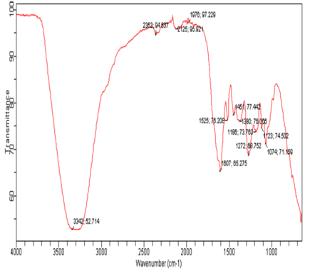
S. No. | Wavenumber (cm⁻¹) | Functional groups present
1. | 3342 | OH group
2. | 1607 | Aromatic
3. | 1272 | Sulfones, sulfonyl chloride, sulfates, sulfonamide
4. | 1074 | Sulfoxide
B-1: FTIR spectra of ethyl acetate fractions of methanolic leaf extract of C. oppositifolia
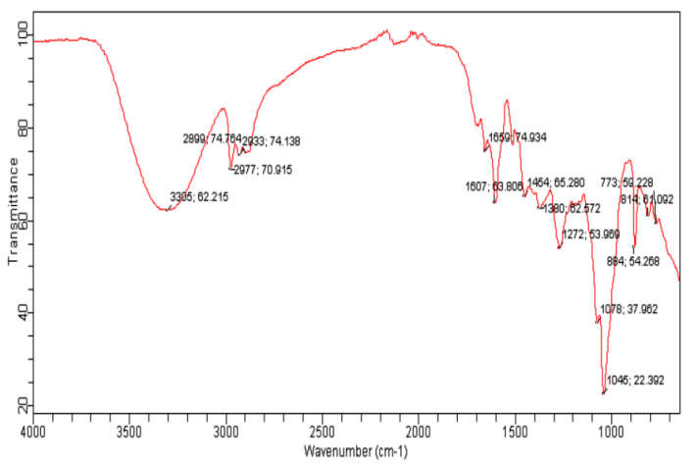
S. No. | Wavenumber (cm⁻¹) | Functional groups present
1. | 3385 | OH group
2. | 3305 | N-H stretch/ O-H group(carboxylic acid)
3. | 2977 | C-H (aldehyde)
4. | 1607 | Aromatic
5. | 1272 | C-N (Amines)
6. | 1045 | Sulfoxide
Supplementary Figure 2: FTIR spectra of ethyl acetate fractions of methanolic leaf extract of C. oppositifolia

Supplementary Figure 3: NMR Spectra of Pure Compounds and Their Mixtures with Inflorescence and Leaf Oils

