Figure S1. Study Flow chart

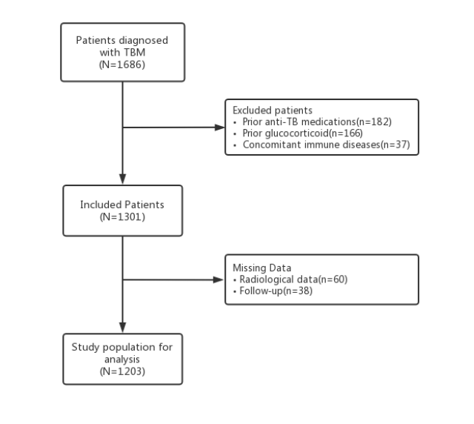

Table S1. Univariable analysis of the association between predictors and END in GLMM
Variables | Without END  (n=1059) | With END  (n=144) | Univariable analysis
Variables | Without END  (n=1059) | With END  (n=144) | OR(95% CI) | P value
Demographics, n(%)
Age, years, mean (SD) | 37.6 (17.9) | 46.7 (18.4) | 1.03 (1.02-1.04) | <0.001
Men | 552 (52.1) | 84 (58.3) | 1.29 (0.90-1.83) | 0.162
BMI, mean (SD) | 21.6 (3.1) | 21.6 (3.0) | 1.00 (0.94-1.06) | 0.987
Hypertension | 135 (12.7) | 24 (16.7) | 1.37 (0.85-2.19) | 0.194
Diabetes | 111 (10.5) | 24 (16.7) | 1.71 (1.06-2.76) | 0.029
Drug-resistant tuberculosis | 21 (2.0) | 3 (2.1) | 1.05 (0.31-3.57) | 0.936
Clinical features, n(%)
Diagnosis classification
Probable TBM | 163 (15.4) | 23 (16.0) |  | Reference
Possible TBM | 739 (69.8) | 99 (66.8) | 0.95 (0.59-1.54) | 0.949
Definite TBM | 157 (14.8) | 22 (15.3) | 0.99 (0.53-1.85) | 0.983
BMRC Grade
Grade I | 585 (55.2) | 18 (12.5) |  | Reference
Grade II | 357 (33.7) | 87 (60.4) | 2.25 (1.15-3.42) | <0.001
Grade III | 117 (11.0) | 39 (27.1) | 1.98 (1.29-3.03) | 0.002
Pulmonary tuberculosis | 798 (75.4) | 105 (72.9) | 0.88 (0.59-1.31) | 0.526
*Other coexisting infections | 287 (27.1) | 49 (34.0) | 1.92 (1.08-2.69) | 0.016
Brain CT/MRI
Tuberculoma | 492 (46.5) | 27 (18.8) | 0.27 (0.17-0.41) | <0.001
Meningeal enhancement | 261 (24.6) | 51 (35.4) | 2.29 (1.17-3.52) | <0.001
Cerebral infarction | 203 (19.2) | 34 (23.6) | 1.09 (0.80-1.56) | 0.330
Hydrocephalus | 111 (10.5) | 24 (16.7) | 1.71 (1.06-2.76) | 0.029
Cerebrospinal Fluid findings, mean (SD)
Pressure, mmH₂0 | 241.4 (76.8) | 238.4 (75.9) | 0.99 (0.99-1.01) | 0.802
Glucose, mmol/L | 2.2 (1.2) | 2.3 (1.1) | 1.07 (0.93-1.22) | 0.346
Chloride, mmol/L | 112.6 (7.8) | 113.6 (6.5) | 1.02 (0.99-1.04) | 0.107
Protein, mg/dl | 153.6 (82.0) | 157.3 (94.6) | 1.00 (0.99-1.00) | 0.647
Leukocyte count,10⁶/L | 198.5 (242.2) | 248.6 (362.6) | 1.00 (1.00-1.00) | 0.031
Mononuclear cells,10⁶/L | 88.2 (140.8) | 124.9 (292.9) | 1.00 (1.00-1.00) | 0.016
Multinuclear cells,10⁶/L | 48.5 (135.8) | 46.8 (126.2) | 1.00 (0.99-1.00) | 0.888
Inflammatory indexes, n (%)
SIRS | 243 (22.9) | 45 (31.3) | 1.92 (1.26-3.01) | 0.006
Temperature <36 or >38°C | 170 (16.0) | 35 (24.3) | 1.84 (1.09-2.68) | 0.010
Respiratory frequency>20 cpm | 60 (5.7) | 10 (6.9) | 1.12 (0.80-1.63) | 0.186
Heart rate >90 bpm | 328 (31.0) | 52 (36.1) | 1.40 (1.01-2.72) | 0.042
Leukopenia, leukocytosis, or  bandemia | 344 (32.5) | 62 (43.0) | 2.26 (1.15-3.49) | <0.001
NLR parameter, mean (SD)
NLR baseline | 5.4 (3.3) | 6.5 (3.8) | 1.08 (1.03-1.14) | 0.016
NLR after | 6.0 (3.2) | 7.8 (3.5) | 1.16 (1.12-1.24) | <0.001
NLR change | 0.9 (0.3) | 1.6 (0.4) | 1.06 (1.02-1.10) | 0.005
NLR ratio | 1.6 (1.4) | 2.2 (1.2) | 1.19 (1.09-1.31) | <0.001
Clinical treatment, n(%)
Isoniazid | 1029 (97.2) | 132 (91.7) | 0.32 (0.16-0.64) | 0.001
Rifampicin | 92 (87.0) | 108 (75.0) | 0.45 (0.29-0.68) | <0.001
Pyrazinamide | 1047 (98.9) | 132 (91.7) | 0.36 (0.25-0.48) | <0.001
Ethambutol | 858 (81.0) | 117 (81.3) | 1.02 (0.65-1.59) | 0.947
Fluoroquinolones | 324 (30.6) | 39 (27.1) | 0.84 (0.57-1.25) | 0.389
Other anti-tuberculosis drugs | 141 (13.3) | 18 (12.5) | 0.93 (0.55-1.57) | 0.787
Intravenous dexamethasone | 697 (65.8) | 95 (66.0) | 1.01 (0.69-1.45) | 0.971
Intrathecal injection | 705 (66.7) | 78 (54.2) | 0.59 (0.42-0.84) | 0.004
Dehydration treatment | 1011 (95.5) | 120 (83.3) | 0.24 (0.14-0.40) | <0.001
END, early neurological deterioration; TBM, Tuberculous Meningitis; BMI, body mass index; BMRC, British MedicalResearch Council;
GLMM, Generalized Linear Mixed Model. SIRS, systemic inflammatory response syndrome;
*indicates other infection in addition to lung and central nerve system

Table S2. Univariable analysis of the association between predictors and poor functional outcome in GLMM
Variables | Without poor outcome (n=858) | With poor outcome (n=345) | Univariable analysis
Variables | Without poor outcome (n=858) | With poor outcome (n=345) | OR(95% CI) | P value
Demographics, n(%)
Age, years, mean (SD) | 44.9 (20.4) | 36.1 (16.6) | 1.03 (1.02-1.03) | <0.001
Men | 456 (53.1) | 180 (52.2) | 0.96 (0.75-1.24) | 0.760
BMI, mean (SD) | 21.5 (3.0) | 21.6 (3.1) | 0.98 (0.95-1.03) | 0.447
Hypertension | 105 (12.2) | 54 (15.7) | 1.33 (0.93-1.89) | 0.115
Diabetes | 87 (10.1) | 48 (13.9) | 1.43 (0.98-2.09) | 0.062
Drug-resistant tuberculosis | 9 (1.0) | 15 (4.3) | 4.29 (1.86-9.89) | 0.001
Clinical features, n(%)
Diagnosis classification
Probable TBM | 131 (15.3) | 55 (15.9) |  | Reference
Possible TBM | 584 (68.1) | 254 (73.6) | 1.04 (0.73-1.47) | 0.842
Definite TBM | 143 (16.7) | 36 (10.4) | 0.60 (0.37-0.97) | 0.038
BMRC Grade
Grade I | 552 (60.8) | 81 (23.5) |  | Reference
Grade II | 279 (32.5) | 165 (47.8) | 3.81 (2.82-5.16) | <0.001
Grade III | 57 (6.6) | 99 (28.7) | 11.19 (7.49-16.72) | <0.001
Pulmonary tuberculosis | 633 (73.8) | 270 (78.3) | 1.28 (0.95-1.72) | 0.104
*Other coexisting infections | 234 (27.3) | 102 (29.6) | 1.12 (0.72-1.68) | 0.202
Brain CT/MRI
Tuberculoma | 384 (44.8) | 135 (39.1) | 0.79 (0.62-1.02) | 0.075
Meningeal enhancement | 228 (26.6) | 84 (24.3) | 0.89 (0.66-1.19) | 0.426
Cerebral infarction | 141 (16.4) | 96 (27.8) | 1.96 (1.46-2.64) | <0.001
Hydrocephalus | 51 (5.9) | 84 (24.3) | 5.09 (3.50-7.41) | <0.001
Cerebrospinal Fluid findings, mean (SD)
Pressure, mmH₂0 | 243.3 (75.0) | 235.4 (80.6) | 0.99 (0.99-1.00) | 0.354
Glucose, mmol/L | 2.2 (1.1) | 2.2 (1.4) | 0.97 (0.88-1.09) | 0.663
Chloride, mmol/L | 112.9 (7.3) | 112.1 (8.3) | 0.98 (0.96-1.00) | 0.070
Protein, mg/dl | 146.2 (94.6) | 183.4 (96.1) | 1.00 (1.00-1.01) | <0.001
Leukocyte count,10⁶/L | 184.2 (302.5) | 212.6 (240.3) | 1.00 (0.99-1.00) | 0.088
Mononuclear cells,10⁶/L | 87.9 (214.8) | 94.5 (143.1) | 1.00 (0.99-1.00) | 0.537
Multinuclear cells,10⁶/L | 46.8 (136.2) | 48.8 (134.1) | 1.00 (0.99-1.00) | 0.820
Inflammatory indexes, n (%)
SIRS | 192 (22.4) | 96 (27.8) | 1.63 (1.06-2.60) | 0.028
Temperature <36 or >38°C | 120 (14.0) | 55 (15.9) | 1.24 (0.96-1.58) | 0.072
Respiratory frequency>20 cpm | 49 (5.7) | 21 (6.1) | 1.02 (0.80-1.13) | 0.389
Heart rate >90 bpm | 264 (30.8) | 116 (33.6) | 1.28 (0.98-1.76) | 0.068
Leukopenia, leukocytosis, or  bandemia | 252 (29.3) | 128 (37.1) | 1.93 (1.05-2.89) | <0.001
NLR parameter, mean (SD)
NLR baseline | 4.9 (3.2) | 6.8 (3.5) | 1.18 (1.14-1.22) | <0.001
NLR after | 5.5 (3.3) | 8.1 (2.0) | 1.32 (1.26-1.38) | <0.001
NLR change | 0.6 (0.4) | 1.3 (0.9) | 1.04 (1.01-1.08) | 0.003
NLR ratio | 1.6 (0.5) | 1.7 (0.6) | 1.01 (0.94-1.10) | 0.738
Clinical treatment, n(%)
Isoniazid | 831 (96.9) | 330 (95.7) | 0.72 (0.38-1.36) | 0.307
Rifampicin | 732 (85.3) | 297 (86.1) | 1.06 (0.74-1.53) | 0.731
Pyrazinamide | 849 (99.0) | 330 (95.7) | 0.23 (0.10-0.54) | 0.001
Ethambutol | 720 (83.9) | 255 (73.9) | 0.54 (0.40-0.73) | <0.001
Fluoroquinolones | 246 (28.7) | 117 (33.9) | 1.28 (0.98-1.66) | 0.074
Other anti-tuberculosis drugs | 99 (11.5) | 60 (17.4) | 1.61 (1.14-2.28) | 0.007
Intravenous dexamethasone | 562 (65.5) | 230 (66.7) | 1.05 (0.81-1.37) | 0.700
Intrathecal injection | 561 (65.4) | 222 (64.3) | 0.96 (0.74-1.24) | 0.733
Dehydration treatment | 810 (94.4) | 321 (93.0) | 0.79 (0.48-1.32) | 0.369
Shunt surgery | 3 (0.3) | 24 (7.0) | 21.31 (6.37-71.25) | <0.001

TBM, Tuberculous Meningitis; BMI, body mass index; BMRC, British Medical Research Council; GLMM, Generalized Linear Mixed Model.
SIRS, systemic inflammatory response syndrome; *indicates other infection in addition to lung and central nerve system

Table S3. Sensitive analysis of NLR parameter for predicting clinical outcomes
 | All patients |  | Dataset1 |  | Dataset2 |  | Dataset3 |  | Dataset4
 | OR(95% CI) | P value | OR(95% CI) | P value | OR(95% CI) | P value | OR(95% CI) | P value | OR(95% CI) | P value
Early neurological deterioration
NLR baseline | 1.04(0.99-1.10) | 0.081 | 1.08(0.96-1.15) | 0.136 | 1.06(0.93-1.15) | 0.172 | 1.05(0.94-1.12) | 0.272 | 1.04(0.98-1.10) | 0.196
NLR after | 1.25(1.14-1.33) | <0.001 | 1.21(1.12-1.31) | <0.001 | 1.25(1.14-1.39) | <0.001 | 1.36(1.12-1.38) | <0.001 | 1.22(1.14-1.35) | <0.001
NLR change | 1.08(1.03-1.12) | <0.001 | 1.09(1.03-1.12) | 0.009 | 1.11(1.03-1.18) | 0.030 | 1.19(1.06-1.28) | 0.009 | 1.09(1.03-1.16) | 0.009
NLR ratio | 1.32(1.16-1.41) | <0.001 | 1.26(1.14-1.47) | <0.001 | 1.36(1.11-1.56) | 0.008 | 1.32(1.16-1.72) | 0.008 | 1.36(1.12-1.42) | <0.001
Poor functional outcome
NLR baseline | 1.16(1.08-1.20) | <0.001 | 1.16(1.09-1.21) | <0.001 | 1.19(1.06-1.24) | 0.005 | 1.19(1.08-1.29) | 0.006 | 1.13(1.09-1.28) | <0.001
NLR after | 1.34(1.26-1.45) | <0.001 | 1.35(1.28-1.44) | <0.001 | 1.31(1.24-1.42) | <0.001 | 1.46(1.36-1.58) | <0.001 | 1.26(1.22-1.38) | <0.001
NLR change | 1.09(1.03-1.11) | <0.001 | 1.09(1.04-1.11) | 0.003 | 1.06(1.02-1.14) | 0.026 | 1.20(1.09-1.18) | <0.001 | 1.09(0.99-1.17) | 0.069
NLR ratio | 1.16(1.05-1.27) | 0.006 | 1.18(1.02-1.26) | 0.022 | 1.12(1.01-1.31) | 0.018 | 1.19(1.03-1.49) | 0.017 | 1.15(1.03-1.36) | 0.009

Dataset1: Patients with dexamethasone treatment; Dataset2: Patients without dexamethasone treatment; Dataset3: patients with BMRC Grade II and III; Dataset4: patients with BMRC Grade I. All dataset adjusted for age, gender, BMI, hypertension, diabetes,drug-resistant tuberculosis, diagnosis classification, BMRC Grade, radiology finding, CSF leukocyte and protein level and clinical treatment. NLR, neutrophil-lymphocyte-ratio. BMI body mass index; BMRC, British Medical Research Council; CSF,cerebrospinal Fluid

Table S4. Dexamethasone and non-Dexamethasone groups were balanced after PSM
 | Dexamethasone |  |  | Standardised difference | Standardised difference  (PSM)
Match variables | No (n=411) | Yes(n=792) | P value | Standardised difference | Standardised difference  (PSM)
Demographics, n(%)
Age, y, mean (SD) | 35.6 (18.2) | 38.2 (18.0) | 0.927 | 0.006 | 0.032
Men | 216 (52.6) | 420 (53.0) | 0.924 | 0.010 | 0.049
Hypertension | 54 (13.1) | 105 (13.3) | 1.000 | 0.004 | 0.021
Diabetes | 45 (10.9) | 90 (11.4) | 0.905 | 0.013 | 0.023
Diagnosis classification |  |  | <0.001 | 0.784 | 0.156
Probable TBM | 0 (0) | 186 (23.5)
Possible TBM | 337 (82.0) | 501 (63.3)
Definite TBM | 74 (18.0) | 105 (13.3)
BMRC |  |  | 0.993 | 0.007 | 0.042
Stage I | 207 (50.4) | 396 (50.0)
Stage II | 151 (36.7) | 293 (37.0)
Stage III | 53 (12.9) | 105 (13.3)
Treatment
Isoniazid | 397 (96.6) | 764 (96.5) | 1.000 | 0.007 | 0.043
Rifampicin | 351 (85.4) | 678 (85.6) | 0.993 | 0.006 | 0.067
Pyrazinamide | 403 (98.1) | 776 (98.0) | 1.000 | 0.005 | 0.038
Ethambutol | 77 (18.7) | 151 (19.1) | 0.951 | 0.008 | 0.085
Fluoroquinolones | 121 (29.4) | 242 (30.6) | 0.739 | 0.024 | 0.060
Other anti-tuberculosis drugs | 54 (13.1) | 105 (13.3) | 1.000 | 0.004 | 0.021
Intrathecal injection | 266 (64.7) | 517 (65.3) | 0.847 | 0.006 | 0.009
Dehydration treatment | 386 (93.9) | 745 (94.1) | 0.918 | 0.012 | 0.018

BMRC, British Medical Research Council; PSM, propensity score matching

Figure S2. Forestplot for other subgroup difference in dexamethasone treatment for early neurological deterioration

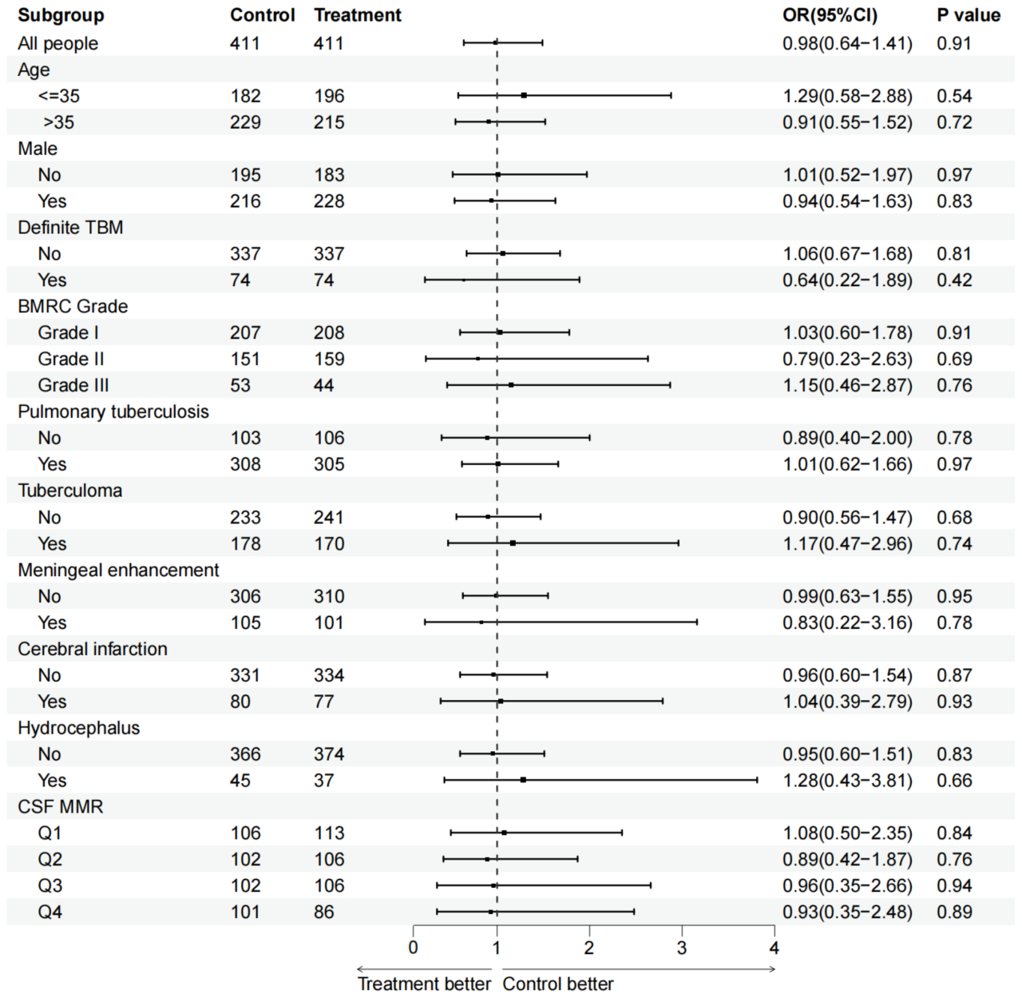
TBM, Tuberculous Meningitis; BMRC, British Medical Research Council;CSF,cerebrospinal Fluid; MMR, Multinuclear-Mononuclear cell ratio

Figure S3. Forestplot for other subgroup difference in dexamethasone treatment for poor functional outcome

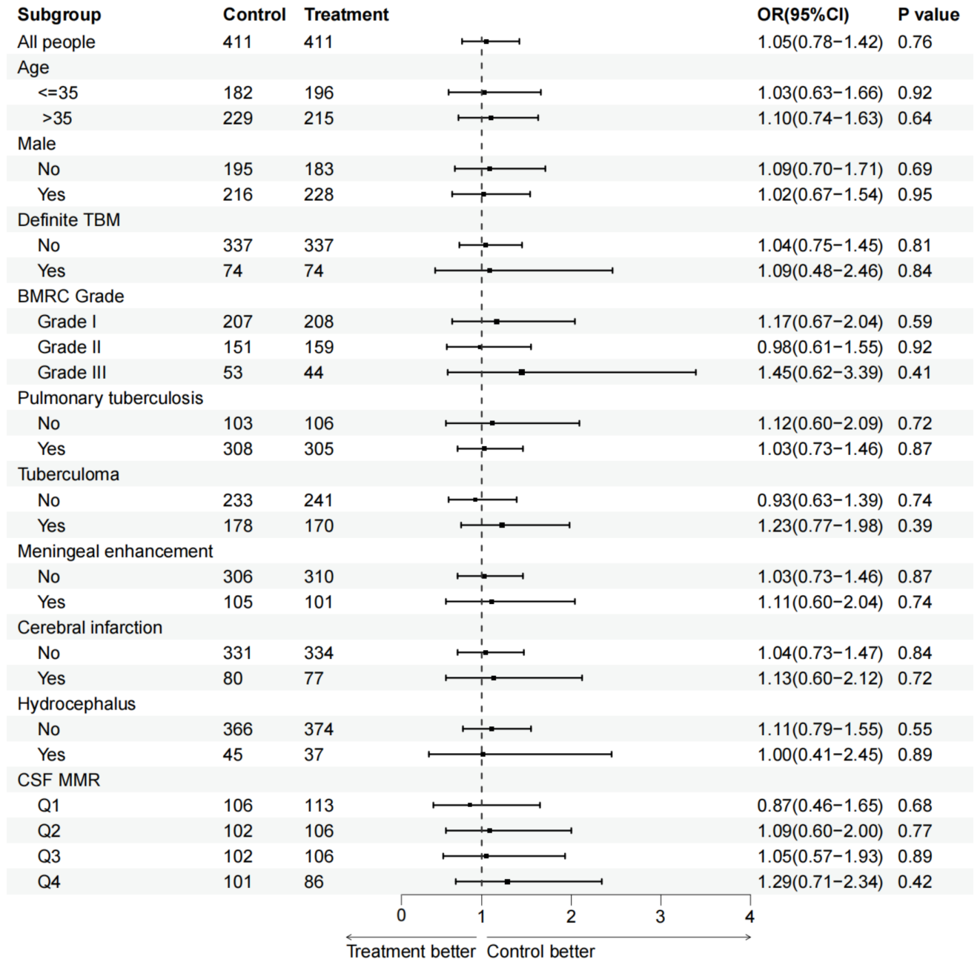
TBM, Tuberculous Meningitis; BMRC, British Medical Research Council;CSF,cerebrospinal Fluid; MMR, Multinuclear-Mononuclear cell ratio

Table S5. The Effect of dexamethasone on clinical outcomes in baseline NLR category accoring to severity stratification

Events | BMRC  Grade II-III | NLR baseline | No. of  Subjects | No. of  Events (%) | OR  (95%CI) | P value
Early neurological deterioration | Yes (n=407) | Q1 | 70 | 2(2.9) | 1.08(0.34-2.84) | 0.982
 |  | Q2 | 117 | 10(8.5) | 1.11(0.50-2.43) | 0.805
 |  | Q3 | 111 | 11(9.9) | 0.85(0.36-2.02) | 0.711
 |  | Q4 | 109 | 13(11.9) | 0.65(0.24-1.92) | 0.594
 | No (n=415) | Q1 | 115 | 10(8.7) | 1.85(0.62-6.26) | 0.248
 |  | Q2 | 130 | 19(14.6) | 1.72(0.58-5.89) | 0.204
 |  | Q3 | 94 | 16(17.0) | 1.06(0.35-3.26) | 0.686
 |  | Q4 | 76 | 16(21.0) | 0.88(0.26-2.36) | 0.657
Poor functional outcome | Yes (n=407) | Q1 | 70 | 13(18.5) | 1.25(0.49-2.89) | 0.637
 |  | Q2 | 111 | 43(38.7) | 1.15(0.54-2.47) | 0.720
 |  | Q3 | 109 | 50(45.9) | 0.89(0.37-2.11) | 0.580
 |  | Q4 | 117 | 70(59.8) | 0.82(0.36-2.01) | 0.507
 | No (n=415) | Q1 | 130 | 8(6.2) | 1.66(0.59-4.59) | 0.964
 |  | Q2 | 115 | 14(12.2) | 1.25(0.42-3.67) | 0.330
 |  | Q3 | 94 | 19(20.2) | 0.97(0.23-4.05) | 0.862
 |  | Q4 | 76 | 17(22.3) | 0.91(0.29-2.77) | 0.691
NLR, neutrophil-lymphocyte-ratio; BMRC, British Medical Research Council

Table S6. The Effect of dexamethasone on clinical outcomes in NLR change category accoring to severity stratification
Events | BMRC  Grade II-III | NLR change | No. of  Subjects | No. of  Events (%) | OR  (95%CI) | P value
Early neurological deterioration | Yes (n=407) | Q1 | 88 | 8(9.1) | 1.09(0.46-2.69) | 0.726
 |  | Q2 | 118 | 6(5.1) | 1.11(0.22-5.75) | 0.898
 |  | Q3 | 109 | 10(9.2) | 1.03(0.39-3.85) | 0.648
 |  | Q4 | 92 | 12(13.0) | 0.84(0.26-3.46) | 0.627
 | No (n=415) | Q1 | 101 | 7(6.9) | 1.57(0.41-5.96) | 0.507
 |  | Q2 | 96 | 10(10.4) | 1.10(0.46-2.67) | 0.822
 |  | Q3 | 116 | 17(14.6) | 0.80(0.29-2.25) | 0.677
 |  | Q4 | 102 | 27(26.5) | 0.78(0.17-3.69) | 0.757
Poor functional outcome | Yes (n=407) | Q1 | 88 | 31(35.2) | 1.52(0.66-3.51) | 0.328
 |  | Q2 | 118 | 43(36.4) | 1.14(0.53-2.43) | 0.741
 |  | Q3 | 109 | 47(43.1) | 0.81(0.38-1.73) | 0.590
 |  | Q4 | 92 | 55(59.8) | 0.65(0.27-1.57) | 0.339
 | No (n=415) | Q1 | 96 | 8(8.3) | 1.00(0.24-4.25) | 1.000
 |  | Q2 | 116 | 11(9.5) | 1.03(0.33-3.94) | 0.844
 |  | Q3 | 101 | 15(14.9) | 0.95(0.42-3.77) | 0.686
 |  | Q4 | 102 | 24(23.5) | 0.88(0.49-3.11) | 0.641

NLR, neutrophil-lymphocyte-ratio; BMRC, British Medical Research Council

Table S7. The Effect of dexamethasone on clinical outcomes in NLR ratio category accoring to severity stratification
Events | BMRC  Grade II-III | NLR  ratio | No. of  Subjects | No. of  Events (%) | OR  (95%CI) | P value
Early neurological deterioration | Yes (n=407) | Q1 | 100 | 4(4.0) | 1.33(0.51-3.43) | 0.556
 |  | Q2 | 92 | 6(6.5) | 1.12(0.45-2.80) | 0.815
 |  | Q3 | 115 | 10(8.7) | 0.93(0.57-2.06) | 0.539
 |  | Q4 | 100 | 16(16.0) | 0.86(0.41-1.99) | 0.603
 | No (n=415) | Q1 | 113 | 11(9.7) | 1.15(0.33-4.02) | 0.822
 |  | Q2 | 79 | 10(12.7) | 1.14(0.47-2.78) | 0.779
 |  | Q3 | 114 | 15(13.2) | 1.03(0.27-3.88) | 0.966
 |  | Q4 | 109 | 25(22.9) | 0.96(0.29-2.55) | 0.782
Poor functional outcome | Yes (n=407) | Q1 | 100 | 21(21.0) | 1.39(0.61-3.19) | 0.425
 |  | Q2 | 92 | 33(35.9) | 1.10(0.47-2.58) | 0.828
 |  | Q3 | 115 | 57(49.6) | 0.89(0.43-1.87) | 0.772
 |  | Q4 | 100 | 65(65.0) | 0.66(0.25-1.74) | 0.403
 | No (n=415) | Q1 | 114 | 5(4.4) | 1.46(0.46-4.69) | 0.523
 |  | Q2 | 113 | 19(16.8) | 1.31(0.49-3.46) | 0.590
 |  | Q3 | 79 | 14(17.7) | 1.06(0.39-2.86) | 0.901
 |  | Q4 | 109 | 20(18.3) | 0.87(0.11-4.07) | 0.650

NLR, neutrophil-lymphocyte-ratio; BMRC, British Medical Research Council

