Appendix Table 1 Effects of different emulsifiers on particle size and stability of ALO-NLC
(Mean±SD, n=3)
Formula | Types of emulsifiers | Mass of each component (mg) | PDI | Average particle size (nm) | Stability at 4°C
1 | SPC/Polyoxyethylene castor oil/SDC | 75/225/45 | 0.23±0.03 | 408.63±24.14 | Adhesions on the wall after 7 days
2 | SPC/DSPE-MPEG 2000/SDC | 75/225/45 | 0.27±0.04 | 374.57±18.72 | Sedimentation after 5 days
3 | SPC/P188/SDC | 75/225/45 | 0.26±0.02 | 448.03±53.46 | Sedimentation after 3 days

Appendix Table 2 Effect of different emulsifier composition on particle size and stability of ALO-NLC (Mean±SD, n=3)
Formula | SPC：SDC  mass ratio | PDI | Average particle size(nm) | Stability at 4°C
1 | 3：7 | 0.24±0.07 | 238.70±62.19 | Precipitation at the bottom after overnight
2 | 5：5 | 0.25±0.04 | 408.63±34.79 | Precipitation at the bottom after overnight
3 | 6：4 | 0.24±0.01 | 527.20±36.21 | Adhesions appeared on the wall after 3 days
4 | 7：3 | 0.28±0.01 | 511.37±100.94 | Adhesions appeared on the wall after 3 days
5 | 8：2 | 0.27±0.01 | 519.60±3.46 | Adhesions appeared on the wall after 3 days

Appendix Table 3 Effect of different stirring time on particle size and stability of ALO-NLC
(Mean±SD, n=3)
Formula | Stirring time (h) | PDI | Average particle size (nm) | Stability at 4°C
1 | 2 | 0.23±0.01 | 432.90±11.31 | Adhesions appeared on the wall after 3 days
2 | 4 | 0.28±0.02 | 427.70±39.03 | Adhesions appeared on the wall after 3 days
3 | 6 | 0.23±0.03 | 408.63±24.14 | Adhesions appeared on the wall after 3 days
4 | 8 | 0.29±0.03 | 459.20±33.48 | Adhesions appeared on the wall after 3 days
5 | 24 | 0.18±0.02 | 497.93±6.13 | No adhesions seen after 3 days
Appendix Table 4 Effect of different amounts of main drug on particle size and stability of ALO-NLC (Mean±SD, n=3)
Formula | Quantity of main drug (mg) | PDI | Average particle size (nm) | Stability at 4°C
1 | 5 | 0.30±0.03 | 446.10±42.92 | Sedimentation after overnight
2 | 10 | 0.18±0.02 | 497.90±6.13 | Sedimentation after 4 days
3 | 15 | 0.13±0.07 | 501.47±46.03 | No sedimentation after 4 days
4 | 20 | 0.24±0.03 | 441.67±62.06 | No sedimentation after 4 days
5 | 25 | 0.30±0.00 | 480.20±25.66 | Sedimentation after 4 days
6 | 30 | 0.20±0.04 | 354.33±63.23 | Sedimentation after 4 days

Appendix Table 5 Effects of different amounts of organic solvents on the particle size and stability of ALO-NLC (Mean±SD, n=3)
Formula | Organic solvent usage (mL) | PDI | Average particle size (nm) | Stability at 4°C
1 | 0.5 | 0.18±0.04 | 451.43±97.28 | Adhesions appear on the walls overnight
2 | 0.8 | 0.32±0.03 | 403.17±37.29 | Flocculation after 3 days
3 | 1.0 | 0.25±0.03 | 463.97±37.29 | No precipitation and flocculation after 3 days
4 | 2.0 | 0.20±0.04 | 354.33±63.23 | Sedimentation after overnight

Appendix Table 6 Effect of different emulsifier dosage on particle size, encapsulation rat and stability of ALO-NLC (Mean±SD, n=3)
Formula | Emulsifier dosage (%) | PDI | Average particle size (nm) | Encapsulation rate (%) | Stability at 4°C
1 | 3.0 | 0.11±0.08 | 368.67±9.00 | 49.42 | Adhesions appeared on the wall after 2 days
2 | 3.5 | 0.13±0.11 | 343.70±43.00 | 57.34 | Adhesions appeared on the wall after 2 days
3 | 4.0 | 0.10±0.01 | 204.40±7.37 | 14.51 | Adhesions appeared on the wall after 2 days

Appendix Table 7 Effect of different lipid dosage on particle size, encapsulation rat and stability of ALO-NLC (Mean±SD, n=3)
Formula | Lipid dosage (%) | PDI | Average particle size (nm) | Encapsulation rate (%) | Stability at 4°C
1 | 0.5 | 0.14±0.08 | 383.87±14.51 | 63.82 | Adhesions appeared on the wall after 4 days
2 | 1.0 | 0.13±0.11 | 343.70±43.00 | 57.34 | Adhesions appeared on the wall after 2 days
3 | 1.5 | 0.16±0.03 | 204.40±7.37 | 64.23 | Adhesions appeared on the wall after 2 days

Appendix Table 8 Effects of different stirring speeds on particle size, encapsulation rat and stability of ALO-NLC (Mean±SD, n=3)
Formula | Stirring speed  (rpm) | PDI | Average particle size (nm) | Encapsulation rate (%) | Stability at 4°C
1 | 800 | 0.09±0.09 | 394.87±6.73 | 67.99 | Adhesions appeared on the wall after 3 days
2 | 1200 | 0.16±0.05 | 456.17±41.95 | 64.19 | Adhesions appeared on the wall after 3 days
3 | 1500 | 0.16±0.12 | 469.70±82.89 | 68.77 | Adhesions appeared on the wall after 3 days
4 | 1600 | 0.27±0.01 | 387.27±19.32 | 65.32 | Adhesions appeared on the wall after 2 days

Appendix Table 9 Effect of different ultrasonic time on particle size, encapsulation rat and stability of ALO-NLC (Mean±SD, n=3)
Formula | Ultrasound time (min) | PDI | Average particle size (nm) | Encapsulation rate (%) | Stability at 4°C
1 | 1 | 0.14±0.10 | 463.43±97.47 | 66.37 | Stratification after 3 days
2 | 2 | 0.42±0.08 | 456.80±14.64 | 66.77 | Stratification after 3 days
3 | 5 | 0.26±0.02 | 441.53±56.30 | 66.26 | Stratification after 5 days

Appendix Table 10 Effect of different ultrasonic power on particle size, encapsulation rat and stability of ALO-NLC (Mean±SD, n=3)
Formula | Ultrasonic power (W) | PDI | Average particle size (nm) | Encapsulation rate (%) | Stability at 4°C
1 | 100 | 0.16±0.11 | 487.23±60.10 | 66.57 | Stratification after 3 days
2 | 200 | 0.26±0.02 | 441.53±56.30 | 66.26 | Stratification after 5days
3 | 400 | 0.31±0.04 | 455.60±24.78 | 61.91 | Stratification after 3 days

Appendix Table 11 Effect of organic solvent types on particle size, encapsulation rat and stability of ALO-NLC (Mean±SD, n=3)
Formula | Organic solvent composition | Dosage (mL) | PDI | Average particle size (nm) | Encapsulation rate (%) | Stability at 4°C
1 | Methanol | 1 mL | 0.26±0.02 | 441.53±56.30 | 66.26 | Flocculation after 1 day
2 | Ethanol | 1 mL | 0.26±0.02 | 584.63±53.52 | 70.63 | Adhesions appeared on the wall after 4 days
3 | Methanol/Ethanol | 0.5 mL/0.5 mL | 0.28±0.04 | 656.43±12.23 | 69.14 | Adhesions appeared on the wall after 3 days
4 | Methanol/Trichloromethane | 0.5 mL/0.5 mL | 0.18±0.09 | 463.07±54.68 | 67.52 | Stratification after 1 day
5 | Ethanol/Trichloromethane | 0.5 mL/0.5 mL | 0.12±0.10 | 439.20±54.36 | 64.68 | Adhesions appeared on the wall after 2 days

Appendix Table 12 Effect of temperature on particle size, encapsulation rat and stability of ALO-NLC (Mean±SD, n=3)
Formula | Temperature | PDI | Average particle size (nm) | Encapsulation rate (%) | Stability at 4°C
1 | indoor temperature | 0.23±0.03 | 423.50±35.87 | 60.66 | No flocculation after 14 days
2 | 37℃ | 0.32±0.02 | 548.83±54.22 | 65.93 | No flocculation after 14 days
3 | 40℃ | 0.22±0.03 | 457.33±52.62 | 59.71 | Flocculation after 5 days

Appendix Table 13 Effect of different solid lipid dosage on particle size, encapsulation rat and stability of ALO-NLC (Mean±SD, n=3)
Formula | Solid lipid dosage (mg) | PDI | Average particle size (nm) | Encapsulation rate (%) | Stability at 4°C
1 | 1 | 0.23±0.03 | 423.50±35.87 | 60.66 | No flocculation after 14 days
2 | 2 | 0.27±0.01 | 449.57±39.91 | 64.97 | No flocculation after 14 days
3 | 3 | 0.30±0.02 | 484.80±67.42 | 65.35 | Flocculation after 2 day

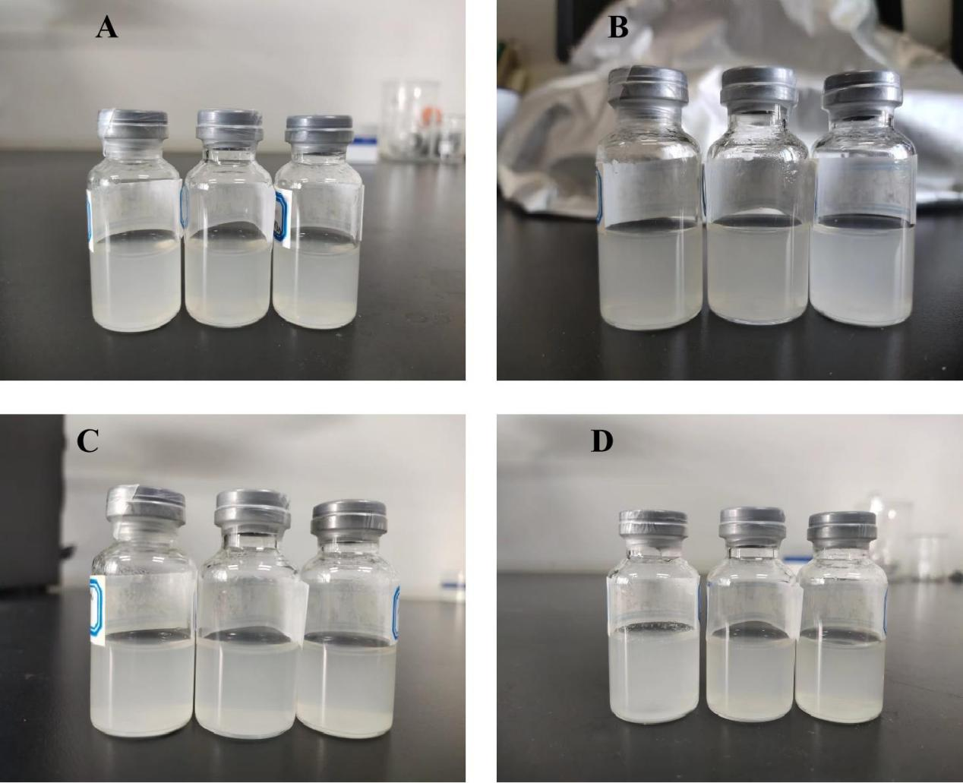
Appendix Figure 1 Appearance of ALO-NLC(A:0 days, 7days, 15 days, 30 days)

