Supplemental Tables
Table S1. Histopathologic scoring of tissue sample.
Variables | Scores
Variables | 0 | 1 | 2 | 3
Re-epithelialization | None | Partial | Complete but immature or thin | Complete and mature
Inflammation cell infiltration | None | Scant | Moderate | Abundant
Fibroblast proliferation | None | Scant | Moderate | Abundant
Neovascularization | None | Up to five vessels per HPF | 6-19 vessels per HPF | More than 10 vessels per HPF
Granulation tissue fibroblast maturation | Immature | Mild Maturation | Moderate Maturation | Fully Matured
HPF, high-power field

Table S2. Wound surface area of five experimental groups: SC, NC, VC, ST and CE. All data are given as mean ± S.E. for six animals in each group.
Groups | Wound surface area (mm)
Groups | Day 12 | Day 13 | Day 14 | Day 15 | Day 16 | Day 17 | Day 18
SC | 2.66 ± 0.96 | 0.94 ± 0.48 | 0.32 ± 0.32 | 0.19 ± 0.19 | 0.00 ± 0.00 | 0.00 ± 0.00 | 0.00 ± 0.00
NC | 8.63 ± 1.81 | 2.94 ± 1.00 | 1.64 ± 0.80 | 0.81 ± 0.48 | 0.30 ± 0.21 | 0.09 ± 0.09 | 0.00 ± 0.00
VC | 9.83 ± 1.83 | 5.78 ± 1.32 | 3.16 ± 0.91 | 1.27 ± 0.50 | 0.19 ± 0.19 | 0.00 ± 0.00 | 0.00 ± 0.00
ST | 12.37 ± 2.54 | 11.06 ± 2.66 | 7.05 ± 1.86 | 4.89 ± 1.38 | 1.92 ± 0.71 | 0.91 ± 0.48 | 0.36 ± 0.25
CE | 0.00 ± 0.00 | 0.00 ± 0.00 | 0.00 ± 0.00 | 0.00 ± 0.00 | 0.00 ± 0.00 | 0.00 ± 0.00 | 0.00 ± 0.00

Table S3. Mean value of different serum biomarkers level such as AST, ALT, TC and TG of five experimental groups: SC, NC, VC, ST and CE. All data are given as mean ± S.E. for three animals in each group each day. Statistically significant results are indicated as (ª) p < 0.001, SC versus NC, VC, ST and CE on the corresponding day; (^{b}) p < 0.01, SC versus NC; p < 0.0001, SC versus VC and ST on the corresponding day; (^{c}) ) p < 0.01, SC versus NC and VC; p < 0.05, SC versus ST and CE on the corresponding day; (^{d}) p ≤ 0.01, SC versus NC, VC, ST and CE on the corresponding day; (^{e}) p < 0.0001, SC versus NC, VC, ST and CE on the corresponding day; (^{f}) p < 0.0001, SC versus NC, VC, ST and CE on the corresponding day; (^{g}) p < 0.0001, SC versus NC, VC, ST and CE on the corresponding day; and (^{h}) p < 0.0001, SC versus NC, VC, ST and CE on the corresponding day. SC: non-diabetic sham control, NC: diabetic negative control (without treatment), VC: diabetic vehicle control, ST: treated with povidone-iodine as standard treatment, CE: treated group with CZ extract, AST: aspartate aminotransferase, ALT: alanine transaminase, TC: total cholesterol, and TG: triglyceride.
Groups | AST (U/L) |  | ALT (U/L) |  | TC (mg/dL) |  | TC (mg/dL)
Groups | Day 3 | Day 9 | Day 3 | Day 9 | Day 3 | Day 9 | Day 3 | Day 9
SC | 270.67 ± 19.55ª | 310.33 ± 9.35 ^{b} | 45.00 ± 3.06 ^{c} | 46.00 ± 3.46 ^{d} | 70.67 ± 4.48 e | 74.67 ± 3.34 ^{f} | 98.33 ± 1.45 ^{g} | 99.00 ± 1.73 ^{h}
NC | 596.33 ± 52.39 | 564.33 ± 54.27 | 226.67 ± 25.44 | 197.33 ± 36.32 | 137.63 ± 4.95 | 131.30 ± 3.58 | 202.27 ± 2.54 | 209.87 ± 2.60
VC | 616.33 ± 39.86 | 716.67 ± 15.60 | 221.00 ± 40.20 | 215.67 ± 31.59 | 136.20 ± 4.52 | 138.37 ± 3.25 | 206.07 ± 2.60 | 198.97 ± 5.49
ST | 627.00 ± 45.24 | 682.67 ± 54.33 | 198.00 ± 29.09 | 224.67 ± 2.40 | 130.07 ± 3.62 | 134.50 ± 2.65 | 201.23 ± 3.38 | 200.97 ± 2.02
CE | 666.00 ± 28.75 | 478.00 ± 41.58 | 199.33 ± 28.88 | 256.00 ± 31.63 | 131.00 ± 2.65 | 130.33 ± 2.03 | 218.87 ± 17.07 | 200.80 ± 2.32

Supplemental Figures
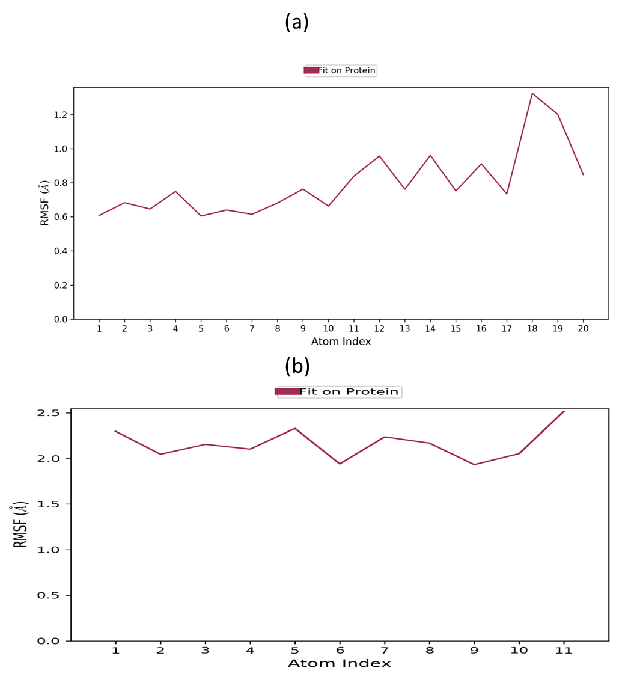
Figure S1. Trajectory plots of molecular dynamics (MD) of target protein-drug complex. Protein-root mean square fluctuation (P-RMSF) with respect to atom index during MD simulation of MMP8 complexed with xanthosine (a) and MMP9 complexed with methylquinoline (b) to figure 5.
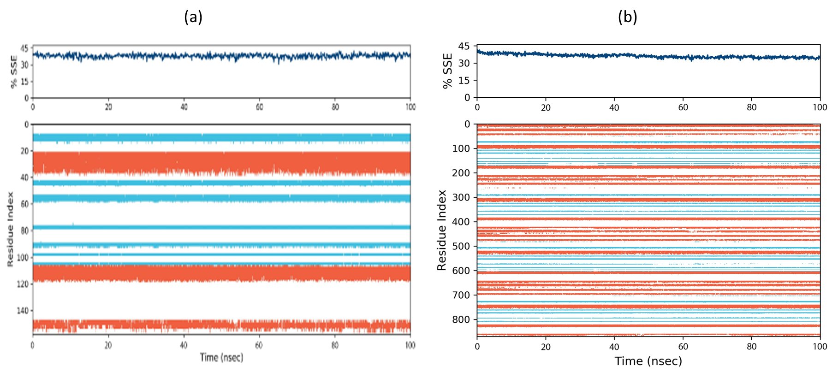
Figure S2. Protein secondary structure elements (SSE) such as alpha-helices and beta-strands are monitored throughout the simulation periods of MMP8 (a) and MMP9 (b).

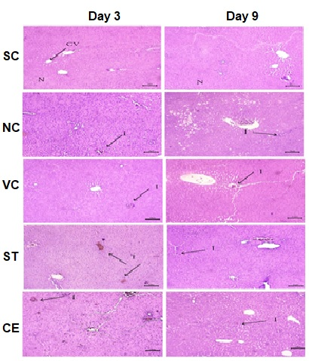
Figure S3. Histopathological view of liver tissue on post-wounded day 3 and day 9 by hematoxylin and eosin (H&E) staining of five experimental groups: SC, NC, VC, ST and CE. Pictures of stain are at 10x magnification. SC: non-diabetic sham control, NC: diabetic negative control (without treatment), VC: diabetic vehicle control, ST: treated with povidone-iodine as standard treatment, CE: treated group with CZ extract, CV: central vein, H: hepatocytes, I: inflammation, and N: normal liver structure. Bar scale: 100 µm.

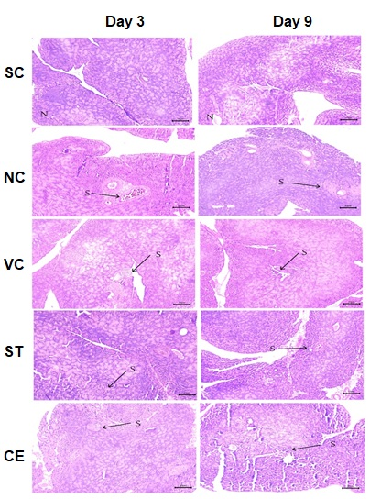
Figure S4. Histopathological view of pancreas tissue on post-wounded day 3 and day 9 by hematoxylin and eosin (H&E) staining of five experimental groups: SC, NC, VC, ST and CE. Pictures of stain are at 10x magnification. SC: non-diabetic sham control, NC: diabetic negative control (without treatment), VC: diabetic vehicle control, ST: treated with povidone-iodine as standard treatment, CE: treated group with CZ extract, N: normal pancreatic structure, and S: shrinkage of islets on Langerhans with degeneration. Bar scale: 100 µm.

