Supplementary Material

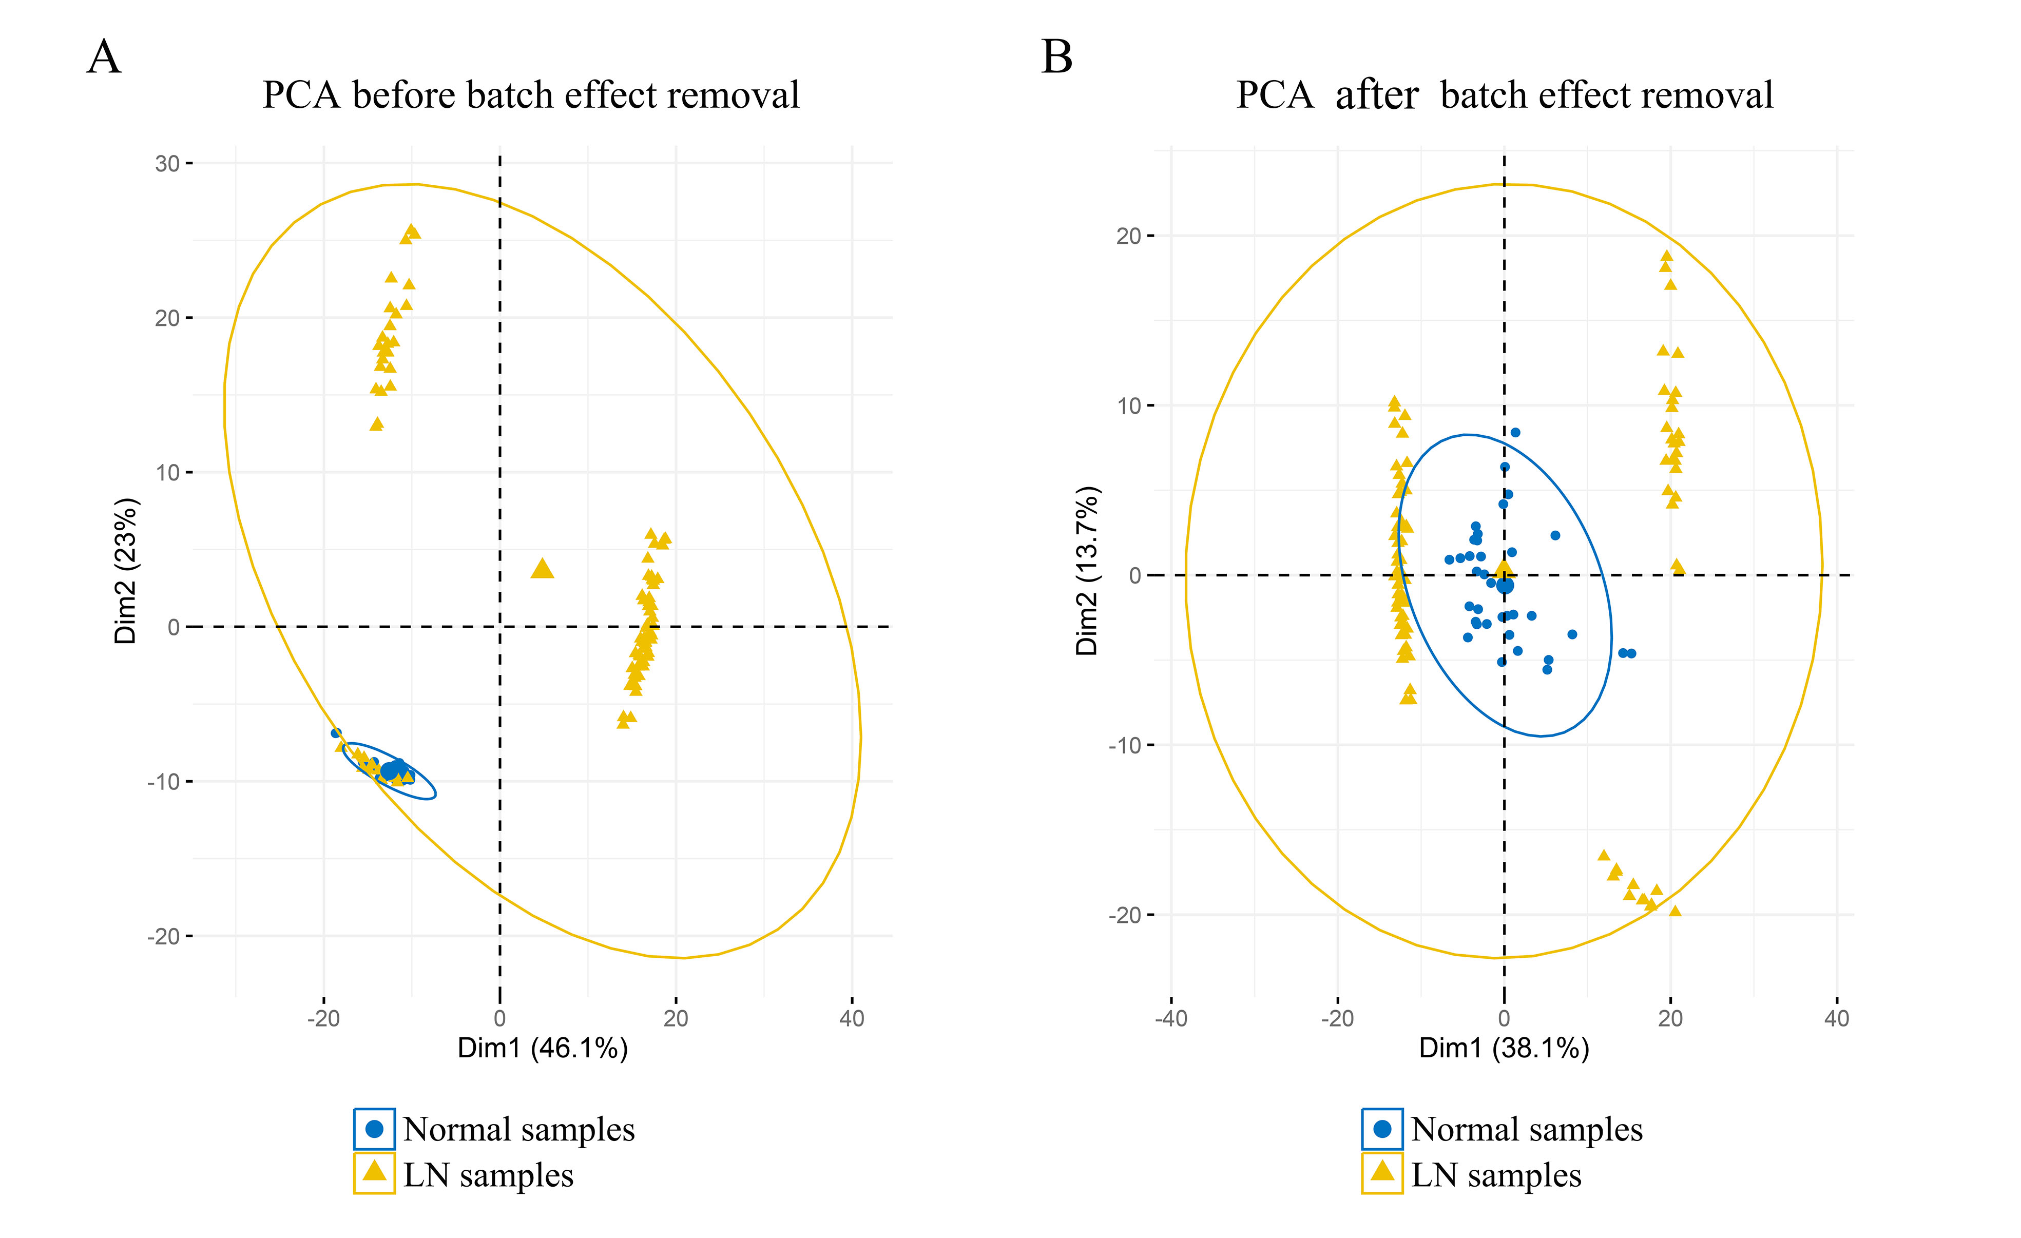
Figure1. The principal component analysis (PCA) showing the distribution of samples in patients with lupus nephritis and normal controls. (A) PCA before batch effect removal. (B) PCA after batch effect removal.
Figure2. Venn diagram of the intersection of candidate diagnostic genes screened through LASSO and SVM-RFE.

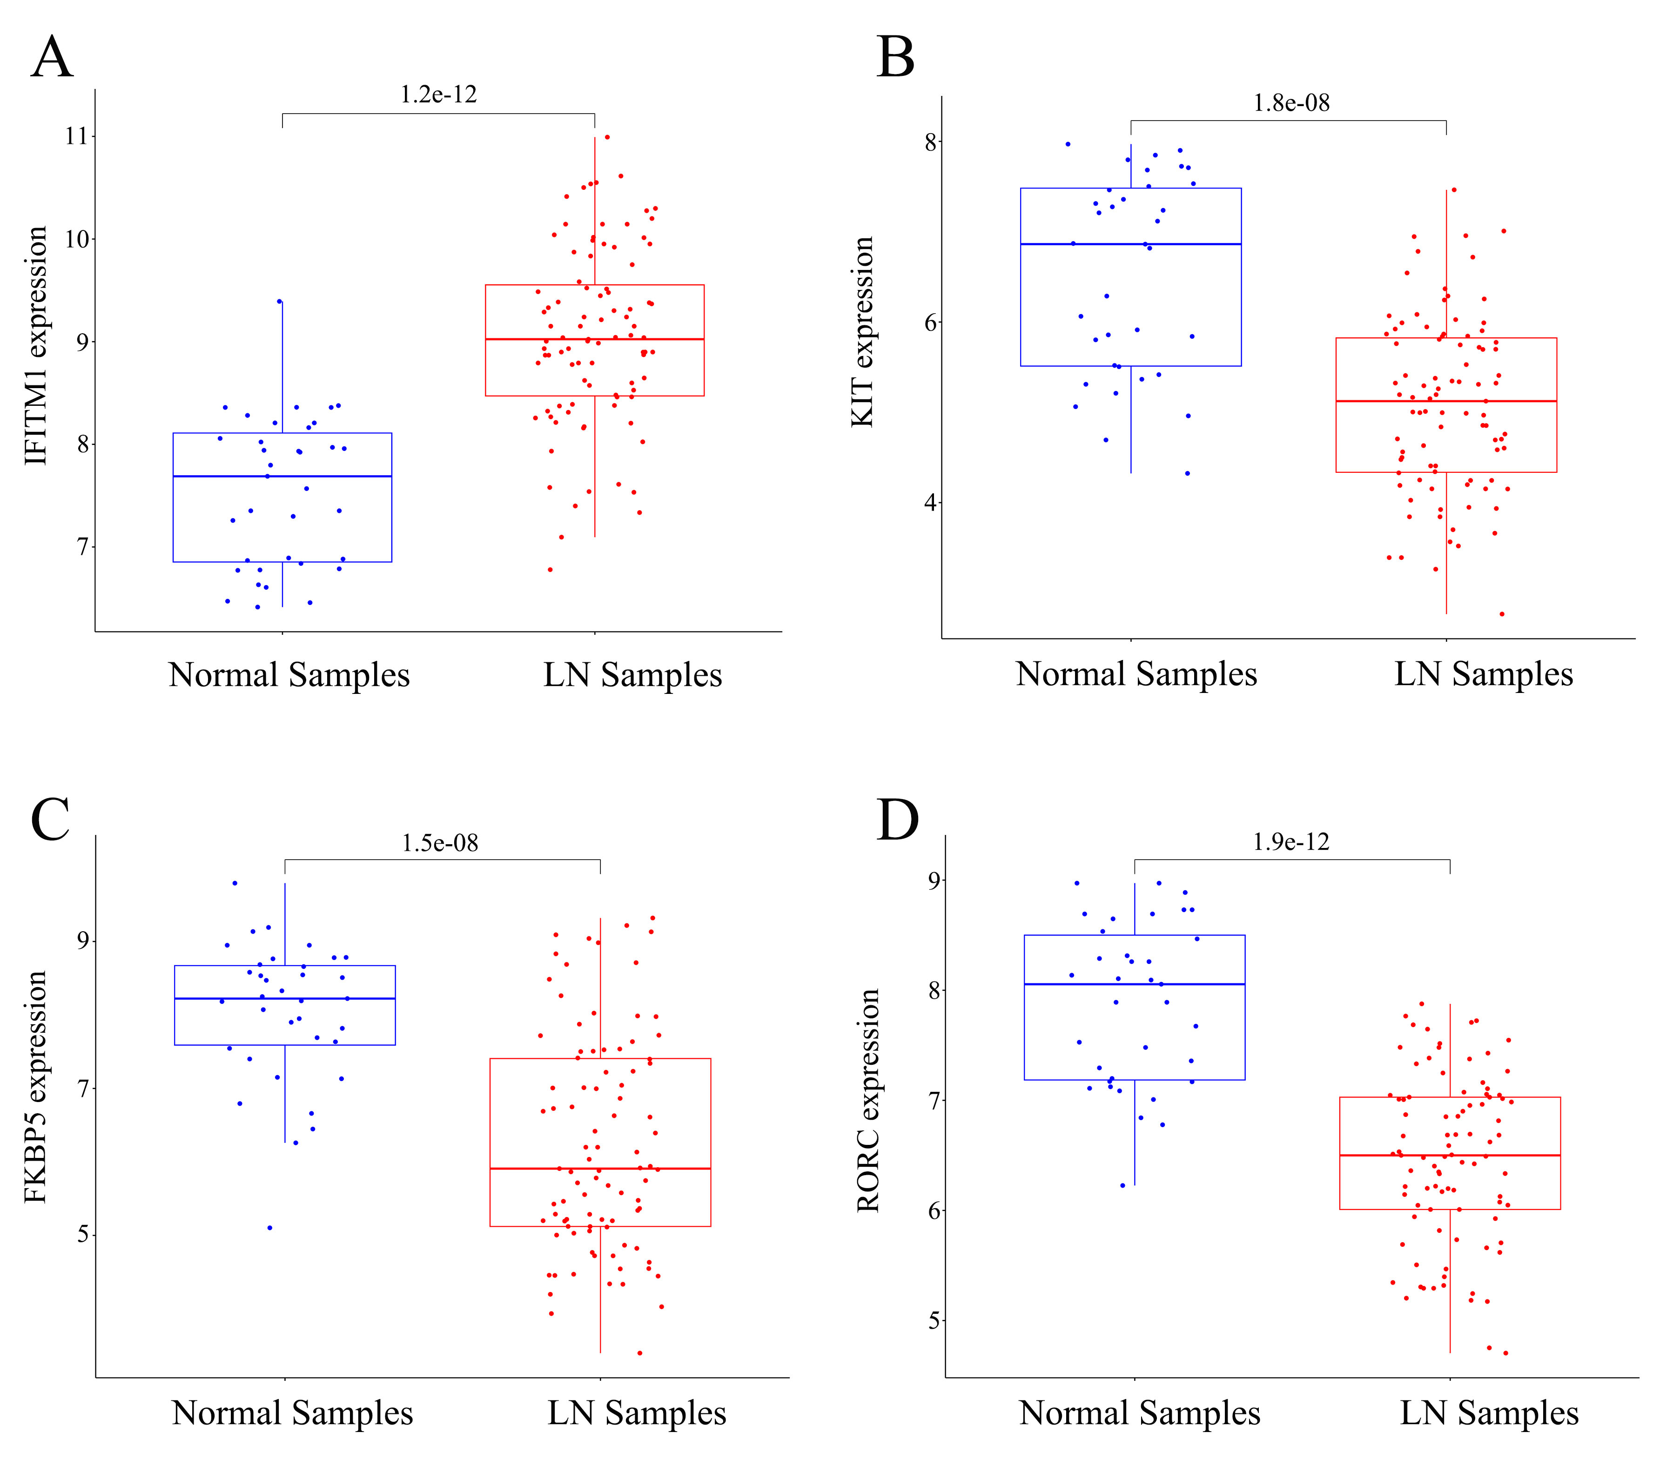
Figure3. The feature genes were differentially expressed in healthy and LN specimens.(A) IFITM1 expression was distinctly upregulated in LN samples.(B) KIT expression was distinctly downregulated in LN samples. (C) FKBP5 expression was distinctly downregulated in LN samples. (D) RORC expression were distinctly downregulated in LN samples.
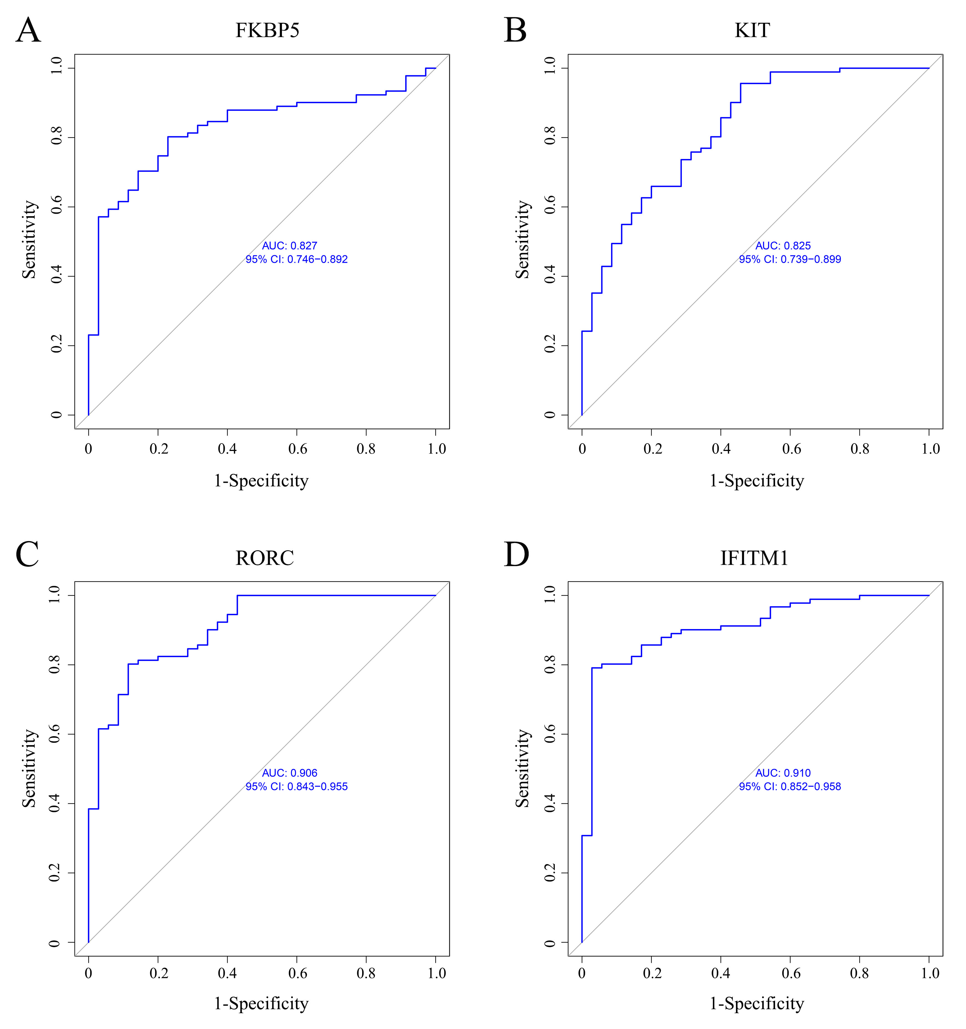
Figure4. The receiver operating characteristic (ROC) curve of the diagnostic values of the feature genes. (A) ROC assays for FKBP5 in LN.(B) ROC assays for KIT in LN. (C) ROC assays for RORC in LN. (D) ROC assays for IFITM1 in LN.

