Table S1：RT-PCR primer sequence list
Primers | Sequences
UBE2D1 F | AGCGGATCCAGAAAGTGAGTG
UBE2D1 R | TAATTCCTGTGCGGGCCGAT
WDR26 F | TAGGACAGCACCTCAATGGC
WDR26 R | TTCCCAACAACGTTTGAGAGAT
Endosome M-GAPDH F | CCTTCCGTGTTCCTACCCC
Endosome M-GAPDH R | GCCCAAGATGCCCTTCAGT

Table S2：Inverse MR analysis results
gene | id.exposure | id.outcome | outcome | exposure | method | nsnp | b | se | pval | lo_ci | up_ci | or | or_lci95 | or_uci95
WDR26 | ieu-b-4980 | eqtl-a-ENSG00000162923 | ENSG00000162923 || id:eqtl-a-ENSG00000162923 | || id:ieu-b-4980 | MR Egger | 5 | -0.063106059 | 0.285961257 | 0.839507007 | -0.623590124 | 0.497378005 | 0.938843895 | 0.536016613 | 1.644403995
WDR26 | ieu-b-4980 | eqtl-a-ENSG00000162923 | ENSG00000162923 || id:eqtl-a-ENSG00000162923 | || id:ieu-b-4980 | Weighted median | 5 | 0.003188382 | 0.125622363 | 0.979751318 | -0.243031451 | 0.249408214 | 1.00319347 | 0.784246848 | 1.283265773
WDR26 | ieu-b-4980 | eqtl-a-ENSG00000162923 | ENSG00000162923 || id:eqtl-a-ENSG00000162923 | || id:ieu-b-4980 | Inverse variance weighted | 5 | 0.011841131 | 0.096089007 | 0.90192429 | -0.176493322 | 0.200175584 | 1.011911515 | 0.838204376 | 1.221617236
WDR26 | ieu-b-4980 | eqtl-a-ENSG00000162923 | ENSG00000162923 || id:eqtl-a-ENSG00000162923 | || id:ieu-b-4980 | Simple mode | 5 | -0.071696182 | 0.165556054 | 0.687298303 | -0.396186047 | 0.252793683 | 0.93081365 | 0.672881496 | 1.287617591
WDR26 | ieu-b-4980 | eqtl-a-ENSG00000162923 | ENSG00000162923 || id:eqtl-a-ENSG00000162923 | || id:ieu-b-4980 | Weighted mode | 5 | -0.028122098 | 0.151617112 | 0.861877357 | -0.325291638 | 0.269047441 | 0.972269647 | 0.722316668 | 1.308717227
UBE2D1 | ieu-b-4980 | eqtl-a-ENSG00000072401 | ENSG00000072401 || id:eqtl-a-ENSG00000072401 | || id:ieu-b-4980 | MR Egger | 5 | -0.041031745 | 0.280466082 | 0.89296352 | -0.590745267 | 0.508681776 | 0.95979866 | 0.553914317 | 1.663097414
UBE2D1 | ieu-b-4980 | eqtl-a-ENSG00000072401 | ENSG00000072401 || id:eqtl-a-ENSG00000072401 | || id:ieu-b-4980 | Weighted median | 5 | -0.056596679 | 0.115042836 | 0.622746361 | -0.282080637 | 0.16888728 | 0.944975121 | 0.754212865 | 1.183986672
UBE2D1 | ieu-b-4980 | eqtl-a-ENSG00000072401 | ENSG00000072401 || id:eqtl-a-ENSG00000072401 | || id:ieu-b-4980 | Inverse variance weighted | 5 | -0.048245269 | 0.096090574 | 0.615610416 | -0.236582793 | 0.140092255 | 0.952900042 | 0.789320529 | 1.150379923
UBE2D1 | ieu-b-4980 | eqtl-a-ENSG00000072401 | ENSG00000072401 || id:eqtl-a-ENSG00000072401 | || id:ieu-b-4980 | Simple mode | 5 | -0.067982929 | 0.137641866 | 0.647261023 | -0.337760985 | 0.201795128 | 0.934276423 | 0.713365772 | 1.223597302
UBE2D1 | ieu-b-4980 | eqtl-a-ENSG00000072401 | ENSG00000072401 || id:eqtl-a-ENSG00000072401 | || id:ieu-b-4980 | Weighted mode | 5 | -0.060075061 | 0.137053783 | 0.683778987 | -0.328700475 | 0.208550353 | 0.941693846 | 0.7198586 | 1.231890957

Table S3：The heterogeneity test
gene name | id.exposure | id.outcome | outcome | exposure | method | Q | Q_df | Q_pval
WDR26 | ieu-b-4980 | eqtl-a-ENSG00000162923 | ENSG00000162923 || id:eqtl-a-ENSG00000162923 | || id:ieu-b-4980 | MR Egger | 3.118702634 | 3 | 0.373683184
WDR26 | ieu-b-4980 | eqtl-a-ENSG00000162923 | ENSG00000162923 || id:eqtl-a-ENSG00000162923 | || id:ieu-b-4980 | Inverse variance weighted | 3.199607408 | 4 | 0.524994359
UBE2D1 | ieu-b-4980 | eqtl-a-ENSG00000072401 | ENSG00000072401 || id:eqtl-a-ENSG00000072401 | || id:ieu-b-4980 | MR Egger | 0.197732899 | 3 | 0.977954453
UBE2D1 | ieu-b-4980 | eqtl-a-ENSG00000072401 | ENSG00000072401 || id:eqtl-a-ENSG00000072401 | || id:ieu-b-4980 | Inverse variance weighted | 0.198482381 | 4 | 0.995389585

Table S4: The horizontal pleiotropy test
gene name | id.exposure | id.outcome | outcome | exposure | egger_intercept | se | pval
WDR26 | ieu-b-4980 | eqtl-a-ENSG00000162923 | ENSG00000162923 || id:eqtl-a-ENSG00000162923 | || id:ieu-b-4980 | 0.006001257 | 0.021512037 | 0.798392032
UBE2D1 | ieu-b-4980 | eqtl-a-ENSG00000072401 | ENSG00000072401 || id:eqtl-a-ENSG00000072401 | || id:ieu-b-4980 | -0.000577615 | 0.02109881 | 0.979878616

Figure S1: Flowchart of the study.
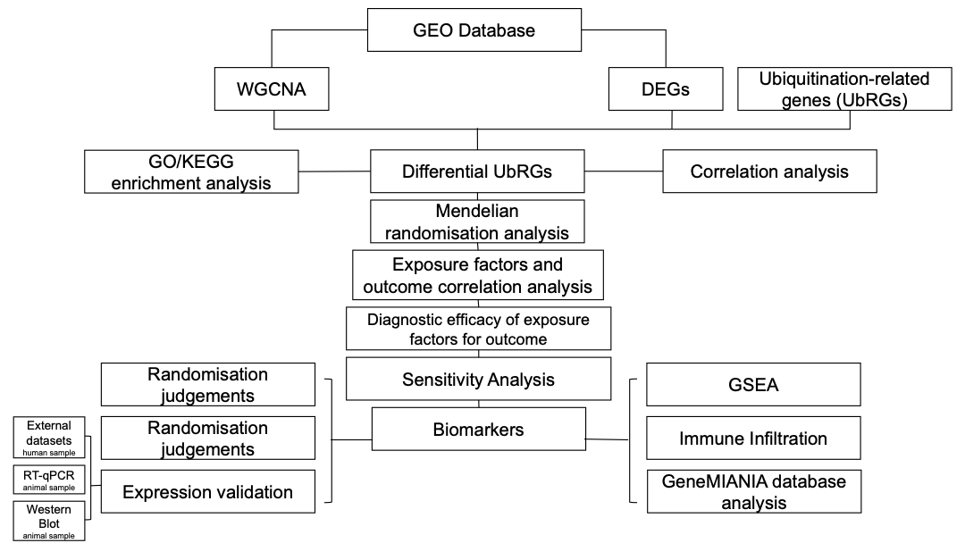

Figure S2 Scatterplot of inverse Mendelian randomisation analysis.
Each dot represented an SNP locus, with the horizontal coordinate indicating the effect of SNP on exposure and the vertical coordinate representing the effect of SNP on outcome. The coloured lines demonstrated the results of fitting different algorithms for MR. A positive slope of the line signified a risk factor, while a negative slope indicated a safety factor. When an intercept was present, it implied confounding.
Figure S3 Forest plot for reverse Mendelian randomisation analysis.
The solid dots on the left were safety factors and the solid dots on the right were risk factors.

Figure S4 Mendelian randomisation analysis funnel plot.
The samples were symmetrically distributed along both sides of the IVW line, indicating that the MR satisfied Mendel's second law of random grouping.

Figure S5: Inverse Mendelian randomisation analysis leave-one-out method.

