Supplementary Table 1. Multivariate linear regression analysis for the independent associations among PrFT, MHR, and UA.
Independent  variables | Dependent  variables | Model 1 |  | Model 2 |  | Model 3
Independent  variables | Dependent  variables | β | P | β | P | β | P
PrFT | UA | 0.419 | <0.001 | 0.329 | <0.001 | 0.251 | <0.001
MHR | UA | 0.340 | <0.001 | 0.193 | 0.002 | 0.181 | <0.001
MHR | PrFT | 0.355 | <0.001 | 0.176 | <0.001 | 0.164 | <0.001
Model 1: adjusted for age, diabetic duration, smoking, drinking, and hypertension.
Model 2: adjusted for body mass index, waist circumference, glycated hemoglobin A1c, alanine aminotransferase, creatinine, triglyceride, total cholesterol, low-density lipoprotein cholesterol, and homeostasis model assessment insulin resistance.
Model 3: additionally adjusted for visceral fat area and subcutaneous fat area.
MHR: monocyte to high-density lipoprotein cholesterol ratio. PrFT: perirenal fat thickness. UA: uric acid.

Supplementary Figure 1: Weighted binomial logistic regression analysis for the correlation of HUA risk with PrFT (A) and MHR (B) in three models. MHR: monocyte to high-density lipoprotein cholesterol ratio. PrFT: perirenal fat thickness. HUA: hyperuricemia.

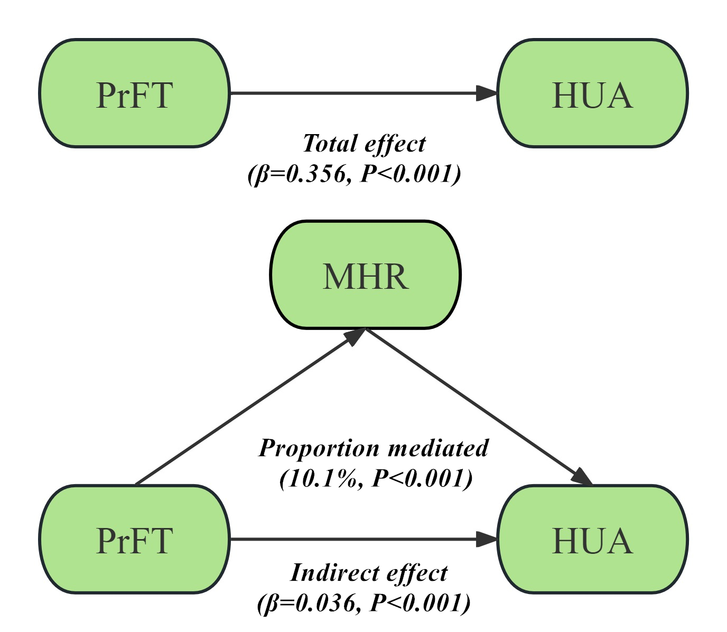

Supplementary Figure 2: Structural model for the mediating role of MHR in the association between PrFT and HUA in women after adjusting for Model 3. MHR: monocyte to high-density lipoprotein cholesterol ratio. PrFT: perirenal fat thickness. HUA: hyperuricemia.

