Supplementary data
Figure S1 Results of the UPLC-MS/MS analysis of the JDNWF.
Abbreviation: JDNWF, Jieduan-Niwan formula.
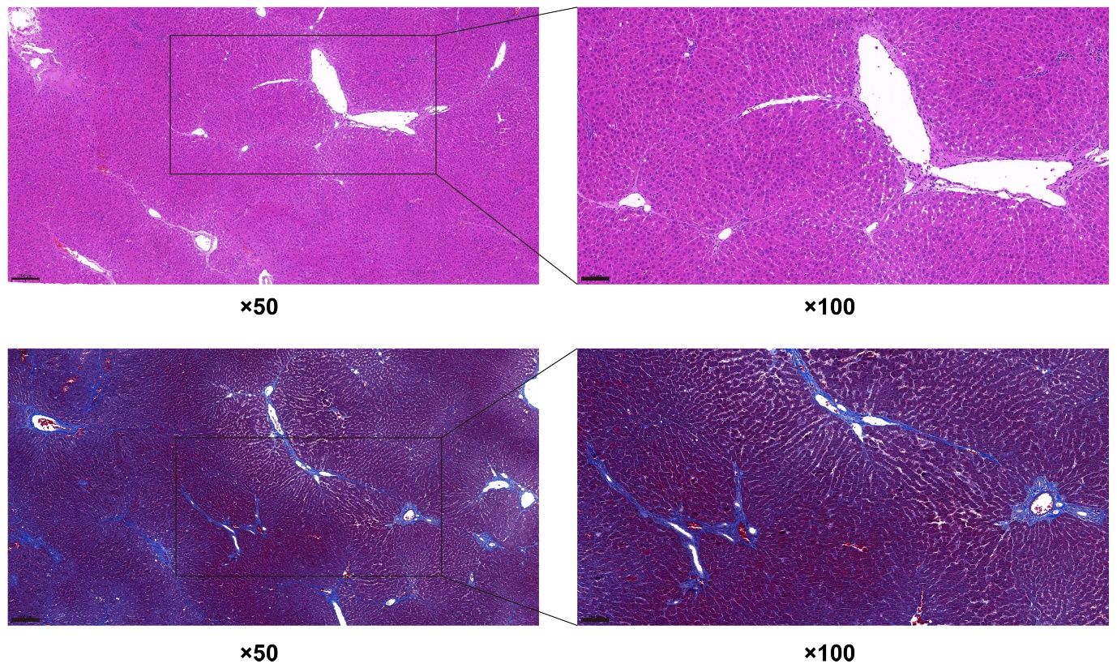
Figure S2 HE and MT staining of liver biopsy of the treatment groups (magnification, ×50 and ×100; scale bar=200 and 100 µm).
Abbreviations: HE staining, hematoxylin and eosin staining; MT staining, masson's trichrome staining.
Figure S3 QQ plots were used to test the normality of experimental data.
Abbreviations: ACLF, acute-on-chronic liver failure; HMGB1, High mobility group box-1; JDNWF, Jieduan-Niwan formula; ALT, alanine aminotransferase; AST, aspartate aminotransferase; TBIL, total bilirubin; ALB, albumin; PT, prothrombin time; INR, international normalized ratio; IL-1β, interleukin-1 β; IL-18, interleukin-18; TNF-α, tumor necrosis factor-α; IL-6, interleukin-6; TLR4, Toll-like receptor 4; RAGE, receptor for advanced glycation end-products; GSDMD, Gasdermin D; LDH, lactate dehydrogenase; NF-κB, nuclear factor kappa-light-chain-enhancer of activated B cells; ASC, the adaptor protein apoptosis-associated speck-like protein containing a caspase recruitment domain.

Table S1
Identification of compounds in JDNWF
Compounds | Formula | Rt (min) | Ionization model | Molecular Weight (Da) | Theoretical  mass (m/z) | Measured mass (m/z)
Spermine | C10H26N4 | 0.59 | [M+H]+ | 202.216 | 203.2230233 | 203.223
4-Guanidinobutanal | C5H11N3O | 0.82 | [M+H]+ | 129.09 | 130.0974884 | 130.0913
Gallic acid | C7H6O5 | 1.73 | [M+H]+ | 170.022 | 171.0287997 | 171.0288
1-Methoxy-indole-3-acetamide | C11H12N2O2 | 2.31 | [M+H]+ | 204.09 | 205.0971541 | 205.097
Quercetin-3-O-rutinoside | C27H30O16 | 3.76 | [M+H]+ | 610.153 | 611.1606613 | 611.1579
Glycitin | C22H22O10 | 3.84 | [M+H]+ | 446.121 | 447.1285733 | 447.1286
Calycosin-7-O-glucoside | C22H22O10 | 3.84 | [M+H]+ | 446.121 | 447.1285733 | 447.1286
Kaempferol-3-O-rutinoside | C27H30O15 | 3.99 | [M+H]+ | 594.159 | 595.1657467 | 595.1658
Formononetin-7-O-glucoside | C22H22O9 | 4.65 | [M+H]+ | 430.126 | 431.1336587 | 431.1337
Quercetin | C15H10O7 | 5.28 | [M+H]+ | 302.043 | 303.0499291 | 303.0499
Kaempferol | C15H10O6 | 5.65 | [M+H]+ | 286.048 | 287.0550145 | 287.055
Astragaloside A | C41H68O14 | 5.94 | [M+H]+ | 784.461 | 785.4681833 | 785.4697
Tanshinone I | C18H12O3 | 9.12 | [M+H]+ | 276.079 | 277.0859207 | 277.0859
Cryptotanshinone | C19H20O3 | 9.14 | [M+H]+ | 296.141 | 297.1485209 | 297.1488
Catalpol | C15H22O10 | 0.85 | [M-H]- | 362.121 | 361.1140205 | 361.114
Rehmannioside D | C27H42O20 | 1.8 | [M-H]- | 686.227 | 685.2196673 | 685.2197
Salvianolic acid I | C27H22O12 | 4.09 | [M-H]- | 538.111 | 537.1038497 | 537.1039
Notoginsenoside R1 | C47H80O18 | 4.27 | [M-H]- | 932.534 | 931.5271893 | 931.5272
Ginsenoside Rg1 | C42H72O14 | 4.42 | [M-H]- | 800.492 | 799.4849306 | 799.4849
Luteolin | C15H10O6 | 5.12 | [M-H]- | 286.048 | 285.0404616 | 285.0405
Abbreviation: JDNWF, Jieduan-Niwan formula.

Table S2
Antibodies and conditions used for western blotting analyses.
Primary Antibody | Source | Place of Origin | Article Number | Dilution
HMGB1 | Abcam | Cambridge, UK | ab79823 | 1:20000
TLR4 | Santa Cruz Biotechnology | Santa Cruz, CA, USA | sc-293072 | 1:400
RAGE | Santa Cruz Biotechnology | Santa Cruz, CA, USA | sc-365154 | 1:500
NF-κB | Cell Signaling Technology | Danvers, MA, USA | #8242 | 1:1000
ASC | Santa Cruz Biotechnology | Santa Cruz, CA, USA | sc-514414 | 1:400
NLRP3 | Abcam | Cambridge, UK | ab263899 | 1:1000
Caspase-1 | Abcam | Cambridge, UK | ab179515 | 1:1000
IL-18 | Abcam | Cambridge, UK | ab191860 | 1:2000
IL-1β | Santa Cruz Biotechnology | Santa Cruz, CA, USA | sc-12742 | 1:400
GSDMD | Abcam | Cambridge, UK | ab219800 | 1:1000
GSDMD-N | Sigma-Aldrich | St. Louis, MO, USA | SAB2108448 | 1:800
Histone H3 | Cell Signaling Technology | Danvers, MA, USA | #4499 | 1:2000
GAPDH | LabLead Bio-Technology Co., Ltd. | Beijing, China | G0100 | 1: 5000

Secondary antibody | Source | place of origin | Number | Dilution
Goat anti-Mouse IgG(H+L)-HRP | LabLead Bio-Technology Co., Ltd. | Beijing, China | S0100 | 1:5000
Goat anti-Rabbit IgG (H+L)-HRP | LabLead Bio-Technology Co., Ltd. | Beijing, China | S0101 | 1:5000
Mouse anti-Armenian hamster IgG-HRP | Santa Cruz Biotechnology | Santa Cruz, CA, USA | sc-2789 | 1:5000
Abbreviations: HMGB1, High mobility group box-1; TLR4, Toll-like receptor 4; RAGE, receptor for advanced glycation end-products; NF-κB, nuclear factor kappa-light-chain-enhancer of activated B cells; ASC, the adaptor protein apoptosis-associated speck-like protein containing a caspase recruitment domain; IL-18, interleukin-18; IL-1β, interleukin-1 β; GSDMD, Gasdermin D.

