Supplementary Information
GSDMD mediates Ang II-induced hypertensive nephropathy by regulating the GATA2/AQP4 signaling pathway

Online Supplement:
- Supplementary Figure S1-4
- Extended Materials and Methods
- Supplementary Table S1-2

Supplementary Figures:
Figure S1 A. Expression levels of Fibronectin, COL-III, COL-I, α-SMA, and TGF-β in kidney tissues of WT and Gsdmd^{-/-} mice induced by Ang II. B. The Corresponding statistical results of Figure S1A (n = 6). C. IL-6, Tnf-α, Cxcl1, Ccl2, Vcam1, Icam1 mRNA levels in kidney tissue from WT and Gsdmd^{-/-} mice induced by Ang II (n = 6). ****, P < 0.0001; ***, P < 0.001; **, P < 0.01; *, P < 0.05.

Figure S2 A. H&E staining depicting the histological alterations in kidney tissues of WT and Gsdmd^{-/-} mice on renal ischemia-reperfusion injury (IRI) , (scale bar = 50 μm). B. Expression levels of Fibronectin, COL-III, COL-I, α-SMA, and TGF-β in kidney tissues of WT and Gsdmd^{-/-} mice on IRI. C.The Corresponding statistical results of Figure S3B.（n=6）.****, P < 0.0001.

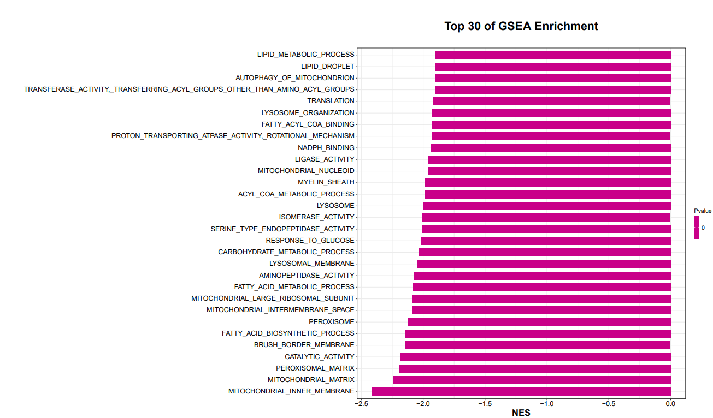
Figure S3 Top 30 of Gene Set Enrichment Analysis (GSEA) on the transcriptomic data (kidney of Gsdmd^{-/-}+Ang II vs WT+Ang II, n = 3). Normalize the enrichment score for each gene set to account for the size of the set, yielding a normalized enrichment score (NES). A positive NES indicates upregulation of the gene set, while a negative NES indicates downregulation .

Figure S4 GI-Y1 effectively attenuated Ang II-mediated fibrosis in TCMK-1 cells in a dose-dependent manner A. The viability of TCMK-1 cells under the effect of different doses of GI-Y1 showed no statistically significant difference among groups. B-C. Expression levels of Fibronectin, COL-III, COL-I, α-SMA, and TGF-β in TCMK-1 cells under different doses of GI-Y1 stimulation with AngII and the corresponding statistical results (n = 3). ****, P < 0.0001; ***, P < 0.001; **, P < 0.01; *, P < 0.05, ns, P > 0.05.

Extended Materials and Methods
Reagents
Ang II (HY-13948) was purchased from MedChemExpress USA (NJ, USA), TGN-020 (S0158) was purchased from Selleck Chemicals LLC. Antibodies against Dersmin (5332S, 1:1000), alpha smooth muscle actin (α-SMA) (ab124964, 1:1000) and transforming growth factor β (TGF-β) (3711S, 1:200-1:1000) were purchased from Cell Signaling Technology (Danvers, MA, USA). Antibodies against GSDMD (ab219800, 1:1000) and WT1 (ab89901, 1:1000) were purchased from Abcam (Cambridge, UK). Antibody against aquaporin 4 (AQP4) (HA500125, 1:1000) was purchased from Huabio (Wuhan, China). Antibodies against Cadherin-16 (15107-1-AP, 1:200), GATA2 (11103-1-AP, 1:50) and collagen type 1 (COL-I) (67288-1-Ig, 1:200-1:1000) were purchased from ProteinTech Group (Chicago, IL, USA). The secondary horseradish peroxidase coupling antibodies for immunoblotting were purchased from Beyotime Biotechnology (A0208 and A0206, Shanghai, China).

Real-time quantitative polymerase chain reaction (RT-PCR)
Messenger ribonucleic acid (mRNA) levels were examined by RT-qPCR assay. TRIzol® Reagent (LifeChemicals, 15596018) was used to extract total ribonucleic acid (RNA) from cells or tissues. RNA was reverse transcribed using RevertAid™ First Strand cDNA Synthesis Kit (Fermentas, K1622) reagent. RT-qPCR was performed using SYBR® Premix Ex Taq™ II (TAKARA, RR820A) and 7300Plus Real-Time PCR System (Applied Biosystems). The relative abundance of Target mRNA was adjusted based on the level of β-actin. RT-qPCR analysis was performed by ΔΔ-Ct algorithm. The primer sequences are presented in Supplementary Table S1 for reference.

Western blot
Protein was extracted from cells and tissues by using lysis buffer (AR0103-100, Boster Biological Technology, Pleasanton, CA). BCA Protein assay (Solarbio, Beijing, China) was used to determine the protein concentration. Equivalent quantities of proteins were added to the pores of the gel and different molecular weights of the proteins were separated by electrophoresis. Proteins were then transferred onto nitrocellulose (NC) membrane membranes and blocked for 1 hour at room temperature. Following incubation in primary antibodies overnight at 4°C, the membrane was then transferred to the corresponding secondary antibodies solution and incubated for another 1 hour at room temperature. Following washing in TBST three times, membranes were detected by the FG Super Sensitive ECL (Meilunbio, Dalian, China). Image J software (Version 1.53e, NIH, Bethesda, MD, USA) was used to quantify band intensities.

Kidney tissue staining
The mouse kidney samples were fixed in 4% neutral buffered formalin and then embedded in paraffin. Tissue samples were sectioned into slices with a thickness of 5 µm. Subsequently, we used hematoxylin-eosin(H&E) staining (Solarbio,G1120) to analyze the specific structure of the kidney tissue sections, 0.1% Sirius Red solution (Solarbio, S8060) to detect collagen deposition, and Masson trichromatic staining (Solarbio, G1340-7) to assess tubulostromal lesions and fibrosis. The degree of these renal damage was evaluated wuth Image J software.
We performed antigen repair of tissues with sodium citrate solution, and quenched peroxidase with 3% H2O2, then the tissues were blocked with 5% bovine serum albumin (BSA) (Solarbio, A8020) for 30 min, followed by primary antibody incubation with COL-I(1:200) and TGF-β(1:200). Finally, HRP-conjugated secondary antibody (Beyotime Biotechnology, 1:2000, A0216) and diaminobenzidine (DAB, Solarbio, DA1010) were used for detection. After staining with hematoxylin, images were captured using an Olympus TH4-200 microscope imaging system (Olympus, Tokyo, Japan). For immunofluorescence, the kidney sample from mice was embedded in optimum cutting temperature (OCT) compound. After rapid freezing, the kidney tissue was sectioned into cryosections with a thickness of 5 µm. The cryosections were fixed with 4% paraformaldehyde and blocked in 5% BSA. Subsequently, they were incubated overnight with the primary antibody Dersmin (1:200), WT1 (1:200) and Cadherin-16 (1:200), and following incubation with the secondary antibody Alexa-488/647 (Abcam, 1:5000) at room temperature for 1 h. The tissue sections were treated with a DAPI-containing anti-fluorescence quenching agent and sealed. Images were observed using a fluorescence microscope.

Gene set enrichment analysis
GSEA was performed using the OmicStudio tools at https://www.omicstudio.cn/tool. The plots was drawn based on the R version 4.1.3 (2022-03-10) on the OmicStudio platform (https://www.omicstudio.cn).

Renal ischemia-reperfusion injury model
To establish a mouse model of acute kidney injury, surgery was performed under general anesthesia induced by sodium pentobarbital (30mg/kg, administered intraperitoneally). The right kidney was removed, and the left renal artery was occluded using a non-invasive vascular clamp for 30 minutes to induce ischemia. After confirming the onset of ischemia, reperfusion was restored, and following a 5-minute observation period to ensure procedural success, the surgical wound was sutured closed.

Supplementary Tables:
Table S1: Sequences for predicted binding sites of GATA2 and AQP4 promoters
Number | Matrix ID | Name | Score | Relative score | Start | End | Strand | Predicted sequence
1 | MA0036.1 | MA0036.1.GATA2 | 5.778177 | 0.949302466 | 1473 | 1477 | + | TGATA
2 | MA0036.1 | MA0036.1.GATA2 | 5.55889 | 0.93657158 | 996 | 1000 | + | AGATG
3 | MA0036.1 | MA0036.1.GATA2 | 5.105046 | 0.91022328 | 77 | 81 | + | TGATG

Table S2: Primer sequences for qPCR
Number | Predicted sequence | Forward | Reverse
1 | TGATA | TCCCCATAATTTCGTCCCCA | AGACTGCTCTAGGGTGCTCA
2 | AGATG | AGGCATCCGTAGGTAATGTGAG | ACACTCTGTCATCACTCGTGCA
3 | TGATG | GAGGCATCCGTAGGTAATGTGAG | TCTGTCATCACTCGTGCATGTATG

