SUPPLEMENTARY DATA

Methods

NHs prototype stability in endothelial cell growth medium (CM)
The stability of NHs prototype upon dilution of 1:25 (v/v) with CM was assessed by DLS analysis (Litesizer 500, Anton Paar, Turin, Italy) as reported in section “Storage stability studies”; three batches were analysed and, for each batch, three measurements were performed.

Confocal imaging
HUVEC cells treated with NH@FITC-dex were observed using a CLSM as reported in section “Cellular uptake”, and 2D images (exported 2D total intensity projection images of the cytoskeleton channel, nuclei channel and NH@FITC-dex channel for each Z-stack) were acquired. Such images were processed with a software associated with the microscope (see section “Cellular uptake”).

Results
NHs prototype stability in CM
For effective targeting of retinal cells, the NHs should be characterized by a hydrodynamic diameter lower than 350 nm.³⁵ Given the critical influence of pH on the NHs properties, the hydrodynamic diameter of the NHs prototype diluted 1:25 (v/v) in CM was evaluated before performing cellular uptake test on HUVEC cells; after dilution, the colloidal dispersion maintained an approximately neutral pH.
Figure 1S highlights that no statistically significant differences occur between N3 prototype as such and N3 diluted 1:25 (v/v) in CM, thus confirming that NHs do not aggregate upon dilution in CM and suggesting that the prototype is able to maintain its capability to be uptaken by the epithelial retinal cells.
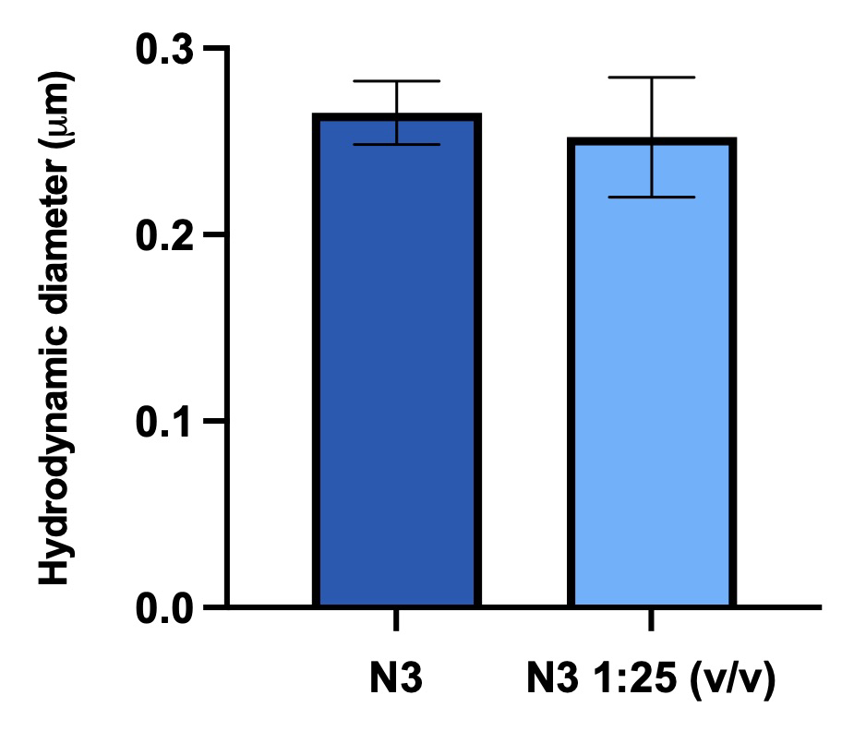
Figure 1S Hydrodynamic diameter of N3 prototype before and after dilution 1:25 (v/v) in CM (mean value ± s.d.; n=3). One-way ANOVA; T test (P value <0.05).

Z-stacks
Figure 2S shows a series of fifteen Z-stack images of HUVEC cells treated with NH@FITC-dex. These images clearly pointed out that loaded NHs (marked in green) were successfully internalized by the cells and not only absorbed on their surface.
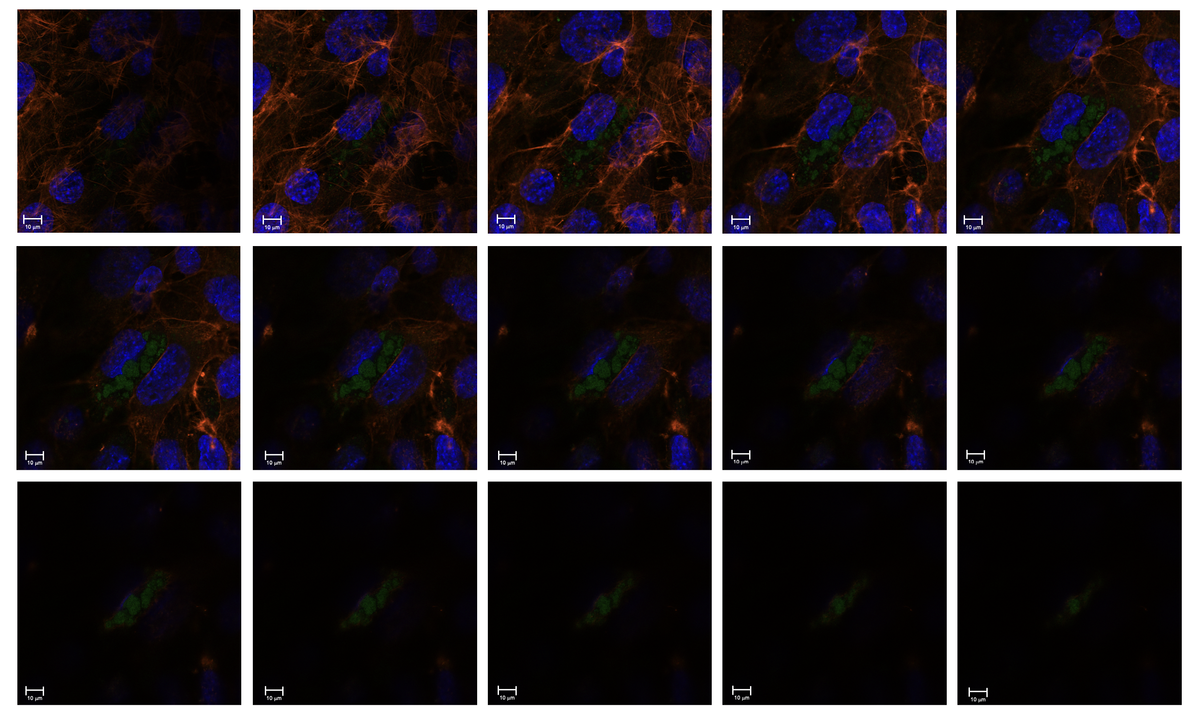
Figure 2S Z-stack images of HUVEC cells treated with NH@FITC-dex. Green: FITC-dex (λ_{ex} 490 nm) loaded into N3; blue: Hoechst dye (λ_{ex} 361 nm/ λ_{em} 497 nm) specific for nuclei staining; red: TRITC (λ_{ex} 514 nm and λ_{em} 580 nm) for actin fibers staining. Scale bar: 10 μm.

