Compression therapy for prevention of Chemotherapy-induced peripheral neuropathy: a systematic review and meta-analysis of randomized controlled trials

APPENDIX TABLES

Table S1 Search Strategy

Database: Pubmed <May 31, 2024>
Search Strategy:
# | Search | Results
1 | "Stockings, Compression"[Mesh] OR "Compression Bandages"[Mesh] OR "compression therap*"[Title/Abstract] OR "pressure therap*"[Title/Abstract] OR "stocking*"[Title/Abstract] OR "hosiery"[Title/Abstract] OR "tights"[Title/Abstract] OR "sock*"[Title/Abstract] OR "gloves"[Title/Abstract] | 33,346
2 | "Peripheral Nervous System Diseases"[Mesh] OR "peripheral nervous system diseases"[Title/Abstract] OR "neuralgia"[Title/Abstract] OR "paresthesia"[Title/Abstract] OR "paraesthesia"[Title/Abstract] OR "hyperalgesia"[Title/Abstract] OR "cipn"[Title/Abstract] OR "neuropath*"[Title/Abstract] OR "polyneuropath*"[Title/Abstract] | 316,226
4 | "Randomized Controlled Trial"[Publication Type] OR "random*"[Title/Abstract] OR "RCT"[Title/Abstract] OR "control*"[Title/Abstract] | 5,745,630
5 | #1 OR #2 OR #3 | 152

Database: Embase <May 31, 2024>
Search Strategy:
# | Search | Results
1 | "Stocking* "/exp OR "Compression therap*"/exp OR "compression therap":ti,ab,kw OR "pressure therapy":ti,ab,kw OR "stocking*":ti,ab,kw OR "hosiery":ti,ab,kw OR "tights":ti,ab,kw OR "sock*":ti,ab,kw OR "gloves":ti,ab,kw | 52,026
2 | "Peripheral Nervous System Diseases"/exp OR "peripheral nervous system diseases":ti,ab,kw OR "neuralgia":ti,ab,kw OR "paresthesia":ti,ab,kw OR "paraesthesia":ti,ab,kw OR "hyperalgesia":ti,ab,kw OR "cipn":ti,ab,kw OR "neuropath*":ti,ab,kw OR "polyneuropath*":ti,ab,kw | 353,162
3 | "Randomized Controlled Trial"/exp OR "random*":ti,ab,kw OR "RCT":ti,ab,kw OR "control*":ti,ab,kw | 5,745,630
4 | #1 OR #2 OR #3 | 294

Database: Cochrane Library <May 31, 2024>
Search Strategy:
# | Search | Results
1 | MeSH descriptor: [Stocking, Compression] explode all trees | 356
2 | "compression therap*" OR "pressure therapy" OR "stocking*" OR "hosiery" OR "tights" OR "sock*" OR "gloves" | 963,366
3 | #1 OR #2 | 963,366
4 | MeSH descriptor: [Peripheral Nervous System Diseases] explode all trees | 8,206
5 | "peripheral nervous system diseases" OR "neuralgia" OR "paresthesia" OR "paraesthesia" OR "hyperalgesia" OR "cipn" OR "neuropath*" OR "polyneuropath*" | 17,048
6 | #4 OR #5 | 20,916
7 | MeSH descriptor: [Randomized Controlled Trial] explode all trees | 37
8 | "random*" OR " RCT" OR "control*" | 1,621,597
9 | #7 OR #8 | 1,621,597
10 | #3 AND #6 AND #9 | 1,178

Database: Web of Science <May 31, 2024>
Search Strategy:
# | Search | Results
1 | TS=("compression therapy" OR "pressure therapy" OR "stocking*" OR "hosiery" OR "tights" OR "sock*" OR "gloves") | 33,964
2 | TS=("peripheral nervous system diseases" OR "neuralgia" OR "paresthesia" OR "paraesthesia" OR "hyperalgesia" OR "cipn" OR "neuropath*" OR "polyneuropath*") | 145,941
3 | TS=("Randomized Controlled Trial" OR "random*" OR "RCT" OR "control*") | 5,178,921
4 | #1 OR #2 OR #3 | 97

Database: CNKI <May 31, 2024>
Search Strategy:
# | Search | Results
1 | TKA= ("compression" + "elasticity" + "gloves" + "socks" + "tight fitting" + "bandages") | 123,999
2 | SU= ("compression" + "elasticity" + "gloves" + "socks" + "tight fitting" + "bandages") | 77,353
3 | #1 OR #2 | 147,586
4 | TKA= ("peripheral nervous system disease" + "neurotoxicity") | 38,387
5 | SU= ("peripheral nervous system disease" + "neurotoxicity") | 27,073
6 | #4 OR #5 | 40,618
7 | TKA= ("randomized controlled trial" + "control" + "randomization" + "clinical study) + "clinical efficacy" + "RCT") | 5,213,166
8 | SU= ("randomized controlled trial" + "control" + "randomization" + "clinical study) + "clinical efficacy" + "RCT") | 2,054,885
9 | #7 OR #8 | 5,424,281
10 | #3 AND #6 ADN #9 | 57

Database: Wanfang <May 31, 2024>
Search Strategy:
# | Search | Results
1 | Topical subject = ("compression" OR "elasticity" OR "gloves" OR "socks" OR "tight fitting clothes" OR "bandages") | 127,482
2 | Topical subject = ("peripheral nervous system disease" OR "neurotoxicity") | 74,918
3 | Topical subject = ("randomized controlled trial" OR "control" OR "randomization" OR "clinical study" OR "clinical efficacy" OR "RCT") | 6,954,155
4 | #1 AND #2 ADN #3 | 126
Database: Sinomed <May 31, 2024>
Search Strategy:
# | Search | Results
1 | " Long socks, pressure" [unweighted: extended] OR "pressure" [common field: intelligent] OR "elasticity" [common field: intelligent] OR "gloves" [common field: intelligent] OR "socks" [common field: intelligent] OR "tight fitting clothes" [common field: intelligent] OR "bandage" [common field: intelligent] | 63,919
2 | "peripheral nervous system disease" [common field: intelligent] OR "neurotoxicity" [common field: intelligent] | 26,474
3 | "randomized controlled trial" [unweighted: extended] OR "control" [common field: intelligent] OR "randomization" [common field: intelligent] OR "clinical study" [common field: intelligent] OR "clinical efficacy" [common field: intelligent] OR "RCT" [common field: intelligent] | 3,397,709
4 | #1 AND #2 ADN #3 | 38

Table S2 Excluded studies
Author, Year | Type of population | Intervention | Comparison | Outcome | Study design | Include/Exclude | Comments
Accordino, 2024^{[1]} | breast cancer | compression Gloves/Socks | placebo | The FACT NTX；comfort/satisfaction；QOL, | RCT | Exclude | post
Anastasio, 2023^{[2]} | Gynecologic Cancer | compression Gloves/Socks | placebo | PNQ；Acceptability | NRCT | Exclude | wrong design
Anastasio, 2023^{[3]} | Gynecologic Cancer | compression Gloves/Socks | placebo | PNQ；Acceptability | NRCT | Exclude | post
Joureau-Chabert, 2024^{[4]} | breast cancer | surgical gloves | frozen gloves | NRS,efficacy,nurse preference | RCT | Exclude | post
Kanbayashi, 2020^{[5]} | breast cancer | surgical glove | frozen gloves | CTCAE | RCT | Exclude | wrong comparator
Kang， 2023^{[6]} | breast cancer | surgical glove | placebo | FACT-Taxane；NCI-CTCAE | NRCT | Exclude | wrong design
Kashiwaba, 2021^{[7]} | breast cancer | surgical glove | frozen gloves | CTCAE | RCT | Exclude | post
Kotani, 2021^{[8]} | breast cancer | surgical glove | placebo | CTCAE,incidence of CIPN | Protocol | Exclude | wrong design
Michel, 2022^{[9]} | breast cancer | surgical gloves | frozen gloves | efficacy, TNSc, EORTC-QLQ-CIPN20 | RCT | Exclude | wrong comparator
Ohno, 2014^{[10]} | breast cancer | Gloves;Stocks;goshajinkigan | no intervention | incidence of CIPN | NRCT | Exclude | wrong design
Suyama, 2024^{[11]} | malignant lymphoma | surgical glove | no intervention | CTCAE;PNQ | NRCT | Exclude | wrong design
Tsuyuki, 2016^{[12]} | breast cancer | surgical glove | no intervention | CTCAE;PNQ | NRCT | Exclude | wrong design
Tsuyuki, 2017^{[13]} | breast cancer | surgical glove | no intervention | CTCAE;PNQ | NRCT | Exclude | post
Tsuyuki, 2018^{[14]} | breast cancer | surgical glove | NA | CTCAE;PNQ | NRCT | Exclude | post
Tsuyuki, 2019^{[15]} | breast cancer | surgical glove | NA | CTCAE;PNQ | single arm trial | Exclude | wrong design
Yamanouchi, 2022^{[16]} | breast cancer | stocking “ + “sleeves | no intervention | incidence of CIPN | historical control trial | Exclude | wrong design
Yamanouchi, 2019^{[17]} | breast cancer | frozen gloves and socks | NA | CTCAE;PNQ | single arm trial | Exclude | wrong design

APPENDIX FIGURE

Appendix figure S1-4: Sensitivity analyses using fixed-effect model

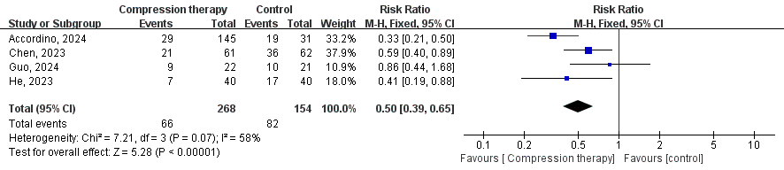
Figure S1 Results of the meta-analysis of the incidence of CIPN: fixed effect mode

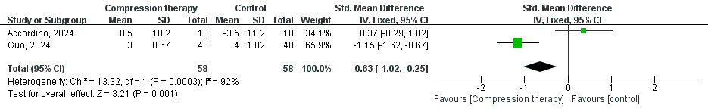
Figure S2 Results of the meta-analysis of the incidence of anxiety: fixed effect mode

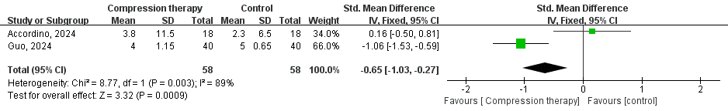
Figure S3 Results of the meta-analysis of the incidence of depression: fixed effect mode

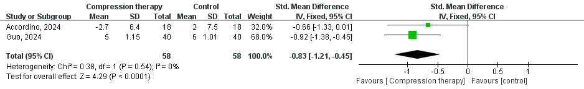
Figure S4 Results of the meta-analysis of the incidence of sleep quality: fixed effect mode

Reference:
[1] Accordino M K, Lee S, Leu C S, et al. Randomized adaptive selection trial of cryotherapy, compression therapy, and placebo to prevent taxane-induced peripheral neuropathy in patients with breast cancer [J]. Breast Cancer Res Treat, 2024, 204(1): 49-59.
[2] Anastasio M K, Unnithan S, Scott A, et al. Cryocompression to Reduce Peripheral Neuropathy in Gynecologic Cancer: A Randomized Controlled Trial [J]. Obstetrics and Gynecology, 2023, 142(6): 1459-67.
[3] Anastasio M K, Unnithan S, Scott A, et al. Cryocompression to Reduce Peripheral Neuropathy in Gynecologic Cancer [J]. OBSTETRICS AND GYNECOLOGY, 2023, 142(6): 1459-67.
[4] Joureau-Chabert A, Ouldbey Y, Toussaint P, et al. Efficacy of surgical gloves (SG) as compression therapy versus frozen gloves (FG) to prevent paclitaxel-induced peripheral neuropathy (PN): The trial ELEGANT [J]. ESMO Open, 2024, 9.
[5] Kanbayashi Y, Sakaguchi K, Ishikawa T, et al. Comparison of the efficacy of cryotherapy and compression therapy for preventing nanoparticle albumin-bound paclitaxel-induced peripheral neuropathy: A prospective self-controlled trial [J]. Breast, 2020, 49: 219-24.
[6] Kang Y J, Yoon C I, Yang Y J, et al. A randomized controlled trial using surgical gloves to prevent chemotherapy-induced peripheral neuropathy by paclitaxel in breast cancer patients (AIUR trial) [J]. BMC Cancer, 2023, 23(1).
[7] Kashiwaba M, Nakayama T, Sangai T, et al. A randomized phase II trial of interventions with frozen groves and compression stockings to prevent nab-paclitaxel induced chemotherapy-induced peripheral neuropathy (SPOT trial) [J]. CANCER RESEARCH, 2021, 81(4).
[8] Kotani H, Terada M, Mori M, et al. Compression therapy using surgical gloves does not prevent paclitaxel-induced peripheral neuropathy: results from a double-blind phase 2 trial [J]. BMC Cancer, 2021, 21(1).
[9] Michel L, Romar P, Feisst M, et al. 1552O Chemotherapy-induced peripheral neuropathy (CIPN) prevention trial evaluating the efficacy of hand-cooling and compression in patients undergoing taxan-based (neo-)adjuvant chemotherapy for primary breast cancer: First results of the prospective, randomized POLAR trial [J]. Annals of Oncology, 2022, 33: S1257-S8.
[10] Ohno T, Mine T, Yoshioka H, et al. Management of peripheral neuropathy induced by nab-paclitaxel treatment for breast cancer [J]. Anticancer Research, 2014, 34(8): 4213-6.
[11] Suyama T, Tsuboi Y, Shimizu M, et al. Compression therapy using surgical gloves is ineffective for the prevention of vincristine-induced neuropathy in patients with malignant lymphoma [J]. Supportive Care in Cancer, 2024, 32(3).
[12] Tsuyuki S, Senda N, Kanng Y, et al. Evaluation of the effect of compression therapy using surgical gloves on nanoparticle albumin-bound paclitaxel-induced peripheral neuropathy: a phase II multicenter study by the Kamigata Breast Cancer Study Group [J]. Breast Cancer Research and Treatment, 2016, 160(1): 61-7.
[13] Tsuyuki S, Senda N, Kanng Y, et al. Efficacy of compression therapy using surgical gloves for nanoparticle albumin-bound-paclitaxel-induced peripheral neuropathy: A phase II multicenter study by the Kamigata breast cancer study group [J]. Cancer Research, 2017, 77(4).
[14] Tsuyuki S, Yamagami K, Yoshibayashi H, et al. Effectiveness and safety of surgical glove compression therapy as a prophylactic method against nanoparticle albumin-bound-paclitaxel-induced peripheral neuropathy [J]. Breast, 2019, 47: 22-7.
[15] Tsuyuki S, Yamagami K, Yoshibayashi H, et al. Effectiveness of surgical glove compression therapy as a prophylactic method against nab-paclitaxel induced peripheral neuropathy [J]. Annals of Oncology, 2018, 29: viii639.
[16] Yamanouchi K, Kuba S, Matsumoto M, et al. An Evaluation of the Efficacy of Compression Therapy Using Sleeves and Stockings to Prevent Docetaxel-induced Peripheral Neuropathy in Breast Cancer Patients [J]. Acta medica Okayama, 2022, 76(6): 689-94.
[17] Yamashita T, Hattori M, Nakada T, et al. Subjective and objective assessment of efficacy of frozen gloves and socks to prevent nab-paclitaxel-induced peripheral neuropathy in patients with breast cancer [J]. Cancer Research, 2019, 79(4).

