Copper-based Nanoparticles For Effective Treatment Against Sepsis-Induced Lung Injury In Mice Model

Figure S1. XPS survey spectrum showing Cu_{4.5}O USNPs composition
Figure S2. Cu_{4.5}O USNPs free radical Scavenging capability. (A) ABTS scavenging capability. (B) DPPH scavenging capability.
Figure S3. Cu_{4.5}O USNPs enzyme activity. (A) CAT activity. (B) The concentration of dissolved oxygen. (C) SOD activity.
Figure S4. Cell Cytotoxicity. The cell viabilities of (A)THP-1, (B) MPVECs and (C) MLE12 cells cultured with various concentrations of Cu_{4.5}O USNPs for 24 h. There were no significant difference between groups.
Figure S5. Cell viability. The cell viabilities of (A) THP-1, (B) MPVECs and (C) MLE12 cells under various concentrations of Cu_{4.5}O USNPs after LPS-treated 24 h in vitro. “LPS”= Lipopolysaccharide. “*”= P < 0.05, “***”= 0.0001 < P < 0.001, “****”= P < 0.0001. “ns”= Difference were not significant between groups.

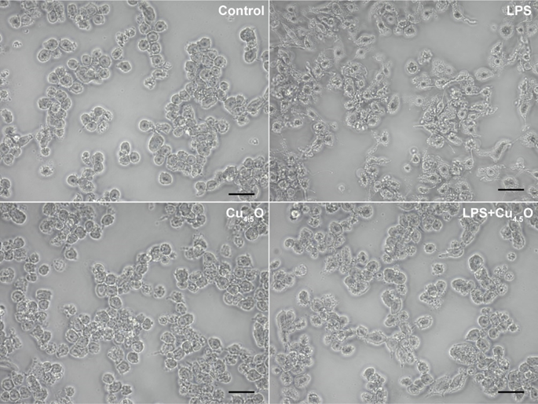
Figure S6. Bright-field image of RAW264.7 cells. The scale bar is 20 μm. “LPS”= Lipopolysaccharide.
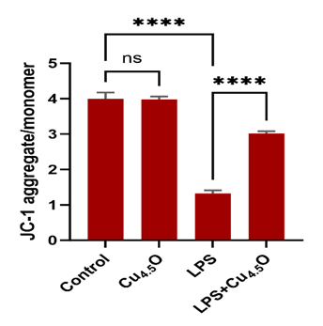
Figure S7. The intensity quantification of mitochondrial membrane potential. “****”= P < 0.0001. “ns”= Difference were not significant between groups.
Figure S8. H&E of lung tissues stained after treated with intratracheal instillation by different concentrations of Cu_{4.5}O USNPs. The scale bar is 25 μm. “LPS”= Lipopolysaccharide.
Figure S9. Assessment of in vivo therapeutic of Cu_{4.5}O USNPs to the lung at 24 h after tail vein injection. (A-B) Representative histopathological images of H&E staining and the quantitative score of pathology of lung. (C-D) Representative histopathological images of H&E staining and the quantitative score of pathology of heart. (E-F) Representative histopathological images of H&E staining and the quantitative score of pathology of liver. (G-H) Representative histopathological images of H&E staining and the quantitative score of spleen. (I-J) Representative histopathological images of H&E staining and the quantitative score of kidney. All scale bars of H&E staining pictures are 25 μm. “LPS”= Lipopolysaccharide. “*”= P < 0.05, “**”= 0.001 < P < 0.01, “***”= 0.0001 < P < 0.001, “****”= P < 0.0001. “ns”= Difference were not significant between groups.
Figure S10 Hemolysis ratio. At a high concentration of 5000ug/mL, influenced by the color of Cu_{4.5}O USNPs itself, the liquid in the EP tube was changed. But hemolysis ratio of all groups is lower than 5%.
Figure S11. Cu_{4.5}O USNPs more effectively alleviated tissue structure damage and reduced alveolar fluid exudation relative to vitamin C. (A) H&E staining of lung tissues after single intravenous administration with Cu_{4.5}O USNPs (850ug/kg) and vitamin C, (50mg/kg). (B) Total protein concentration in bronchoalveolar lavage fluid. A Bicinchoninic Acid protein assay kit was used to quantify the total protein in bronchoalveolar lavage fluid (Thermo Fisher Scientific, America). “LPS”= Lipopolysaccharide. “*”= P < 0.05, “**”= 0.001 < P < 0.01.

