Supplementary Table 1. ICD-9 and ICD-10 codes used for heart failure (HF) incidence
ICD-9 codes | Disease Description | ICD-10 codes
398.91 | Rheumatic heart failure | I09.81
402.xx | Hypertensive heart disease | I11.9
404.xx | Hypertensive heart and chronic disease | I13.0, I13.2
428.0; 428.1; 428.2x; 428.3x; 428.4x; 428.9 | Heart failure (includes Systolic heart failure; Diastolic heart failure; Combined systolic and diastolic heart failure) | I50.xx

Supplementary Table 2. Included and excluded variables during data-preprocessing
Variable condition | Variables
Missing value <30% | Age, Sex, Basophil, Eosinophil, Lymphocyte, Monocyte, Neutrophil, Albumin, APTT, BUN, CKMB, CPK, Creatinine, CRP, eGFR, Glucose AC, GOT, GPT, HCT, HGB, K, MCH, MCHC, MCV, Na, PLT, PT_INR, RBC, Troponin_I, WBC, BF, AIDS Disease, Cerebrovascular Disease, Chronic Pulmonary Disease, Dementia Disease, Diabetes with Chronic Disease, Diabetes without Chronic Disease, Hemiplegia Paraplegia Disease, HIV Infection Disease, ICU week, ICU 1yr, Malignancy Disease, Mild Liver Disease, Moderate or Severe Liver Disease, Peptic Ulcer Disease, Peripheral Vascular Disease, Renal Disease, Rheumatic Disease
Missing Value ≥30% | %Albumin, %Reticulocyte, ABEc, ACTH, ALK_P, Anti_cardiolipin_IgG, Height, Bilirubin_D, Bilirubin_T, Blood_gas_pH, Body_Temperature, Weight, Ca, Cholesterol, Cl, Cl_Ur, COHB, Cortisol, Digoxin, Eosinophil_count, ESR_1HR, ESR_2HR, Factor_IX, Factor_VIII, Fe, Ferritin, Fibrinogen, Globulin_B, GlucosePC, Hb_A1, HbA1C, Hb-A2, Hb-F, HCO3, HDL, K_Ur, LDH, Lipase, MetHb, Mg, Microalbumin_Ur, mp, NT-proBNP, O2Hb, Osmolarity, Osmolarity_Ur, P_B, pCO2, pO2, Prealbumin, PTH, SBP, sO2, TG_B, tHb, TIBC, TP_24hrUr, TP_B, Transferrin, UACR, UreaN_Ur, Uric_acid_24hrsUr, Uric_acid, Zn

Supplementary Table 3. The information of all the packages and functions about algorithms used in R
Models | Hyperparameter | Library Package and Code
Logistic regression | family = "binomial"(link="logit") | glm(formula, family = gaussian, data, weights, subset, na.action, start = NULL, etastart, mustart, offset, control = list(...), model = TRUE, method = "glm.fit", x = FALSE, y = TRUE, singular.ok = TRUE, contrasts = NULL, ...)
Naïve Bayes | Laplace=0 (controlling Laplace smoothing) | library(e1071)  naiveBayes(formula, data, laplace = 0, ..., subset, na.action = na.pass)
SVM | type='C-classification',  kernel='linear'  kernel='polynomial'  probability = TRUE | library(e1071)  library(kernlab)  svm(formula, data = NULL, ..., subset, na.action = na.omit, scale = TRUE)
CART | control=rpart.control(minsplit = 20) | library(rpart)  library(partykit)  rpart(formula, data, weights, subset, na.action = na.rpart, method,  model = FALSE, x = FALSE, y = TRUE, parms, control, cost, ...)  rparty.tree <- as.party(cart.model)  plot(rparty.tree,main="CART")  rpart.control(minsplit = 20, minbucket = round(minsplit/3), cp = 0.01,  maxcompete = 4, maxsurrogate = 5, usesurrogate = 2, xval = 10,  surrogatestyle = 0, maxdepth = 30, ...)
C5.0 | control = C5.0Control(minCases = 30) | library(C50)  C5.0(formula, data, weights, subset, na.action = na.pass, ...)
Adaboost | # for a bootstrap sample of the training set is drawn  boos=TRUE  boos=FALSE  coeflearn='Breiman'  mfinal = 100 | library(adabag)  library(rpart)  boosting(formula, data, boos = TRUE, mfinal = 100, coeflearn = 'Breiman', control,...)
RandomForest | ntree=100  importance=TRUE  proximity=TRUE | library(randomForest)  ## S3 method for class 'formula'  randomForest(formula, data=NULL, ..., subset, na.action=na.fail)  ## Default S3 method:  randomForest(x, y=NULL, xtest=NULL, ytest=NULL, ntree=500,  mtry=if (!is.null(y) && !is.factor(y))  max(floor(ncol(x)/3), 1) else floor(sqrt(ncol(x))),  weights=NULL,  replace=TRUE, ...)  varImpPlot(model, …)

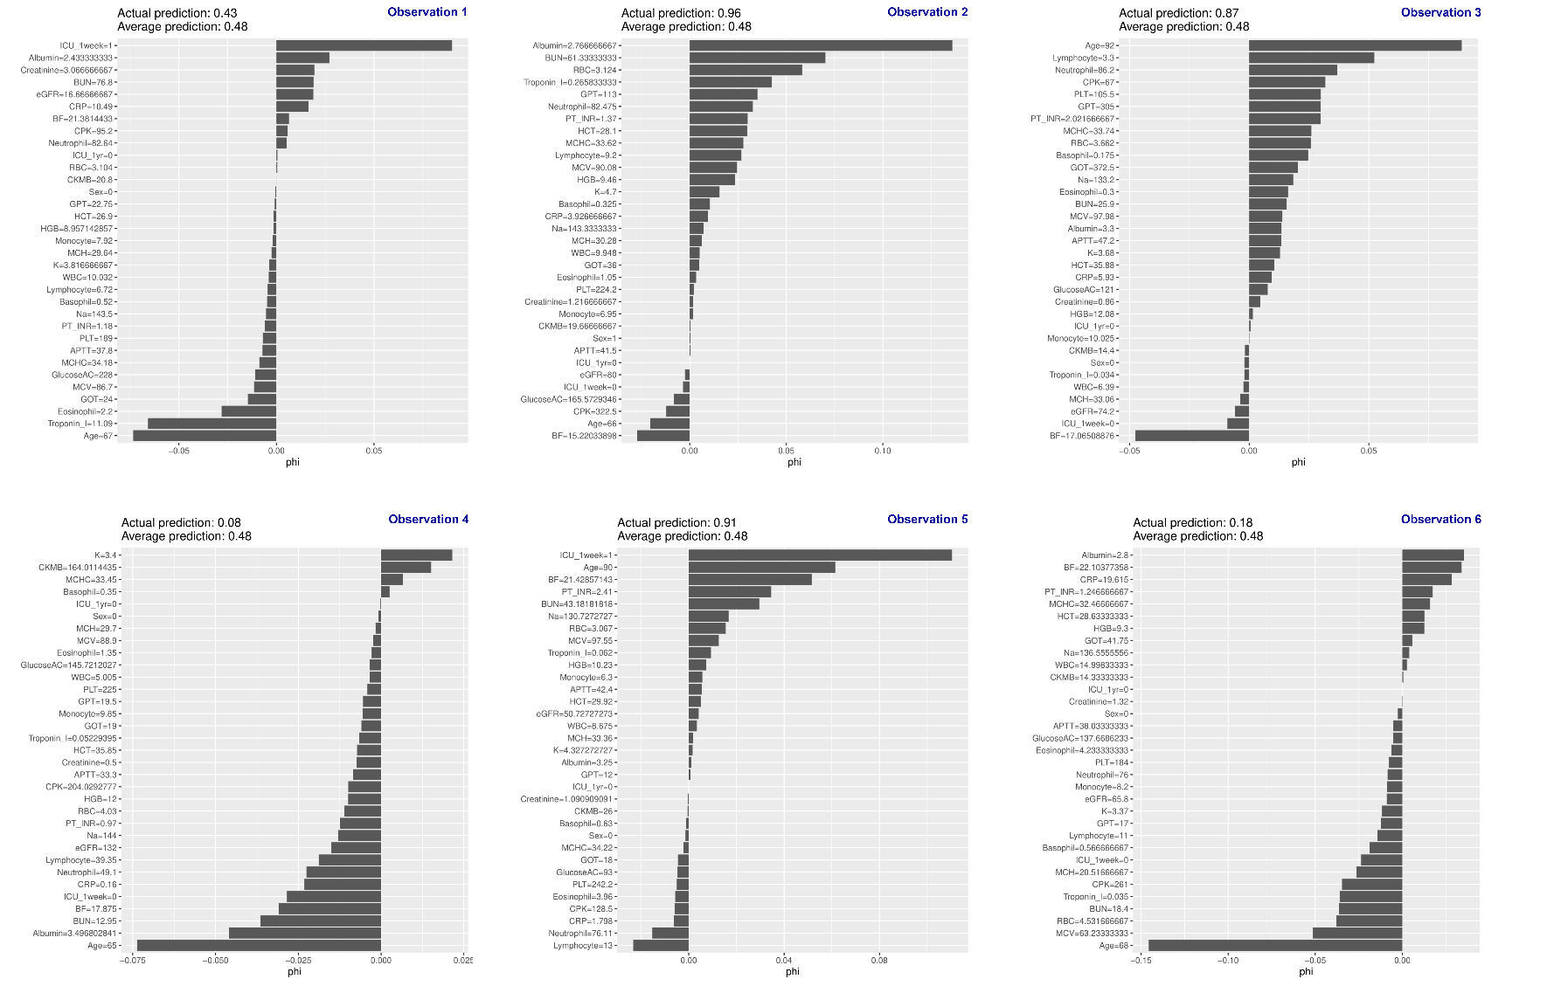
Supplementary Figure 1. The outcome of sampling of testing dataset with SHAP (SHapley Additive exPlanations) method
Supplementary Figure 2. Heart failure subtype proportion among survival and death cohort

