Supporting information

Elucidating the mechanism of large-diameter titanium dioxide nanotubes in protecting osteoblasts under oxidative stress environment: The role of fibronectin and albumin adsorption
Yun Xiang^{1,2,#}, Dini Lin^{1,#}, Qiang Zhou¹, Hongyu Luo¹, Zixin Zhou¹, Shuyi Wu², Keyuan Xu², Xiaoting Tang¹, Pingping Ma², Chunyun Cai^{1,}*, Xinkun Shen^{1,}*

Address:
¹Wenzhou Key Laboratory for the Diagnosis and Prevention of Diabetic Complications, The Third Affiliated Hospital of Wenzhou Medical University (Ruian People's Hospital), Wenzhou 325016, People’s Republic of China.
²School and Hospital of Stomatology, Wenzhou Medical University, Wenzhou 325027, People’s Republic of China.
#Co-authors:
These authors contributed equally to this work and share first authorship.
*Corresponding authors:
Xinkun Shen:
Wenzhou Key Laboratory for the Diagnosis and Prevention of Diabetic Complications, The Third Affiliated Hospital of Wenzhou Medical University (Ruian People's Hospital), Wenzhou 325016, People’s Republic of China.
108# Wansong Road, Ruian City, Zhejiang Province, China; E-mail: shenxinkun123@wmu.edu.cn.

Chunyuan Cai:
Wenzhou Key Laboratory for the Diagnosis and Prevention of Diabetic Complications, The Third Affiliated Hospital of Wenzhou Medical University (Ruian People's Hospital), Wenzhou 325016, People’s Republic of China.
108# Wansong Road, Ruian City, Zhejiang Province, China; E-mail: caichunyuan123@wmu.edu.cn.

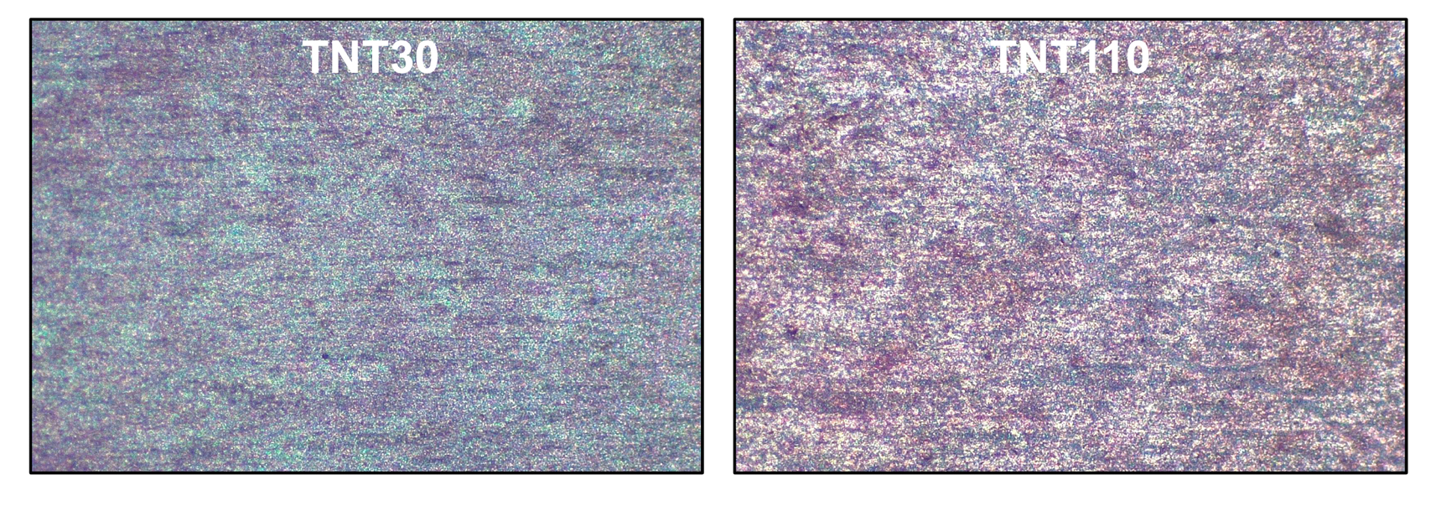
Fig. S1. Images of the mineralized nodules on TNT30 and TNT110 surfaces.

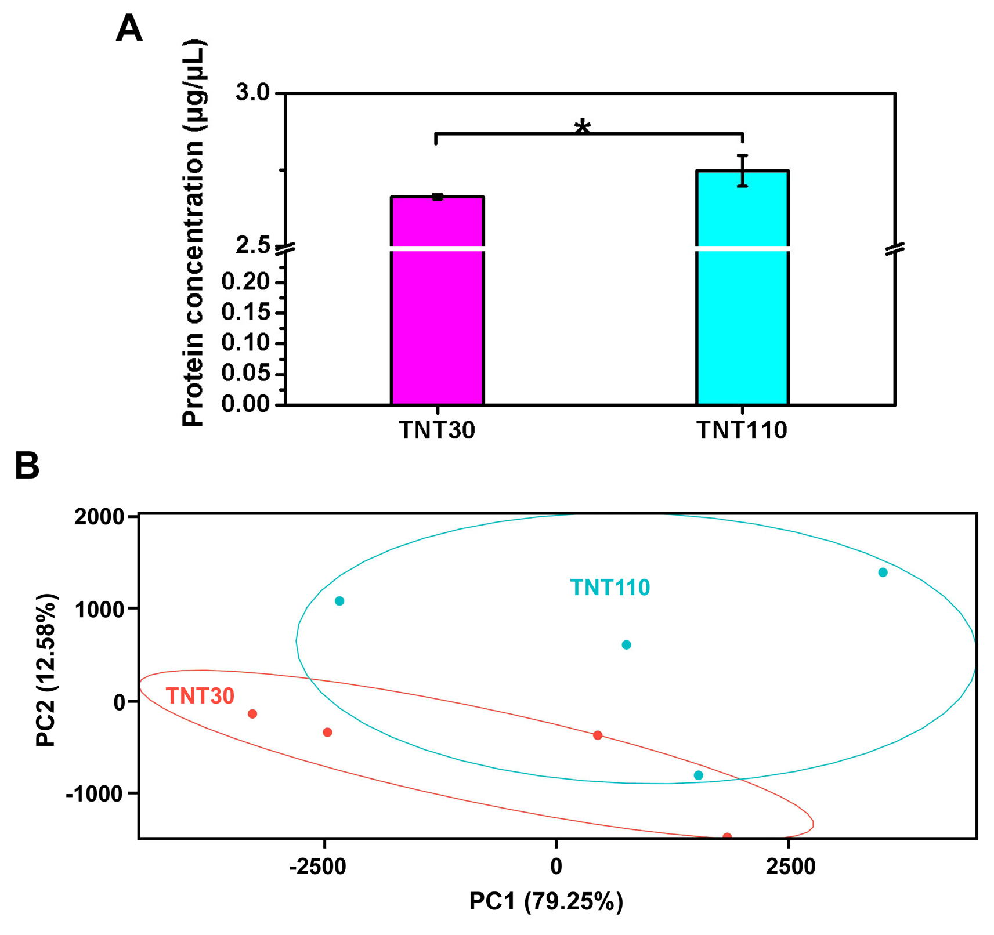
Fig. S2. Principal component analysis (PCA) for RNA sequencing.

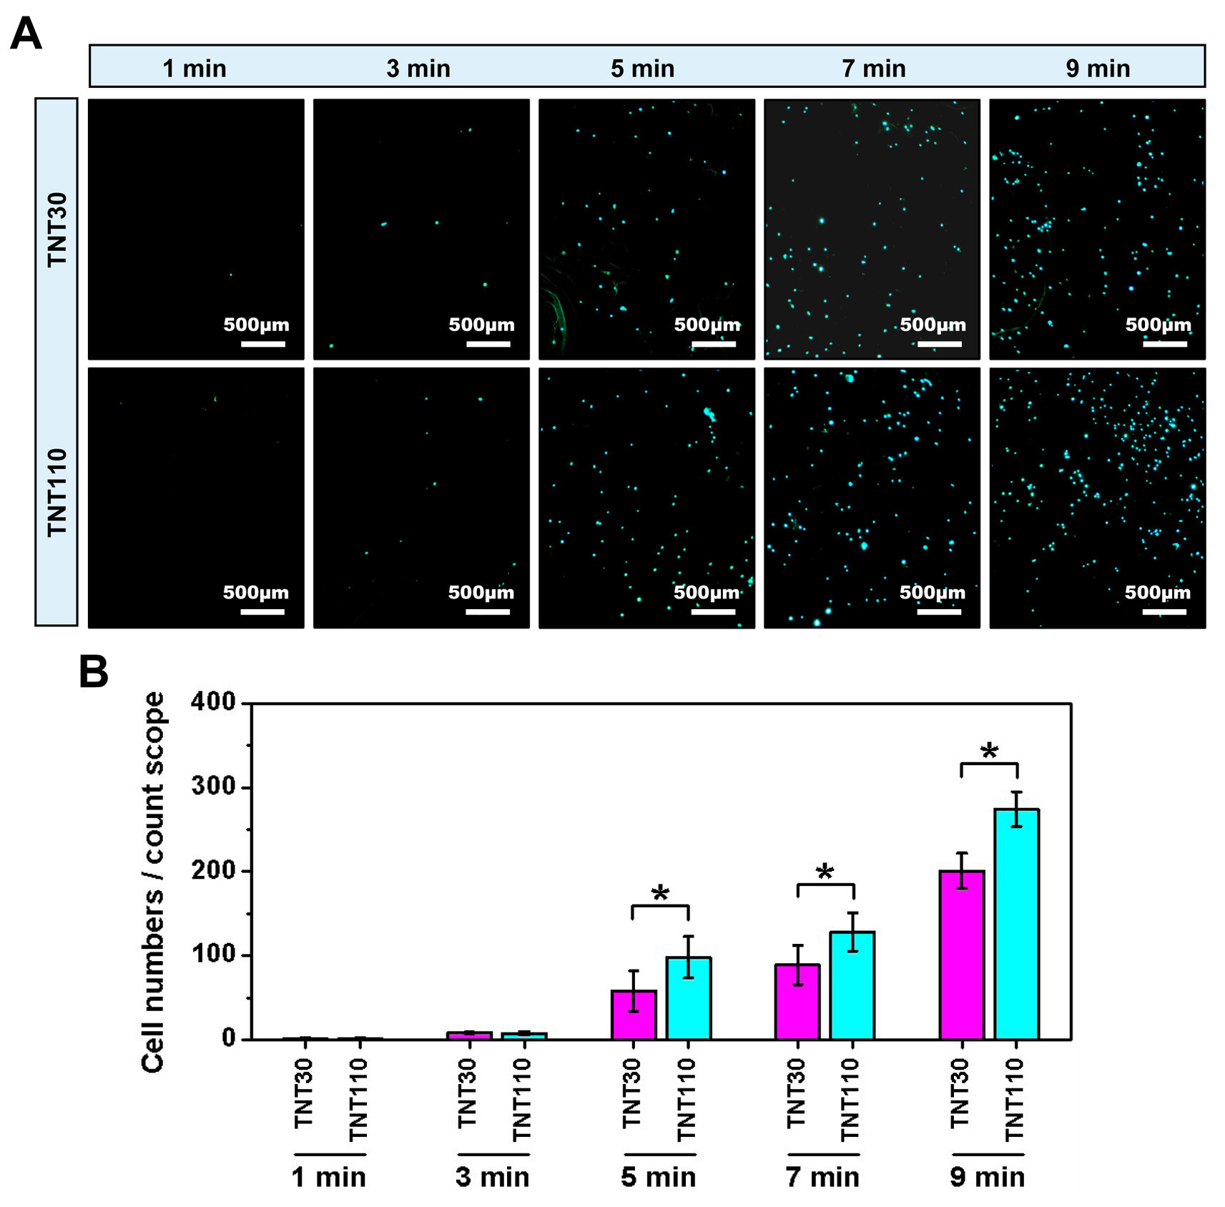
Fig. S3. (A) Nuclear staining images of MC3T3-E1 cells inoculated on TNT30 and TNT110 surfaces at 1, 3, 5, 7, and 9 min under OS conditions; and (B) Quantitative results of cell adhesion numbers,*P < 0.05.

Fig. S4. Concentration of total proteins adsorbed on TNT30 and TNT110 surface after pre-adsorption of 10% FBS for 5 min, *P < 0.05.

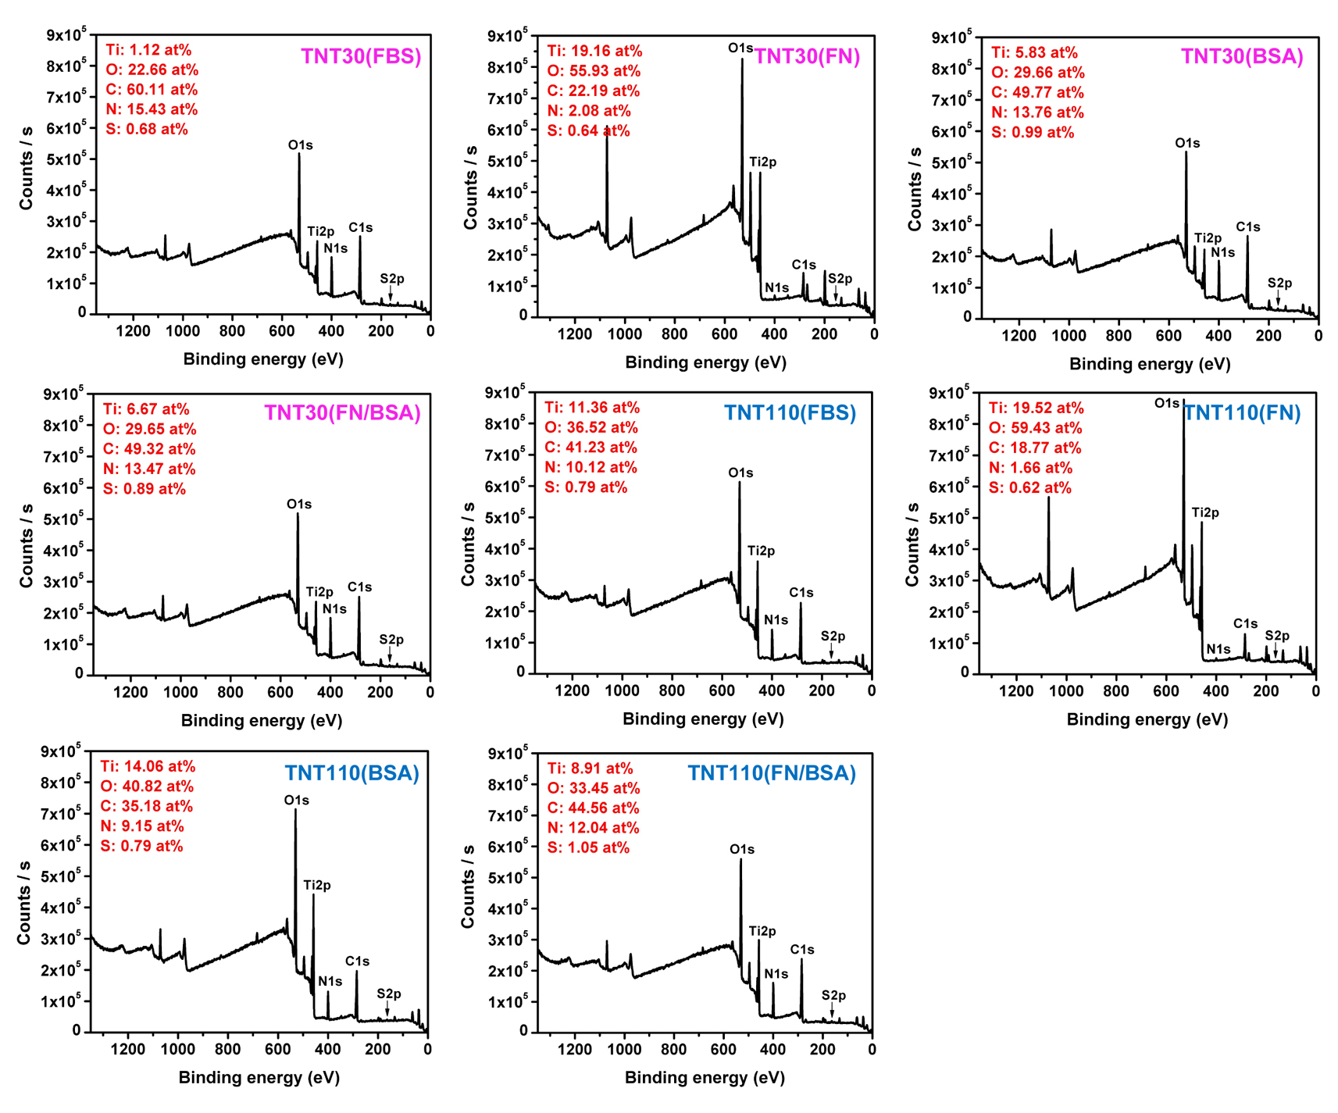
Fig. S5. XPS results of protein pre-adsorbed samples: TNT30(BSA), TNT30(FN), TNT30(FN/BSA), TNT30(FBS), TNT110(BSA), TNT110(FN) TNT110(FN/BSA), TNT110(FBS).

