Supplementary figures
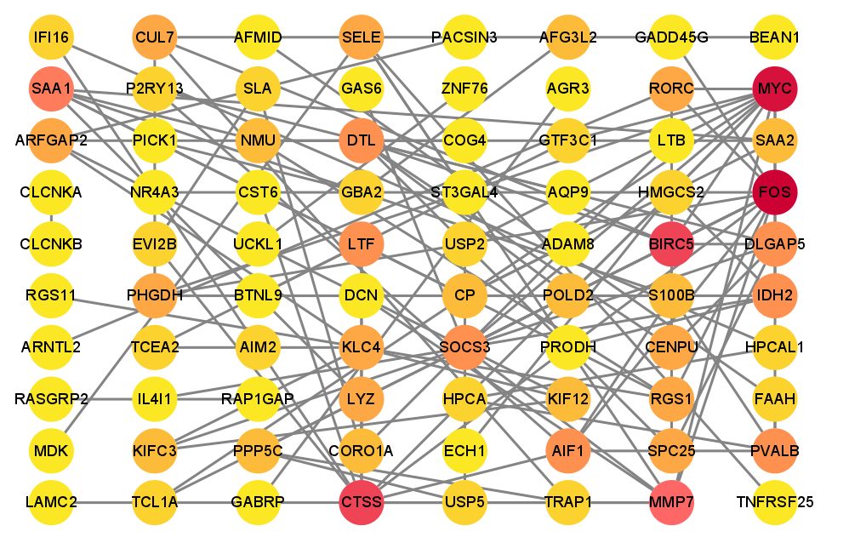
Figure S1 The PPI network of DIGs in patients with CKD. Each node represents a gene, and the edges (grey lines) denote the interactions between these genes' encoded proteins. The color intensity of the nodes correlates with the degree centrality value; darker colors indicate a higher degree centrality, signifying a greater number of connections or interactions with other genes within the network.

Figure S2 Identification of immune microenvironment score-related module by WGCNA. Each row represents a different module color, with the correlation coefficients on the left side indicating the strength and direction of the relationship between module eigengenes and immune score. The accompanying p-values, depicted with a gradient of blue hues, reflect the statistical significance of these correlations. The color intensity on the right-hand side represents the correlation coefficient range, with darker colors (red) indicating higher positive correlations and darker colors (green) indicating higher negative correlations.

Figure S3 The potential pathways in association with the RGS1 (A), IL4I1 (B), NR4A3 (C), and SOCS3 (D) have been identified by GSEA. The x-axis represents the rank in the ordered dataset, while the y-axis shows the enrichment score. The pathways are ranked based on enrichment scores (ES) and statistical significance (p-value).

