Supporting Information
Table S1. Application of natural phenolic compounds in tumor therapy
Drug name | Therapeutic Mechanism | Characteristic | Applications | Reference
Curcumin | Induces apoptosis;  Block tumor cell growth signaling pathways;  Inhibit tumor angiogenesis | High biosafety  Low toxicity  Rapid metabolism  Low bioavailability | Liver Cancer  Stomach Cancer  Esophageal Cancer  Colorectal Cancer | 38, 39, 40
EGCG | Direct receptor for anticancer effects;.  Induction of apoptosis in tumor cells ;  Induction of tumor cell cycle block;  Inhibition of tumor cell invasion and metastasis | Anti-tumor effects have been demonstrated in cell culture, animal experiments and clinical trials;  The potential molecular mechanisms of apoptosis induction in cancer cells remain to be explored. | Breast Cancer  Lung Cancer  Prostate Cancer  Colon Cancer | 41, 42
Resveratrol | Antioxidant effects;  Activation of immune cells in the tumor microenvironment;  Blocking the cell cycle | Enhances the sensitivity of cancer cells to radiation therapy;  Protect normal tissue cells;  Strong time-concentration dependence of anti-tumor effects;  Lack of perfect anti-tumor system network | Breast cancer  Colorectal cancer  Liver Cancer | 43
Quercetin | Induction of apoptosis;  Anti-microangiogenesis;  Antioxidant effects;  Reversal of drug resistance | Lower toxicity  Low side effects  Effective ROS scavenger  Selective sensitivity to melanoma tumor cells | Prostate Cancer  Breast Cancer  Pancreatic Cancer Melanoma  Oral Cancer  Skin Cancer | 44, 45
Soy isoflavone | Sex hormone-like effects;  Inhibition of tyrosine protein kinas activity;  Inhibition of DNA topoisomerase II activity;  Antioxidant effects | Taget cancer stem cells | Breast Cancer  Prostate Cancer  Liver Cancer  Stomach Cancer | 46
Silymarin | Scavenging of reactive oxygen species;  Inhibition of nitric oxide production and its interaction with O₂⁻ | Protects liver cells by blocking entry of toxins;  Removes toxins from liver cells | Liver Disease  Breast cancer | 47

Supplementary figures
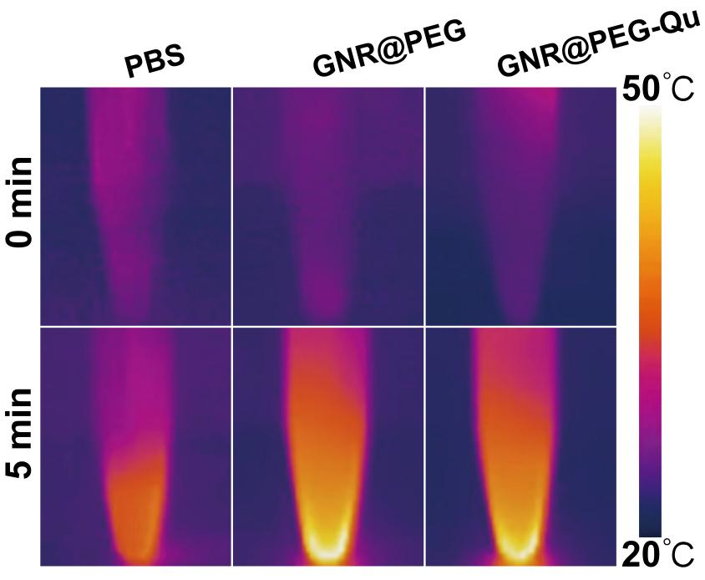
Figure S1. Thermal imaging of PBS, GNR@PEG and GNR@PEG-Qu nanoparticles under irradiation.
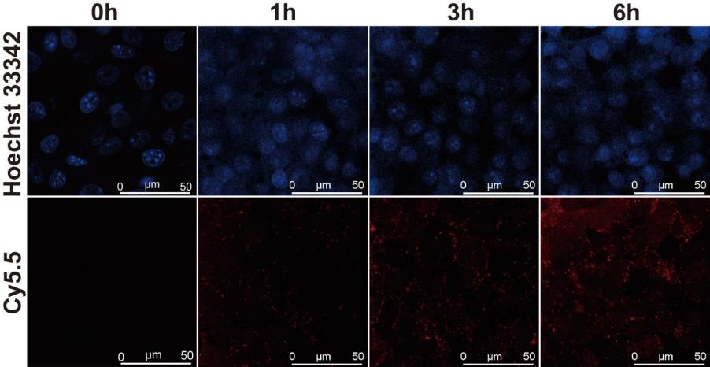
Figure S2. Location and distribution of nuclei (blue) and GNR@PEG-Qu (red) in cellular uptake experiments.
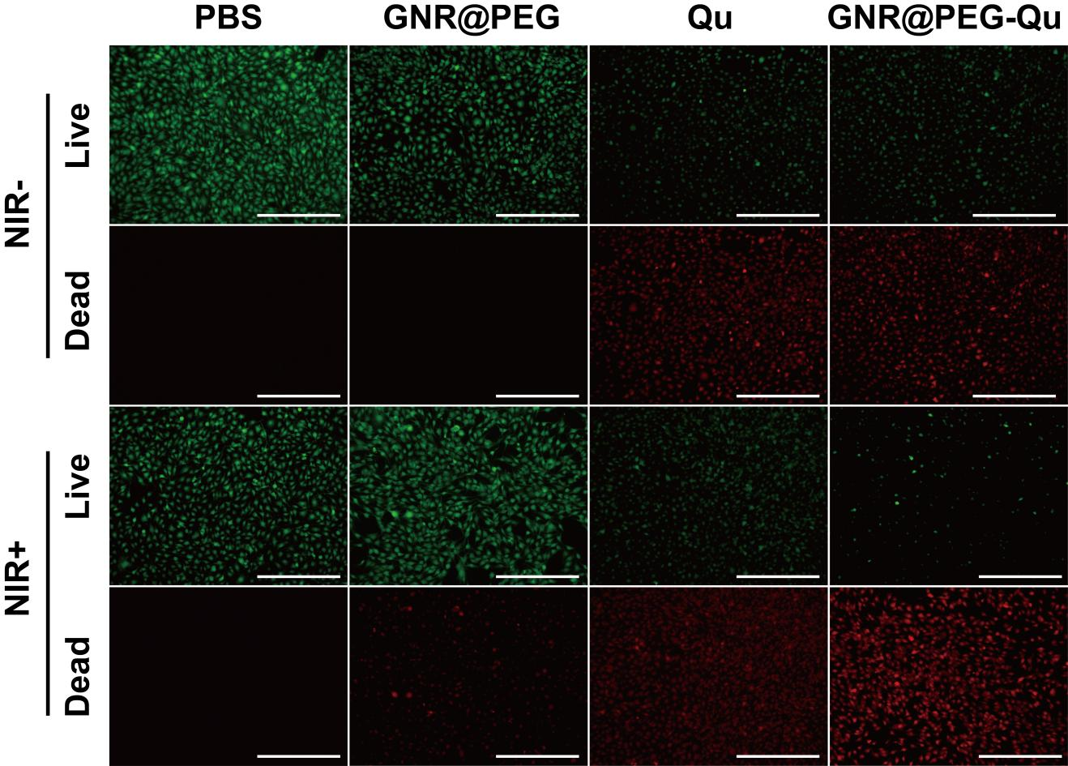
Figure S3. Live/dead staining of B16F10 cell lines after different treatments. Scale bar = 400 µm.
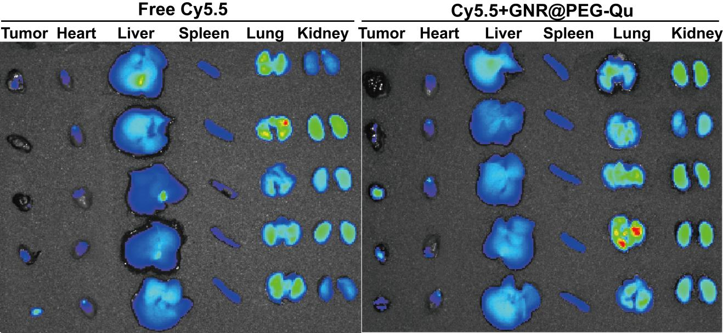
Figure S4. Fluorescence images of major organs and tumors removed in tumor-bearing mice 24 hours after administration.
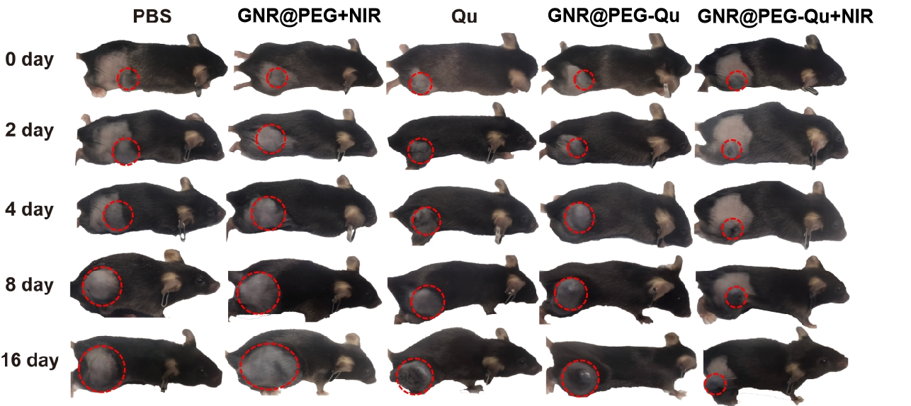
Figure S5. Typical photographs of mice to evaluate the tumor growth inhibition after various treatments.

