Supplementary material

Supplement 1: Cut-off values defining dose categories. 2
Supplement 2: ATC-codes per condition 3
Supplement 3: Models’ functional form 4
Supplement 4: Lasagna plots 6
Supplement 5: Start step per subgroup 11
Supplement 6: First to last step matrices for atopic disease, cardiovascular diseases, mental health problems, and peptic ulcer & gastroesophageal reflux disease subgroups. 12

Supplement 1: Cut-off values defining dose categories
Generic drug name | Inhaler type | Low daily dose (mcg) | Medium daily dose (mcg) | High daily dose (mcg)
Beclomethasone | Aerosol  Dry powder  Aerosol (extra fine) | < 600  < 600  < 300 | ≥ 600 - < 900  ≥ 600 - < 1200  ≥ 300 - < 600 | ≥ 900  ≥ 1200  ≥ 600
Budesonide | Aerosol  Dry powder | < 600  < 600 | ≥ 600 - < 1200  ≥ 600 - < 1200 | ≥ 1200  ≥ 1200
Fluticasone | Aerosol  Dry powder | < 375  < 350 | ≥ 375 - < 750  ≥ 350 - < 750 | ≥ 750  ≥ 750
Ciclesonide | Aerosol | < 120 | ≥ 120 - < 400 | ≥ 400
Beclomethasone/formoterol | Aerosol/  Dry powder | ≤ 200/12 | ≥ 300/12 - ≤ 500/30 | ≥ 600/18
Budesonide/formoterol | Aerosol/  Dry powder | ≤ 400/24 | ≥ 480/13.5 - ≤ 1000/48 | ≥ 1200/36
Fluticasone/salmeterol | Aerosol  Dry powder | ≤ 300/150  ≤ 300/150 | ≥ 375/50 - ≤ 625/225  ≥ 400/50 - ≤ 600/300 | ≥ 750/75  ≥ 750/100
Fluticasone/vilanterol | Dry powder | ≤ 92/22 | ≥ 184/22 - ≤ 184/44 | ≥ 368/44
Budesonide/salmeterol | Dry powder | ≤ 240/40 | ≥ 480/40 | -
Fluticasone/formoterol | Aerosol | ≤ 250/20 | ≥ 375/15 - ≤ 500/20 | ≥ 750/30
Abbreviations: mcg, microgram. Note: For ICS/LABA, the ICS dosages are leading.

Supplement 2: ATC-codes per condition
Drugs used for… | ATC-codes
Arthritis | M01 or M02
Atopic diseasesª | D07, D11AH, R01AC, R01AD, R06, S01GX
Cardiovascular disease | C01AA05, C01DA, C02, C03, C07, C08, C09
Diabetes | A10
Mental health problems^{b} | N05B, N05C, N06A, N06D
Peptic ulcer and GERD | A02B
Thyroid disease | H03
Immunosuppressants | L01, L04, J05A
Abbreviations: ATC-codes = Anatomic Therapeutic Chemical -codes, GERD = gastroesophageal reflux disease.
ª Includes allergies, allergic rhinitis, allergic conjunctivitis, and dermatitis
^{b} Includes depression and dementia

Supplement 3: Models’ functional form

The models’ functional form was determined by the following procedure. The inclusion of variables was based on expert knowledge and availability of data. Several variations of the model (e.g. with or without splines and interactions) were visually compared to the empirical data based on the proportions per treatment step for each month of follow-up. To guard against overfitting, we used a measure of fit (the proportions per treatment step for each month of follow-up) that does not have a one-to-one relation with the outcomes of interest (proportion of individuals switching, time until first switch, and number of switches) but is sufficiently indicative of population trajectories.
Evaluation methods commonly used in machine learning for predictive modelling, such as cross-validation might be recommended and should be explored.

Variable list
Startyear – year at baseline, continuous
ns(startyear, df=4) – natural spine with 4 degrees of freedom
Startage – age at baseline, standardized, continuous
Sex – binary (0 = female, 1 = male)
Diabetes, cardiovascular disease, mental health problems, arthritis, thyroid disease, atopic disease, GERD, immunosuppressants – binary (0 = absent, 1 = present)
Startstep – factor variable of treatment step at baseline
l.[variable] – lagged variable; indicates that this information comes from the previous time point, eg. if you are predicting timepoint t, then l.step2 indicates whether the treatment step at timepoint t-1 equals step 2 or not.
steptimer – indicates how long someone has been in the current treatment step and starts recounting when they switch to another step; continuous, linear, 1 unit increase per month
step0, step2, step3, step4 – dummy variables indicating treatment step, step 1 is used as reference (thus if others are all 0, then step1 is implied); binary

Natural course

outcome ~ # time constant variables #
splines::ns(startyear, df=4) + startage +
startstep # coded as factor # +
sex + diabetes + cardiovascular disease + mental health problems + arthritis +
thyroid disease + atopic disease + GERD + immunosuppressants +

# time varying variables #
splines::ns(time,df=5) +
l.steptimer +
l.step2 + l.step2*l.steptimer +
l.step3 + l.step3*l.steptimer +
l.step4 + l.step4*l.steptimer +
l.step0 + l.step0*l.steptimer
# step 1 is reference category

Counter factual scenario’s

Condition = sex, diabetes, cardiovascular disease, mental health problems, arthritis, thyroid disease, atopic disease, GERD, immunosuppressants (one condition per model execution).

outcome ~ # time constant variables #
splines::ns(startyear, df=4) + startage +
startstep # coded as factor # +
sex + diabetes + cardiovascular disease + mental health problems + arthritis +
thyroid disease + atopic disease + GERD + immunosuppressants +

# time varying variables #
splines::ns(time,df=5) +
condition *
(l.steptimer +
l.step2 + l.step2*l.steptimer +
l.step3 + l.step3*l.steptimer +
l.step4 + l.step4*l.steptimer +
l.step0 + l.step0*l.steptimer )
# step 1 is reference category

Supplement 4: Lasagna plots
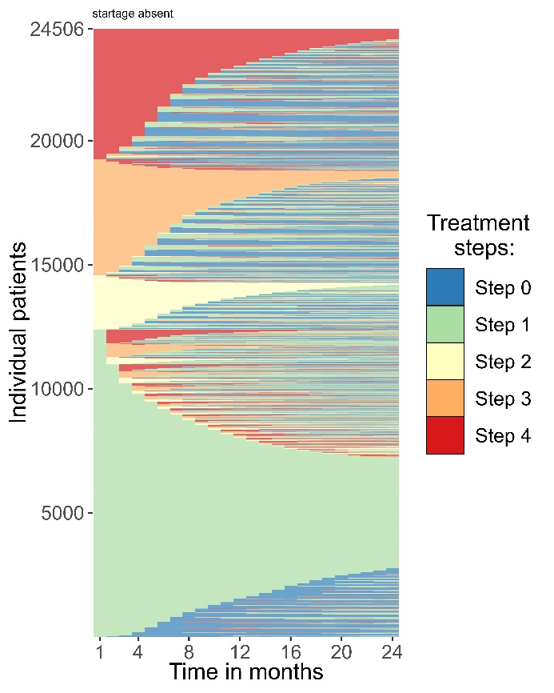
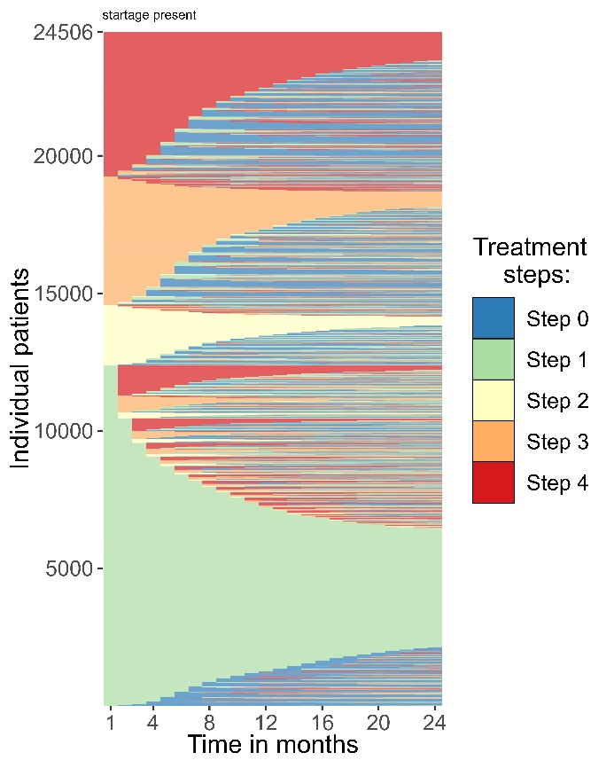
16 years old at initiation 45 years old at initiation

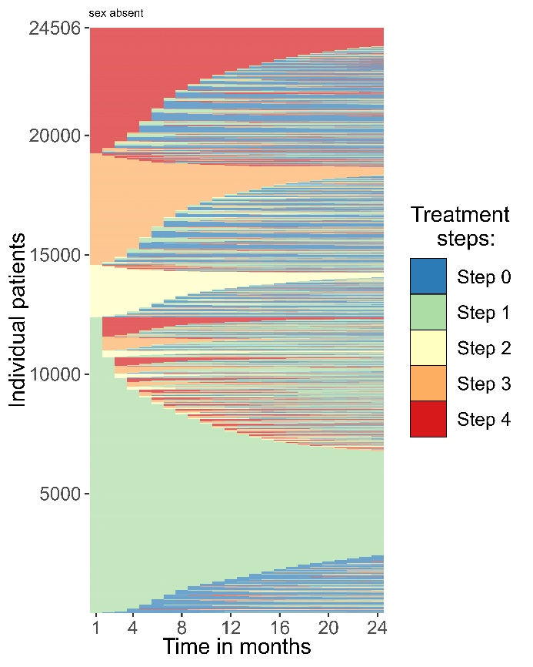
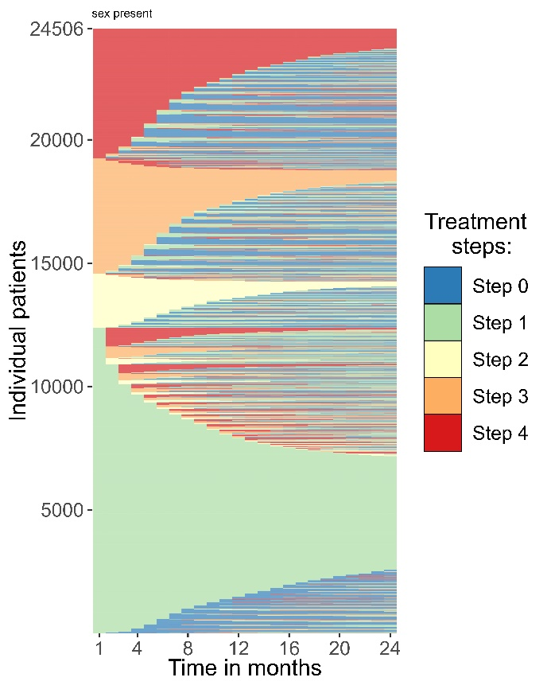
Sex female Sex male
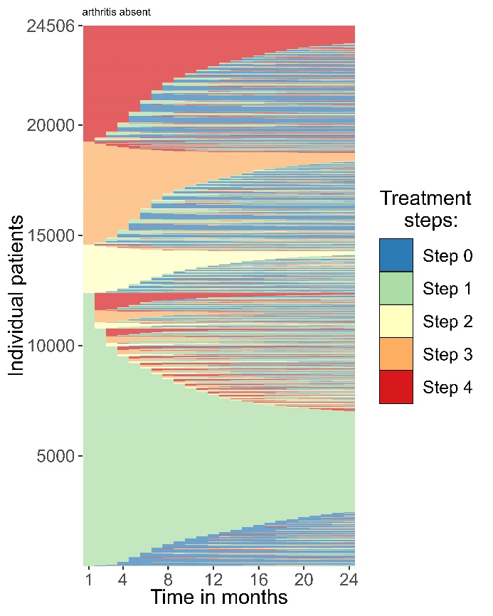
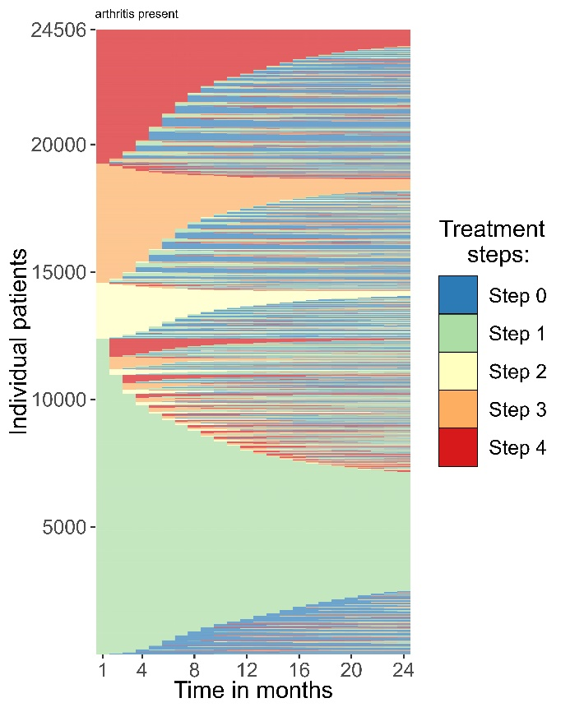
Arthritis absent Arthritis present

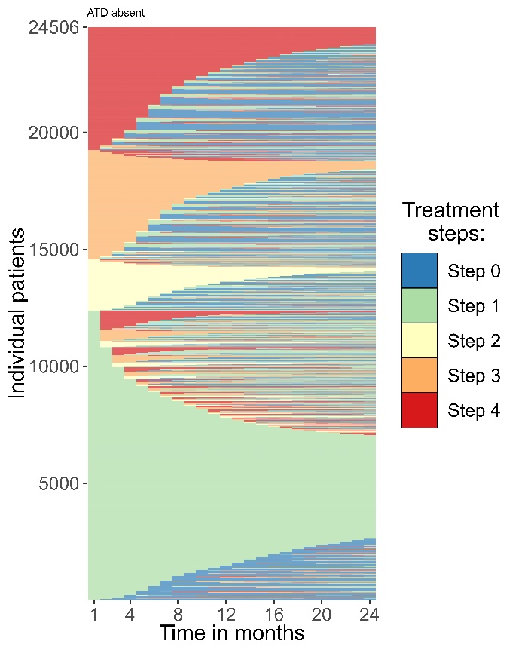
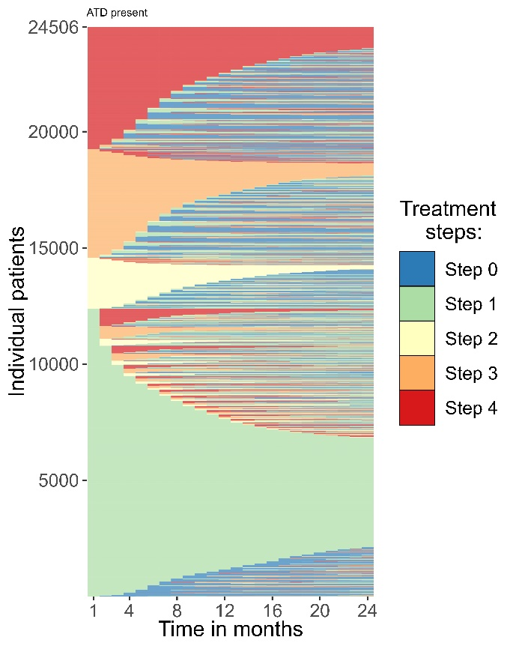
Atopic diseases absent Atopic diseases present

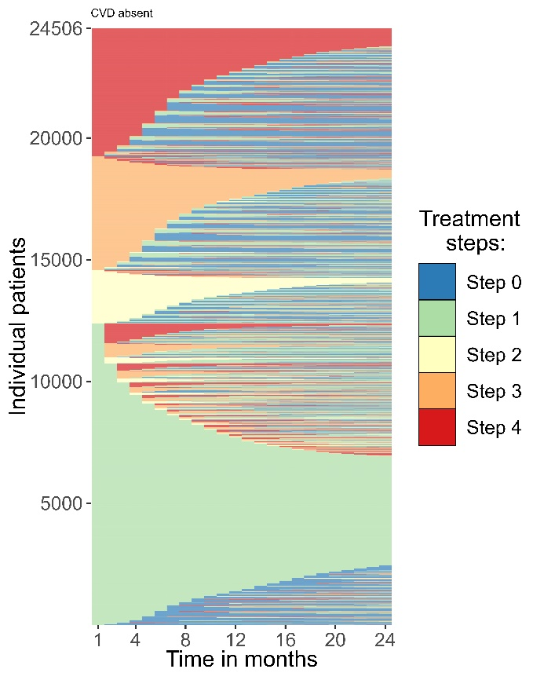
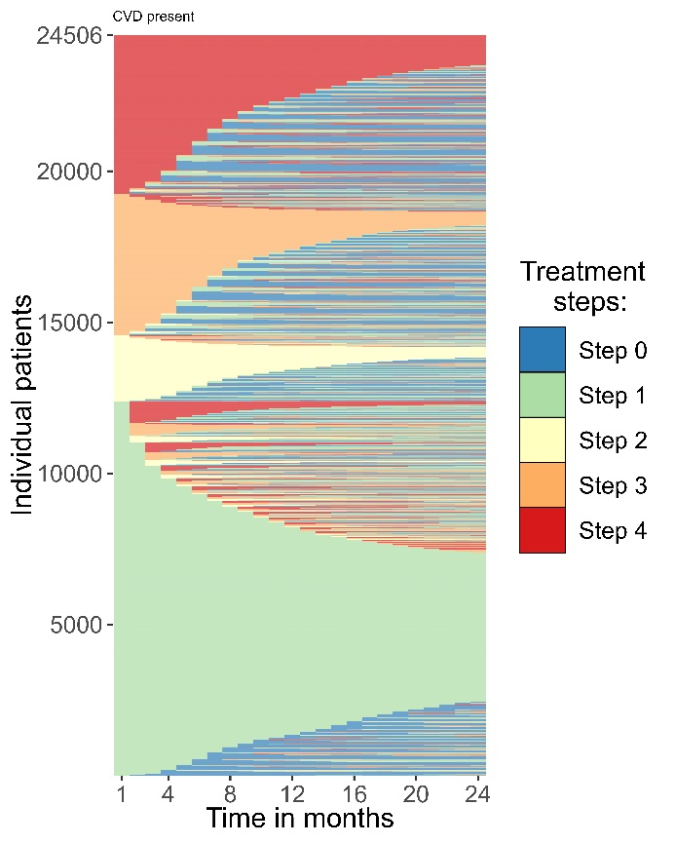
Cardiovascular diseases absent Cardiovascular diseases present

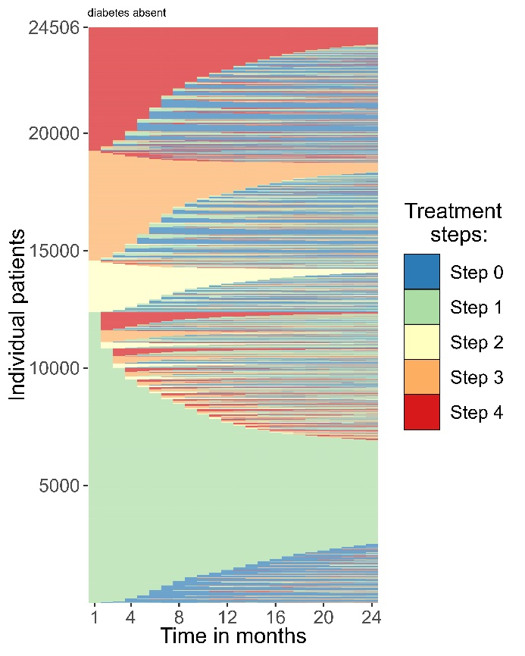
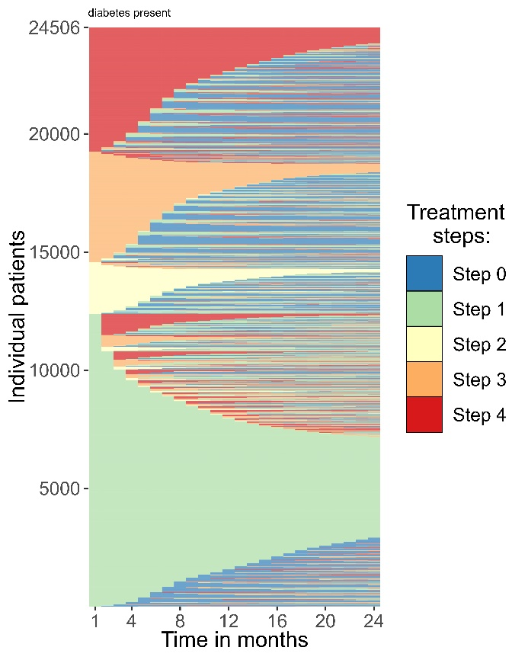
Diabetes absent Diabetes present

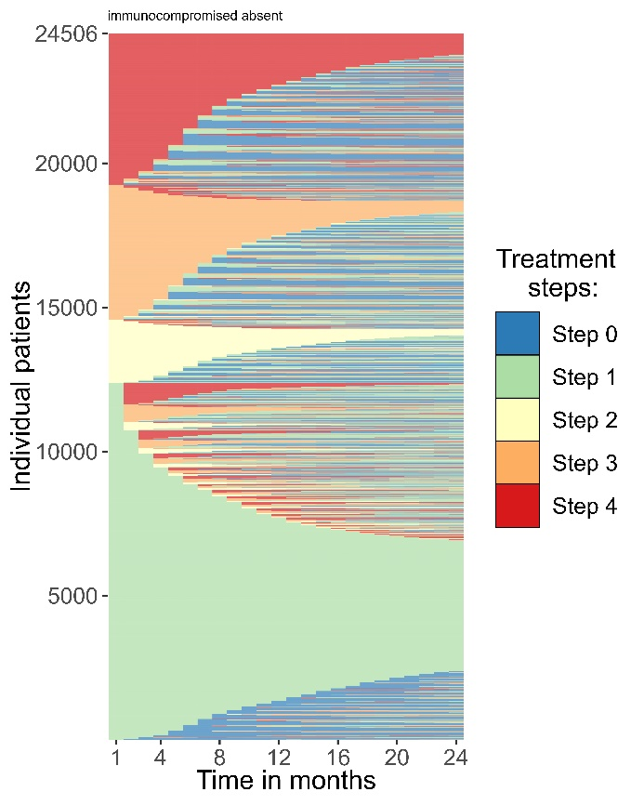
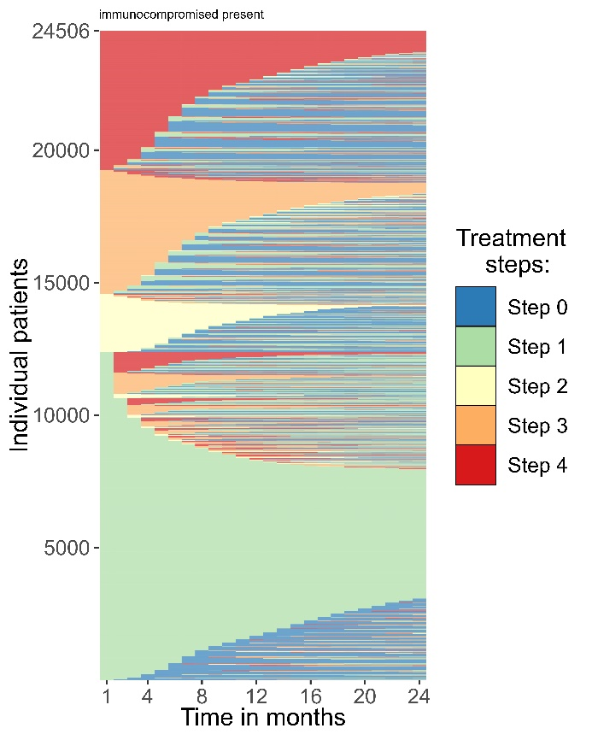
Immunosuppressants absent Immunosuppressants present

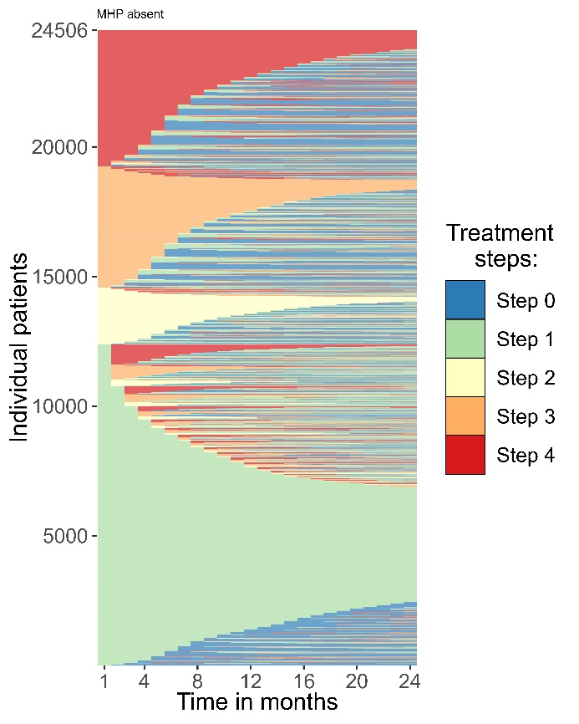
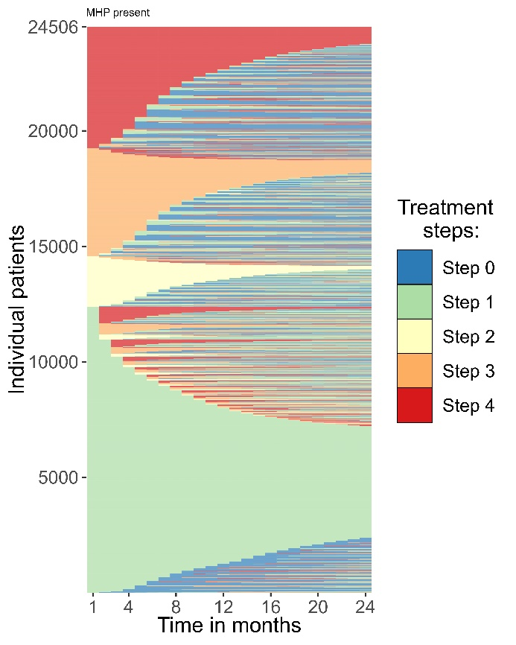
Mental health problems absent Mental health problems present

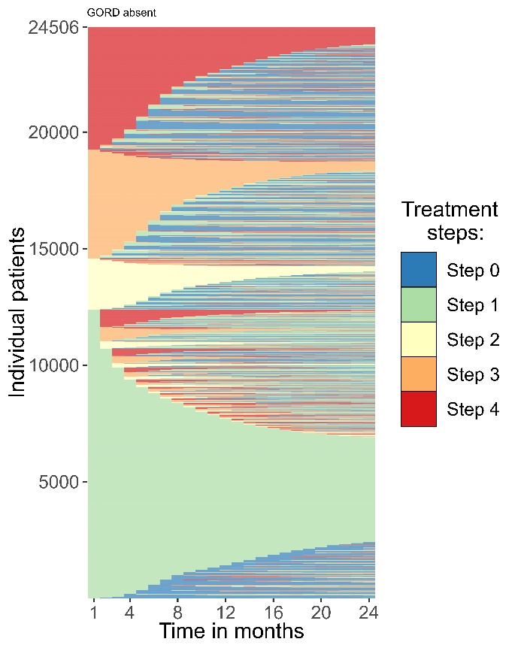
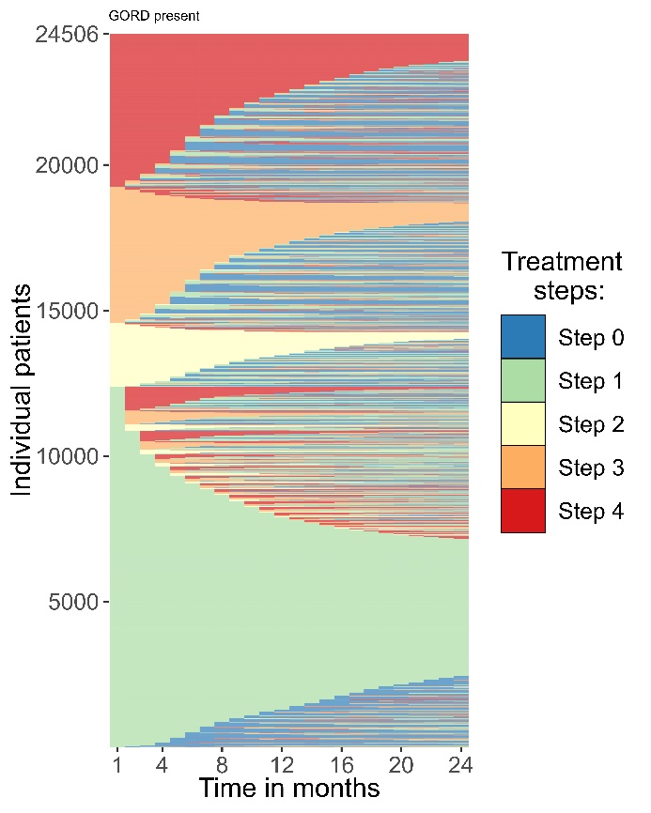
Peptic ulcer & GERD absent Peptic ulcer & GERD present

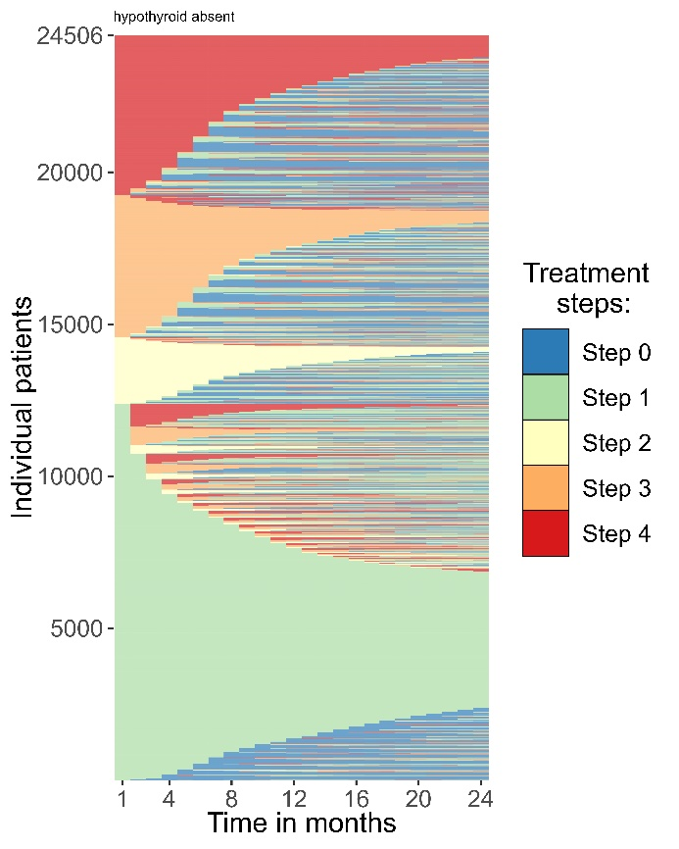
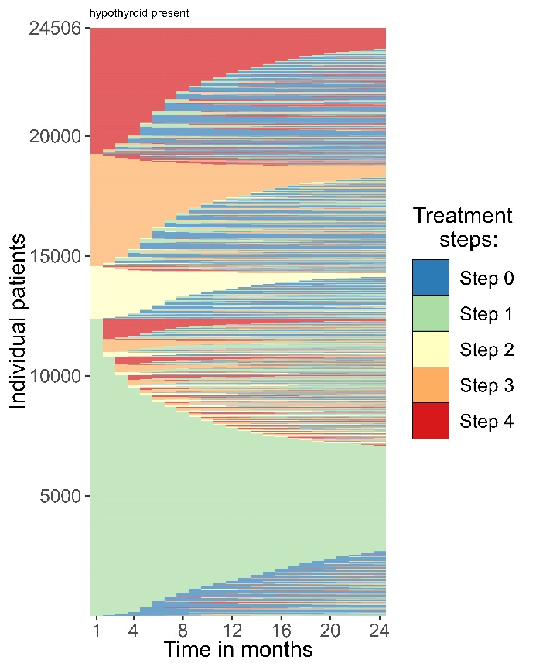
Thyroid disease absent Thyroid disease present

Supplement 5: Start step per subgroup
Altered condition | Mean step | Step 1  % | Step 2  % | Step 3  % | Step 4  %
Age  Below average  Above average | 2.0  2.2 | 55.0  46.9 | 9.7  8.3 | 17.6  20.4 | 17.8  24.4
Sex  Female  Male | 2.1  2.2 | 50.9  49.9 | 9.4  8.0 | 19.6  18.2 | 20.1  23.9
Arthritis  Absent  Present | 2.1  2.1 | 50.5  51.0 | 9.0  8.2 | 19.2  18.3 | 21.3  22.5
Atopic diseases  Absent  Present | 2.1  2.1 | 50.4  50.8 | 8.8  9.4 | 18.9  20.0 | 21.9  19.9
Cardiovascular diseases  Absent  Present | 2.1  2.3 | 50.9  45.4 | 9.0  7.3 | 19.1  20.2 | 21.0  27.2
Diabetes  Absent  Present | 2.1  2.1 | 50.5  52.7 | 9.0  5.0 | 19.2  18.3 | 21.4  24.0
Immunosuppressants  Absent  Present | 2.1  2.1 | 50.5  52.3 | 9.0  4.6 | 19.1  19.0 | 21.4  24.1
Mental health problems  Absent  Present | 2.1  2.1 | 50.5  50.6 | 9.1  7.9 | 19.2  18.5 | 21.2  22.9
Peptic ulcer & GERD  Absent  Present | 2.1  2.2 | 50.7  48.8 | 9.1  7.3 | 19.2  18.8 | 21.0  25.1
Thyroid disease  Absent  Present | 2.1  2.2 | 50.5  49.8 | 8.9  9.0 | 19.2  16.3 | 21.3  24.9
Abbreviations: CI = Confidence interval, GERD = gastroesophageal reflux disease.

Supplement 6: First to last step matrices for atopic diseases, cardiovascular diseases, mental health problems, and peptic ulcer & gastroesophageal reflux diseases
 | Without atopic diseases |  |  |  |  | With atopic diseases
From:  To: | Step 1 | Step 2 | Step 3 | Step 4 |  | Step 1 | Step 2 | Step 3 | Step 4
step0 | 23.5 | 40.0 | 46.5 | 46.8 |  | 19.5 | 39.4 | 39.9 | 40.2
step1 | 59.7 | 30.5 | 25.2 | 21.7 |  | 61.2 | 29.3 | 26.0 | 22.8
step2 | 3.2 | 17.0 | 2.4 | 0.9 |  | 3.9 | 17.5 | 3.0 | 1.2
step3 | 5.2 | 5.8 | 18.5 | 3.1 |  | 6.1 | 6.5 | 22.7 | 3.7
step4 | 8.3 | 6.6 | 7.3 | 27.5 |  | 9.3 | 7.2 | 8.5 | 32.1
 | Without cardiovascular diseases |  |  |  |  | With cardiovascular diseases
From:  To: | Step 1 | Step 2 | Step 3 | Step 4 |  | Step 1 | Step 2 | Step 3 | Step 4
step0 | 22.8 | 40.1 | 44.9 | 45.9 |  | 21.2 | 36.3 | 45.1 | 41.7
step1 | 60.1 | 30.4 | 25.6 | 22.1 |  | 59.8 | 25.3 | 22.5 | 20.4
step2 | 3.4 | 16.7 | 2.6 | 1.1 |  | 3.4 | 24.9 | 2.6 | 0.8
step3 | 5.4 | 6.1 | 19.4 | 3.2 |  | 5.8 | 5.8 | 21.3 | 3.4
step4 | 8.4 | 6.7 | 7.5 | 27.9 |  | 9.8 | 7.6 | 8.6 | 33.7
 | Without mental health problems |  |  |  |  | With mental health problems
From:  To: | Step 1 | Step 2 | Step 3 | Step 4 |  | Step 1 | Step 2 | Step 3 | Step 4
step0 | 22.9 | 40.2 | 45.3 | 45.9 |  | 21.3 | 37.9 | 42.8 | 43.4
step1 | 59.6 | 29.7 | 25.3 | 21.4 |  | 62.3 | 33.1 | 25.8 | 24.4
step2 | 3.5 | 17.6 | 2.7 | 1.1 |  | 2.7 | 14.6 | 2.0 | 0.8
step3 | 5.4 | 5.8 | 19.1 | 3.2 |  | 5.6 | 6.9 | 22.0 | 3.4
step4 | 8.6 | 6.7 | 7.6 | 28.5 |  | 8.2 | 7.6 | 7.4 | 28.1
 | Without peptic ulcer & GERD |  |  |  |  | With peptic ulcer & GERD
From:  To: | Step 1 | Step 2 | Step 3 | Step 4 |  | Step 1 | Step 2 | Step 3 | Step 4
step0 | 22.8 | 40.2 | 45.3 | 45.9 |  | 21.0 | 36.7 | 41.3 | 41.8
step1 | 60.0 | 30.1 | 25.6 | 22.0 |  | 60.2 | 31 | 23.8 | 20.9
step2 | 3.4 | 17.1 | 2.6 | 1.0 |  | 2.8 | 17.1 | 2.1 | 0.8
step3 | 5.4 | 5.9 | 19.1 | 3.2 |  | 5.7 | 6.6 | 23.8 | 3.2
step4 | 8.3 | 6.6 | 7.4 | 27.9 |  | 10.2 | 8.6 | 9.1 | 33.3
Abbreviations: GERD = gastroesophageal reflux disease.

