Supplementary Figure S1: Time trends of PHF treatment during COVID-19 pandemic in Germany. Reference values were given by pooled data from 2010-2019.
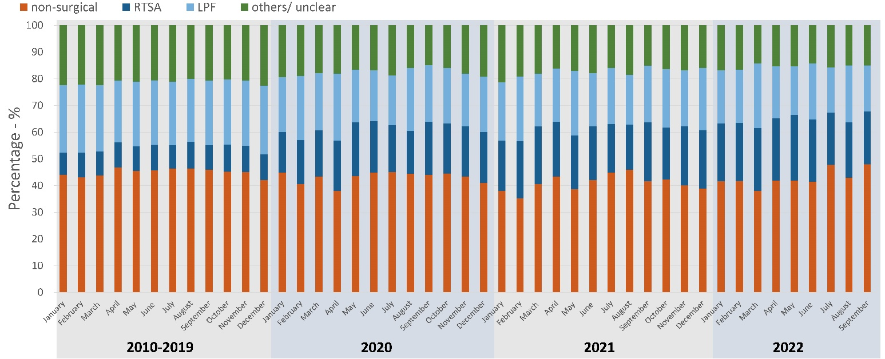

Supplementary Figure S2: In-hospital outcome depending on SARS-CoV-19 infection during hospital stay stratified by non-surgical (A) and surgical treatment (B).
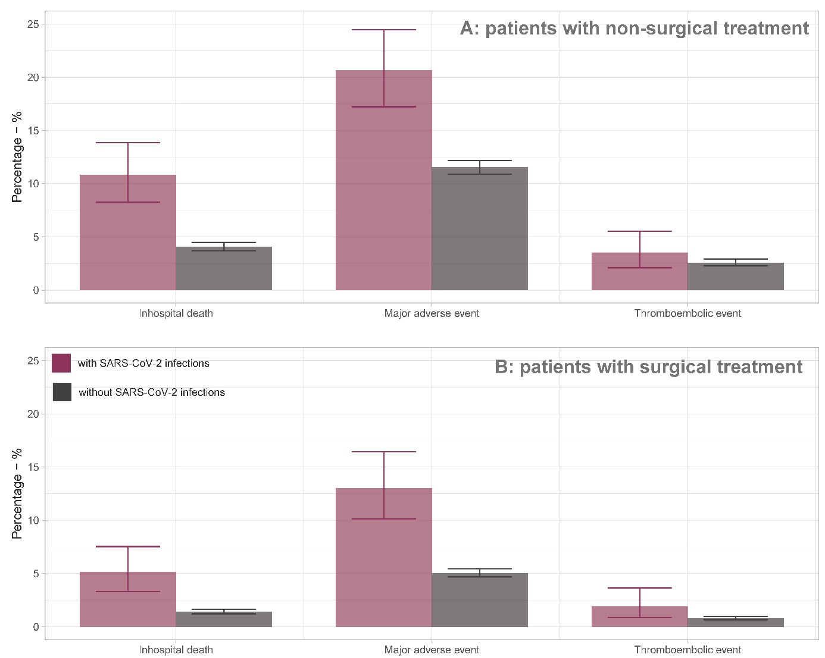

Supplementary Table S1: Regression models for in-hospital outcomes.
 | Regression parameter β | 95% confidence interval | P value
Inhospital death
Length of hospital stay (per day) | -0.01 | (-0.02; -0.00) | 0.008
SARS-CoV-19 infection during hospital stay | 1.03 | (0.75; 1.31) | <0.001
Year index 2021 vs 2020 | 0.01 | (-0.19; 0.20) | 0.944
Year index 2022 vs 2020 | 0.04 | (-0.16; 0.25) | 0.673
Male sex | 0.64 | (0.45; 0.83) | <0.001
Age at PHF (per year) | 0.08 | (0.07; 0.95) | <0.001
Osteoporosis | -0.36 | (-0.61;-0.10) | <0.001
Cancer | 1.53 | (1.22; 1.83) | <0.001
Diabetes mellitus | 0.13 | (-0.06;0.33) | 0.180
Dementia | 0.65 | (0.41; 0.88) | <0.001
Chronic polyarthritis | 0.38 | (-0.16; 0.91) | 0.172
Obesity | -0.42 | (-0.89; 0.06) | 0.087
Nicotine abuse | 0.61 | (-0.25; 1.46) | 0.167
Parkinson | 0.27 | (-0.14; 0.68) | 0.191
Rotator cuff rupture | -0.26 | (-0.88; 0.36) | 0.414
Alcohol abuse | 1.34 | (0.88; 1.81) | <0.001
Atrial fibrillation and flutter | 0.43 | (0.24; 0.62) | <0.001
Hypertension | 0.44 | (0.26; 0.62) | <0.001
Chronic heart failure | 1.30 | (1.10; 1.51) | <0.001
Coronary heart disease | 0.31 | (0.10; 0.52) | 0.004
Atherosclerosis | -0.10 | (-0.51; 0.31) | 0.642
Chronic kidney disease | 0.32 | (0.13; 0.51) | 0.001
Surgical treatment | -0.53 | (-0.71; -0.35) | <0.001
Intercept | -10.60 | (-11.70; 9.49) | <0.001
Major adverse event
Length of hospital stay (per day) | 0.03 | (0.03; 0.04) | <0.001
SARS-CoV-19 infection during hospital stay | 0.36 | (0.14; 0.57) | 0.001
Year index 2021 vs 2020 | 0.00 | (-0.12; 0.12) | 0.973
Year index 2022 vs 2020 | -0.07 | (-0.2; 0.06) | 0.288
Male sex | 0.46 | (0.34; 0.59) | <0.001
Age at PHF (per year) | 0.04 | (0.03; 0.04) | <0.001
Osteoporosis | -0.25 | (-0.40; -0.09) | 0.002
Cancer | 0.76 | (0.52; 1.00) | <0.001
Diabetes mellitus | -0.32 | (-0.45; -0.20) | <0.001
Dementia | 0.49 | (0.32; 0.66) | <0.001
Chronic polyarthritis | 0.27 | (-0.08; 0.61) | 0.125
Obesity | -0.08 | (-0.31; 0.16) | 0.515
Nicotine abuse | 0.28 | (-0.29; 0.86) | 0.331
Parkinson | 0.03 | (-0.24; 0.30) | 0.835
Rotator cuff rupture | 0.05 | (-0.29; 0.40) | 0.761
Alcohol abuse | 0.91 | (0.59; 1.23) | <0.001
Atrial fibrillation and flutter | 0.48 | (0.36; 0.60) | <0.001
Hypertension | 0.16 | (0.04; 0.27) | 0.010
Chronic heart failure | 0.79 | (0.66; 0.92) | <0.001
Coronary heart disease | 0.35 | (0.21; 0.49) | <0.001
Atherosclerosis | -0.23 | (-0.48; 0.02) | 0.070
Chronic kidney disease | 0.64 | (0.52; 0.76) | <0.001
Surgical treatment | -0.57 | (-0.67; -0.46) | <0.001
Intercept | -6.24 | (-6.90; -5.58) | <0.001
Thromboembolic event
Length of hospital stay (per day) | 0.040 | (0.03; 0.05) | <0.001
SARS-CoV-19 infection during hospital stay | -0.09 | (-0.55; 0.37) | 0.710
Year index 2021 vs 2020 | 0.21 | (-0.07; 0.48) | 0.140
Year index 2022 vs 2020 | 0.16 | (-0.14; 0.45) | 0.302
Male sex | 0.09 | (-0.21; 0.39) | 0.545
Age at PHF (per year) | 0.00 | (-0.01; 0.02) | 0.649
Osteoporosis | -0.33 | (-0.66; 0.00) | 0.050
Cancer | 0.51 | (0.03; 0.99) | 0.038
Diabetes mellitus | -0.36 | (-0.62; -0.09) | 0.008
Dementia | 0.45 | (0.09; 0.81) | 0.014
Chronic polyarthritis | 0.37 | (-0.33; 1.07) | 0.300
Obesity | -0.28 | (-0.81; 0.25) | 0.295
Nicotine abuse | 0.29 | (-0.86; 1.45) | 0.619
Parkinson | -0.50 | (-1.25; 0.25) | 0.192
Rotator cuff rupture | 0.43 | (-0.39; 1.25) | 0.309
Alcohol abuse | -0.01 | (-0.77; 0.75) | 0.972
Atrial fibrillation and flutter | 0.39 | (0.11; 0.67) | 0.006
Hypertension | -0.10 | (-0.36; 0.16) | 0.456
Chronic heart failure | 0.36 | (0.06; 0.66) | 0.018
Coronary heart disease | -0.02 | (-0.36; 0.31) | 0.900
Atherosclerosis | -0.47 | (-0.97; 0.03) | 0.068
Chronic kidney disease | -0.01 | (-0.29; 0.27) | 0.958
Surgical treatment | -0.99 | (-1.23; -0.75) | <0.001
Intercept | -5.06 | (-6.34; -3.78) | <0.001

Supplementary Table S2: Regression models for in-hospital outcomes including interaction term SARS-CoV-19*surgical treatment.

 | Regression parameter β | 95% confidence interval | P value
Inhospital death
Length of hospital stay (per day) | -0.01 | (-0.02; 0.00) | 0.008
SARS-CoV-19 infection during hospital stay | 0.97 | (0.62; 1.31) | <0.001
Year index 2021 vs 2020 | 0.01 | (-0.19; 0.21) | 0.929
Year index 2022 vs 2020 | 0.05 | (-0.16; 0.25) | 0.662
Male sex | 0.64 | (0.45; 0.83) | <0.001
Age at PHF (per year) | 0.08 | (0.07; 0.09) | <0.001
Osteoporosis | -0.36 | (-0.61; -0.10) | 0.007
Cancer | 1.53 | (1.22; 1.83) | <0.001
Diabetes mellitus | 0.13 | (-0.06; 0.33) | 0.181
Dementia | 0.65 | (0.41; 0.89) | <0.001
Chronic polyarthritis | 0.37 | (-0.17; 0.91) | 0.175
Obesity | -0.42 | (-0.90; 0.06) | 0.085
Nicotine abuse | 0.61 | (-0.25; 1.46) | 0.165
Parkinson | 0.28 | (-0.13; 0.68) | 0.186
Rotator cuff rupture | -0.27 | (-0.89; 0.35) | 0.395
Alcohol abuse | 1.35 | (0.88; 1.81) | <0.001
Atrial fibrillation and flutter | 0.43 | (0.24; 0.62) | <0.001
Hypertension | -0.44 | (-0.62; -0.26) | <0.001
Chronic heart failure | 1.30 | (1.10; 1.51) | <0.001
Coronary heart disease | 0.31 | (0.10; 0.52) | 0.004
Atherosclerosis | 0.10 | (-0.31; 0.51) | 0.644
Chronic kidney disease | 0.32 | (0.13; 0.51) | 0.001
Surgical treatment | -0.55 | (-0.74; -0.36) | <0.001
SARS-CoV-19* Surgical treatment | 0.19 | (-0.36; 0.74) | 0.498
Intercept | -10.59 | (-11.70; -9.49) | <0.001
Major adverse event
Length of hospital stay (per day) | 0.03 | (0.03; 0.04) | <0.001
SARS-CoV-19 infection during hospital stay | 0.25 | (-0.03; 0.53) | 0.081
Year index 2021 vs 2020 | 0.00 | (-0.12; 0.13) | 0.949
Year index 2022 vs 2020 | -0.07 | (-0.20; 0.06) | 0.294
Male sex | 0.46 | (0.34; 0.59) | <0.001
Age at PHF (per year) | 0.04 | (0.03; 0.04) | <0.001
Osteoporosis | -0.25 | (-0.40; -0.09) | 0.002
Cancer | 0.76 | (0.52; 1.00) | <0.001
Diabetes mellitus | 0.32 | (0.20; 0.45) | <0.001
Dementia | 0.49 | (0.32; 0.66) | <0.001
Chronic polyarthritis | 0.27 | (-0.08; 0.61) | 0.127
Obesity | -0.08 | (-0.31; 0.15) | 0.506
Nicotine abuse | 0.29 | (-0.29; 0.86) | 0.329
Parkinson | 0.03 | (-0.24; 0.31) | 0.811
Rotator cuff rupture | 0.05 | (-0.30; 0.39) | 0.788
Alcohol abuse | 0.91 | (0.59; 1.23) | <0.001
Atrial fibrillation and flutter | 0.48 | (0.36; 0.60) | <0.001
Hypertension | -0.16 | (-0.27; -0.04) | 0.010
Chronic heart failure | 0.79 | (0.66; 0.92) | <0.001
Coronary heart disease | 0.35 | (0.21; 0.49) | <0.001
Atherosclerosis | 0.23 | (-0.02; 0.48) | 0.071
Chronic kidney disease | 0.64 | (0.52; 0.76) | <0.001
Surgical treatment | -0.59 | (-0.70; -0.48) | <0.001
SARS-CoV-19* Surgical treatment | 0.27 | (-0.12; 0.70) | 0.172
Intercept | -6.23 | (-6.89; -5.57) | <0.001
Thromboembolic event
Length of hospital stay (per day) | 0.04 | (0.03; 0.05) | <0.001
SARS-CoV-19 infection during hospital stay | -0.26 | (-0.82; 0.30) | 0.357
Year index 2021 vs 2020 | 0.21 | (-0.06; 0.49) | 0.132
Year index 2022 vs 2020 | 0.16 | (-0.14; 0.45) | 0.289
Male sex | 0.09 | (-0.20; 0.39) | 0.535
Age at PHF (per year) | 0.00 | (-0.01; 0.02) | 0.657
Osteoporosis | -0.33 | (-0.66; 0.00) | 0.050
Cancer | 0.50 | (0.02; 0.98) | 0.043
Diabetes mellitus | 0.36 | (0.10; 0.62) | 0.008
Dementia | 0.45 | (0.09; 0.81) | 0.014
Chronic polyarthritis | 0.37 | (-0.33; 1.07) | 0.301
Obesity | -0.29 | (-0.81; 0.24) | 0.288
Nicotine abuse | 0.30 | (-0.86; 1.45) | 0.617
Parkinson | -0.49 | (-1.24; 0.26) | 0.197
Rotator cuff rupture | 0.42 | (-0.40; 1.24) | 0.316
Alcohol abuse | -0.03 | (-0.79; 0.74) | 0.945
Atrial fibrillation and flutter | 0.39 | (0.11; 0.67) | 0.006
Hypertension | 0.10 | (-0.16; 0.36) | 0.445
Chronic heart failure | 0.36 | (0.06; 0.65) | 0.019
Coronary heart disease | -0.03 | (-0.36; 0.31) | 0.881
Atherosclerosis | 0.46 | (-0.04; 0.97) | 0.069
Chronic kidney disease | -0.01 | (-0.28; 0.27) | 0.959
Surgical treatment | -1.03 | (-1.27; -0.79) | <0.001
SARS-CoV-19* Surgical treatment | 0.59 | (-0.30; 1.48) | 0.192
Intercept | -5.04 | (-6.23; 3.76) | <0.001

Supplementary Table S3: Regression models for in-hospital outcomes comparing different time periods for fracture.
 | Regression parameter β | 95% confidence interval | P value
Inhospital death
Length of hospital stay (per day) | -0.00 | (-0.01; 0.00) | 0.2004
SARS-CoV-19 infection during hospital stay | 0.95 | (0.68; 1.23) | <0.001
Year index (per year) | 0.63 | (0.52; 0.73) | <0.001
Male sex | 0.08 | (0.07; 0.08) | <0.001
Age at PHF (per year) | 0.01 | (0.00; 0.03) | 0.1155
Osteoporosis | -0.31 | (-0.45; -0.18) | <0.001
Cancer | 1.44 | (1.27; 1.60) | <0.001
Diabetes mellitus | 0.16 | (0.05; 0.26) | 0.0034
Dementia | 0.37 | (0.24; 0.50) | <0.001
Chronic polyarthritis | -0.08 | (-0.45; 0.29) | 0.6666
Obesity | -0.40 | (-0.64; -0.15) | 0.0015
Nicotine abuse | 0.29 | (-0.21; 0.78) | 0.2539
Parkinson | 0.24 | (0.02; 0.46) | 0.0340
Rotator cuff rupture | -0.64 | (-1.05; -0.24) | 0.0017
Alcohol abuse | 1.16 | (0.91; 1.41) | <0.001
Atrial fibrillation and flutter | 0.58 | (0.48; 0.68) | <0.001
Hypertension | -0.54 | (-0.63; -0.45) | <0.001
Chronic heart failure | 1.25 | (1.14; 1.35) | <0.001
Coronary heart disease | 0.26 | (0.15; 0.38) | <0.001
Atherosclerosis | 0.29 | (0.09; 0.50) | 0.0057
Chronic kidney disease | 0.39 | (0.28; 0.49) | <0.001
Surgical treatment | -0.49 | (-0.59; -0.40) | <0.001
2020 vs reference period (2010-2019) | 0.0782 | (-0.10; 0.25) | 0.382
2021 vs reference period (2010-2019) | 0.0538 | (-0.13; 0.23) | 0.560
2022 vs reference period (2010-2019) | 0.0747 | (-0.13; 0.28) | 0.481
Intercept | -39.02 | (-74.58; -3.45) | 0.032
Major adverse event
Length of hospital stay (per day) | 0.04 | (0.03; 0.04) | <0.001
SARS-CoV-19 infection during hospital stay | 0.34 | (0.12; 0.56) | 0.0020
Year index (per year) | 0.07 | (0.05; 0.08) | <0.001
Male sex | 0.43 | (0.36; 0.50) | <0.001
Age at PHF (per year) | 0.04 | (0.03; 0.04) | <0.001
Osteoporosis | -0.30 | (-0.38; -0.21) | <0.001
Cancer | 0.86 | (0.73; 0.99) | <0.001
Diabetes mellitus | 0.26 | (0.19; 0.32) | <0.001
Dementia | 0.38 | (0.28; 0.47) | <0.001
Chronic polyarthritis | 0.18 | (-0.01; 0.38) | 0.0646
Obesity | -0.06 | (-0.18; 0.06) | 0.3455
Nicotine abuse | 0.15 | (-0.14; 0.45) | 0.3131
Parkinson | 0.08 | (-0.08; 0.23) | 0.3317
Rotator cuff rupture | -0.31 | (-0.51; -0.10) | 0.0038
Alcohol abuse | 1.01 | (0.85; 1.17) | <0.001
Atrial fibrillation and flutter | 0.55 | (0.48; 0.62) | <0.001
Hypertension | -0.20 | (-0.26; -0.14) | <0.001
Chronic heart failure | 0.82 | (0.75; 0.89) | <0.001
Coronary heart disease | 0.41 | (0.34; 0.49) | <0.001
Atherosclerosis | 0.33 | (0.20; 0.47) | <0.001
Chronic kidney disease | 0.63 | (0.56; 0.69) | <0.001
Surgical treatment | -0.52 | (-0.58; -0.46) | <0.001
2020 vs reference period (2010-2019) | 0.04 | (-0.07; 0.15) | 0.475
2021 vs reference period (2010-2019) | -0.03 | (-0.14; 0.09) | 0.660
2022 vs reference period (2010-2019) | -0.17 | (-0.30; -0.03) | 0.015
Intercept | -137.96 | (-161.6; -114.32) | <0.001
Thromboembolic event
Length of hospital stay (per day) | 0.03 | (0.03; 0.04) | <0.001
SARS-CoV-19 infection during hospital stay | 0.01 | (-0.41; 0.43) | 0.9639
Year index (per year) | 0.02 | (-0.01; 0.04) | 0.1521
Male sex | -0.00 | (-0.16; 0.15) | 0.9624
Age at PHF (per year) | 0.01 | (0.00; 0.02) | 0.0126
Osteoporosis | -0.27 | (-0.45; -0.10) | 0.0017
Cancer | 0.63 | (0.36; 0.90) | <0.001
Diabetes mellitus | 0.16 | (0.02; 0.30) | 0.0225
Dementia | 0.44 | (0.26; 0.62) | <0.001
Chronic polyarthritis | 0.41 | (0.07; 0.74) | 0.0184
Obesity | -0.15 | (-0.41; 0.11) | 0.2579
Nicotine abuse | 0.43 | (-0.07; 0.94) | 0.0937
Parkinson | 0.12 | (-0.23; 0.47) | 0.5113
Rotator cuff rupture | -0.09 | (-0.54; 0.36) | 0.6860
Alcohol abuse | 0.18 | (-0.19; 0.55) | 0.3488
Atrial fibrillation and flutter | 0.57 | (0.43; 0.71) | <0.001
Hypertension | 0.26 | (0.13; 0.39) | 0.0001
Chronic heart failure | 0.32 | (0.17; 0.47) | <0.001
Coronary heart disease | 0.09 | (-0.08; 0.25) | 0.3126
Atherosclerosis | 0.59 | (0.33; 0.84) | <0.001
Chronic kidney disease | -0.03 | (-0.17; 0.12) | 0.7318
Surgical treatment | -0.93 | (-1.05; -0.82) | <0.001
2020 vs reference period (2010-2019) | -0.06 | (-0.30; 0.18) | 0.626
2021 vs reference period (2010-2019) | 0.12 | (-0.12; 0.36) | 0.310
2022 vs reference period (2010-2019) | 0.06 | (-0.21; 0.33) | 0.677
Intercept | -39.37 | (-85.50; 6.76) | 0.094

Supplementary Figure S3: Time trends of outpatient incidence of PHF per 100,000/ person months during COVID-19 pandemic in Germany. Reference values were given by pooled data from 2010-2019. 7-day incidence for SARS-CoV-19 was given by the data of the Robert-Koch institute (www.rki.de/inzidenzen, as of 11.09.2022). Pandemic control policies were marked by red background.
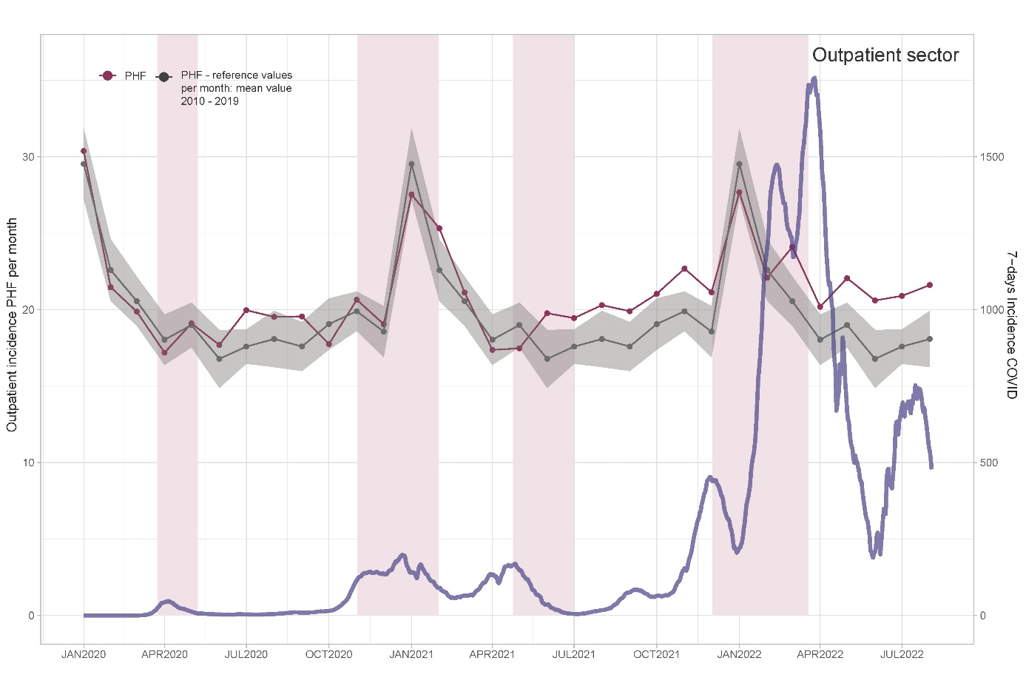

Supplementary Figure S4: The mobility flow in Germany based on mobile phone data from January 2020 to April 2022 (https://www.covid-19-mobility.org/mobility-monitor/, 25.02.2024). 