Supplement 1: Additional parts

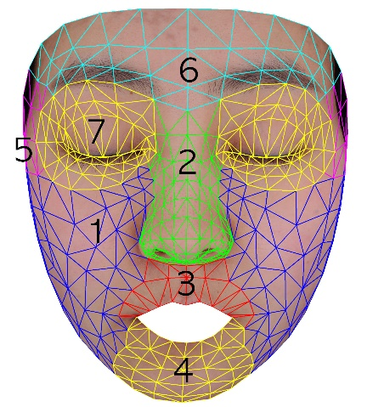
1. Both cheeks
2. Nose
3. Philtrum
4. Chin
5. Temporal
6. Forehead
7. Around the eyes

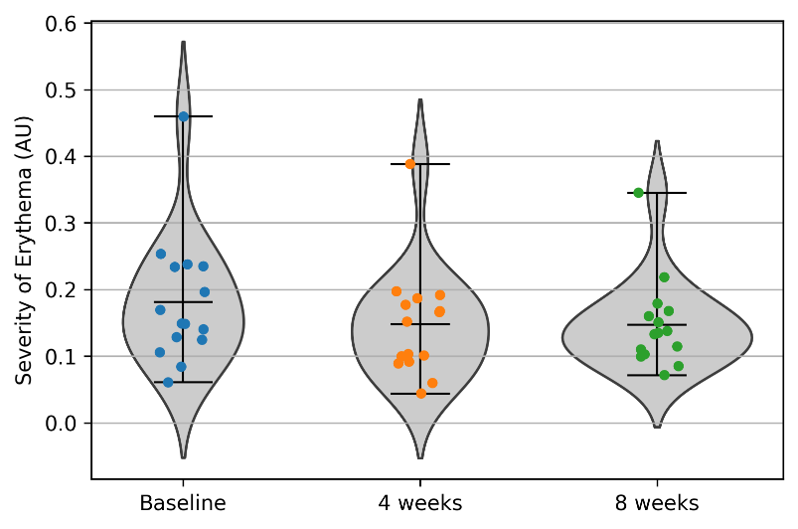
Dealing with Face
baseline mean, std = 0.181702674711902 0.09353680361966868
4 weeks mean, std = 0.14761785132859964 0.08038788796336414
8 weeks mean, std = 0.1473178902899294 0.06460307156512282
Perform the Wilcoxon signed-rank test Face
Reject the null hypothesis: There is a significant difference from the null value.
Test Statistic: 19.0
P-value: 0.01806640625
Fail to reject the null hypothesis: No significant difference from the null value.
Test Statistic: 54.0
P-value: 0.76153564453125
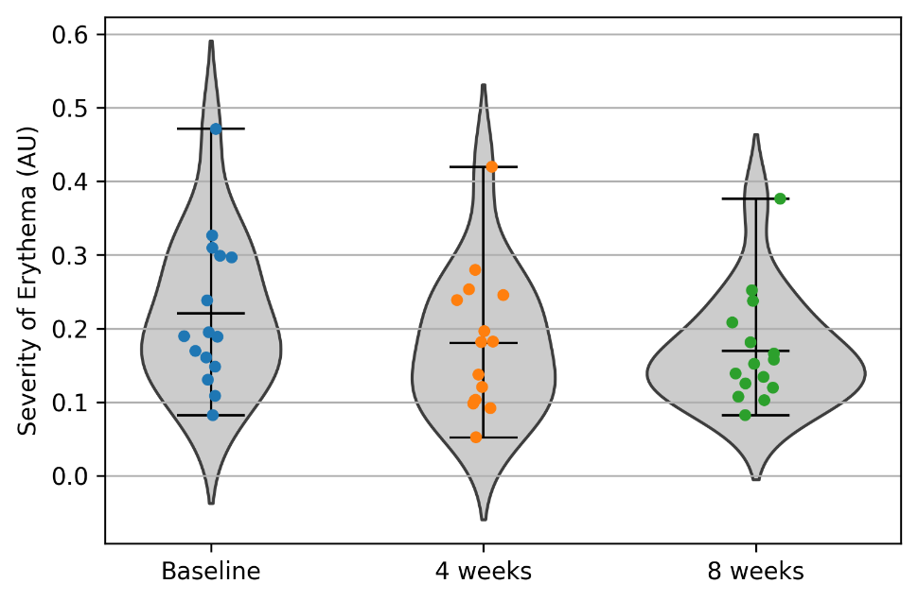
Dealing with Part1 (both cheeks)
baseline mean, std = 0.22085319769355952 0.09931352415210651
4 weeks mean, std = 0.18013722002712276 0.09267609044638604
8 weeks mean, std = 0.16937805140839923 0.07249903730432258
Perform the Wilcoxon signed-rank test Part1
Reject the null hypothesis: There is a significant difference from the null value.
Test Statistic: 17.0
P-value: 0.012451171875
Fail to reject the null hypothesis: No significant difference from the null value.
Test Statistic: 53.0
P-value: 0.7197265625
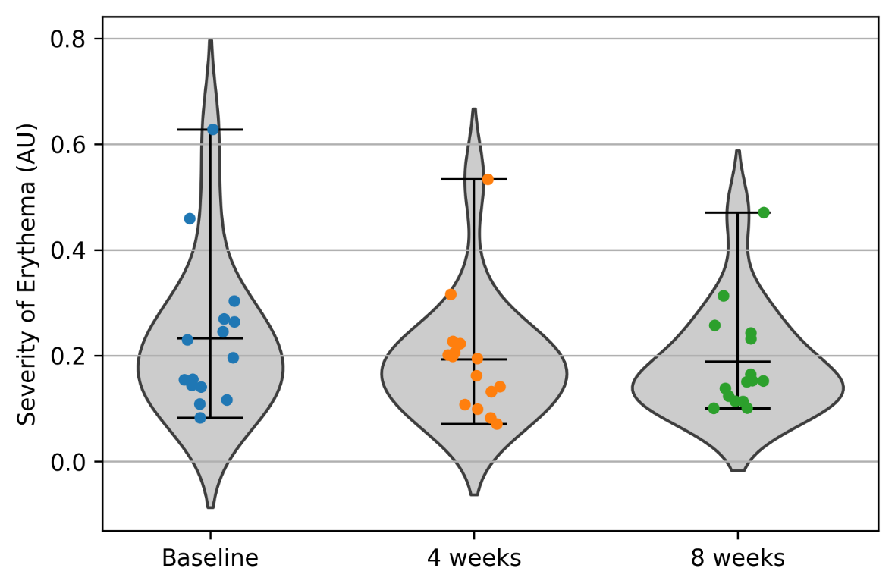
Dealing with Part2 (nose)
baseline mean, std = 0.2330071426395657 0.14042441496098448
4 weeks mean, std = 0.19290834479367405 0.11068549816524853
8 weeks mean, std = 0.1883517319218437 0.09748339930960438
Perform the Wilcoxon signed-rank test Part2
Reject the null hypothesis: There is a significant difference from the null value.
Test Statistic: 21.0
P-value: 0.02557373046875
Fail to reject the null hypothesis: No significant difference from the null value.
Test Statistic: 55.0
P-value: 0.803955078125
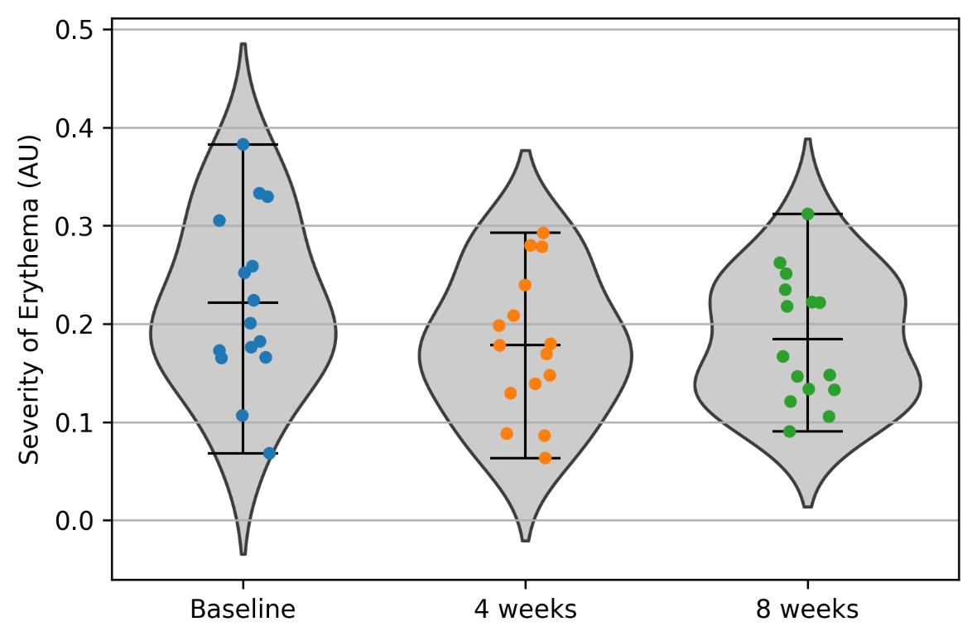
Dealing with Part3 (philtrum)
baseline mean, std = 0.22151108382960844 0.08515574094854271
4 weeks mean, std = 0.17851528802713318 0.06986813296242318
8 weeks mean, std = 0.1843897303316692 0.06357369679820767
Perform the Wilcoxon signed-rank test Part3
Reject the null hypothesis: There is a significant difference from the null value.
Test Statistic: 24.0
P-value: 0.041259765625
Fail to reject the null hypothesis: No significant difference from the null value.
Test Statistic: 53.0
P-value: 0.7197265625
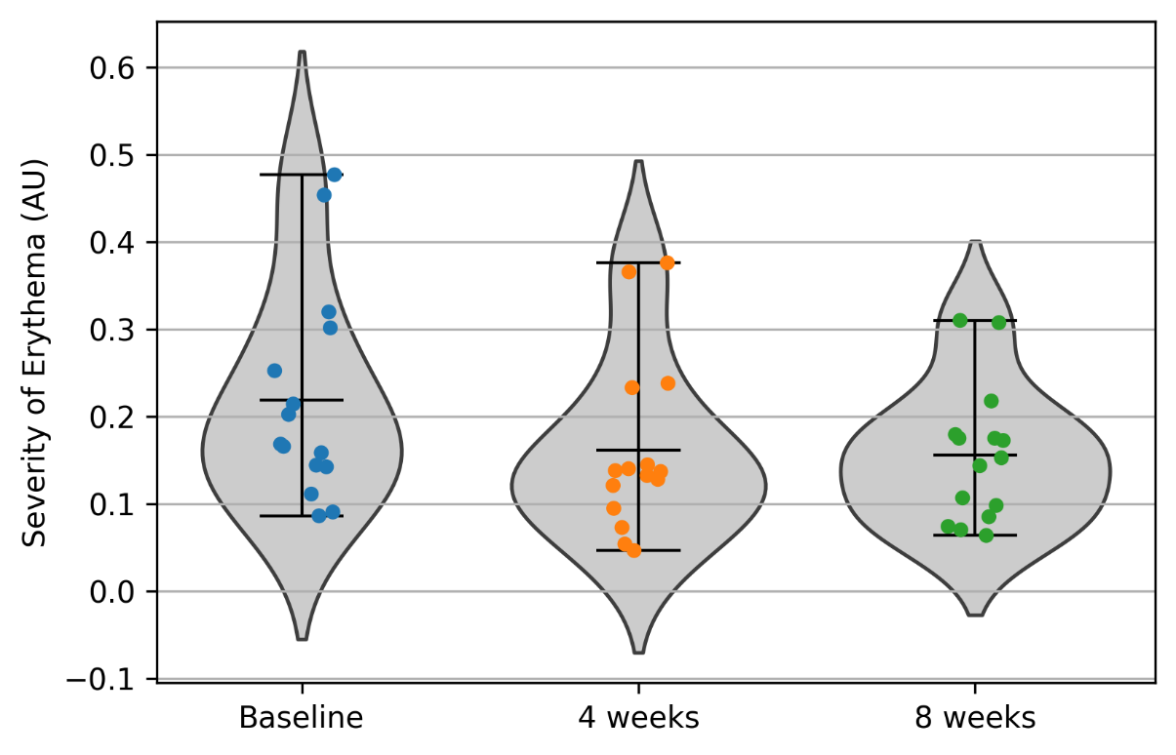
Dealing with Part4 (chin)
baseline mean, std = 0.21942429126417545 0.1172685749744974
4 weeks mean, std = 0.16167927067730162 0.09704306607556709
8 weeks mean, std = 0.15565938473850524 0.07554594159812049
Perform the Wilcoxon signed-rank test Part4
Reject the null hypothesis: There is a significant difference from the null value.
Test Statistic: 20.0
P-value: 0.02154541015625
Fail to reject the null hypothesis: No significant difference from the null value.
Test Statistic: 52.0
P-value: 0.67877197265625
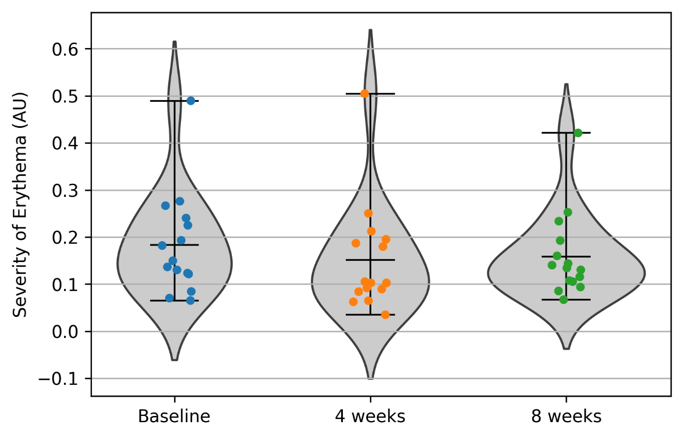
Dealing with Part5 (temporal)
baseline mean, std = 0.1836780796077728 0.10470183827142147
4 weeks mean, std = 0.15124428784972693 0.11254169234208866
8 weeks mean, std = 0.15897982639779845 0.08631259231549997
Perform the Wilcoxon signed-rank test Part5
Reject the null hypothesis: There is a significant difference from the null value.
Test Statistic: 13.0
P-value: 0.00537109375
Fail to reject the null hypothesis: No significant difference from the null value.
Test Statistic: 46.0
P-value: 0.45428466796875
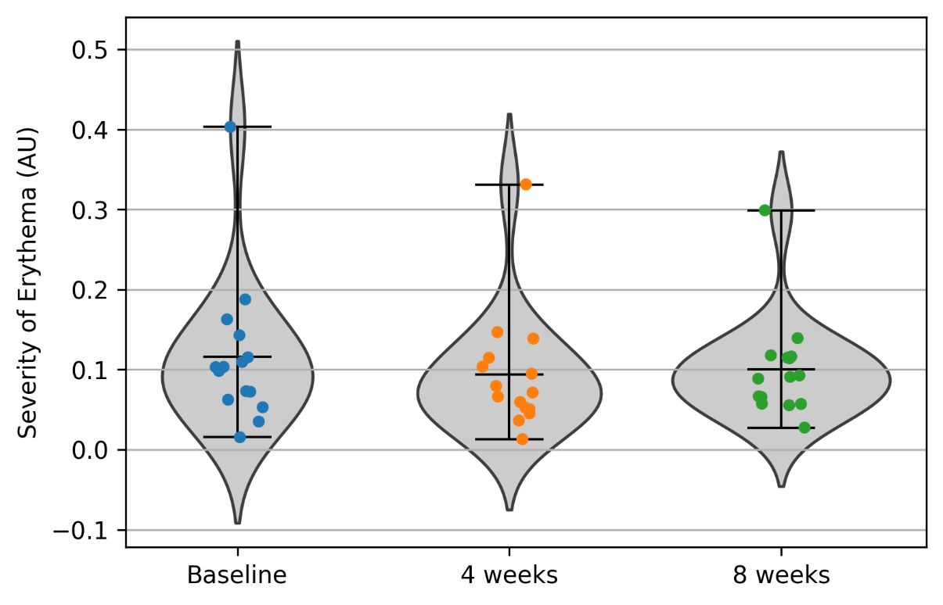
Dealing with Part6 (forehead)
baseline mean, std = 0.11580034407383985 0.08889807206447971
4 weeks mean, std = 0.09357648242419218 0.07314451118937218
8 weeks mean, std = 0.10021537724285583 0.06088984348482498
Perform the Wilcoxon signed-rank test Part6
Fail to reject the null hypothesis: No significant difference from the null value.
Test Statistic: 27.0
P-value: 0.063720703125
Fail to reject the null hypothesis: No significant difference from the null value.
Test Statistic: 39.0
P-value: 0.25238037109375
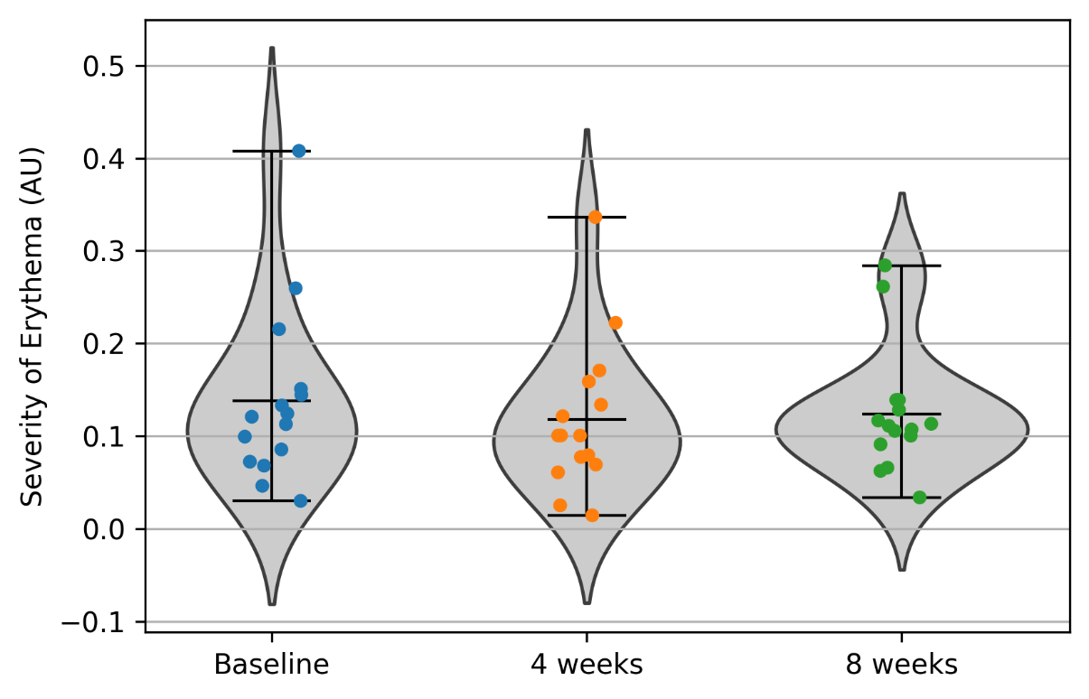
Dealing with Part7 (Around the eyes)
baseline mean, std = 0.13791094693303121 0.09255798078050262
4 weeks mean, std = 0.11796038515412342 0.07846348226871223
8 weeks mean, std = 0.12378698881629185 0.06478392509751942
Perform the Wilcoxon signed-rank test Part7
Fail to reject the null hypothesis: No significant difference from the null value.
Test Statistic: 27.0
P-value: 0.063720703125
Fail to reject the null hypothesis: No significant difference from the null value.
Test Statistic: 49.0
P-value: 0.5614013671875

