Figure S1 Elemental analysis of GASe by scanning electron microscope
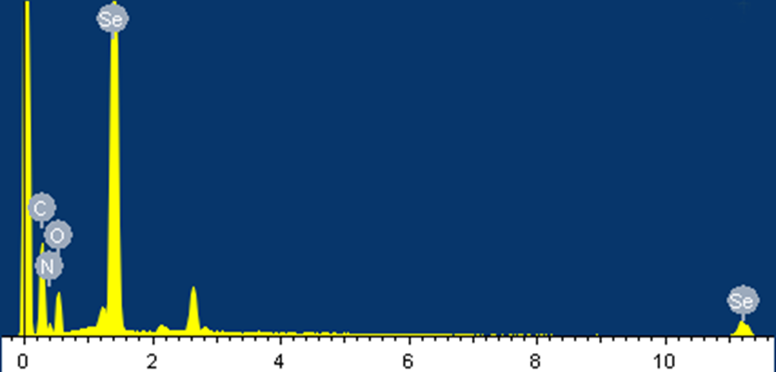

Figure S2 Time-of-flight secondary ion mass spectrogram of GASe
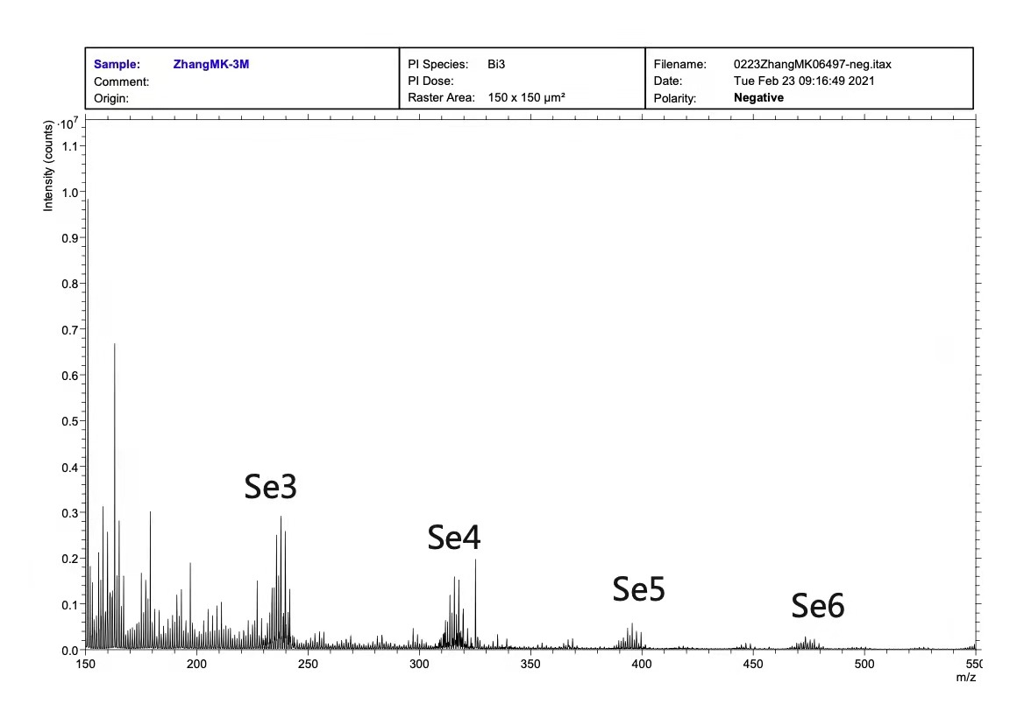

Figure S3 X-ray photoelectron spectroscopy of GASe
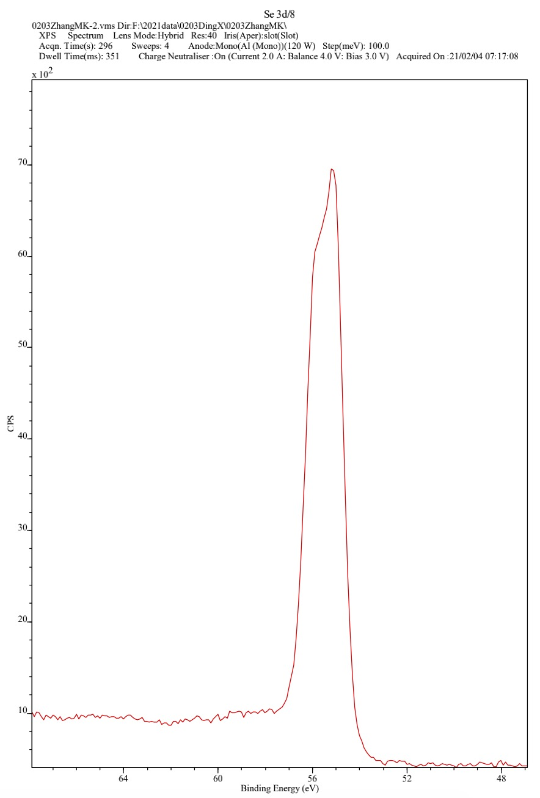
Figure S4 Evaluation of data normalization and clustering of DEGs. A, Boxplots display the distribution of normalized data in GSE87466 and GSE53306 datasets. B, Clustering heatmap of top 15 upregulated and 15 downregulated genes in GSE87466 and GSE53306 datasets.
