Advancing Heart Valve replacement: risk mitigation of Decellularized Pulmonary valve preparation for its implementation in Public Tissue Banks.
Jose Ignacio Rodríguez Martínez ^{1,2,*}, Cristina Castells-Sala ^{1,2,*}, Ana Rita. Pitera ^{1,2}, , Giulia Montagner⁴; Diletta. Trojan⁴, Pablo Martinez-Legazpi^{5,7}, Alejandra Acosta Ocampo^{6,7}, Maria Eugenia Fernández-Santos^{6,7}, Javier Bermejo^{6,7,8}, Ramadan Jashari⁻⁹, Maria Luisa Pérez^{1,3}, Elba Agustí^{1,3}, Jaime Tabera ^{1,2}, Anna Vilarrodona ^{1,3}.
- Barcelona Tissue Bank, Banc de Sang i Teixits (BST), Barcelona, Spain
- Biomedical Research Institute (IIB-Sant Pau; SGR1113), Barcelona, Spain
- Vall Hebron Institute of Research (VHIR), Barcelona, Spain
- Fondazione Banca dei Tessuti del Veneto, Treviso, Italy
- Department of Mathematical Physics and Fluids, Universidad Nacional de Educación a Distancia, UNED, Madrid, Spain.
- Department of Cardiology, Hospital General Universitario Gregorio Marañón, Gregorio Marañón Health Research Institute (IiSGM), Madrid, Spain.
- Centre for Biomedical Research in Cardiovascular Disease Network (CIBER-CV) and Red de Investigación Cooperativa Orientada a Resultados en Salud (RICORS) TERAV, from the Instituto de Salud Carlos III Madrid, Spain.
- Facultad de Medicina, Universidad Complutense, Madrid, Spain.
- European Hommograft Bank (EHB) Cliniques Universitaires Saint-Luc Bruxelles

Supplemental Material

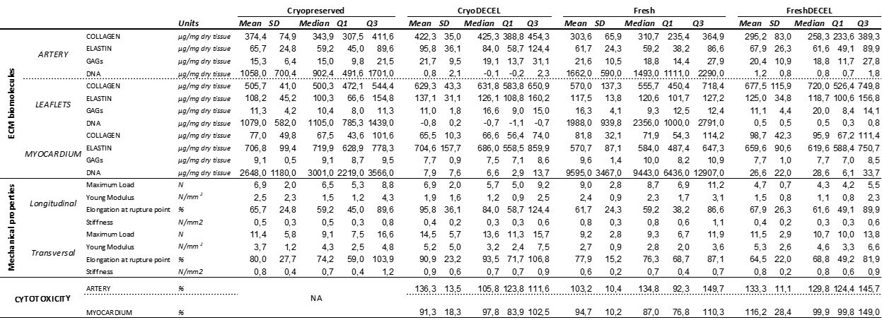
Supplemental Table 1: Mean, standard deviation (SD) and median, interquartile range (Q1 and Q3) of all quantitative variables (ECM biomolecules quantification, mechanical properties and cytotoxicity) evaluated for the four groups (cryopreserve, cryoDESCEL, fresh and freshDESCEL).
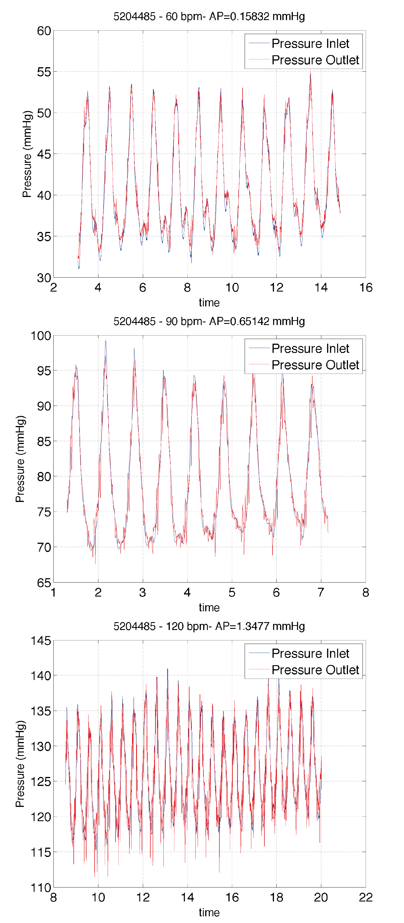
Supplemental Figure 1: Example of valve competence results at 60 (top), 90(medium) and 120 (bottom) beats per minute. Valve pressure inlet is depicted in blue, whereas pressure outlet is shown in red. Average pressure loss and opening time are calculated using the signal peak locations.
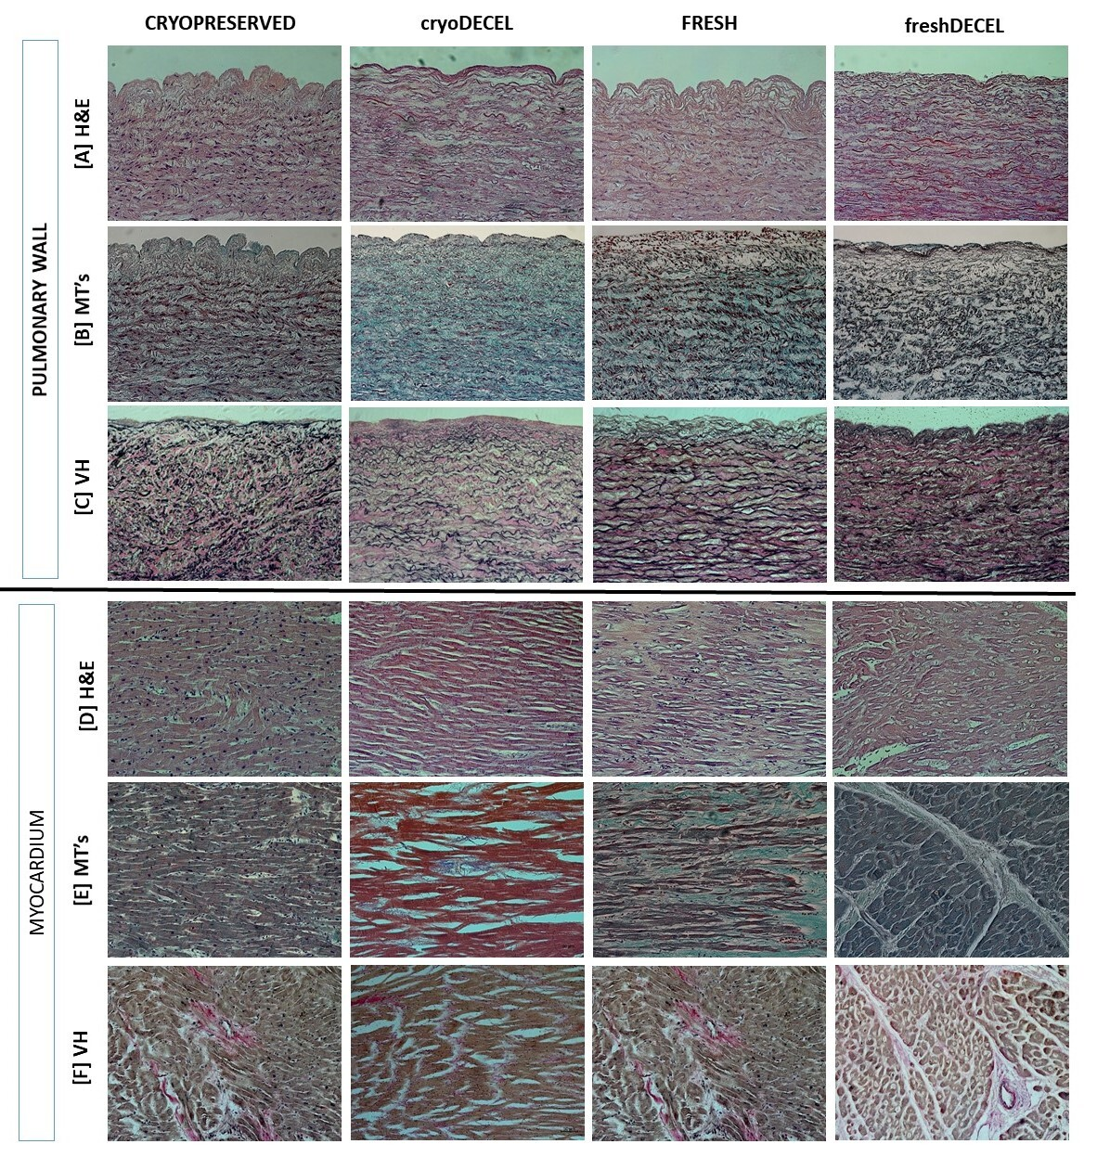
Supplemental Figure 2: Tissue structure evaluation by histology (20x). Sections of arterial pulmonary wall and myocardium of 4 different conditions (cryopreserved, cryopreserved-decellularized, fresh and fresh-decellularized tissue) stained with Haematoxylins-Eosin (H&E), Masson Trichrome (MS’s) and Verhoeff-Van Gieson (VH) staining. [A]Staining of pulmonary wall from four distinct conditions using H&E; [B] Staining of pulmonary wall from four distinct conditions using MT’s; [C] Staining of pulmonary wall from four distinct conditions using VH; [D] Staining of myocardium from four distinct conditions using H&E; [E] Staining of myocardium from four distinct conditions using; [F] Staining of myocardium from four distinct conditions using VH.

