Dual-Stimulus Responsive Nanocarrier for Enhanced Antitumor Responses against Hepatocellular Carcinoma
Deteng Zhang^{c}, Jinxiao Song^{d}, Zhenghui Jing^{d}, Huan Qin^{d}, You Wu^{c}, Jingyi Zhou^{d} and Xinlong Zang^{a,b,c,d}
a. The Affiliated Hospital of Qingdao University, Qingdao University, Qingdao, Shandong, China
b. Qingdao Cancer Institute, Qingdao University, Qingdao, China
c. Institute of Neuroregeneration and Neurorehabilitation, Qingdao University, Qingdao, China.
d. School of basic medicine, Qingdao medical college, Qingdao University, PR China
*Corresponding author:
Xinlong Zang, E-mail: zangxinlong@126.com;
Supporting information
1 Synthesis of copolymers
1.1 Synthesis of PGal-PEG-PPBP
The PGal-PEG-PPBP block copolymer was synthesized via the reversible addition fragmentation chain transfer (RAFT) polymerization technique, as previously reported, with some modifications (Figure S1A)[1]. In summary, MAGalAc, MAPBB, PEGMA, and DDMAT were combined in a round-bottom flask containing 3 mL of DMF. The reaction occurred at 75°C for 24 hours with AIBN acting as the initiator. The resulting product was precipitated in cold ethyl ether overnight and collected as a light-yellow oil through centrifugation. This oil was then mixed with CH3ONa at 0°C, and the pH was adjusted to 7.4. The resulting pellets were dialyzed against distilled deionized water and freeze-dried to yield light-yellow powders of PGal-PEG-PPBP.
1.2 Synthesis of PBA-PEG
PBA-PEG was prepared through ester coupling reactions as described in a previous study (Figure S1B)[2]. In summary, a solution was created by dissolving 0.206g 4-carboxyphenylboronic acid, 1.0g PEG-OH, and 0.061g DMAP in a DCM-THF mixture (1:1, V/V). After 10min, DCC (0.21g, 1mmol) was then added dropwise as a solid to the solution while keeping it on ice. After a reaction period of 48 hours at room temperature, the resulting mixture was precipitated using 100mL Et₂O, collected by centrifugation and subsequently dried under vacuum to yield PBA-PEG.
2 Characterization of copolymers
The ¹H NMR spectra of PGal-PEG-PPBP, PBA-PEG, and their intermediates were acquired using an AVANCE III HD 400MHz spectrometer (Bruker, Switzerland). To evaluate the suitability of these materials for in vivo use, a hemolytic assay was conducted. Specifically, fresh rabbit erythrocytes were treated with PGal-PEG-PPBP and PBA-PEG at polymer concentrations ranging from 0.05 to 1 mg/mL in PBS. The samples were incubated at 37°C for 2 hours and subsequently examined to determine their hemolytic potential.
Figure S1. Schematic illustration of PGal-PEG-PPBP (A) and PEG-PBA (B) synthesis.
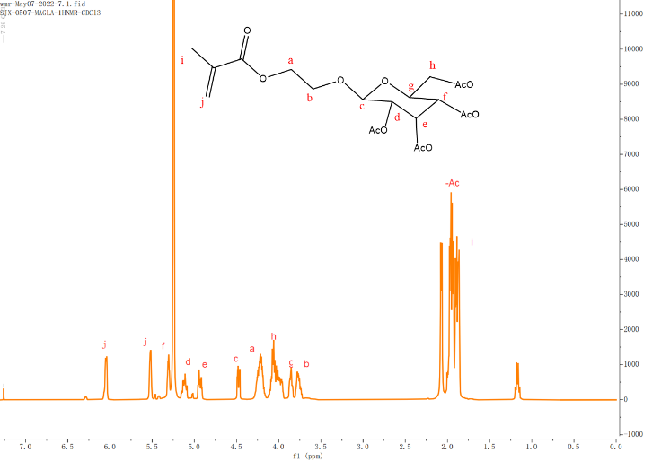
Figure S2. ¹H NMR of MAGalAc in CDCl₃.
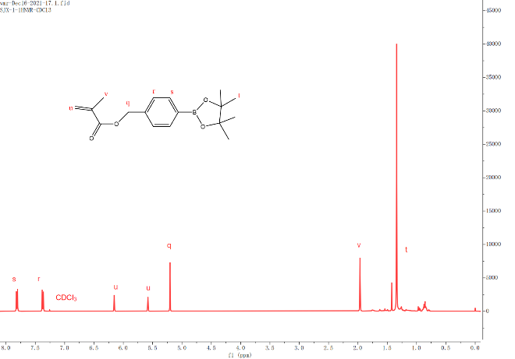
Figure S3. ¹H NMR of MAPBP in CDCl₃.
Figure S4. ¹H NMR of PGalAc in CDCl₃.
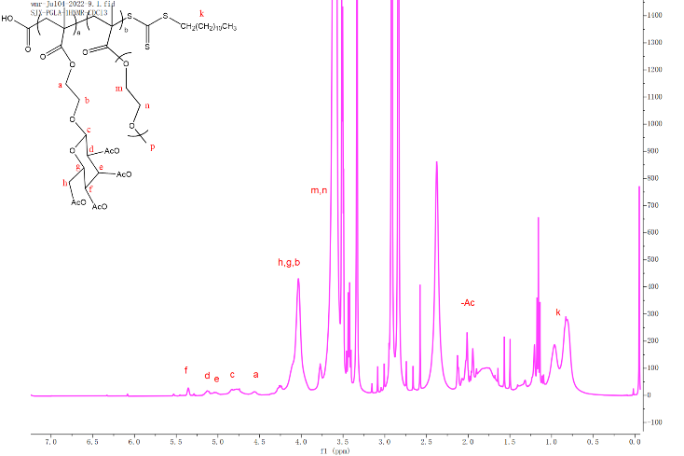
Figure S5. ¹H NMR of PGalAc-PEG in CDCl₃.

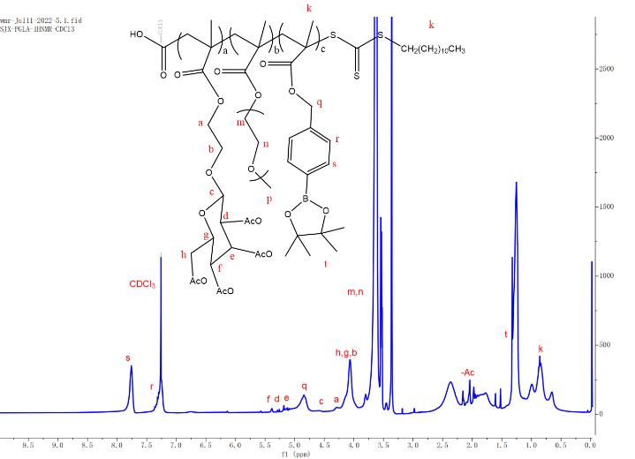
Figure S6. ¹H NMR of PGalAc-PEG-PPBP in CDCl₃.
Table S1. Particle sizes of nanoparticles at different pHs and redox conditions (n=3).
Formulations | Particle sizes (nm) |  | Zeta potential (mV)
Formulations | Without H₂O₂ | With H₂O₂ | Zeta potential (mV)
PN@GPB NPs | 103.36 ± 2.31 | 873.3 ± 50.3 | -14.7 ± 0.67
PN@GPB-PEG NPs at pH6.5 | 99.44 ± 3.46 | 906.9 ± 51.32 | -11.7 ± 1.06
PN@GPB-PEG NPs at pH7.4 | 87.83 ± 5.61 | 735 ± 100.1 | -3.73 ± 0.24

Table S2. The encapsulation and drug loading efficiency of different formulations.
Formulations | PTX |  | NLG919
Formulations | EE (%) | DLE (%) | EE (%) | DLE (%)
PN@GPB NPs | 75±0.50 | 4.41±0.30 | 48.77±0.25 | 1.48±0.00
PN@GPB-PEG NPs at pH6.5 | 77.5±0.45 | 4.55±0.28 | 41.04±0.62 | 0.94±0.01
PN@GPB-PEG NPs at pH7.4 | 69.5±0.33 | 4.1±0.54 | 55.6±0.54 | 1.27±0.02
Figure S7. Body weight of mice received different treatments.
Figure S8. HE staining of main organs (heart, liver, spleen, lung and kidney) obtained from mice in different treatment groups.

[1] J.Y. Zhou, K.K. Li, X.L. Zang, Y. Xie, J.X. Song, X.H. Chen, ROS-responsive Galactosylated-nanoparticles with Doxorubicin Entrapment for Triple Negative Breast Cancer Therapy, INTERNATIONAL JOURNAL OF NANOMEDICINE 18 (2023) 1381-1397.
[2] D. Zhao, J.-Q. Xu, X.-Q. Yi, Q. Zhang, S.-X. Cheng, R.-X. Zhuo, F. Li, pH-Activated Targeting Drug Delivery System Based on the Selective Binding of Phenylboronic Acid, ACS Applied Materials & Interfaces 8(23) (2016) 14845-14854.

