Figure S1. The quantitative profile of GTSs based on UPLC-MS.

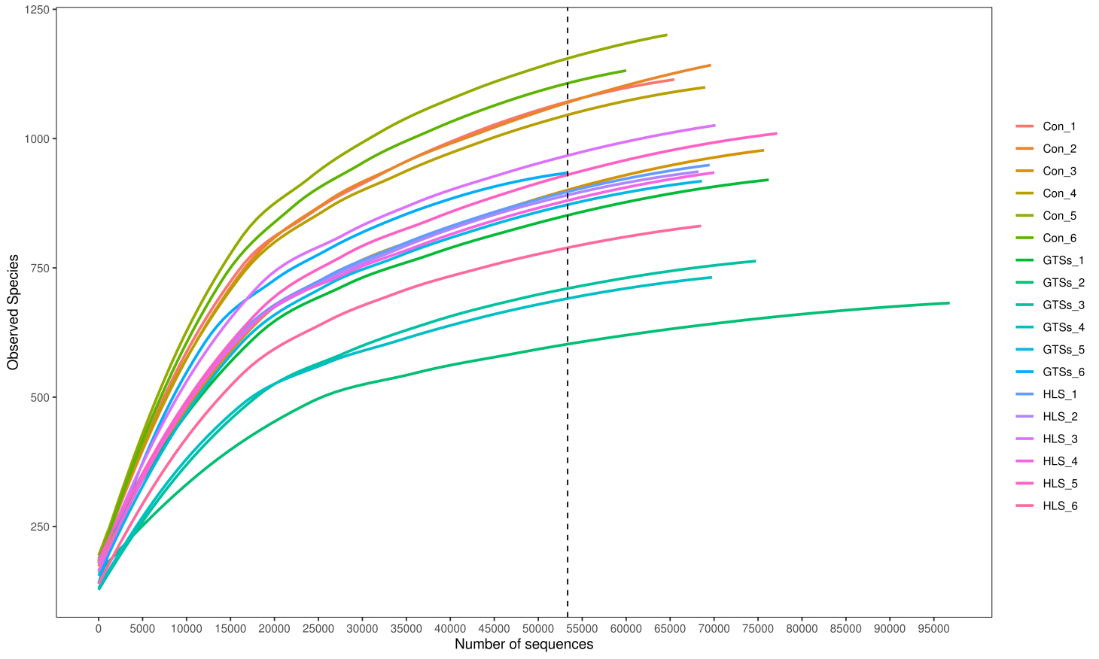
Figure S2. The rarefaction curve of experimental samples. When the curve flattens out as the number of extracted sequences increases in the dilutability graph, it indicated the sequencing volume of a sample was reasonable.

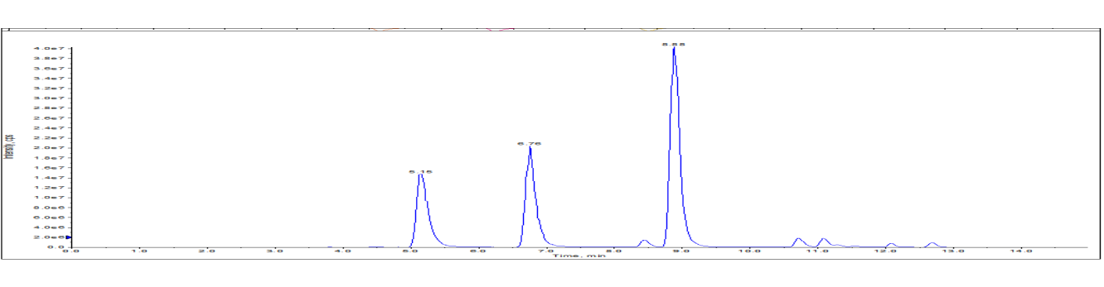
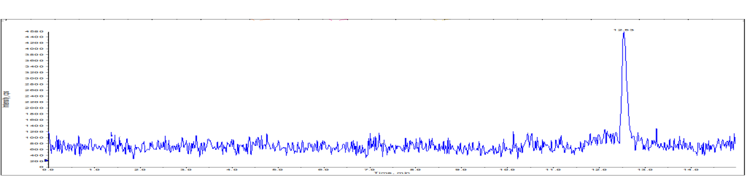
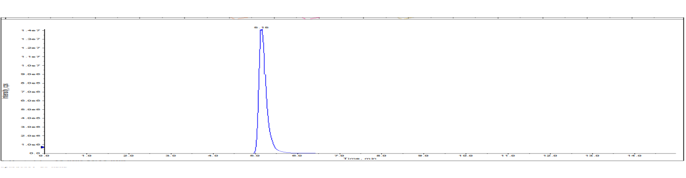
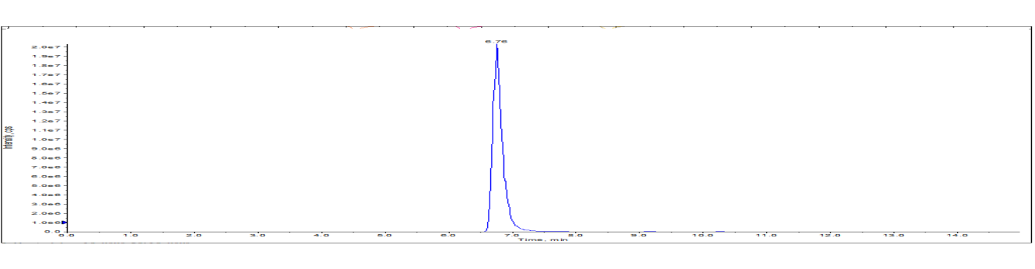
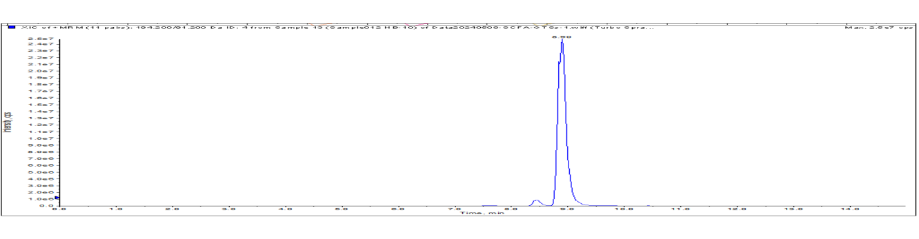
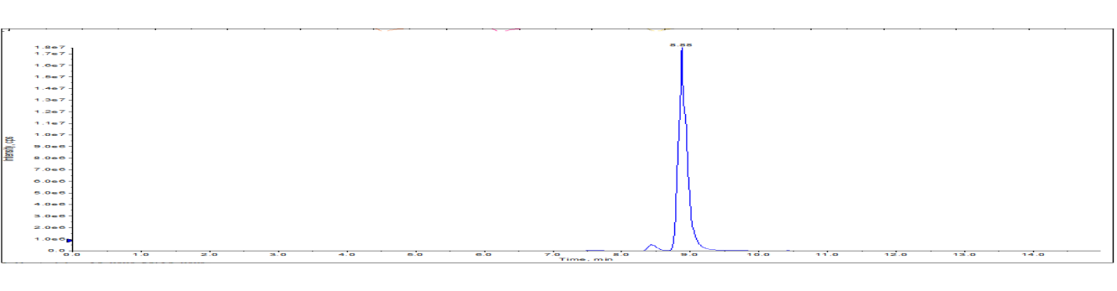
Figure S3. The quantitative profile of short-chain fatty acids based on UPLC-MS.
Acetic acid 5.15
Propionic acid 6.76
Butyric acid 8.90
Isobutyric acid 8.88
IS 12.53
Acetic acid
IS
Propionic acid
Butyric acid
Isoutyric acid

Table S1. The quantitative analysis parameters of GTSs.
Name | Ploarity | Q1 MS (m/Z) | Q3 MS (m/Z) | DP (V) | CE (V)
Re | ESI- | 945.5 | 637.2 | 340 | 45
Rf | ESI- | 799.4 | 475.3 | 320 | 55
Rg1 | ESI- | 799.5 | 637.2 | 310 | 40
Rg2 | ESI- | 783.4 | 475.5 | 310 | 56
Rb1 | ESI- | 1107.4 | 945.3 | 380 | 70
Rc | ESI- | 1077.3 | 945.5 | 360 | 65
Rb2 | ESI- | 1077.6 | 783.5 | 370 | 65
Rd | ESI- | 945.7 | 621.5 | 350 | 55

Table S2. RT-PCR primer sequence.
Gene name | Forward (5’-3’) | Reverse (5’-3’)
Slfn4 | TGAAAGCTTGGGGAGGACAC | CTTGGCTCGGAATCTGGGTT
Oas1a | CAGGGCTTCCGGACAATCTT | TCACAGGCCTGGATTTTCTGA
Oas2 | AGTGGTTAAGGGTGGCTCCTA | TCATGGCTTTTCAGCCGTTG
Ifi27l2b | ACCAGAACTACTCGCCTGCT | CACAGCCACAACTCCTCCTAT
Oasl2 | GCGACCGGCCTATCATTCTA | GGAGGTAGTGCGCGATAGAT
Isg15 | CTACAGCCATGACCTGGAACC | GCCTGATAAGGGCAACACCA
Oas3 | AGCTTCACGCTGACATCCAA | CGGACTTCAGCTGACCAAGA
Ly6e | GAGCCTTCAGCCTTTGGTGA | CCAAAGAAGCCTACTCCGGG
Occludin | CAACGGCAAAGTGAATGGCAAGAG | TCATCCACGGACAAGGTCAGAGG
Claudin-1 | CTTCTGGGTTTCATCCTGGCTTCG | CCTGAGCAGTCACGATGTTGTCC
TNF-α | CTCAAGCCCTGGTATGAGCC | CTCCAAAGTAGACCTGCCCG
IL-1β | GCAACTGTTCCTGAACTCAACT | ATCTTTTGGGGTCCGTCAACT
IL-6 | GTTGCCTTCTTGGGACTGATG | TACTGGTCTGTTGTGGGTGGT
IL-7 | AATTCCTCCCCTGATCCTTG | TTGTCCAGTTGATTGATGCTG
GAPDH | ATGGTGAAGGTCGGTGTGAA | TGGAAGATGGTGATGGGCTT

Table S3. The quantitative analysis parameters of SCFAs.
Name | Ploarity | Q1 MS (m/Z) | Q3 MS (m/Z) | DP (V) | CE (V)
Acetic acid | ESI+ | 166.1 | 91.2 | 50 | 18
Propionic acid | ESI+ | 180.1 | 91.2 | 68 | 20
Butyric acid | ESI+ | 194.2 | 91.2 | 72 | 21
Isobutyric acid | ESI+ | 194.2 | 91.1 | 89 | 20
Acetic acid C-13 | ESI+ | 167.1 | 91.2 | 91 | 59

Table S4. The quality analysis of sequencing data
Sample | Clean reads | Clean bases | Q20 (%) | Q30 (%) | GC (%)
Con-1 | 284082 | 70026213 | 95.45 | 90.17 | 53.87
Con-2 | 292438 | 71939748 | 95.25 | 89.77 | 53.29
Con-3 | 289622 | 71681445 | 95.54 | 90.32 | 53.54
Con-4 | 280204 | 69210388 | 95.40 | 90.02 | 53.84
Con-5 | 292602 | 72126393 | 95.42 | 90.07 | 53.92
Con-6 | 270212 | 66472152 | 95.17 | 89.65 | 53.52
HLS-1 | 292016 | 72273960 | 95.41 | 90.03 | 53.88
HLS-2 | 274114 | 67706158 | 95.40 | 90.02 | 53.79
HLS-3 | 273636 | 67451274 | 95.45 | 90.12 | 53.61
HLS-4 | 284550 | 69999300 | 95.03 | 89.36 | 53.52
HLS-5 | 283698 | 70215255 | 95.27 | 89.86 | 53.88
HLS-6 | 281616 | 69559152 | 95.34 | 89.93 | 53.96
GTSs-1 | 284314 | 70083401 | 95.24 | 89.79 | 53.85
GTSs-2 | 273280 | 67226880 | 94.97 | 89.28 | 52.46
GTSs-3 | 292036 | 72278910 | 95.07 | 89.49 | 53.53
GTSs-4 | 270478 | 66808066 | 95.23 | 89.76 | 53.33
GTSs-5 | 275010 | 67789965 | 95.10 | 89.61 | 53.09
GTSs-6 | 274794 | 67599324 | 95.08 | 89.49 | 53.58

Table S5. The statistical datas of bacteria with significant differences between groups
Gut Microbiome (genus level) | Relative abundance |  |  | Trend change
Gut Microbiome (genus level) | Con | HLS | GTSs | HLS vs Con | GTSs vs HLS
Turicibacter | 0.012105 | 0.000383 | 0.000422 | ↓** | ↑
Anaeroplasma | 0.000407 | 1.22E-05 | 1.79E-05 | ↓* | ↑
Anaerostipes | 0.000235 | 2.38E-05 | 3.44E-06 | ↓* | ↓
Enterococcus | 0.000466 | 0.000281 | 7.60E-05 | ↓ | ↓
Lactococcus | 0.000185 | 1.92E-05 | 0.000116 | ↓* | ↑
Leptotrichia | 7.42E-05 | 1.21E-05 | 2.19E-06 | ↓ | ↓
Pseudoalteromonas | 4.84E-05 | 9.57E-06 | 8.75E-06 | ↓* | ↓
Haemophilus | 2.58E-05 | 8.64E-06 | 2.19E-06 | ↓ | ↓
Anaerospora | 2.42E-06 | 7.22E-06 | 0 | ↑ | ↓#
Loktanella | 0 | 1.20E-05 | 0 | ↑* | ↓#
Veillonella | 1.51E-05 | 2.84E-05 | 4.58E-06 | ↑ | ↓# #
Collinsella | 3.56E-05 | 0.00014 | 2.49E-05 | ↑* | ↓#
Bifidobacterium | 5.57E-05 | 0.000173 | 4.51E-05 | ↑* | ↓#
Staphylococcus | 2.69E-05 | 0.000271 | 7.76E-05 | ↑** | ↓#
Corynebacterium | 0.000309 | 0.00098 | 7.82E-05 | ↑* | ↓# #
Adlercreutzia | 0.002021 | 0.002989 | 0.001417 | ↑ | ↓#
Coprococcus | 0.006635 | 0.007902 | 0.016722 | ↑ | ↑#
Bacteroides | 0.002732 | 0.004277 | 0.001446 | ↑ | ↓#
Jeotgalicoccus | 0 | 0.00164 | 3.73E-05 | ↑* | ↓#
Clostridium | 0.007317 | 0.018253 | 0.005844 | ↑ | ↓#
Prevotella | 0.012598 | 0.041706 | 0.014745 | ↑** | ↓# #
Lactobacillus | 0.098414 | 0.164593 | 0.409591 | ↑ | ↑# #
Note: *P < 0.05, **P < 0.01, ***P < 0.001, compared with CON group; #P < 0.05, ##P < 0.01, ###P < 0.001, compared with HLS group. “↑” represent increases; “↓” represents decrease. After LEfSe analysis, significant changes in the microbial community were obtained. Prevotella, Bifidobacterium, Staphylococcus, Corynebacterium and Jeotgalicoccus were the dominant bacteria in the HLS group, and their relative abundance were significantly decreased after GTSs intervention. Specific changes in these microbiota are indicated in bold text.
实时翻译
划译
After LEfSe analysis, significant changes in the microbial community were obtained. Prevotella, Bifidobacterium, Staphylococcus, Corynebacterium, and Global Microbes were the dominant bacteria in the model group, and their relative abundance significantly decreased after GTSs intervention

Table S6. The Parameters for calibration curves in rat feces
Name | Linear equation | R^2 | Linear range (µM)
Acetic acid | y = 16.478 * x + 137.62 | 0.9987 | 0.625～320
Propionic acid | y = 20.25 * x + 95.868 | 0.9985 | 0.625～320
Butyric acid | y = 24.863 * x + 96.316 | 0.9981 | 0.625～320
Isobutyric acid | y = 0.4222 * x + 11.585 | 0.9975 | 0.625～320

