Table S1. 5W1H checklist used to investigate the reasons of sample rejection

Why | 5.3 | 5.4 | 5.5 | 5.6 | 5.7 | 5.8 | 5.9 | Sum
Sample without Collection Info | 5 | 5 | 2 | 8 | 40 | 13 | 13 | 85
Clotted samples | 0 | 1 | 0 | 2 | 2 | 0 | 3 | 8
Incorrect sample type | 0 | 0 | 0 | 2 | 4 | 1 | 0 | 7
haemolysed samples | 0 | 1 | 0 | 1 | 3 | 0 | 1 | 6
Incorrect specimen collection container | 0 | 0 | 0 | 0 | 5 | 0 | 0 | 5
poor-quality sputum specimens | 0 | 4 | 0 | 0 | 0 | 0 | 0 | 4
Sample leaked in transit | 0 | 0 | 0 | 1 | 0 | 0 | 0 | 1
Insufficient specimen volume | 0 | 0 | 0 | 0 | 0 | 1 | 0 | 1
Sum | 5 | 11 | 2 | 14 | 54 | 15 | 16 | 117
What: Investigate the reasons for sample recall
Who: Personnel :LBJ
When: May 3, 2021 to May 9, 2021
Where: Clinical laboratory
How: Retrieve sample recall records using the Laboratory Information System

Table S2. Root Cause Analysis (RCA) Scoring Sheet for “Sample without Collection Info”
Cause | Score
Cause | Member1 | Member2 | Member3 | Member4 | Member5 | Member6 | Member7 | Member8 | Sum
People
Nurses forget to scan the bar code | 3 | 3 | 3 | 5 | 5 | 3 | 5 | 3 | 30
Inadequate supervision | 5 | 5 | 5 | 5 | 5 | 5 | 5 | 5 | 40
Equipment
Bar code scanning devices are not sensitive | 3 | 3 | 3 | 3 | 3 | 3 | 1 | 1 | 20
The computer software lacks a sample bar code scanning interface | 1 | 1 | 3 | 1 | 1 | 1 | 1 | 1 | 10
Policy
Inconsistent operational procedures in some departments | 5 | 3 | 5 | 3 | 5 | 3 | 3 | 3 | 30
Inadequate communication and dissemination of the new specimen collection process | 5 | 5 | 5 | 5 | 5 | 5 | 5 | 5 | 40
Material
blurred bar code | 3 | 3 | 3 | 3 | 3 | 3 | 3 | 3 | 24
Note: In the quality control circle, members have assigned ratings on a scale of 1 (not important), 3 (moderately important), and 5 (very important) to assess each factor. A total of 8 circle members participated in the scoring process, with a maximum possible total score of 40. According to the Pareto principle, factors scoring 32 or above are considered root causes.

Table S3. Root Cause Analysis (RCA) Scoring Sheet for “Clotted Specimen”
Cause | Score
Cause | Member1 | Member2 | Member3 | Member4 | Member5 | Member6 | Member7 | Member8 | Sum
People
Patient's medication intake | 3 | 3 | 3 | 3 | 3 | 3 | 3 | 1 | 20
Inadequate post-blood collection mixing | 5 | 5 | 5 | 5 | 5 | 5 | 5 | 5 | 40
Equipment
Suboptimal blood flow during venipuncture | 5 | 5 | 5 | 5 | 5 | 5 | 5 | 5 | 40
Policy
Incorrect specimen collection order | 3 | 5 | 5 | 3 | 5 | 5 | 5 | 5 | 36
Material
Non-compliant blood collection tube quality | 3 | 5 | 5 | 3 | 5 | 3 | 5 | 3 | 30
Note: In the quality control circle, members have assigned ratings on a scale of 1 (not important), 3 (moderately important), and 5 (very important) to assess each factor. A total of 8 circle members participated in the scoring process, with a maximum possible total score of 40. According to the Pareto principle, factors scoring 32 or above are considered root causes.

Table S4. The Fundamental Cause and Interventions Measures
Factors | Fundamental Cause | Interventions Measures
Sample without Collection Info | - inadequate communication and dissemination of the new specimen collection process | Establish a WeChat group for specimen collection coordinators. If a nurse has any questions about the collection conditions or procedures for a specimen, they can directly consult with our colleagues in the group
Sample without Collection Info | - inadequate supervision | Set up a quality control team in the nursing department
Sample without Collection Info | - Bar code scanning devices are not sensitive | Organize regular maintenance of personal digital assistant (PDA) devices by nursing staff
Sample without Collection Info | - the computer software lacks a sample bar code scanning interface | Coordinate with the Information Technology Department to maintain computer software without collection interfaces.
Sample without Collection Info | - blurred bar code | Conduct training on the use of bar code printers.
Sample without Collection Info | - inconsistent operational procedures in some departments | Develop a standard operating procedure (SOP) for the specimen collection process and communicate it to clinical nurses and laboratory staff through a meeting. Distribute the SOP and provide training and competency assessment for all nurses involved.
Sample without Collection Info | - nurses forget to scan the bar code | Strengthen training for all nurses, and nursing assistants who may transport specimens. Include forgetting to scan the bar code as one of the performance evaluation indicators for nurse compensation
Clotted samples | - Incorrect specimen collection order | Develop a SOP for the specimen collection process and provide training on blood collection order.
Clotted samples | - patient's medication intake | Inform the Nursing Department to inquire about medication usage before blood collection and implement measures to delay blood collection for patients taking medication
Clotted samples | - Sub-optimal blood flow during venipuncture | Standardize blood collection procedures, with a tourniquet application time not exceeding 1 minute.
Clotted samples | - non-compliant blood collection tube quality | Establish a management program for the quality of reagents and consumables in the laboratory and enhance their quality control.
Clotted samples | - inadequate post-blood collection mixing | Standardize the number of inversions for blood collection tubes.

Table S5. 5W1H checklist used to investigate the reasons for sample rejection after QCC activities
Why | 6.6 | 6.7 | 6.8 | 6.9 | 6.10 | 6.11 | 6.12 | Sum
Sample without Collection Info | 0 | 2 | 11 | 3 | 7 | 3 | 0 | 26
Clotted samples | 2 | 1 | 2 | 0 | 0 | 1 | 0 | 6
Incorrect sample type | 0 | 0 | 0 | 0 | 0 | 0 | 0 | 0
haemolysed samples | 1 | 1 | 0 | 0 | 0 | 0 | 0 | 2
Incorrect specimen collection container | 0 | 1 | 1 | 0 | 1 | 0 | 0 | 3
poor-quality sputum specimens | 0 | 0 | 0 | 2 | 0 | 10 | 0 | 12
Sample leaked in transit | 0 | 1 | 0 | 0 | 0 | 0 | 0 | 1
Insufficient specimen volume | 0 | 0 | 1 | 0 | 0 | 0 | 1 | 2
Sum | 3 | 6 | 15 | 5 | 8 | 14 | 1 | 52
What: Investigate the reasons for sample recall
Who: Personnel LBJ
When: June 6, 2022 to June 12, 2022
Where: Clinical laboratory
How: Retrieve sample recall records using the Laboratory Information System

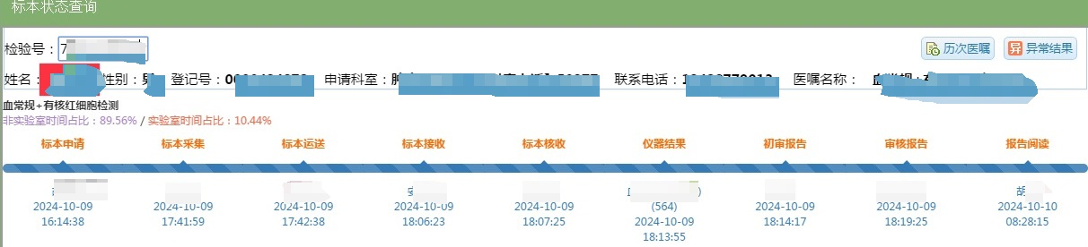

Figure S1. Display of the specimen collection process after scanning in the laboratory

