Supplemental Materials
Figure S1. A classification example comparing sleep stages between polysomnography and the wireless radar framework (Andar).
Figure S2. Correlation and Bland-Altman plots comparing the apnea-hypopnea index obtained from home sleep apnea testing (HSAT) with the radar-based respiratory disturbance index (bRDI) collected via the Andar wireless radar sleep monitoring device in patients with severe obstructive sleep apnea (OSA).

Figure S1. An Example of Sleep Stage Classification Comparison Between 648 Polysomnographic Results and the Radar System.
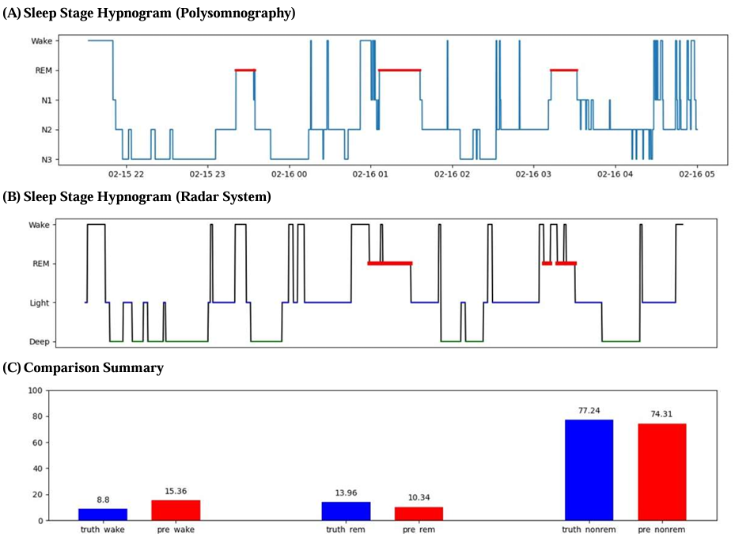
Figure S2. Correlation and Bland-Altman plots comparing the apnea-hypopnea index obtained from home sleep apnea testing (HSAT) with the radar-based respiratory disturbance index (bRDI) collected via the Andar wireless radar sleep monitoring device in patients with severe obstructive sleep apnea (OSA).
(A) Correlation between the apnea-hypopnea index (AHI) derived from HSAT and the bRDI retrieved from the wireless radar framework in patients with severe obstructive sleep apnea (OSA). (B) Degree of agreement between results from HSAT (i.e., AHI) and the wireless radar framework (i.e., bRDI) in patients with severe OSA.

