Supplementary Figures
Supplementary Figure 1 to Supplementary Figure 4 indicate supplementary figures in the SFVA networks.
Supplementary Figure 5 to Supplementary Figure 8 indicate supplementary figures in the SFVA-IR networks.
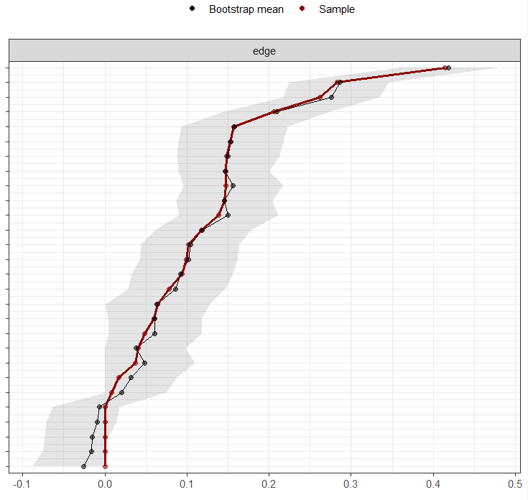
A. early adolescence

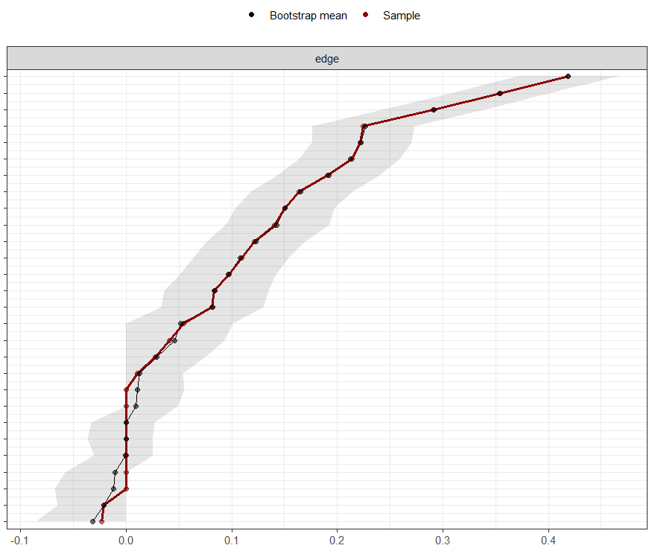
B. middle adolescence
Supplementary Figure 1 Edge-weight accuracy for the SFVA networks in (A) early and (B) middle adolescence. Bootstrapped confidence intervals of estimated edge-weights for the estimated network.
Note: The red line indicates the sample values and the gray area indicates the bootstrapped confidence intervals. Each horizontal line represents one edge of the network, ordered from the edge with the highest edge-weight to the edge with the lowest edge-weight.

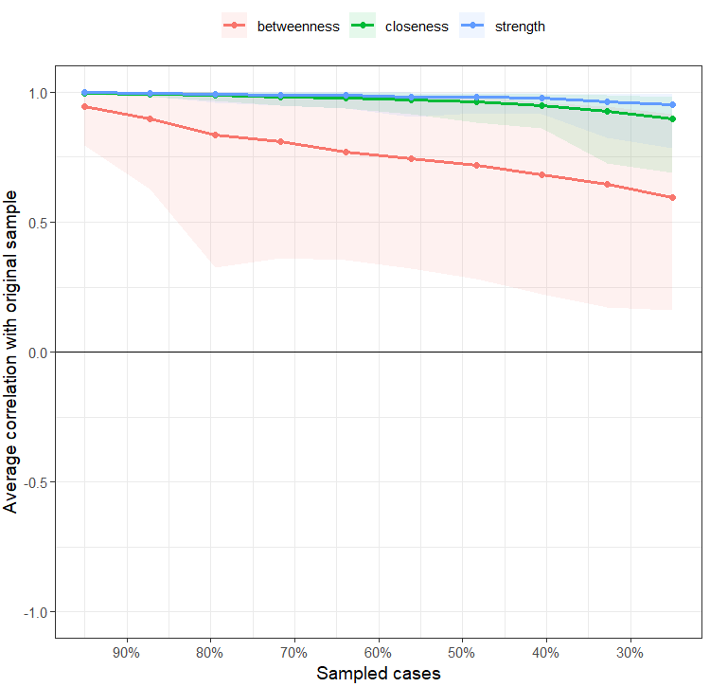
A. early adolescence

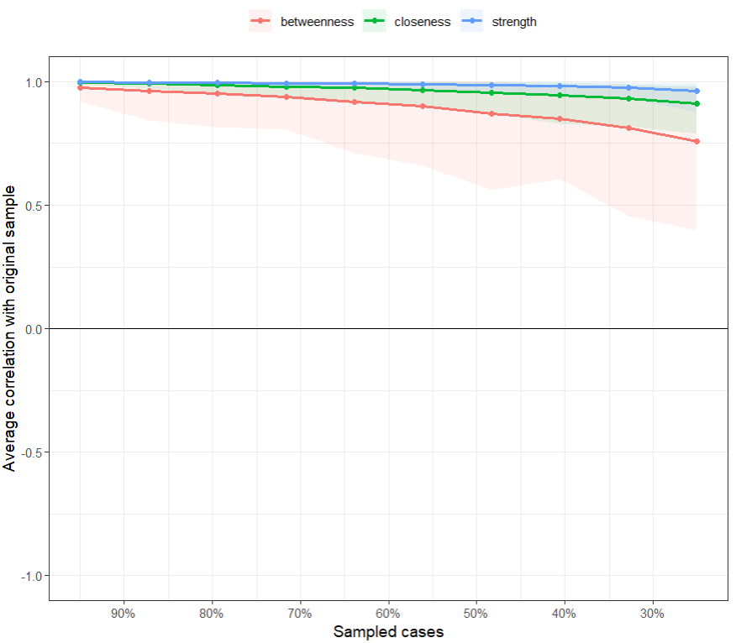
B. middle adolescence
Supplementary Figure 2 Centrality stability for the SFVA networks in (A) early and (B) middle adolescence.
Note: The x-axis illustrates the sample decrease from 95% to 25% of the original sample, and the y-axis illustrates the changes in correlation estimates between the subsample and the original entire sample. Lines indicate the means, and areas indicate the range from the 2.5th quantile to the 97.5th quantile.
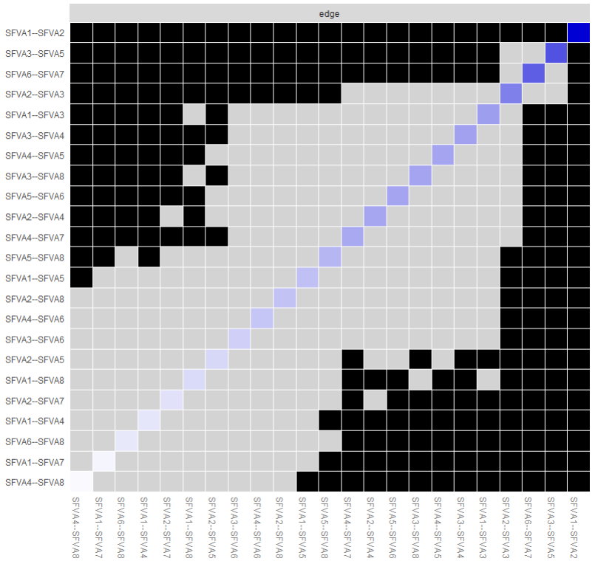
A. early adolescence

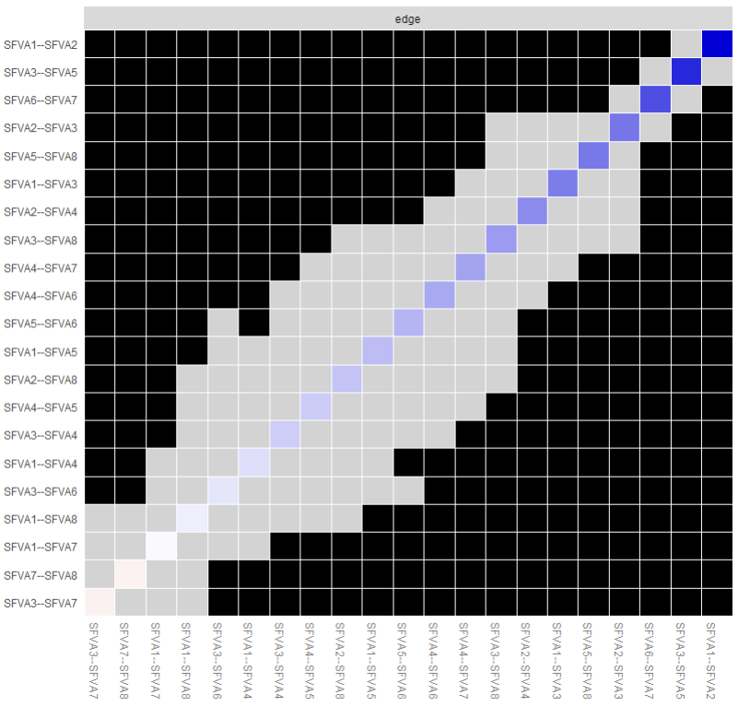
B. middle adolescence
Supplementary Figure 3 Edge difference test for the SFVA networks in (A) early and (B) middle adolescence.
Note: The gray box represents nodes or edges that do not differ significantly from one-another, the black box represents nodes or edges that do differ significantly from one-another, and the white box in the centrality plot shows the value of node strength.
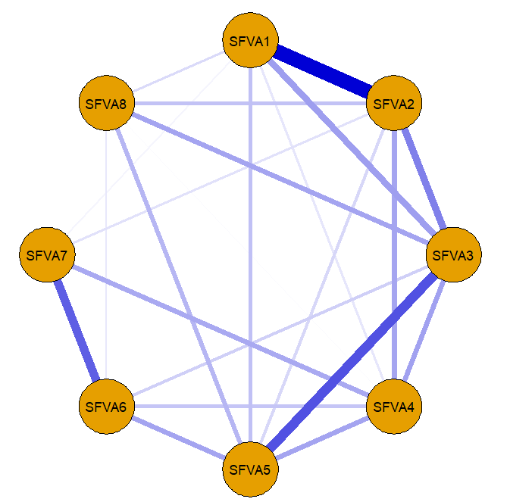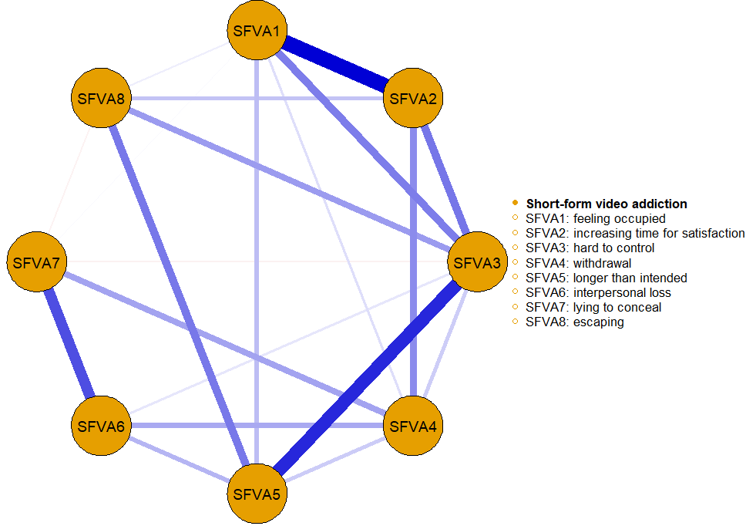
A. early adolescence B. middle adolescence
Supplementary Figure 4 Network structures of SFVA symptoms in (A) early and (B) middle adolescence in a “circle” layout.
Note: The color and meaning of the nodes and edges are the same as Figure 1.

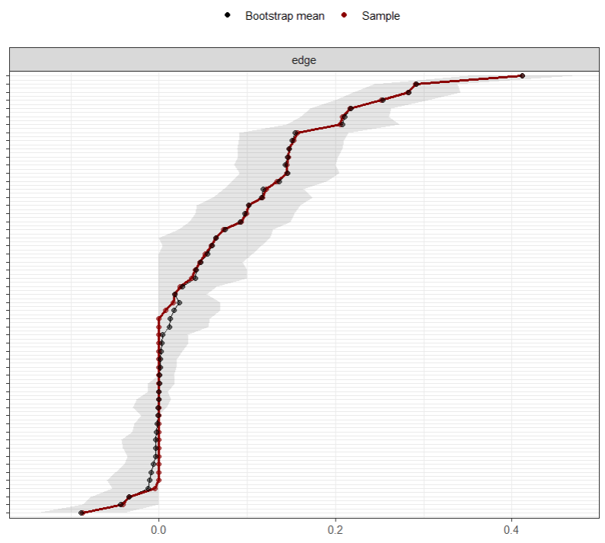
A. early adolescence

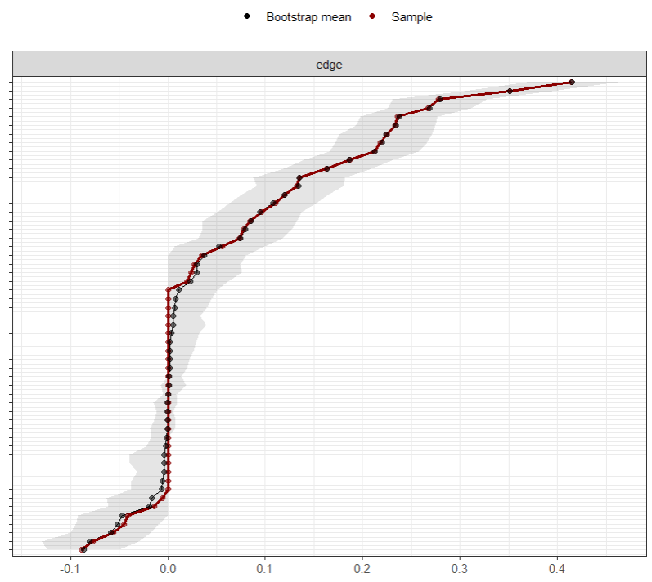
B. middle adolescence
Supplementary Figure 5 Edge-weight accuracy for the SFVA networks in (A) early and (B) middle adolescence. Bootstrapped confidence intervals of estimated edge-weights for the estimated network. Note: The red line indicates the sample values and the gray area indicates the bootstrapped confidence intervals. Each horizontal line represents one edge of the network, ordered from the edge with the highest edge-weight to the edge with the lowest edge-weight.
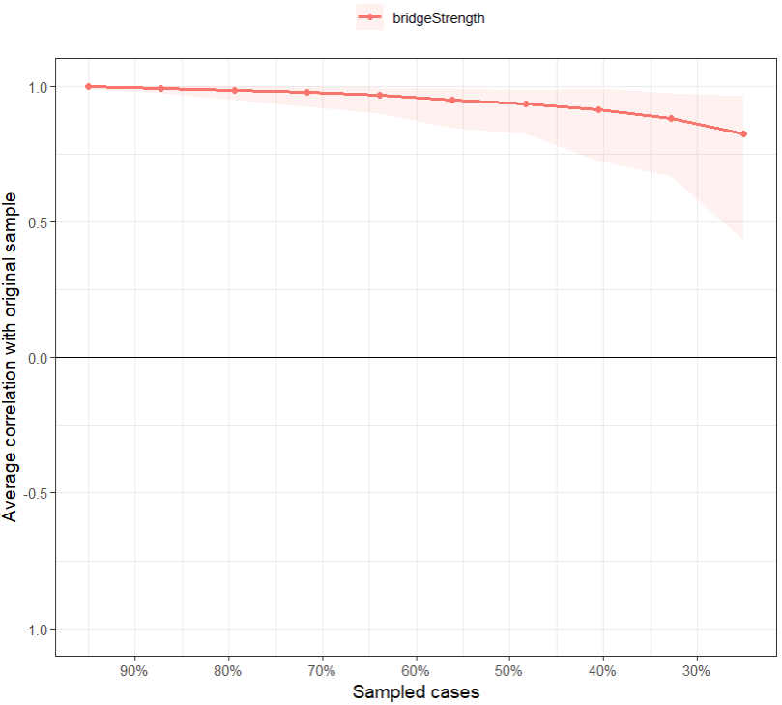
A. early adolescence

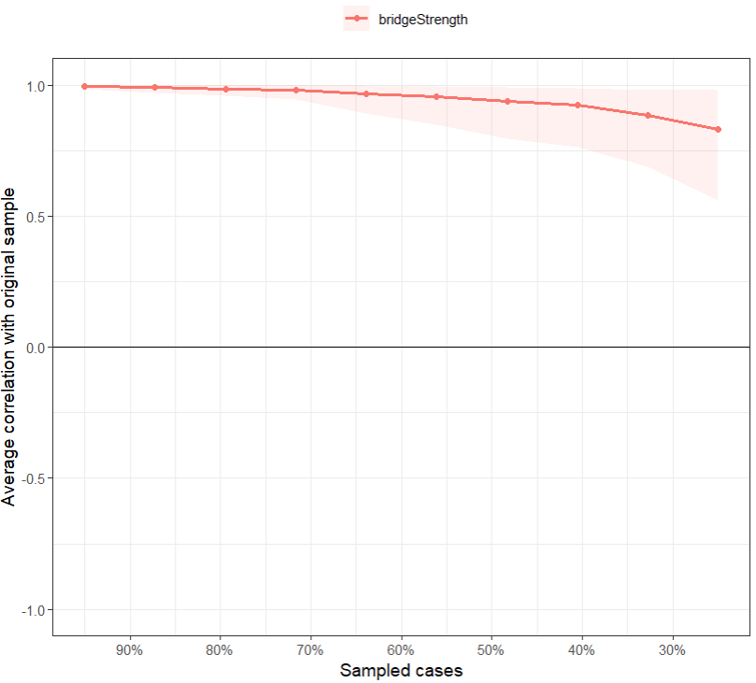
B. middle adolescence
Supplementary Figure 6 Bridge strength centrality stability for the SFVA-IR networks in (A) early and (B) middle adolescence.
Note: The x-axis illustrates the sample decrease from 95% to 25% of the original sample, and the y-axis illustrates the changes in correlation estimates between the subsample and the original entire sample. Lines indicate the means, and areas indicate the range from the 2.5th quantile to the 97.5th quantile.
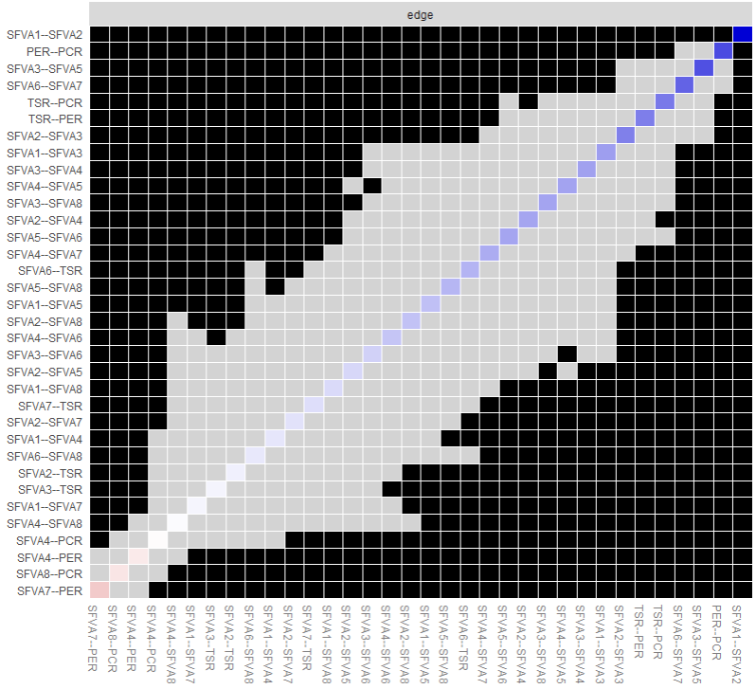
A. early adolescence

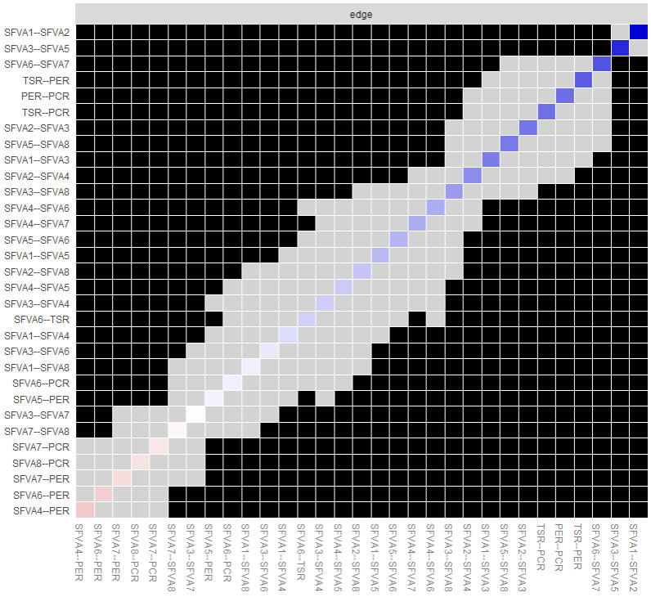
B. middle adolescence
Supplementary Figure 7 Edge difference test for the SFVA-IR networks in (A) early and (B) middle adolescence.
Note: The gray box represents nodes or edges that do not differ significantly from one-another, the black box represents nodes or edges that do differ significantly from one-another, and the white box in the centrality plot shows the value of node strength.
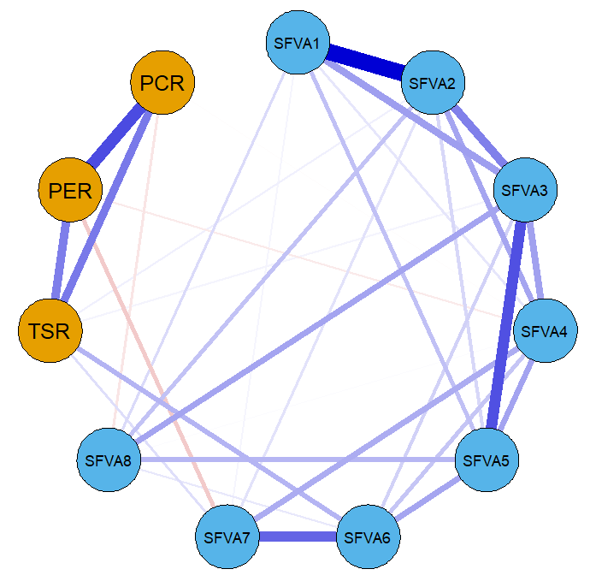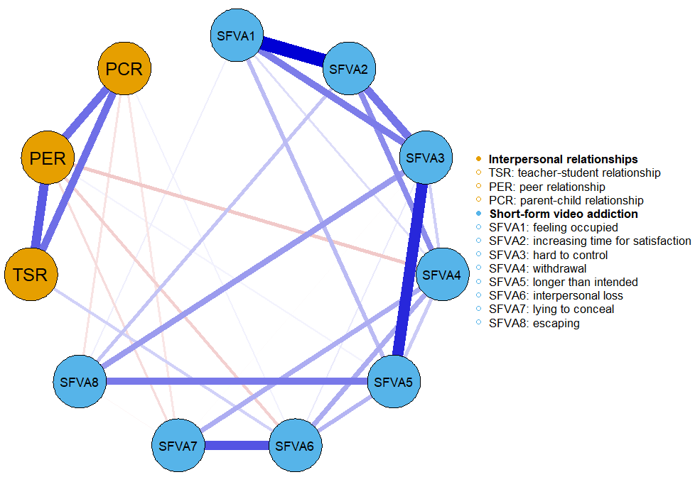
A. early adolescence B. middle adolescence
Supplementary Figure 8 Network structures of interpersonal relationships and SFVA symptoms in (A) early and (B) middle adolescence in a “circle” layout.
Note: The color and meaning of the nodes and edges are the same as Figure 1.

