Figure S1 The ROC curve of APACHE II score, SOFA score, number of organ failures and length of hospital stay predicting CRE colonization 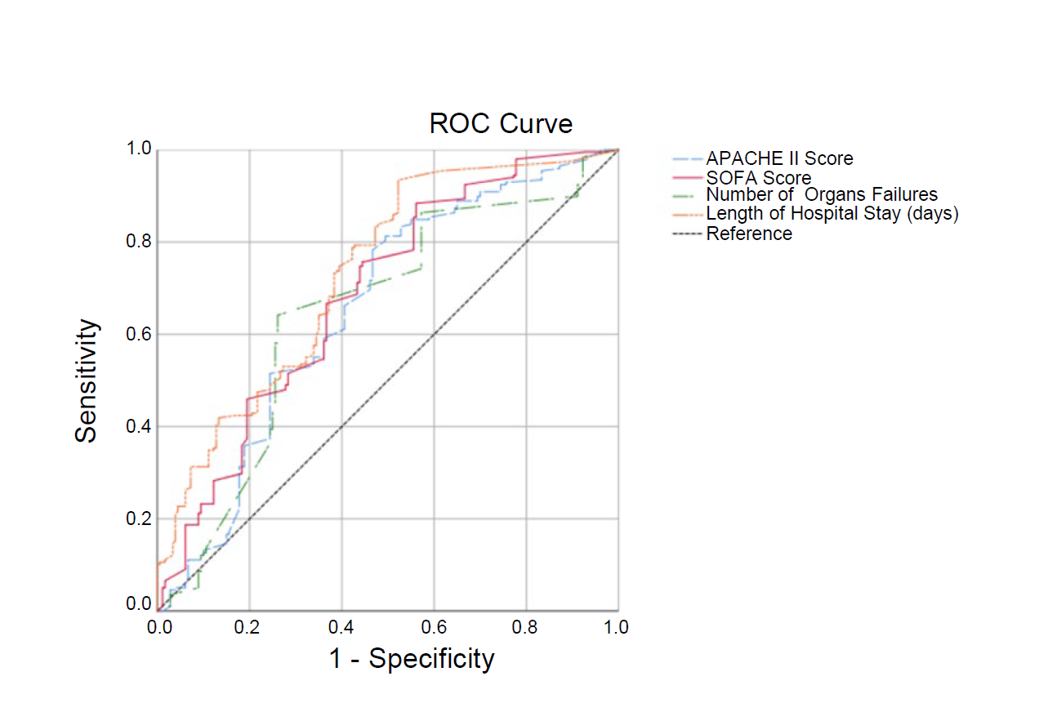
Table S1 Distribution of the CRE-colonized group’s swabs
CRE | All sites, n (%) | Throat, n (%) | Rectum, n (%)
Escherichia coli | 14(58.3%) | 1(4.2%) | 14(58.3%)
Klebsiella pneumoniae | 4(16.7%) | 2(8.3%) | 3(12.5%)
Acinetobacter baumannii | 2(8.3%) | 1(4.2%) | 2(8.3%)
Enterobacter cloacae | 1(4.2%) | 0(0.0%) | 1(4.2%)
Citrobacter freundii | 1(4.2%) | 0(0.0%) | 1(4.2%)
Klebsiella aerogenes | 1(4.2%) | 0(0.0%) | 1(4.2%)
Klebsiella oxytoca | 1(4.2%) | 0(0.0%) | 1(4.2%)
Total | 24(100.0%) | 4(16.7%) | 23(95.8%)

Abbreviations: CRE: Carbapenem-Resistant Enterobacteriaceae.

Table S2 Distribution of CRE resistance to antibiotics
CRE | IPM | MEM | CTX | FEP | ATM
Escherichia coli | 14(100.0%) | 14(100.0%) | 13(92.9%) | 13(92.9%) | 5(35.7%)
Klebsiella pneumoniae | 4(100.0%) | 4(100.0%) | 3(75.0%) | 3(75.0%) | 2(50.0%)
Acinetobacter baumannii | 2(100.0%) | 2(100.0%) | 2(100.0%) | 2(100.0%) | 1(50.0%)
Enterobacter cloacae | 1(100.0%) | 1(100.0%) | 1(100.0%) | 1(100.0%) | 0(0.0%)
Citrobacter freundii | 1(100.0%) | 1(100.0%) | 1(100.0%) | 1(100.0%) | 0(0.0%)
Klebsiella aerogenes | 1(100.0%) | 1(100.0%) | 1(100.0%) | 1(100.0%) | 1(100.0%)
Klebsiella oxytoca | 1(100.0%) | 1(100.0%) | 1(100.0%) | 1(100.0%) | 0(0.0%)
Total | 24(100.0%) | 24(100.0%) | 22(91.7%) | 22(91.7%) | 9(37.5%)

Abbreviations: CRE: Carbapenem-Resistant Enterobacteriaceae; IPM: Imipenem; MEM: Meropenem; CTX: Ceftazidime; FEP: Cefepime; ATM: Aztreonam.

Table S3 Influencing factors predict the area under ROC curve of CRE colonization
 | Cut-Off Value | Sensitivity | Specificity | AUC
APACHE II Score | 16 | 0.80 | 0.51 | 0.656
SOFA Score | 6 | 0.88 | 0.56 | 0.686
Number of Organ Failures | 2 | 0.65 | 0.62 | 0.649
Length of Hospital Stay (days) | 31 | 0.50 | 0.83 | 0.732

Abbreviations: CRE: Carbapenem-Resistant Enterobacteriaceae; ROC: Receiver Operator Characteristic; APACHE II: Acute Physiology and Chronic Health Evaluation; SOFA: Sequential Organ Failure Assessment.

