Supplementary Materials
Association of Vascular Aging Phenotypes with Adverse Clinical Outcomes in the Chinese Population: A Multicentre Study

Figure S1. HR and 95% confidence intervals for adverse clinical outcome derived from restricted cubic spline regression
Table S1. Parameters of equation for vascular age calculation
Table S2. Clinical Characteristics of the Train and Validation Set
Table S3. Hazard Ratio for Δ-age as Continuous Variable for Outcomes
Table S4. Reclassification and discrimination statistics for different outcomes by baPWV, CIMT and VAg phenotypes.
Table S5. Hazard Ratio for VAg Phenotypes for Outcomes in Men
Table S6. Hazard Ratio for VAg Phenotypes for Outcomes in Women

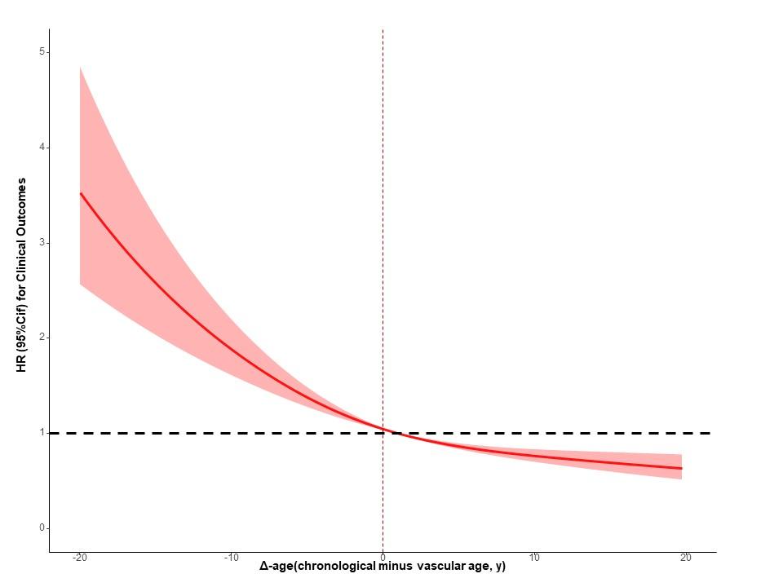
Figure S1. HR and 95% confidence intervals for adverse clinical outcome derived from restricted cubic spline regression

Table S1. Parameters of equations for VA calculation
Parameters, units | Coefficient | Data type
Intercept | 39.543 | -
Sex (Male=1, Female=0) | -2.670 | Categorial variable
Current drinker (Yes=1, No=0) | -1.124 | Categorial variable
log (BMI), kg/m² | -0.639 | Continuous variable
log (MAP), mmHg | -4.533 | Continuous variable
log (HR), beats/minute | -12.826 | Continuous variable
log (TC), mmol/L | 3.679 | Continuous variable
log (TG), mmol/L | -1.216 | Continuous variable
log (FBG), mmol/L | 4.695 | Continuous variable
Hypertension (Yes=1, No=0) | 2.600 | Categorial variable
Diabetes (Yes=1, No=0) | 0.873 | Categorial variable
log (baPWV), m/s | 29.911 | Continuous variable
log (CIMT), mm | 9.511 | Continuous variable
BMI, body mass index; MAP, mean blood pressure; HR, heart rates; TC, total cholesterol; TG, triglyceride; FBG, fasting blood glucose; baPWV, brachial-ankle pulse wave velocity; CIMT, carotid intima-media thickness.

Table S2. Clinical Characteristics of the Training and Validation Set
 | Training Set  (N=15580) | Validation Set  (N=5316) | P-value
Chronological age (y) | 51.0 (45.0-57.0) | 54.0 (47.0-64.0) | <0.001
Vascular age (y) | 50.1 (46.3-54.7) | 53.3 (48.4-60.0) | <0.001
Female (%) | 5635 (36.2%) | 2115 (39.8%) | <0.001
BMI (kg/m²) | 24.3 (22.2-26.4) | 24.8 (22.8-27.1) | <0.001
Systolic BP (mmHg) | 122 (111-135) | 130 (120-141) | <0.001
Diastolic BP (mmHg) | 75.0 (67.0-84.0) | 80.0 (77.0-90.0) | <0.001
MAP (mmHg) | 91.0 (82.0-101) | 97.0 (91.0-107) | <0.001
Current smoker (%) | 3669 (23.5%) | 1554 (29.2%) | <0.001
Current drinker (%) | 2368 (15.2%) | 1629 (30.6%) | <0.001
Hypertension (%) | 2189 (14.1%) | 1328 (25.0%) | <0.001
Hyperlipemia (%) | 422 (2.7%) | 515 (9.7%) | <0.001
Diabetes (%) | 779 (5.0%) | 376 (7.1%) | <0.001
FBG (mmol/L) | 5.01 (4.66-5.48) | 5.27 (4.86-5.87) | <0.001
HDL-C (mmol/L) | 1.31 (1.12-1.55) | 1.57 (1.31-1.91) | <0.001
LDL-C (mmol/L) | 2.81 (2.33-3.33) | 2.63 (2.18-3.09) | <0.001
TC (mmol/L) | 4.92 (4.34-5.56) | 5.00 (4.40-5.70) | <0.001
TG (mmol/L) | 1.41 (0.980-2.10) | 1.31 (0.940-1.94) | <0.001
baPWV (m/s) | 14.1 (12.7-15.9) | 15.1 (13.2-18.0) | <0.001
CIMT (mm) | 0.70 (0.60-0.90) | 0.80 (0.70-0.90) | <0.001
BMI: body mass index; BP: blood pressure; MAP, mean arterial pressure; FBG, fast blood glucose; HDL-C, high-density lipoprotein cholesterol; LDL-C, low-density lipoprotein cholesterol; TC, total cholesterol; TG, triglyceride; baPWV, brachial-ankle pulse wave velocity; CIMT: carotid artery intima-media thickness
Table S3. Hazard Ratio for Δ-age as Continuous Variable for Outcomes
Outcomes | HR (95%CI)
Outcomes | Model 1 | Model 2
Adverse Clinical Outcome
Δ-age | 0.964 (0.955-0.973) | 0.971 (0.962-0.982)
Cardiovascular Disease
Δ-age | 0.945 (0.932-0.958) | 0.956 (0.941-0.970)
Stroke
Δ-age | 0.946 (0.931-0.961) | 0.958 (0.941-0.974)
Myocardial Infarction
Δ-age | 0.947 (0.919-0.976) | 0.956 (0.926-0.987)
All-cause Death
Δ-age | 0.977 (0.966-0.989) | 0.982 (0.970-0.994)
Model 1: age- and sex- adjusted; model2: +atherosclerotic cardiovascular disease risk score at baseline. Δ-age, chronological minus vascular age.
Table S4. Reclassification and discrimination statistics for different outcomes by baPWV, CIMT and VAg phenotypes.
 | C-index |  | IDI |  | NRI
 | Estimate (95%) | P-value | Estimate (95%) | P-value | Estimate (95%) | P-value
Adverse Clinical Outcome
Basic model ª | Reference |  | Reference |  | Reference
Basic model +baPWV | 0.007 (0.007-0.008) | <0.001 | 0.004 (0.000-0.009) | 0.068 | 0.086 (0.035-0.137) | 0.016
Basic model +baPWV +CIMT | 0.008 (0.008-0.009) | <0.001 | 0.003 (0.000-0.010) | 0.056 | 0.103 (0.029-0.146) | 0.004
Basic model +VAg phenotypes | 0.011 (0.011-0.012) | <0.001 | 0.004 (0.000-0.011) | 0.012 | 0.201 (0.161-0.240) | <0.001
Cardiovascular Disease
Conventional model ^{b} | Reference |  | Reference |  | Reference
Conventional model +baPWV | 0.010 (0.008-0.012) | <0.001 | 0.002 (0.000-0.006） | 0.119 | 0.111 (0.026-0.153) | <0.001
Conventional model +baPWV +CIMT | 0.013(0.011-0.015) | <0.001 | 0.003 (0.000-0.008) | 0.040 | 0.139 (0.062-0.191) | <0.001
Conventional model +VAg phenotypes | 0.016 (0.014-0.018) | <0.001 | 0.004 (0.000-0.010) | 0.059 | 0.193 (0.117-0.267) | <0.001
Stroke
Conventional model | Reference |  | Reference |  | Reference
Conventional model +baPWV | 0.010 (0.009-0.011) | 0.002 | 0.001 (0.000-0.006) | 0.198 | 0.124 (0.067-0.184) | <0.001
Conventional model +baPWV +CIMT | 0.012 (0.011-0.013) | 0.002 | 0.002 (0.000-0.006) | 0.079 | 0.134 (0.060-0.169) | <0.001
Conventional model +VAg phenotypes | 0.014 (0.013-0.015) | <0.001 | 0.003 (0.000-0.008) | 0.059 | 0.237 (0.114-0.278) | <0.001
Myocardial Infarction
Conventional model | Reference |  | Reference |  | Reference
Conventional model +baPWV | 0.009(0.007-0.011) | 0.181 | 0.000 (0.000-0.008) | 0.356 | 0.065 (-0.064-0.177) | 0.257
Conventional model +baPWV +CIMT | 0.011 (0.009-0.013) | 0.216 | 0.001 (0.000-0008) | 0.099 | 0.114 (0.001-0.226) | 0.040
Conventional model +VAg phenotypes | 0.017 (0.013-0.023) | 0.008 | 0.001 (0.000-0.008) | 0.119 | 0.106 (0.007-0.263) | 0.040
All-cause Death
Conventional model | Reference |  | Reference |  | Reference
Conventional model +baPWV | 0.002 (0.002-0.002) | 0.004 | 0.002 (-0.001-0.010) | 0.317 | 0.091 (-0.016-0.191) | 0.119
Conventional model +baPWV +CIMT | 0.001 (0.000-0.001) | 0.013 | 0.002 (-0.001-0.010) | 0.238 | 0.106 (-0.037-0.127) | 0.079
Conventional model +VAg phenotypes | 0.002 (0.002-0.002) | 0.004 | 0.000 (-0.001-0.003) | 0.386 | 0.217 (0.010-0.328) | 0.040
Values are difference in C-statistic, IDI, and NRI. ª Basic model: age and sex; ^{b} Conventional model: age, sex and atherosclerotic cardiovascular disease score at baseline. IDI, integrated discrimination improvement; NRI, net reclassification index; baPWV, brachial-ankle pulse wave velocity; CIMT, carotid intima-media thickness; VAg, vascular aging.
Table S5. Hazard Ratio for VAg Phenotypes for Outcomes in Men
outcomes | VA categories | Model1 | Model 2
Adverse clinical outcomes | SUPERNOVA | 0.78 (0.64-0.94) | 0.86 (0.71-1.04)
Adverse clinical outcomes | Normal vascular aging | reference | reference
Adverse clinical outcomes | EVA | 2.18 (1.51-3.15) | 2.02 (1.40-2.92)
Cardiovascular Disease | SUPERNOVA | 0.65 (0.46-0.88) | 0.74 (0.53-1.03)
Cardiovascular Disease | Normal vascular aging | reference | reference
Cardiovascular Disease | EVA | 1.95 (1.20-3.20) | 1.72 (1.05-2.83)
Stroke | SUPERNOVA | 0.54 (0.38-0.79) | 0.64 (0.44-0.94)
Stroke | Normal vascular aging | reference | reference
Stroke | EVA | 1.77 (0.99-3.14) | 1.54 (0.87-2.75)
Myocardial Infarction | SUPERNOVA | 0.94 (0.50-1.78) | 1.06 (0.56-2.03)
Myocardial Infarction | Normal vascular aging | reference | reference
Myocardial Infarction | EVA | 2.15 (0.84-5.53) | 1.95 (0.75-5.04)
All-cause Death | SUPERNOVA | 0.88 (0.71-1.10) | 0.95 (0.76-1.19)
All-cause Death | Normal vascular aging | reference | reference
All-cause Death | EVA | 2.08 (1.24-3.47) | 1.97 (1.18-3.29)
Values are HR (95% CI). Model 1: age- and sex- adjusted; model2: +atherosclerotic cardiovascular disease risk score at baseline. VAg, vascular aging; SUPERNOVA, supernormal vascular aging; EVA, early vascular aging.

Table S6. Hazard Ratio for VAg Phenotypes for Outcomes in Women
outcomes | VA categories |  | Model1 | Model 2
Adverse clinical outcome |  | SUPERNOVA | 0.72 (0.47-1.11) | 0.86 (0.56-1.33)
 |  | Normal vascular aging | reference | reference
 |  | EVA | 3.27 (1.94-5.49) | 2.87 (1.70-4.85)
Cardiovascular Disease |  | SUPERNOVA | 0.45 (0.20-0.99) | 0.59 (0.26-1.32)
 |  | Normal vascular aging | reference | reference
 |  | EVA | 4.57 (2.52-8.28) | 3.70 (2.02-6.79)
Stroke |  | SUPERNOVA | 0.54 (0.24-1.20) | 0.68 (0.30-1.55)
 |  | Normal vascular aging | reference | reference
 |  | EVA | 3.65 (1.84-7.29) | 3.02 (1.50-6.10)
Myocardial Infarction |  | SUPERNOVA | / | /
 |  | Normal vascular aging | reference | reference
 |  | EVA | 8.61 (2.55-29.0) | 6.46 (1.86-22.4)
All-cause Death |  | SUPERNOVA | 0.90 (0.55-1.46) | 0.96 (0.58-1.59)
 |  | Normal vascular aging | reference | reference
 |  | EVA | 1.12 (0.35-3.59) | 1.06 (0.33-3.43)
Values are HR (95% CI). Model 1: age- and sex- adjusted; model2: +atherosclerotic cardiovascular disease risk score at baseline. VAg, vascular aging; SUPERNOVA, supernormal vascular aging; EVA, early vascular aging.
The association could not be analyzed in subgroups with no events, and the HR (95%CI) was showed by “/”.

