Supplementary Data

Characterizations of CGA-Q[6] complexes
The FTIR analysis results (Figure S1) showed that Q[6]@CGA had a hydroxyl stretching peak of CGA at 2936 cm⁻¹, which is the stretching vibration of alkyl C-H of CGA. Additionally, a weak interaction between CGA and Q[6] was observed.
The TGA of CGA, Q[6], and Q[6]@CGA (Figure S2) showed that the weight loss of the first stage of CGA was 16%, which occurred at 0–59°C. A rapid weight loss of 68% occurred at 221–401°C. The weight loss of the first stage of Q[6] was 5%. A rapid weight loss of 61% occurred at 0–134°C and 317–400°C. A rapid weight loss of 9% occurred at 0–105°C in the first stage of Q[6]@CGA, and a rapid weight loss of 47% was observed at 257–336°C. The proportions of weight loss due to water evaporation were 16% and 5% in the first sections of CGA and Q[6], respectively, and 9% in Q[6]@CGA. The collapse of the long carbon backbone of CGA occurred at 221–401°C, Q[6] at 317–400°C, and Q[6]@CGA at 257–336°C. No obvious shift was observed at the turning point of weightlessness compared to the pure CGA and Q[6].
Free CGA, Q[6], and Q[6]@CGA (200 μM each) were treated with MC3T3-E1 for 5 days. In the CCK-8 (Figure S3) analysis, the free CGA group showed obvious cytotoxicity, the Q[6]@CGA group also demonstrated an inhibitory effect on the proliferation of the cells, while the Q[6] group showed no cytotoxicity. According to the cytotoxicity test results, the cytotoxicity of the complex was not significantly reduced compared to that of the free CGA.
Heat release curve of CGA, Q[6], Q[6]@CGA, Q[7], Q[7]@CGA, and Q[7]@2CGA
The heat release curves of CGA, Q[6], Q[6]@CGA, Q[7]@CGA, and Q[7]@2CGA (Figure S4) showed that the heat release process of Q[6]@CGA was similar to that of Q[6], which is approximately the superposition of CGA and Q[6]. The heat release process of Q[7]@CGA was similar to that of Q[7]@2CGA and different from those of CGA and Q[7]. This is consistent with the thermogravimetric analysis results described in the text.

Figure S1 FTIR patterns of CGA, Q[6], and Q[6]@CGA.

Figure S2 TGA diagram of CGA, Q[6], and Q[6]@CGA.

Figure S3 CCK-8 of results of MC3T3-E1 cells with free CGA, Q[6], and Q[6]@CGA for 1, 3 and 5 days. ** p＜0.01 represent significant differences compared to the control group.

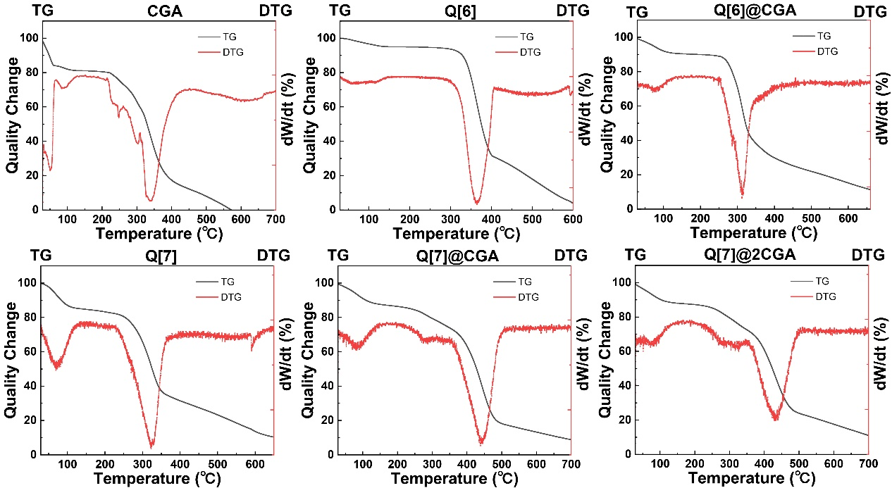
Figure S4 TGA and DTG patterns of CGA, Q[6], Q[6]@CGA, Q[7], Q[7]@CGA, and Q[7]@2CGA.

