Supplementary Material
Table S1 Strength centrality and predictability of the PHQ and DAS items.
Item | Predictability
DAS1 (Fear of death) | 0.775
DAS2 (Rarely think of death) | 0.849
DAS3 (Don’t get nervous talking about death) | 0.879
DAS4 (Fear of surgery) | 0.906
DAS5 (No fear of death at all) | 0.742
DAS6 (No fear of cancer) | 0.879
DAS7 (Not troubled by the thought of death) | 0.743
DAS8 (Agonizing over how fast time flies) | 0.858
DAS9 (Fear of a painful death) | 0.883
DAS10 (The topic of post death is very confusing to me) | 0.778
DAS11 (Fear of heart attack) | 0.852
DAS12(Life is too short) | 0.863
DAS13 (Hear about the end of the world scares me) | 0.863
DAS14 (Feel creepy seeing a dead body) | 0.885
DAS15 (Nothing to fear about the future) | 0.821
PHQ1 (Anhedonia) | 0.642
PHQ2 (Sad mood) | 0.612
PHQ3 (Sleep problem) | 0.750
PHQ4 (Fatigue) | 0.645
PHQ5 (Poor appetite/overeating) | 0.722
PHQ6 (Guilt feelings) | 0.657
PHQ7 (Problems with concentration) | 0.741
PHQ8 (Moving/speaking slowly or being fidget) | 0.708
PHQ9 (Suicide ideation) | 0.706
Note: DAS = Death anxiety scale, PHQ = Patient health questionnaire.

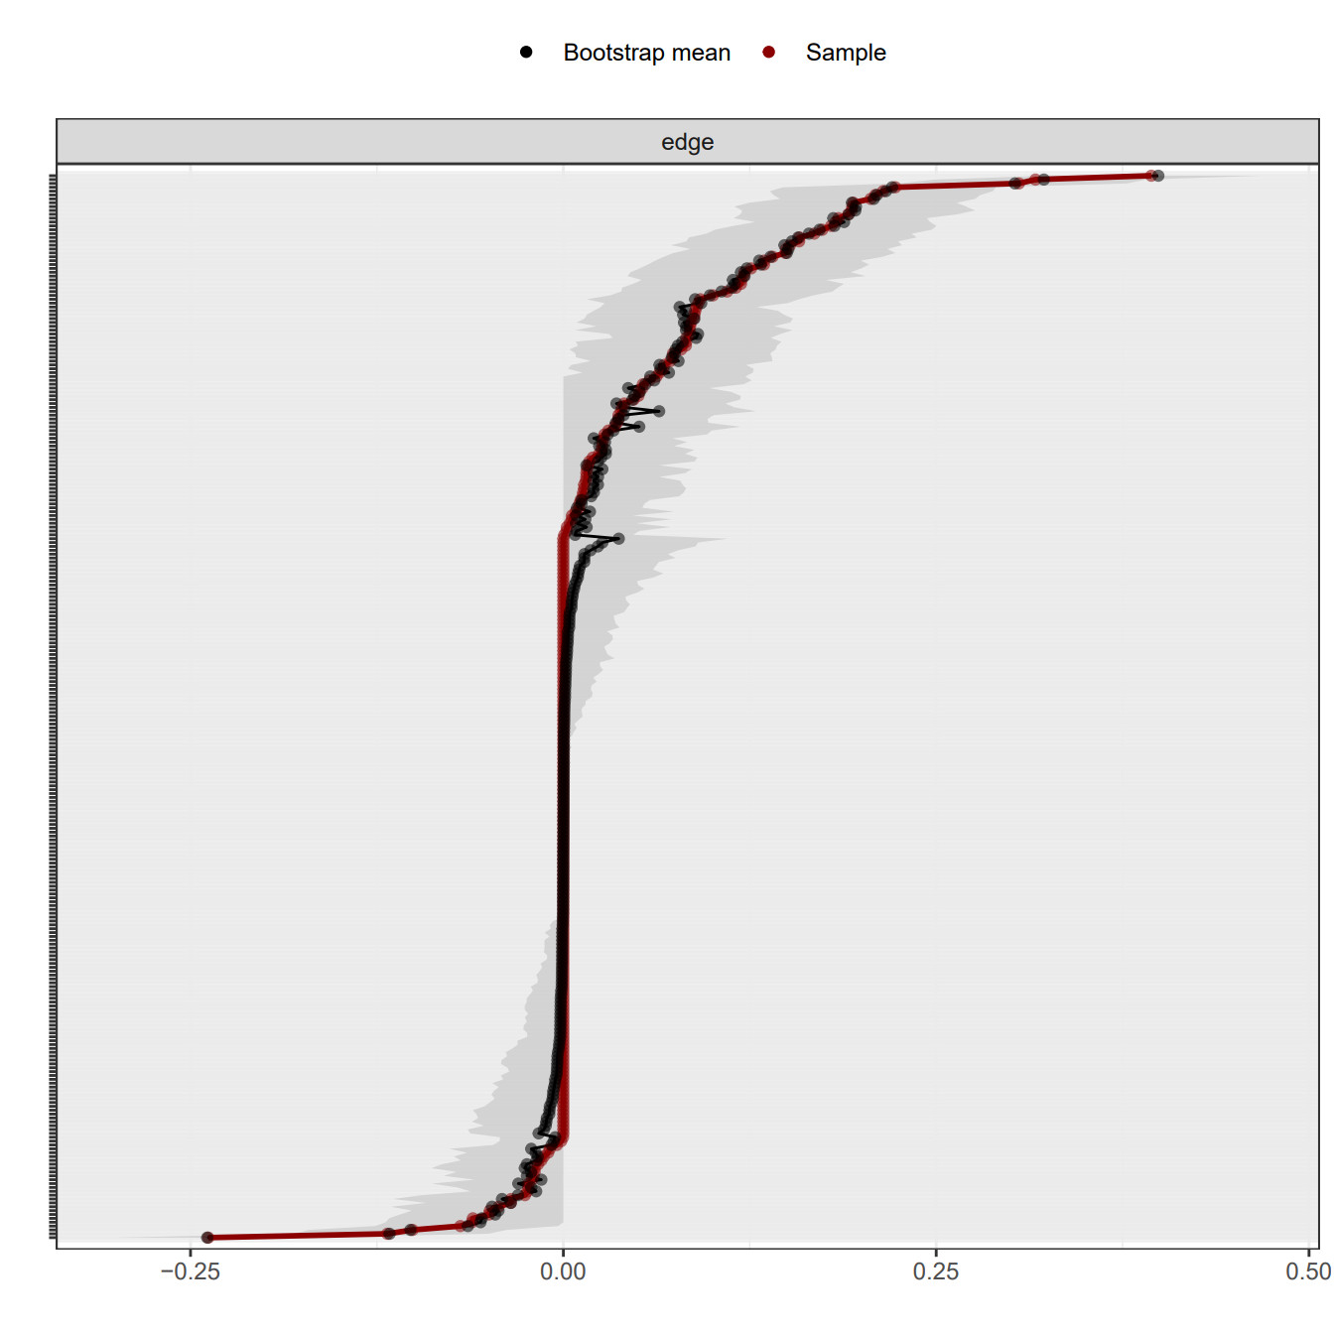
Figure S1. Bootstrapped 95% CIs of estimated edge weights. Note: The red line represents the edge generated by the sample. The grey indicates 95% bootstrapped confidence interval.

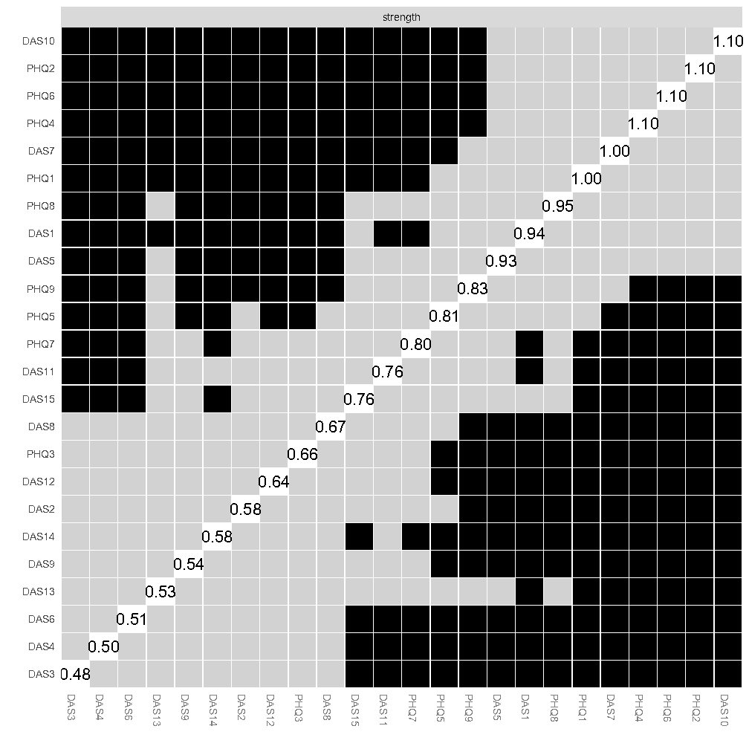
Figure S2. Nonparametric bootstrapped difference test for node strength of the death anxiety and depression network.

