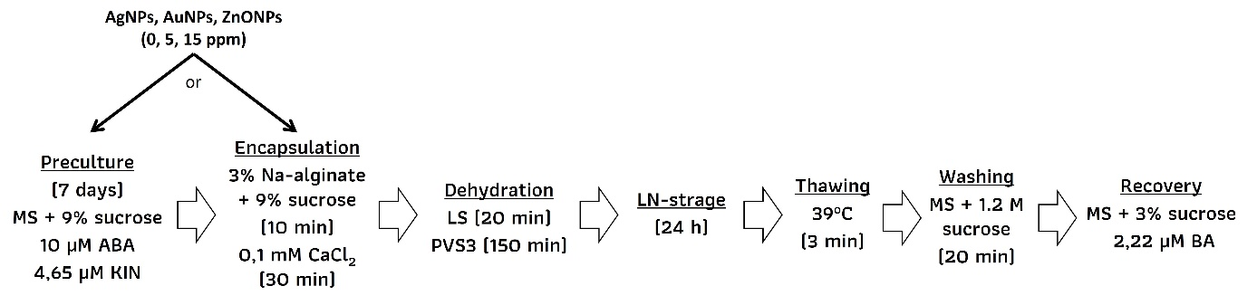

Supplementary Figure 1 A flowchart of key cryopreservation steps.

