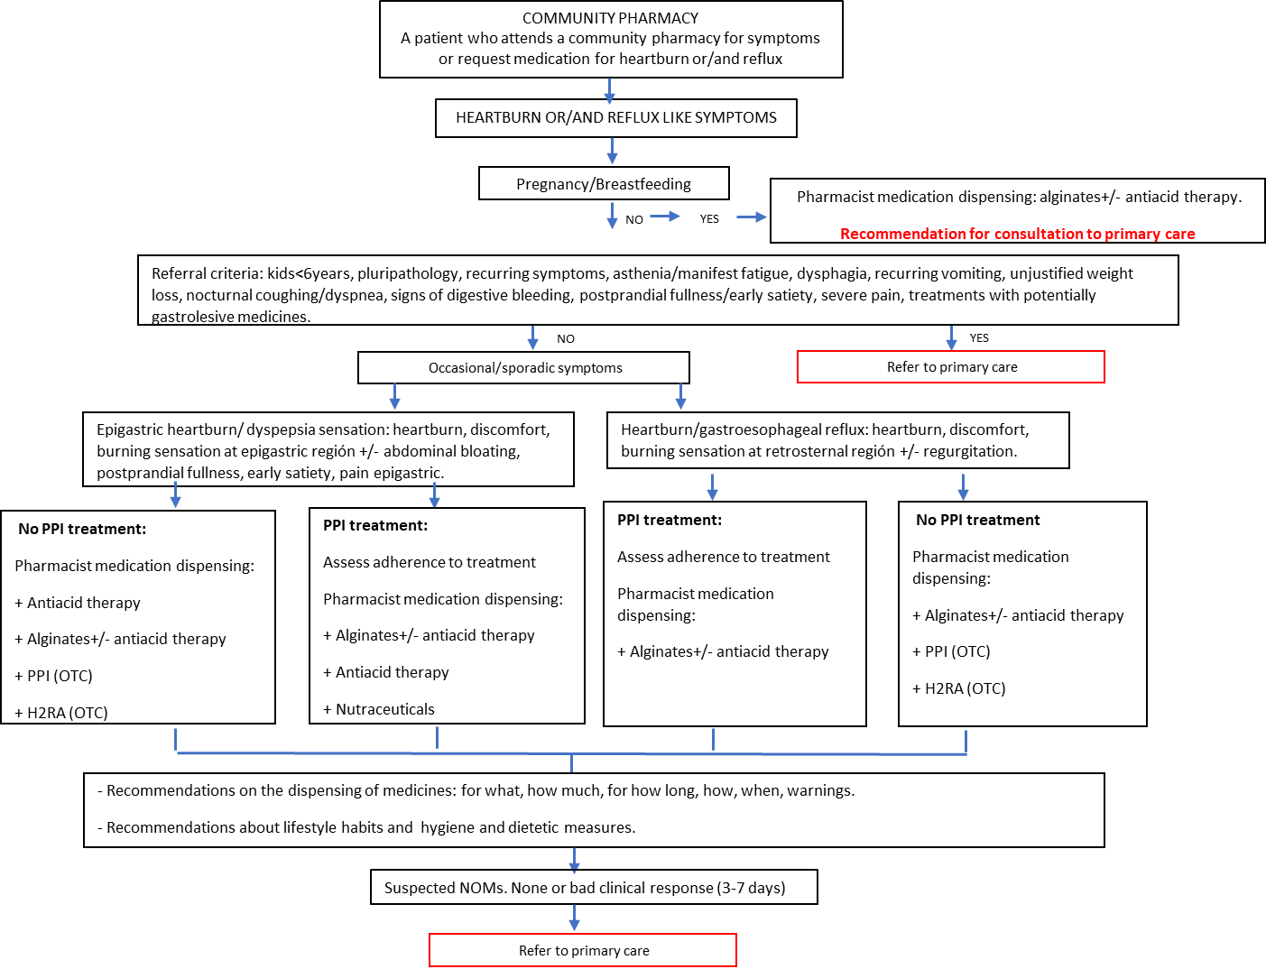
Supplementary Figure 1. Heartburn and/or reflux-like symptom management algorithm in community pharmacy.

Supplementary Data. Description of the variables collected in the baseline visit, intervention, training and standardization procedures
Variables collected:
• Outcome variable: Adherence to PPIs (Proton Pump Inhibitors) was evaluated using the 4-item Morisky Medication Adherence Scale (MMAS-4)²¹ which was recorded in a data collection notebook. The scale consists of 4 questions orally posed to the patient: a) Do you ever forget to take it? (yes/no), b) Do you take it at the indicated time? (yes/no), c) When you feel well, do you stop taking the medication? (yes/no), and d) If it ever bothers you, do you stop taking it? (yes/no). Once the questions were completed, the pharmacist classified the patient as adherent if they answered No to questions a), c), d), and Yes to question b), and as non-adherent if the patient answered No to question b) and/or Yes to questions a), c), and/or d).
• Sociodemographic variables: age; sex; educational level (no studies/primary education, secondary education/ university education); employment status (employee, self-employed, retired, unemployed); marital status (single, married, divorced-separated, widowed).
• Clinical variables: Body Mass Index (BMI) (weight (kg)/height (m)2); reasons for consultation (seeking treatment advice for the symptoms, requesting over the counter medication, both); requested over the counter medication (antacid monotherapy, alginate+antacids, PPIs, non-pharmacological treatment/others); smoking habit (smoker/ex-smoker, non-smoked); previous diagnosis of any gastrointestinal disease; presence of alarm criteria: symptoms (asthenia, dysphagia, recurrent vomiting, unexplained weight loss, gastrointestinal bleeding, severe pain, dyspnea, shortness of breath, nocturnal cough); intake of medicines often associated with symptoms (anti-inflammatory analgesics, bisphosphonates alendronates, calcium antagonists and/or nitrates, progesterone/oral contraceptives, tricyclic antidepressants/amitriptyline, theophylline, iron supplements, benzodiazepines, alpha-adrenergic antagonists/ doxazosin and systemic corticosteroids), and diagnosis of gastrointestinal disorders or diseases (GERD, gastric ulcer, hiatus hernia, infection with Helicobacter pillory, food intolerances, colon disorders, gastritis); characteristics of the previous medication used by the patient before visiting the pharmacy (prescribed, over the counter, both); how the patient felt about the previous medication used (it alleviated the symptoms or not); PPI regimen (breakfast, lunch, dinner, breakfast and dinner); when the PPI prescription started (1-4 weeks, 1-6 months, 1 year or more)
• Patient's quality of life and the distribution of patient’s symptoms through Gastroesophageal Reflux Disease Impact Scale (GIS) questionnaire. This questionnaire is validated in Spain ²² and is used by healthcare professionals for managing reflux symptoms. It consists of five questions, the first one is detailed and refers to the symptom location, and questions 2 to 5 refer to how the symptoms interfere with the patient's quality of life. The symptoms classification was divided in: epigastric, retrosternal or overlapping (both). Patients with epigastric symptoms were those who had a punctuation from 1 to 3 (frequency of symptoms: daily, often, or sometimes) in the question which refers to symptoms in the upper part of the stomach associated to the epigastric area and a 4 (never) in questions which refer to symptoms associated with the retrosternal area. Patients with retrosternal symptoms were those who had a punctuation from 1 to 3 (frequency of symptoms: daily, often, or sometimes) in questions which refer to symptoms associated with the retrosternal area and a punctuation of 4 (never) in the question which refers to symptoms associated to the epigastric area. Patients with overlapping symptoms were those who fulfilled both definitions.
Intervention
If patients with an active PPI prescription had a non-compliant result in the Morisky Green test and the patient agreed, the pharmacist carried out an intervention to improve treatment adherence. The intervention was to reinforce and examine the items on the Morisky scale on which the patient was non-adherent. Then, the pharmacist explained how and when to take the medication and provided the patient with strategies to improve adherence.
Training and standardization procedures
All registered pharmacists received prior training by the research team on the objective, methodology and procedures of the study. Prior training consisted of an online course hosted on the study’s platform, which included three 'training modules' and a structured interview with the study's instructor to validate the received training. This training was accredited by the Miguel Hernandez University of Elche, where the research team is located.
This study had an epidemiological monitor, responsible for overseeing data collection and validating the information gathered, while also serving as a communication link between the research team and the investigating pharmacists

