Figure S1: Protein Structure of Pro-Inflammatory Transcription Factors Activated by Chronic Stress.
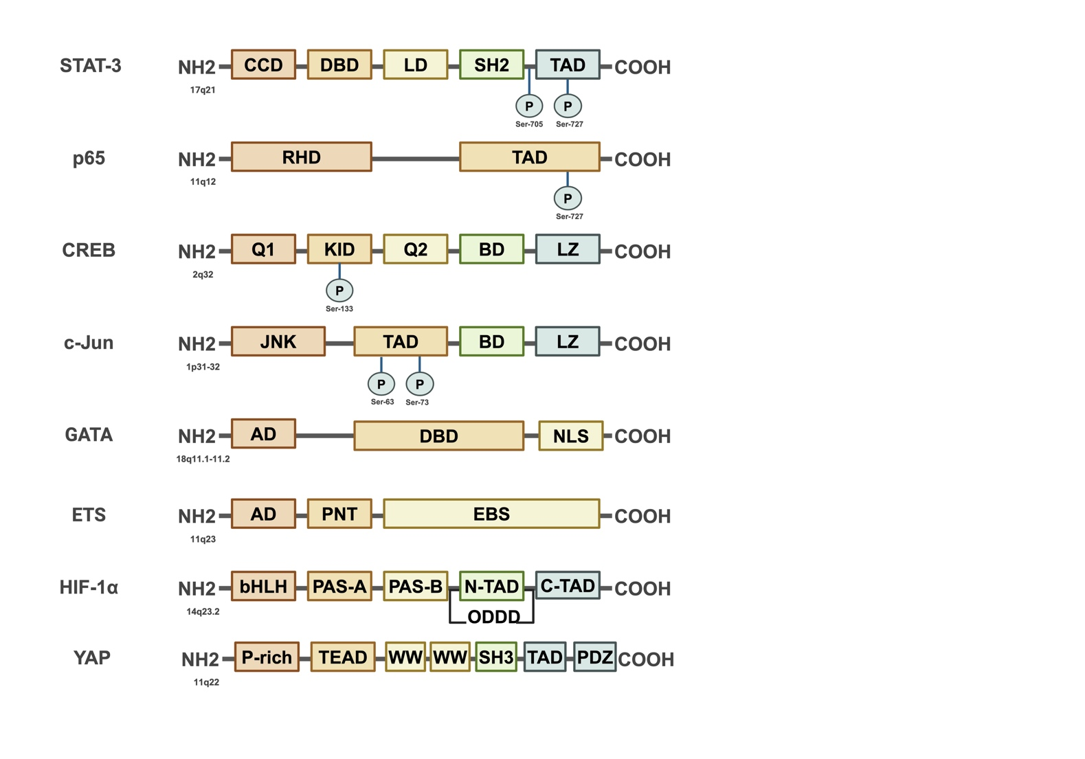

Figure S2: The positive feedback loop of L-6-STAT-3 and TNF-α-NF-κB mediated by chronic inflammation promotes the occurrence and progression of cancer.
