Supplementary, Definitions
Definition of immigrant and Danish-born patients
In accordance with the definition used by statistics Denmark ¹, Danish citizens born outside Denmark and without Danish-born parents were defined immigrant patients. Citizens born in Denmark and citizens born with at least one Danish-born parent with Danish citizenship were categorized as Danish-born patients.
Definition of Western countries
Western countries include all 28 EU countries plus Andorra, Iceland, Liechtenstein, Monaco, Norway, San Marino, Switzerland, The Vatican, Canada, USA, Australia, and New Zealand.
Non-Western countries include all other countries.
Supplementary, Interpretation of the Mediation Analysis
When assessing the effects of an exposure (immigration status) on an outcome (survival), it is of interest to investigate the mechanism of how the exposure effects the outcome. For this purpose, mediators are considered. Mediators are variables affected by the exposure, which in turn also affects the outcome. Thereby, a part of the overall effect of an exposure on an outcome is mediated through mediators.
The mediation analysis conducted in this study employed the natural effects Cox model with a weighting scheme which allowed for causal pathways through multiple mediators ². By assuming a causal structure (Figure S1) and controlling for confounders, the effects of immigration status (total effect) was decomposed into direct and indirect effects. The indirect effects are the effects on the causal pathway that goes through any mediators, while the direct (unexplained) effect is the remnant effect that is not explained through any of the considered mediators. An indirect effect through a mediator quantifies the amount of the total effect on the outcome that is due to the difference in distribution between the exposure groups. Thus, an indirect effect measures a combination of the predictive power of the mediator as well as how much the mediator distribution varies between exposure groups.
Despite disease stage being a strong predictor of OS, there were no significant differences in its distribution between non-Western immigrant and Danish-born patients after controlling for confounders. Consequently, the estimated effect of immigration status mediated through disease stage yielded a hazard ratio of 1. However, as income quartile is a predictor of OS and there were significant disparities in income distribution between non-Western immigrant and Danish-born patients, this led to an estimated indirect hazard ratio through income of 1.06. Since exposure can affect the mediators differently, the effects may not always align. Some effects may lead to better OS for non-Western immigrant patients, while others may result in inferior OS compared to Danish-born patients. Regardless of whether the direct effect and indirect effects align or oppose each other, the total causal effect is determined by multiplying the hazard ratios for each indirect effect and the direct effect.
In this study, although the direct effect was significant, no total causal effect was observed due to its counteraction by the indirect effects mediated through ECOG PS and income.
Supplementary, Data Sources
The Danish Civil Registration System ³ was used to identify patients across registers using a unique 10-digit social security number, as well as information on emigration, country of origin, and time of death.
The Danish DREAM database ⁴ was used to obtain the employment status of the patients one year prior to lymphoma diagnosis
The Danish Salary Register ⁵ was used to categorize patients into income quartiles based on their age and standardized household income one year prior to lymphoma diagnosis.
The Danish Education Registry ⁶ was to categorize the patients highest attained educational level as either higher (5-8) or lower (0-4) based on International Standard Classification of Education (ISCED) 2011 codes.
References
1. Immigrants and their descendants - Statistics Denmark [Internet]. [cited 2024 April 23]. Available from: https://www.dst.dk/en/Statistik/emner/borgere/befolkning/indvandrere-og-efterkommere.
2. Lange T, Rasmussen M, Thygesen LC. Assessing natural direct and indirect effects through multiple pathways. Am J Epidemiol. 2014;179(4):513-518. doi:10.1093/aje/kwt270
3. Schmidt M, Pedersen L, Sørensen HT. The Danish Civil Registration System as a tool in epidemiology. Eur J Epidemiol. 2014;29(8):541-549. doi:10.1007/s10654-014-9930-3
4. Hjollund NH, Larsen FB, Andersen JH. Register-based follow-up of social benefits and other transfer payments: Accuracy and degree of completeness in a Danish interdepartmental administrative database compared with a population-based survey. Scand J Public Health. 2007;35(5):497-502. doi:10.1080/14034940701271882
5. Baadsgaard M, Quitzau J. Danish registers on personal income and transfer payments. Scand J Public Health. 2011;39(7_suppl):103-105. doi:10.1177/1403494811405098
6. Jensen VM, Rasmussen AW. Danish education registers. Scand J Public Health. 2011;39(7_suppl):91-94. doi:10.1177/1403494810394715

Table S1
Effect type | Effects size (95% confidence interval)
Natural direct effect | 0.79 (0.70-0.88)
Natural indirect effect through disease stage | 0.99 (0.89-1.10)
Natural indirect effect through performance status | 1.05 (0.94-1.16)
Natural indirect effect through income quartile | 1.19 (1.07-1.32)
Total causal effect | 0.97 (0.78-1.20)
Notes: Results from a mediation using a natural effects Cox model considering only patients diagnosed with diffuse large B-cell lymphoma. Here, age, sex, and calendar year were considered as confounders.

Figure S1
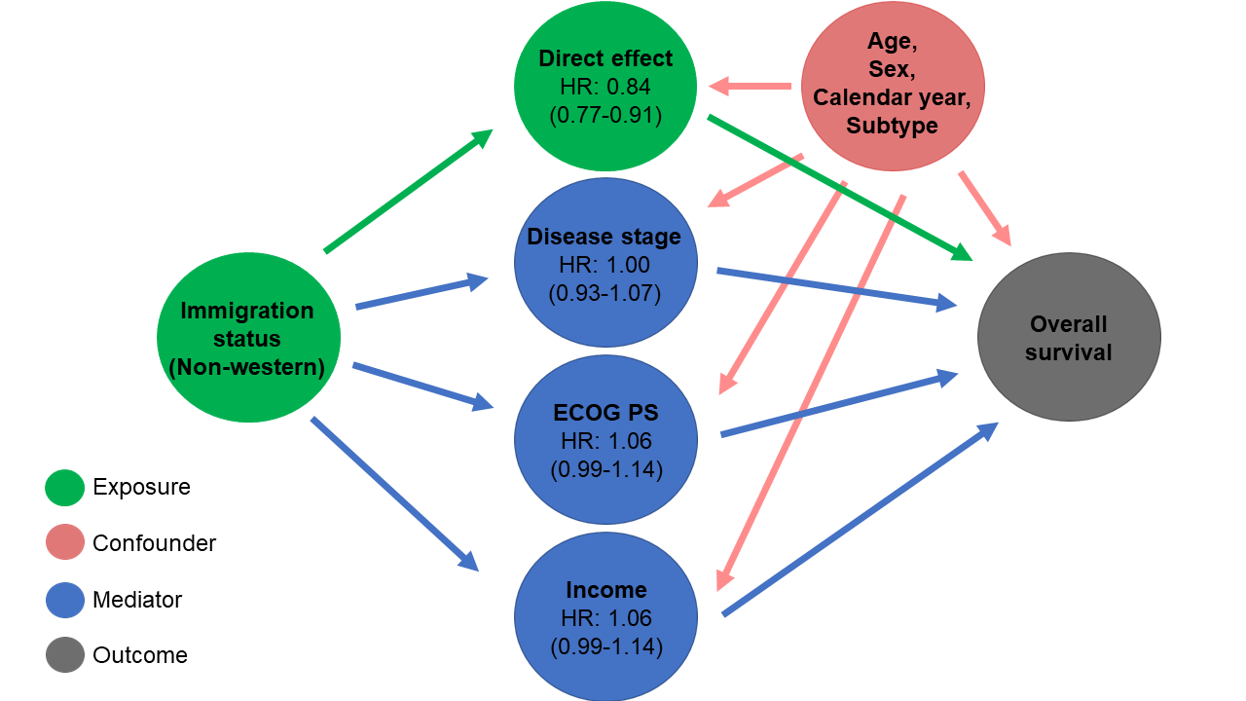

Notes: Causal directed acyclic graph (DAG) indicating the assuming causal structure in the study. The DAG shows the causal pathways from immigration status to overall survival through the mediators and directly, as well as the confounding. At each of the mediators and the direct effect, the corresponding hazard ratios and p-values from the mediation analysis are presented.
Abbreviations: ECOG PS, Eastern Cooperative Oncology Group performance status; disease stage, Ann Arbor disease stage; age, age at diagnosis; calendar year, calendar year at diagnosis.

Figure S2


Notes: Forest plot showing the inverse probability weighted hazard ratios for all-cause mortality with Danish-born patients as a reference for each considered lymphoma subtype.
Abbreviations: cHL = classical Hodgkin’s lymphoma, DLBCL = diffuse large B-cell lymphoma, FL = follicular lymphoma, MZL = marginal zone lymphoma, PTCL = peripheral T-cell lymphoma, ECOG PS= Eastern Cooperative Oncology Group performance status, HR = Hazard ratio, CI = confidence interval.

