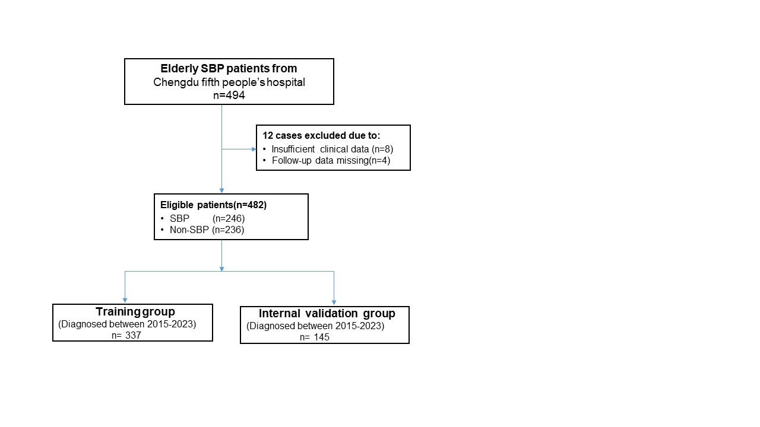

Figure S1 . Screening flowchart for patient selection. SBP: spontaneous bacterial peritonitis.

