Supplementary Material
Virtual Pulmonary Rehabilitation Program Description
The Blue Marble Health V-PR Platform contains both a downloadable patient-facing app (Health in Motion) and a clinician-facing web app both requiring a unique login and password. Passwords can be reset using a work or personal email or, if a study participant, by contacting the clinician (Figure S1a and S1b).
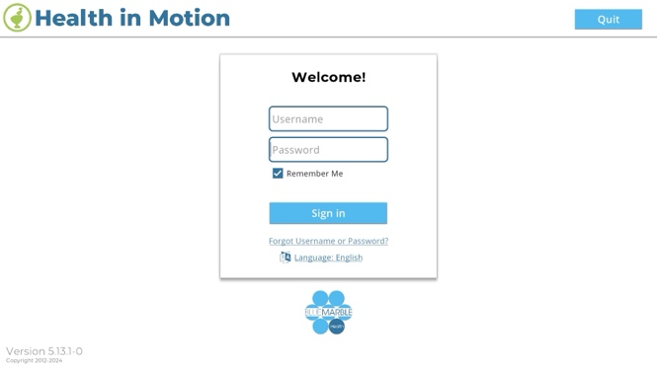
Figure S1a. Patient-facing app login screen, S1b. Clinician-facing web-app login screen.
The protocol required the completion of several patient-reported outcomes (Figure S2) and tests, many of which are contained within the Platform. The clinician selected the PROs and tests via the web app and assigned them to the patient’s account.
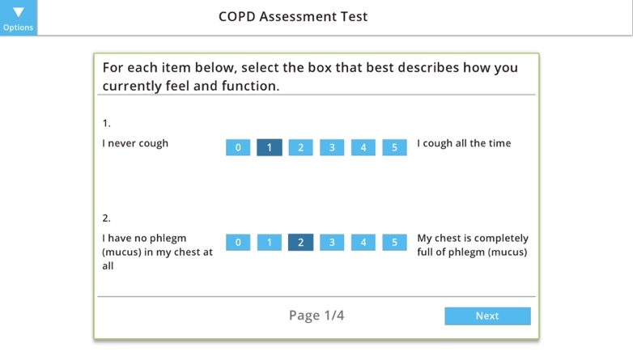
Figure S2. Screenshot of in-app survey (CAT).
The clinician used the Home Program Wizard to design and assign a personalized program based on the patient’s ability (Figure S3).
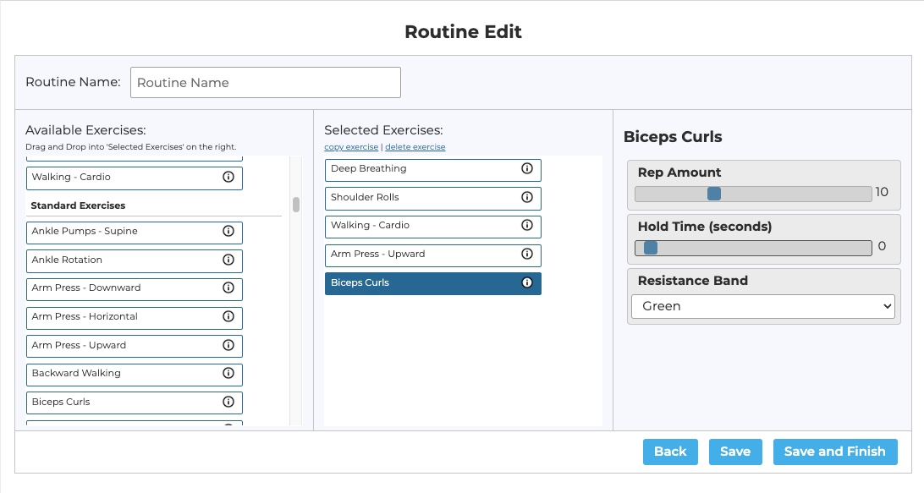
Figure S3. Clinician-facing Home Program Wizard dashboard
The Home Program consists of avatar-guided exercises (Figure S4a and S4b), educational modules (Figure S5a-S5c), and a COPD Action Plan (Figure S6a-6b). The patient-facing app also contains a health diary in which the patient logs blood pressure, heart rate, and oxygen saturation as appropriate. The health diary also includes a text box for entering feelings about their health or asking the supervising study clinician a question. All patient data entered via the app is then shared with the clinician via the web-based dashboard.
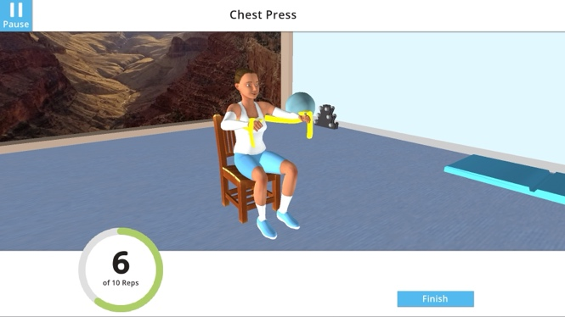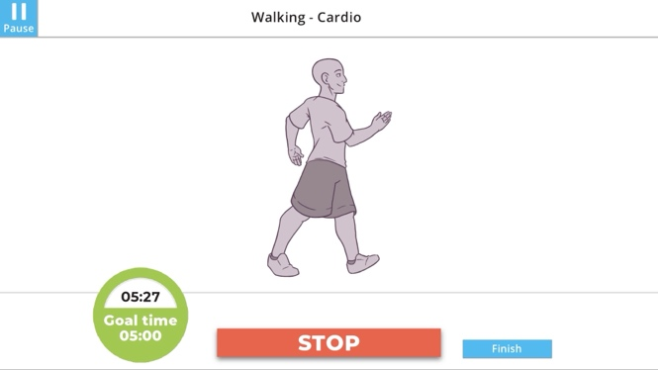
Figure S4a. Screenshot of in-app avatar-guided Chest Press exercise. The clinician sets the number of reps, color TheraBand, time, and intensity. Figure S4b. Screenshot of in-app Walking exercise. The clinician sets the goal time and intensity. The O₂ saturation and Heart Rate are displayed on the screen if the patient uses a blue-tooth pulse oximeter;
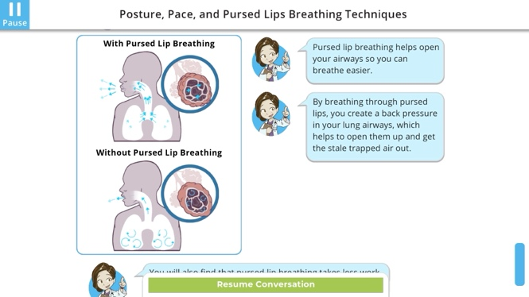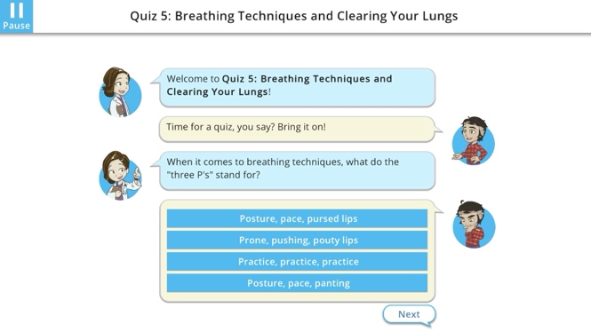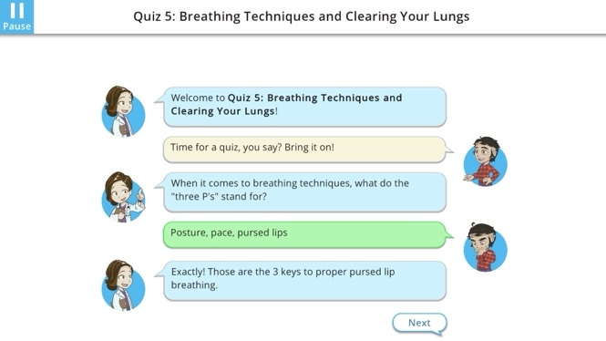
Figure S5a. Screenshot of patient-facing Class (Posture, Pace, and Pursed Lips Breathing Techniques Class). The class offers interactive elements to increase knowledge transfer.Figure S5b and S5c. Screenshots of patient-facing Quiz. The quiz questions are multiple-choice with the correct response chat bubble highlighted green, whereas the incorrect response is highlighted in red.

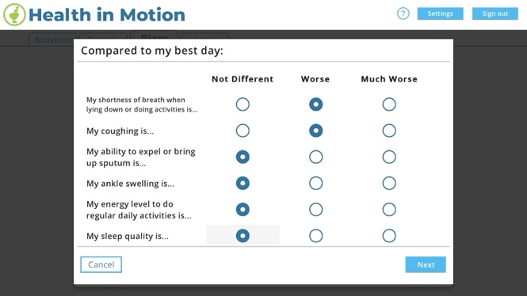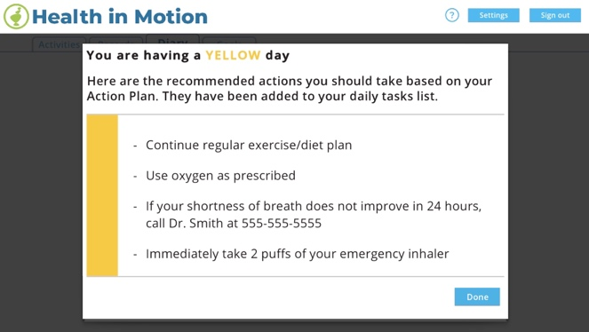
Figure S6a. Screenshot of in-app Action Plan Survey; Figure S6b. Screenshot of in-app Action Plan Results
The clinician logged into the web app and selected the patient of interest. All data is displayed in on a dashboard, including exercise adherence, exercise symptoms, completed educational classes, quiz scores, Action Plan results, including a color day and actions, and health diary information.
The personalized home program Is designed for each patient. The Platform contains over 130 potential exercises, of which 66 unique exercises were used during this study. Supplementary Material – Table S1 indicates the exercise and the frequency of assignment for the V-PR group. At one site, participants were started with at least 10 minutes of walking and a strength program. Participants with access to a recumbent bike used it for aerobic training. The duration of aerobic training was progressed each week by 2’-5’, based on participants’ tolerance to exercise the week prior. They were assigned aerobic training 5x/week, strength training for upper extremity 2x/week, and strength training for lower extremity 2x/week. Strength training was progressed each week by increasing reps or resistance. At the other sites, the participants were encouraged to exercise thrice weekly. The individualized exercise program consisted of endurance training (walking, home treadmill, or home stationary bike), strength training (using TheraBand and light hand weights), and balance training. Exercise intensity progressed incrementally each week as the subject tolerated utilizing the rate of perceived exertion/Pain/SpO2 scales. The goal for each participant was to work up to 20-30 continuous minutes of aerobic exercise, 20-30 min of strength training, and 10 minutes of balance training.
Table S1. Exercises prescribed in the personalized V-PR program and the percentage of participants assigned to each exercise.
Exercise | Percent of participants assigned this exercise | Exercise Icon | Exercise | Percent of participants assigned this exercise | Exercise Icon
Biceps Curls | 100.0% | 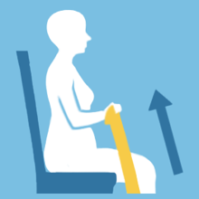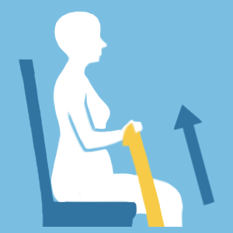 | Tai Chi: Brush Knee | 21.7% | 
Chest Press | 100.0% | 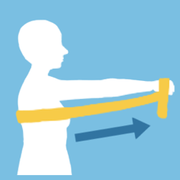 | Tai Chi: Grasp The Peacock's Tail | 21.7% | 
Sit to Stand | 100.0% | 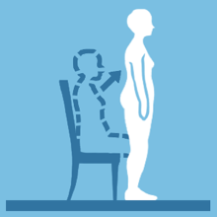 | Tai Chi: Hands Like Clouds | 21.7% | 
Overground Walking | 100.0% | 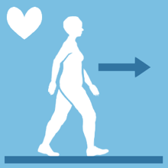 | Tai Chi: Holding the Ball | 21.7% | 
Overhead Press | 87.0% | 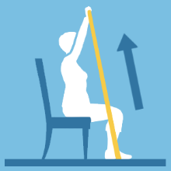 | Tai Chi: Moon Rise | 21.7% | 
Shoulder Abduction | 87.0% | 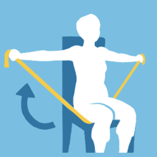 | Tai Chi: Parting the Horse's Mane Advanced | 21.7% | 
Knee Extension - Sitting | 82.6% | 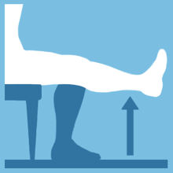 | Tai Chi: Parting the Horse's Mane Basic | 21.7% | 
Heel Raises | 73.9% | 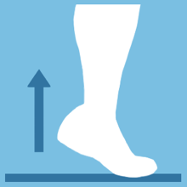 | Tai Chi: Repulse Monkey | 21.7% | 
Ankle Pumps - Sitting | 69.6% | 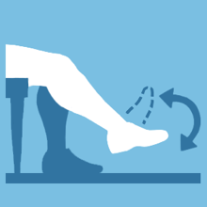 | Tai Chi: Single Whip | 21.7% | 
Deep Breathing | 69.6% | 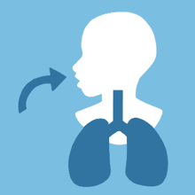 | Treadmill - Cardio | 21.7% | 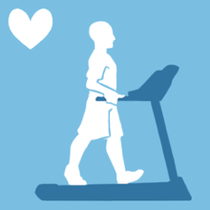
Leg Press | 69.6% | 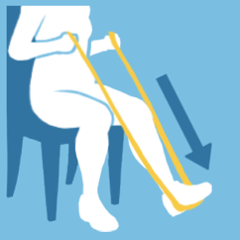 | Recumbent Bike - Cardio | 17.4% | 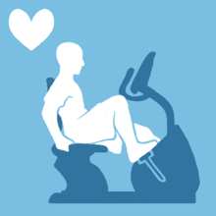
Trunk Rotation | 69.6% |  | Clamshell | 13.0% | 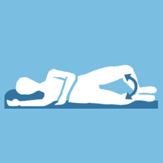
Shoulder Rolls | 65.2% |  | Hip Circles | 13.0% | 
Rowing | 56.5% | 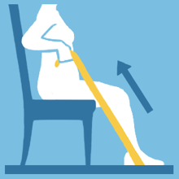 | Arm Press - Downward | 8.7% | 
Back Extension | 52.2% | 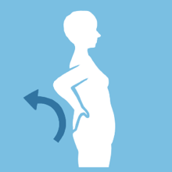 | Arm Press - Horizontal | 8.7% | 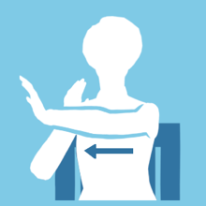
Good Morning Stretch | 52.2% |  | Arm Press - Upward | 8.7% | 
Standing On One Leg | 52.2% | 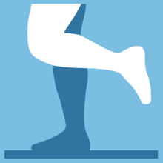 | Bear Hug Stretch | 8.7% | 
Calf Stretch - Standing | 47.8% | 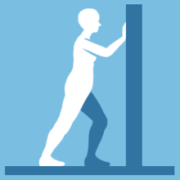 | Bridging | 8.7% | 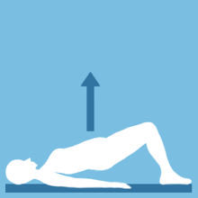
Calf Press | 43.5% | 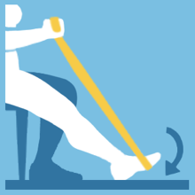 | Deep Breathing - Sitting | 8.7% | 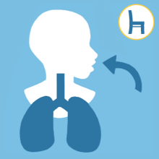
Foot Circles | 43.5% | 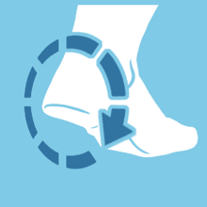 | Hamstring Sets | 8.7% | 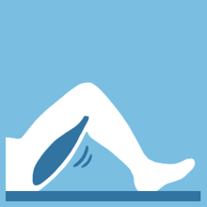
Hip Abduction - Sitting | 43.5% | 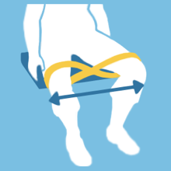 | Heel Toe Stand | 8.7% | 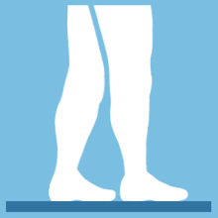
Hip Flexion - Sitting | 43.5% | 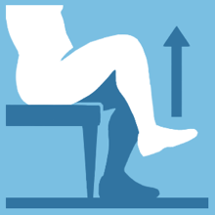 | Heel Walking | 8.7% | 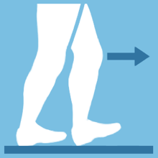
Mini Prompt - Take a few breaths in sitting and standing | 43.5% |  | Hip Flexion - Standing | 8.7% | 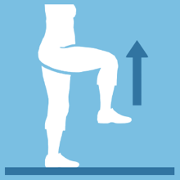
Chair Push Ups | 39.1% | 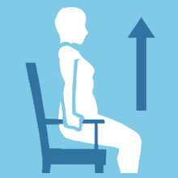 | Knee Extension Stretch - Sitting | 8.7% | 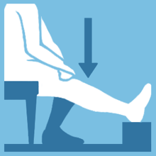
Hip Abduction - Standing | 39.1% | 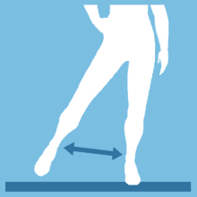 | Mindful Stair Climbing | 8.7% | 
Hip Extension - Standing | 39.1% | 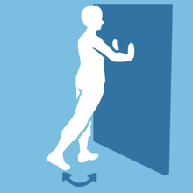 | Multidirectional Stepping | 8.7% | 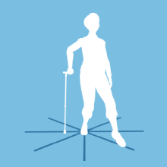
Knee Flexion - Standing | 39.1% | 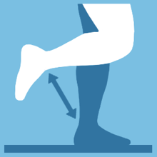 | Quad Sets | 8.7% | 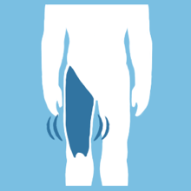
Chin Tuck | 30.4% | 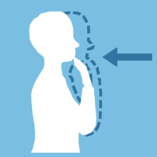 | Step Overs - Lateral | 8.7% | 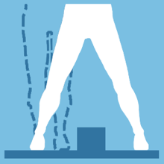
Hamstring Stretch | 30.4% | 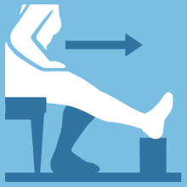 | Straight Leg Raise | 8.7% | 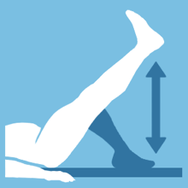
Shoulder Stretch - Elbows Touch | 30.4% |  | Toe Walking | 8.7% | 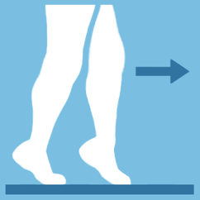
Glute Sets | 21.7% | 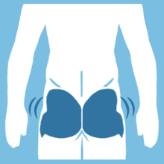 | Ankle Pumps - Supine | 4.3% | 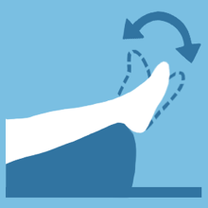
Neck Rotation | 21.7% |  | Recumbent Cross Trainer - Cardio | 4.3% | 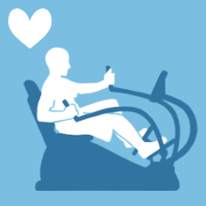
Tai Chi : Brush Knee | 21.7% |  | Semi-Squats | 4.3% | 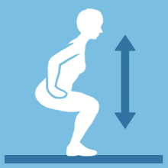

Education was provided through the app. The topics were modeled after the education topics presented to the in-person group. VPR educational topics included Pulmonary Anatomy and Physiology, Medical Tests for COPD, Medications, Breathing Techniques, the Importance of Exercise, Eating Right, Activities of Daily Living, Irritant Avoidance, Coping with COPD, Exacerbations, and advanced directives/Palliative Care.
Patient data is collected automatically as the patient completes each activity, limiting the burden of manually entering information. Participants manually enter their exercise symptoms using the rating scale.
The Platform does not provide direct “chat” messaging between the patient and clinician via the app; however, the patient can send a message to the clinician via the health diary text box.
In terms of virtual monitoring, clinicians used the web app dashboard to monitor the following parameters: Action Plan color days, exercise adherence (i.e., number of reps completed, time walking completed, etc.), completion of the educational class, quiz scores, exercise symptom rating scales (i.e., for breathlessness, exertion, pain, fatigue, and oxygen saturation as appropriate), and health diary entries.
The weekly phone calls, lasting 10-20 minutes, were performed by the study physical therapist or respiratory therapist and consisted of the following:
- Exercises: review of exercise plan and specific exercises, address any questions or concerns for each exercise. Exercises were modified as appropriate if the participant indicated they were unable to complete the exercise due to pain, musculoskeletal limitations, or space. Exercises were progressed as appropriate based on patient’s feedback and exercise symptom ratings and these changes were discussed with the participant. If exercise-related changes in symptoms, pain, desaturations were noted, these were also discussed.
- Educational Topics: discussed educational topics completed, answered any questions, and discussed the upcoming topics to be completed next week.
- Vital signs were reviewed and discussed if participants entered comments in the health diary. Any health-related or new onset of symptoms was also discussed, and the patient was encouraged to discuss changes in symptoms with their physician as appropriate.
- Answered any additional exercise-related questions, symptoms, education, or technical issues.
- The study staff was also available via call or message to address technical and Wi-Fi connection issues.

Clinic-based Pulmonary Rehabilitation Program Description
Each site conducted PR as per its typical program based on standardized guidelines set by the AACVPR. Each participant was provided with an individualized PR program, which included exercise and education. At one location, patients moved through three 10-minute stations consisting of walking (on the track or treadmill), stationary biking (recumbent bike or NuStep), and strengthening (upper extremity and lower extremity). Station time was increased by 2 minutes each session up to 20-25 minutes. Once 20 minutes of biking was achieved, resistance was increased in stages to provide a greater challenge (i.e., Level 2x5 minutes + level 1 for 15 minutes). At the other sites, individual exercise programs consisted of endurance training (walking on the track, treadmill, recumbent bike, or NuStep for 20 minutes) and strength training using TheraBand for 10 minutes. Exercise intensity progressed incrementally each session based on the participant’s subjective reports of exertion and pain, and oxygen saturation.
Educational material was performed via in-person lectures and handouts. In some cases, education was conducted one-on-one and included demonstrations and videos. Educational classes typically lasted 30 minutes.

Table S2 – Recruitment Sites
Recruitment Site | Number of Patients Recruited
*West Virginia Cabin Creek, WV | 3
*West Virginia New River, WV | 3
Wake Forest University Main Campus, NC | 12
Wake Forest Lexington Campus, NC | 14
Duke University, NC | 16
*West Virginia sites offered only V-PR as their facility-based program was closed during the COVID-19 pandemic. The 3 North Carolina sites offered both C-PR and V-PR.

Table S3: Pre- and post-intervention scores for multiple efficacy criteria.
Color coding this column | Group | Baseline Mean (SD) | Post-Test Mean (SD) | Change Scores | Within (t-test)  p-Value (Effect Size) | Between ANCOVA  p-value  (ω2)
6-Minute Walk Test | C-PR | 347.9 (69.1) | 395.6 (60.8) | 47.7 (46.8) | .004  (-0.979) | 0.437 (0.020)
 | V-PR | 356.9 (110.9) | 390.9 (104.2) | 34.0 (49.2) | .006  (-0.674) | 0.437 (0.020)
St. George’s Respiratory Questionnaire (SGRQ) | C-PR | 51.86 (14.01) | 42.76 (12.38) | -9.1 (13.5) | 0.014* (0.67) | 0.724 (0.00)
St. George’s Respiratory Questionnaire (SGRQ) | V-PR | 49.20 (13.49) | 42.25 (15.79) | -7.0 (10.7) | 0.005 (0.65) | 0.724 (0.00)
COPD Assessment Test (CAT) | C-PR | 21.47 (6.65) | 17.88 (5.86) | -3.6 (4.2) | 0.004* (0.83) | 0.919 (0.00)
COPD Assessment Test (CAT) | V-PR | 18.74 (6.10) | 15.96 (6.52) | -2.8 (5.7) | 0.031* (0.48) | 0.919 (0.00)
Lung Information Needs Questionnaire (LINQ) | C-PR | 8.71 (3.86) | 3.82 (2.33) | -4.9 (3.8) | <0.001* (1.26) | 0.800 (0.00)
Lung Information Needs Questionnaire (LINQ) | V-PR | 6.83 (3.04) | 3.70 (2.79) | -3.1 (3.6) | <0.001* (0.85) | 0.800 (0.00)
30 Second Sit to Stand (30STST) | C-PR | 9.94 (3.61) | 12.65 (3.30) | 2.7  (2.0) | <0.001* (-1.34) | 0.048* (0.045)
30 Second Sit to Stand (30STST) | V-PR | 10.39 (3.22) | 11.39 (2.94) | 1.0  (3.0) | 0.128  (-0.33) | 0.048* (0.045)
4 Stage Balance Test (4SBT) | C-PR | 38.59 (2.82) | 39.28 (1.49) | 0.7  (2.3) | 0.295  (-0.52) | 0.863 (0.000)
4 Stage Balance Test (4SBT) | V-PR | 35.6 (7.55) | 38.31 (3.06) | 2.7  (5.7) | 0.023*  (-0.79) | 0.863 (0.000)
Timed Up and Go Test (TUG) | C-PR | 8.65 (1.77) | 8.19 (2.55) | -0.5 (2.0) | 0.383 (0.22) | 0.970 (0.00)
Timed Up and Go Test (TUG) | V-PR | 8.89 (2.00) | 8.34 (2.95) | -0.5 (2.5) | 0.314 (0.22) | 0.970 (0.00)
Depression screen (DS) | C-PR | 0.41 (0.80) | 0.47 (0.80) | 0.06 (0.8) | 0.890  (-0.13) | 0.923 (0.00)
Depression screen (DS) | V-PR | 0.61 (0.72) | 0.57 (0.84) | -0.04 (0.7) | 0.821 (0.11) | 0.923 (0.00)
Fall Risk Questionnaire (FRQ)$ | C-PR | 3.82 (2.70) | 2.88 (1.97) | -0.9 (2.2) | 0.108 (0.41) | 0.261 (0.00)
Fall Risk Questionnaire (FRQ)$ | V-PR | 2.50 (3.02) | 2.55 (2.99) | 0.05 (1.3) | 0.870  (-0.04) | 0.261 (0.00)
Single Item Literacy Screen (SILS) | C-PR | 1.94 (0.97) | 1.94 (0.75) | 0.0  (0.9) | 1.000 (0.00) | 0.027* (0.08)
Single Item Literacy Screen (SILS) | V-PR | 1.44 (0.59) | 1.30 (0.56) | -0.1 (0.6) | 0.374 (0.43) | 0.027* (0.08)
NIH PROMIS Physical | C-PR | 39.13 (4.01) | 41.68 (3.69) | 2.6  (4.6) | 0.040*  (-0.54) | 0.393 (0.00)
NIH PROMIS Physical | V-PR | 42.85 (5.66) | 45.81 (6.88) | 3.0  (4.1) | 0.003*  (-0.70) | 0.393 (0.00)
NIH PROMIS Mental | C-PR | 45.84 (6.50) | 45.41 (5.57) | -0.4 (5.8) | 0.769 (0.07) | 0.364 (0.00)
NIH PROMIS Mental | V-PR | 47.78 (6.68) | 48.49 (8.43) | 0.7  (6.2) | 0.598  (-0.11) | 0.364 (0.00)
NIH PROMIS General | C-PR | 2.29 (0.47) | 2.24 (0.44) | -0.1 (0.42) | 0.773 (0.33) | 0.57 (0.037)
NIH PROMIS General | V-PR | 2.48 (0.73) | 2.70 (0.82) | 0.2  (0.6) | 0.110  (-0.56) | 0.57 (0.037)
NIH PROMIS Social | C-PR | 2.88 (0.78) | 2.94 (0.75) | 0.0  (0.5) | 0.766  (-0.20) | 0.631 (0.00)
NIH PROMIS Social | V-PR | 3.30 (0.77) | 3.30 (1.11) | 0.0  (1.1) | 0.912  (-0.037) | 0.631 (0.00)
VR12 PCS (Physical) Mail | C-PR | 30.92 (7.15) | 33.74 (5.94) | 2.8  (6.6) | 0.107  (-0.414) | 0.202 (0.011)
VR12 PCS (Physical) Mail | V-PR | 34.90 (6.99) | 38.87 (8.50) | 4.0  (6.6) | 0.010*  (-0.592) | 0.202 (0.011)
VR12 MCS (Mental) Mail | C-PR | 49.44 (9.54) | 50.7 (9.09) | 1.3  (9.0) | 0.59  (-0.135) | 0.710 (0.000)
VR12 MCS (Mental) Mail | V-PR | 52.78 (12.47) | 53.30 (10.48) | 0.5 (10.7) | 0.822  (-0.047) | 0.710 (0.000)
*p-value < 0.05
$n=1 V-PR participant did not complete the post-test

The number of participants included in the analysis was C-PR n=17, V-PR n=23; the FRQ included only n=22 in the V-PR group.

